
Project Name: ServiceSathi.pk
Course: Fundamentals of Software Engineering
Deliverable: Iteration 3 (Sprint 3)

Group Members:
Syeda Faryal Zehra (24L-2556)
Ibrahim Qaiser (24L-2513)
Syeda Ume Abeeha Naqvi (24L-2528)

Class: BDS-4B
Submission Date: 3rd-May-2026

Service Sathi
ServiceSathi.pk is an online service marketplace that connects customers with service providers such as plumbers, cleaners, cooks, and electricians throughout Lahore. The system includes three main actors: users, sellers, and administrators. The system is implemented using Flask (Python), HTML/CSS, and a SQL database.
Sprint 3:
Module Name: Booking & Account Management Module
Description: Building upon the transactional and booking management capabilities introduced in Sprint 2, Sprint 3 focuses on enhancing user engagement, system interactivity, and service transparency. This iteration enables users and sellers to manage their profiles, receive real-time notifications, and build trust through reviews and ratings. Payment and booking statuses are now tracked dynamically, improving system clarity and user experience. Additionally, an intelligent Sathi Bot has been introduced to assist users with queries and navigation, making the platform more interactive and user-friendly.

Sprint Backlog
Tasks | Description
Profile Editing | Allows users and sellers to update their personal information, contact details, and profile settings.
Reviews | Allows users to rate and review services after booking completion to ensure transparency and quality.
Notifications | The user will receive notifications of the booking status from seller and vice versa
Payment status | Displays and tracks whether a booking has been paid or is pending.
Booking status update | Allows sellers (and system/admin) to update booking status such as accepted, rejected, or completed.
Sathi Bot | Provides an interactive chatbot to assist users with queries, navigation, and platform guidance.
User Stories
User Stories
Story ID: US-01  Story title: Profile Editing  User Story:  As a user/seller, I want to update my profile details so that I can keep my account personalized and up to date.  Description:  This story focuses on allowing users and sellers to edit their profile information including profile picture, personal details, and password.  Sub User Stories:  • Upload or change profile picture  • Update name, email, and phone number  • Change account password  Acceptance Criteria:  • User can upload/change profile picture  • User can update personal details  • User can successfully change password  • Changes are saved and reflected immediately | Priority: High  Estimated Hours: 4

User Stories
Story ID: US-02  Story title: Reviews and Ratings  User Story:  As a user, I want to rate and review sellers so that I can share my experience with others.  Description:  This story enables users to provide feedback through ratings and written reviews after using a service.  Sub User Stories:  • Give rating to seller  • Write review/comment  • Submit feedback  Acceptance Criteria:  • User can rate sellers  • User can write and submit reviews  • Reviews are visible to other users  • Reviews are linked to completed services only | Priority: High  Estimated Hours: 4

User Stories
Story ID: US-03  Story title: Notifications  User Story:  As a user/seller, I want to receive notifications so that I stay informed about booking updates and actions.  Description:  This story implements a notification system for key events such as booking acceptance, rejection, and review reminders.  Sub User Stories:  • Notify user on booking acceptance  • Notify user to leave review  • Notify seller on booking rejection  Acceptance Criteria:  • User receives notification on acceptance  • User receives reminder to review  • Seller receives rejection notification  • Notifications are timely and accurate | Priority: Medium  Estimated Hours: 3

User Stories
Story ID: US-04  Story title: Payment Status  User Story:  As a user/seller, I want to track and update payment and task status so that I can monitor service completion.  Description:  This story manages the workflow of marking tasks as complete and updating payment status, ensuring both parties stay informed.  Sub User Stories:  • Seller updates payment status  • System marks task as completed  • User views updated booking status  • User adds review after completion  Acceptance Criteria:  • Seller can mark task as completed  • Payment status updates correctly  • User can view updated status  • Review option appears only after completion | Priority: High  Estimated Hours: 5

User Stories
Story ID: US-05  Story title: Booking Status Update  User Story:  As a user, I want to mark a booking as complete so that service completion is confirmed.  Description:  This story allows users to update the booking status after task completion for confirmation between both parties.  Sub User Stories:  • User marks booking as complete  • System updates booking status  Acceptance Criteria:  • User can mark booking as complete  • Status updates successfully  • Both user and seller can view updated status | Priority: High  Estimated Hours: 3

User Stories
Story ID: US-06  Story title: Sathi Bot  User Story:  As a user/seller, I want a chatbot assistant so that I can easily navigate and use the platform.  Description:  This story introduces Sathi Bot to assist users and sellers with queries, service search, and platform guidance.  Sub User Stories:  • Answer user queries  • Search services via bot  • Guide sellers on adding categories  Acceptance Criteria:  • Bot responds to user queries  • Bot can suggest/search services  • Bot provides guidance for sellers  • Responses are relevant and helpful | Priority: Medium  Estimated Hours: 4

Scrum Board
1.

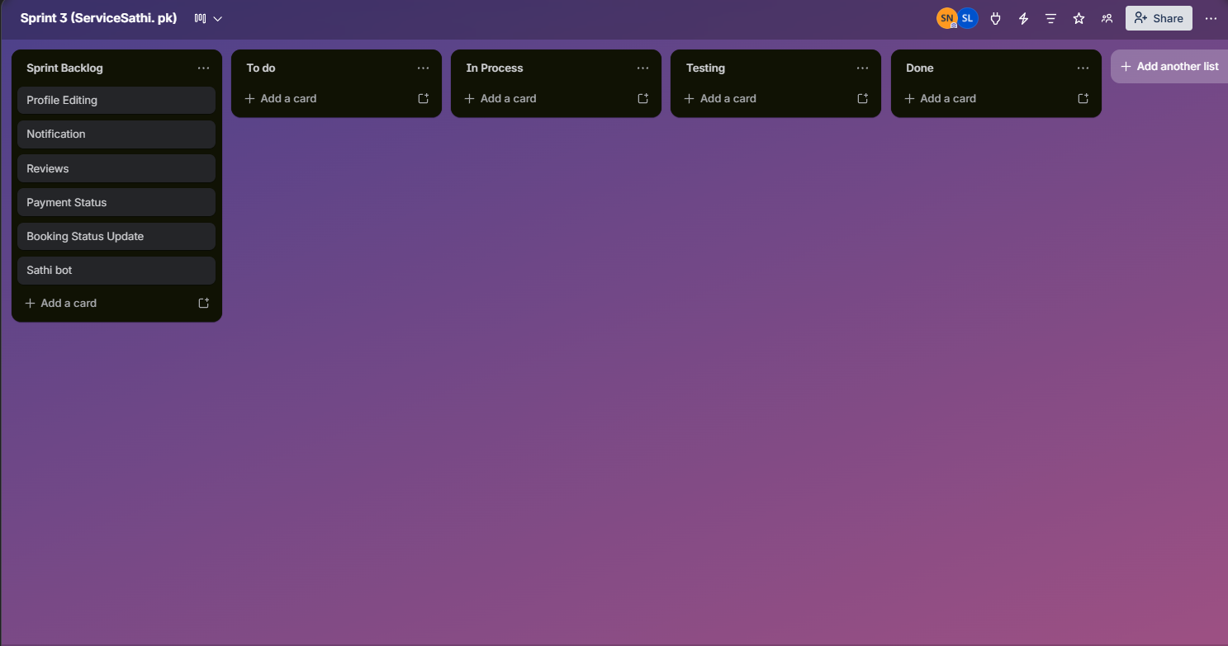
2

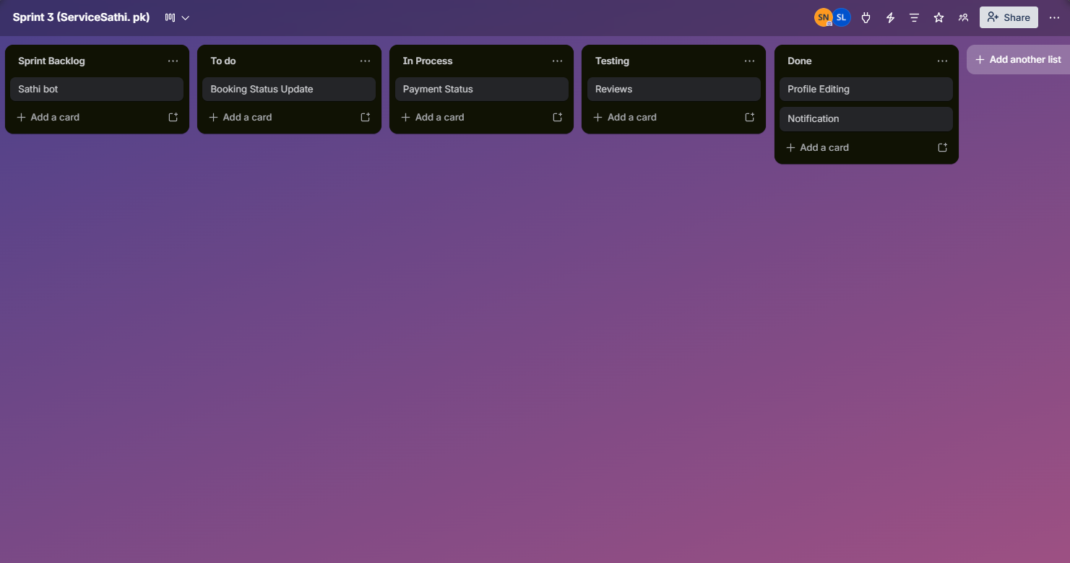

3

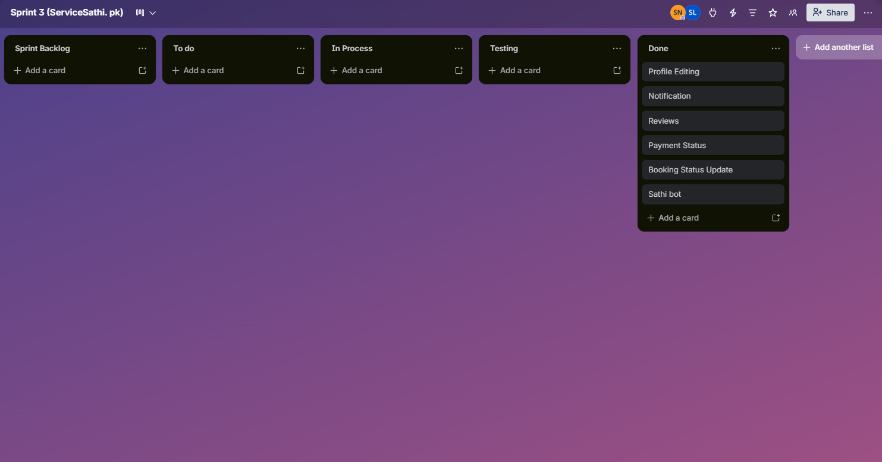

Burn Down Chart
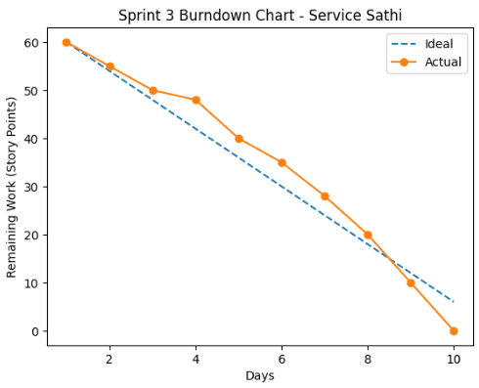

Implementation:
1.Profile Editing
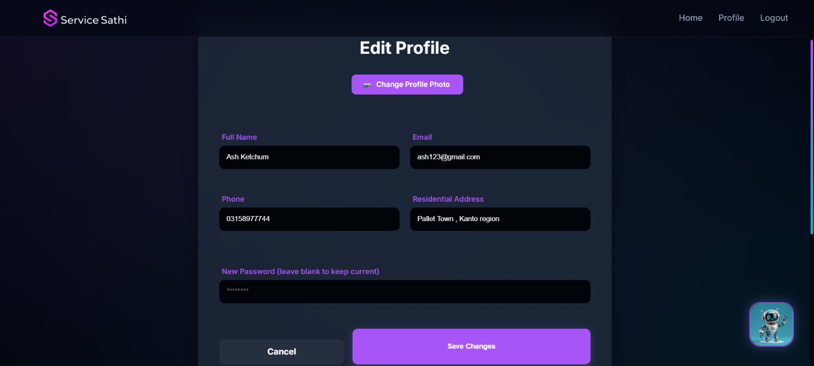
2.Reviews
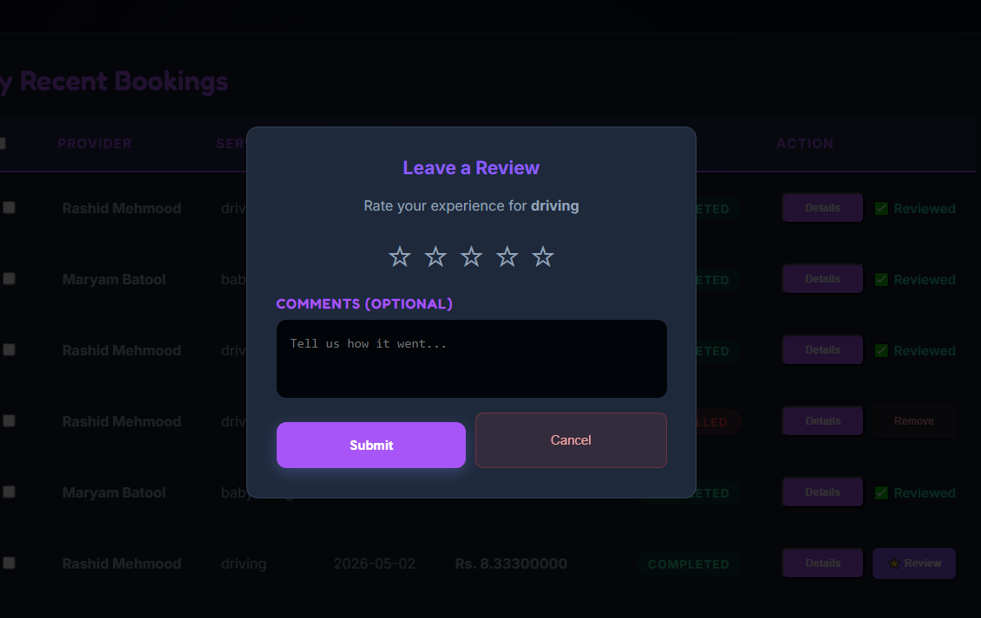
3.Notifications
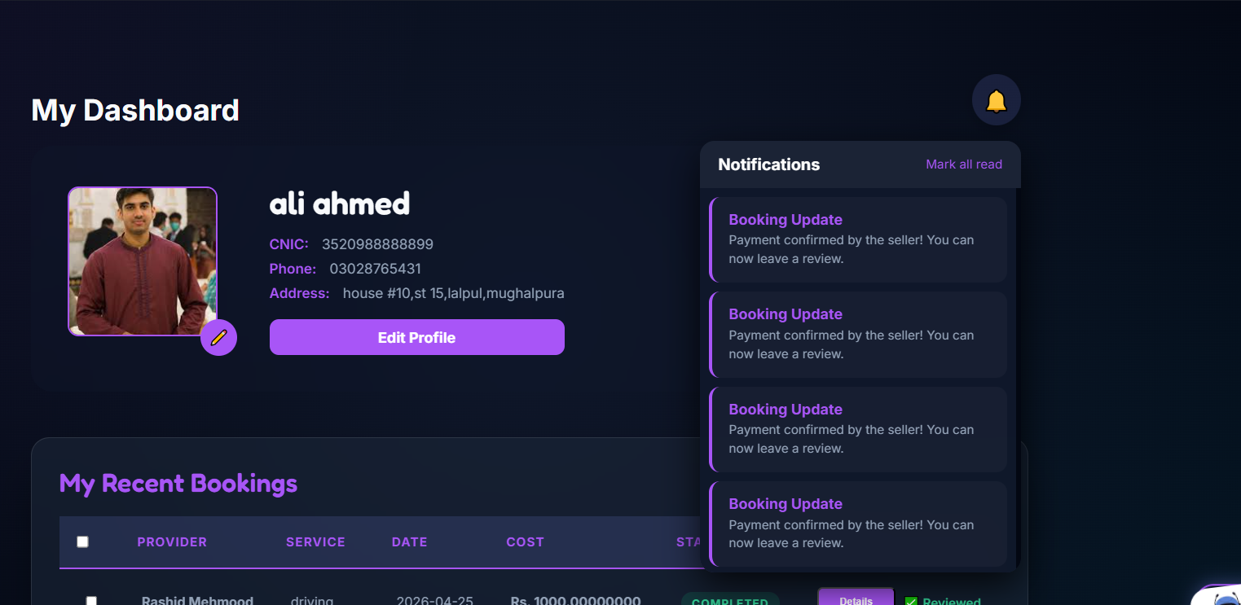
4. Payment and Booking status
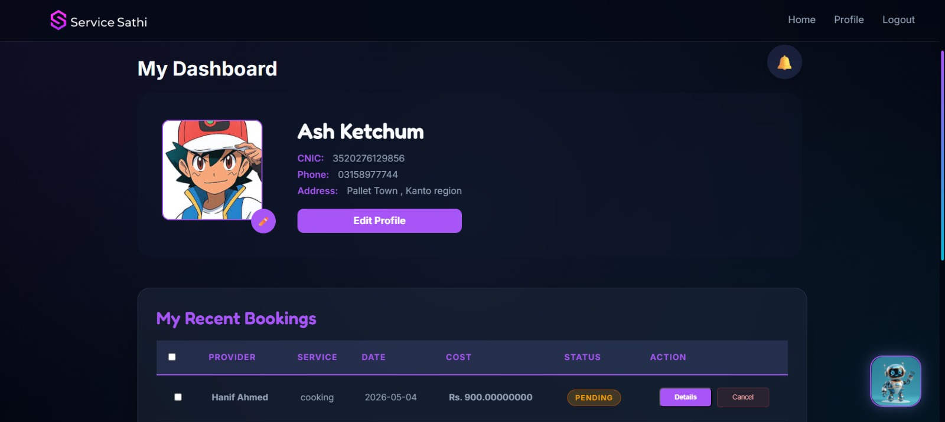
5. Sathibot
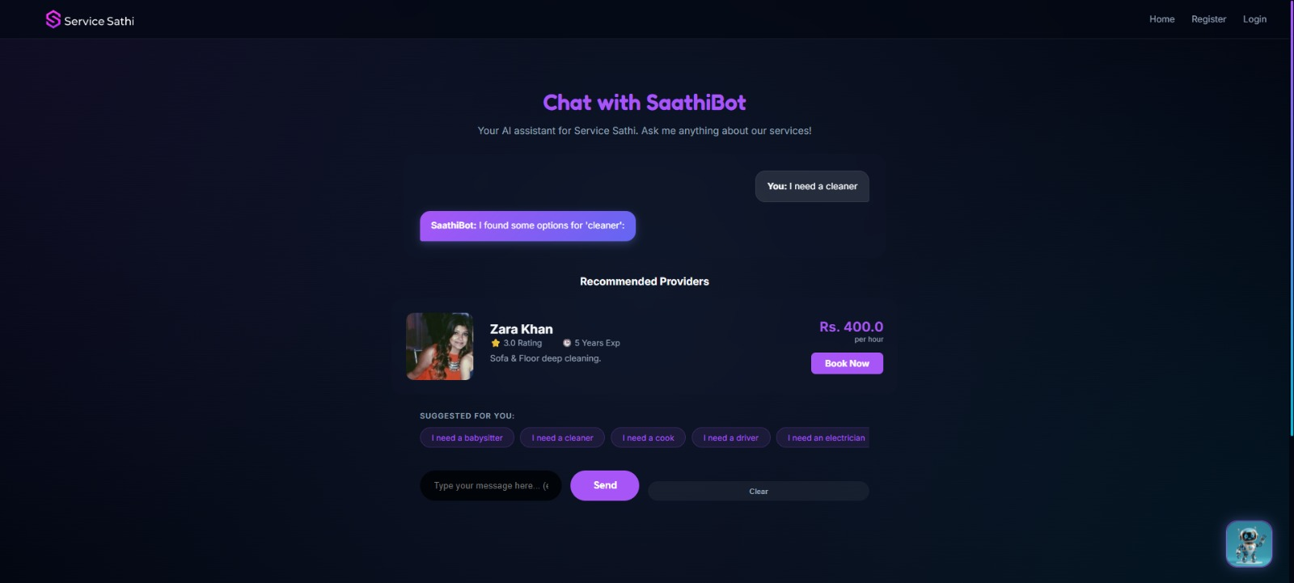

Work distribution

Team members | Tasks
Syeda Faryal Zehra | Frontend(HTML/CSS), Integration,Trello
Ibrahim Qaiser | Backend(Flask routes),  Booking Logic, Sathibot
Syeda Ume Abeeha Naqvi | Database, Documents, Testing, Diagrams

