
Project Name: ServiceSathi.pk
Course: Fundamentals of Software Engineering
Deliverable: Iteration 2 (Sprint 2)

Group Members:
Syeda Faryal Zehra (24L-2556)
Ibrahim Qaiser (24L-2513)
Syeda Ume Abeeha Naqvi (24L-2528)

Class: BDS-4B
Submission Date: 13th-April-2026

Service Sathi
ServiceSathi.pk is an online service marketplace that connects customers with service providers such as plumbers, cleaners, cooks, and electricians throughout Lahore. The system includes three main actors: users, sellers, and administrators. The system is implemented using Flask (Python), HTML/CSS, and a SQL database.
Sprint 2:
Module Name: Booking, Status Management, and Admin Expansion Module
Description:
Building upon the User and Service Management module from Sprint 1, Sprint 2 introduces the core transactional capabilities of the platform. Users can now book specific services and provide exact job addresses and instructions. Sellers are empowered to manage these requests by accepting or rejecting them. We also introduced dynamic UI elements for better data viewing, robust time-based constraints for booking cancellations, and administrative controls to dynamically expand platform categories.
Sprint Backlog
Tasks | Description
Service Booking | Allows users to book a service with date, time, address, and instructions.
Accept/Reject Booking | Allows sellers to accept or reject incoming booking requests.
Notifications | The user will receive notifications of the booking status from seller and vice versa
Cancel Booking | Allows users to cancel pending/accepted bookings with a 30-minute lockout.
Search seller and filter | Allows the user to search seller and apply price filters
Admin Management | Allows admins to create new service categories dynamically and remove sellers.
User Stories
User Stories
Story ID: US-01  Story title: Search Sellers  User Story:  As a user, I want to search sellers by name or price so that I can find suitable services easily.  Description:  This story involves implementing a search functionality where users can filter sellers based on their name or the price of their services.  Sub User Stories:  • Enter seller name or price range  • System filters sellers accordingly  • Display matching sellers  Acceptance Criteria:  • User can search by name  • User can search by price  • Relevant sellers are displayed  • No results message shown | Priority: High  Estimated Hours: 4

User Stories
Story ID: US-02  Story title: Book a Service  User Story:  As a user, I want to book a service so that I can schedule it with a seller.  Description:  Users can select a service, choose a time, and confirm booking.  Sub User Stories:  • Select a service  • Choose date and time  • Confirm booking  • Store booking details  Acceptance Criteria:  • Booking stored in database  • Confirmation displayed | Priority: High  Estimated Hours: 5

User Stories
Story ID: US-03  Story title: Cancel Booking  User Story:  As a user, I want to cancel a booking if time ≤ 30 minutes.  Description:  Allows cancellation only if time constraint is met.  Sub User Stories:  • Check time remaining  • Allow cancel  • Update status  Acceptance Criteria:  • Cancellation rule enforced  • Status updates correctly | Priority: High  Estimated Hours: 4

User Stories
Story ID: US-04  Story title: Add Category  User Story:  As an admin, I want to add new categories.  Description:  Admin can create categories.  Sub User Stories:  • Enter category name  • Save category  • Display categories  Acceptance Criteria:  • Category stored  • Visible in system | Priority: Medium  Estimated Hours: 3

User Stories
Story ID: US-05  Story title: Remove User/Seller  User Story:  As an admin, I want to remove users or sellers.  Description:  Admin deletes users or sellers.  Sub User Stories:  • Select entity  • Remove from system  • Update records  Acceptance Criteria:  • Removed successfully  • System updated | Priority: High  Estimated Hours: 4

User Stories
Story ID: US-06  Story title: Accept/Reject Booking  User Story:  As a seller, I want to accept or reject bookings.  Description:  Seller manages booking requests.  Sub User Stories:  • View requests  • Accept booking  • Reject booking  Acceptance Criteria:  • Status updated  • User notified | Priority: High  Estimated Hours: 4

User Stories
Story ID: US-07  Story title: Send Notifications  User Story:  System sends notifications based on booking status.  Description:  Notify user and seller on changes.  Sub User Stories:  • Detect status changes  • Notify user  • Notify seller  Acceptance Criteria:  • Notifications sent correctly | Priority: High  Estimated Hours: 5

Scrum Board
1.

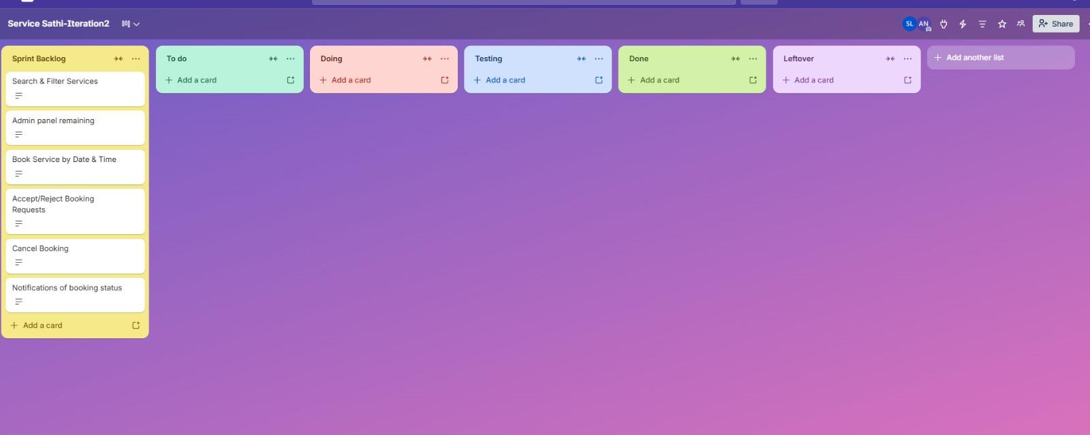
2

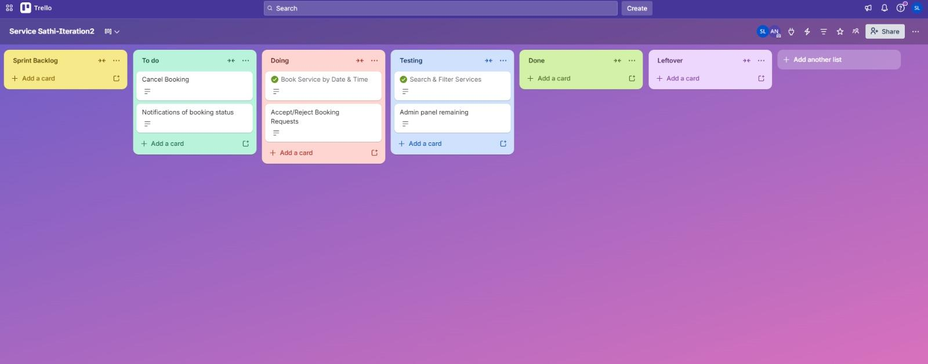
3

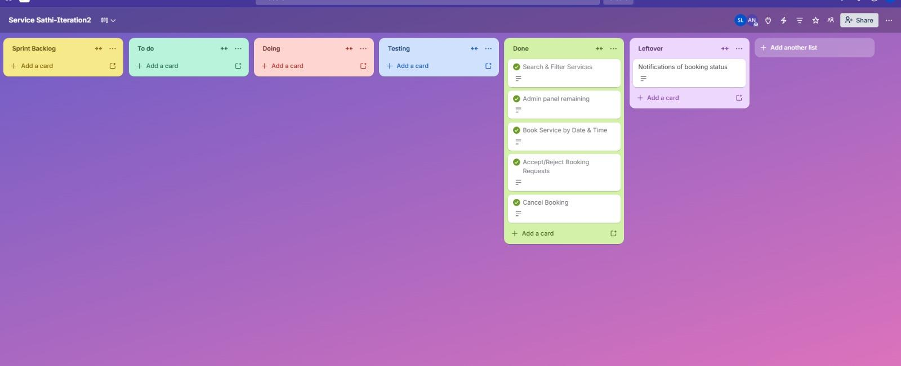

Burn Down Chart
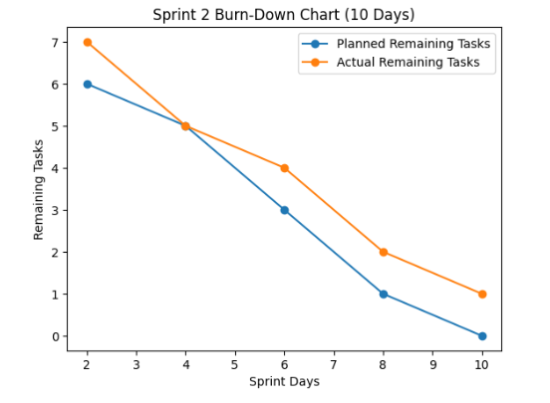

Uml Diagrams
1.UseCase
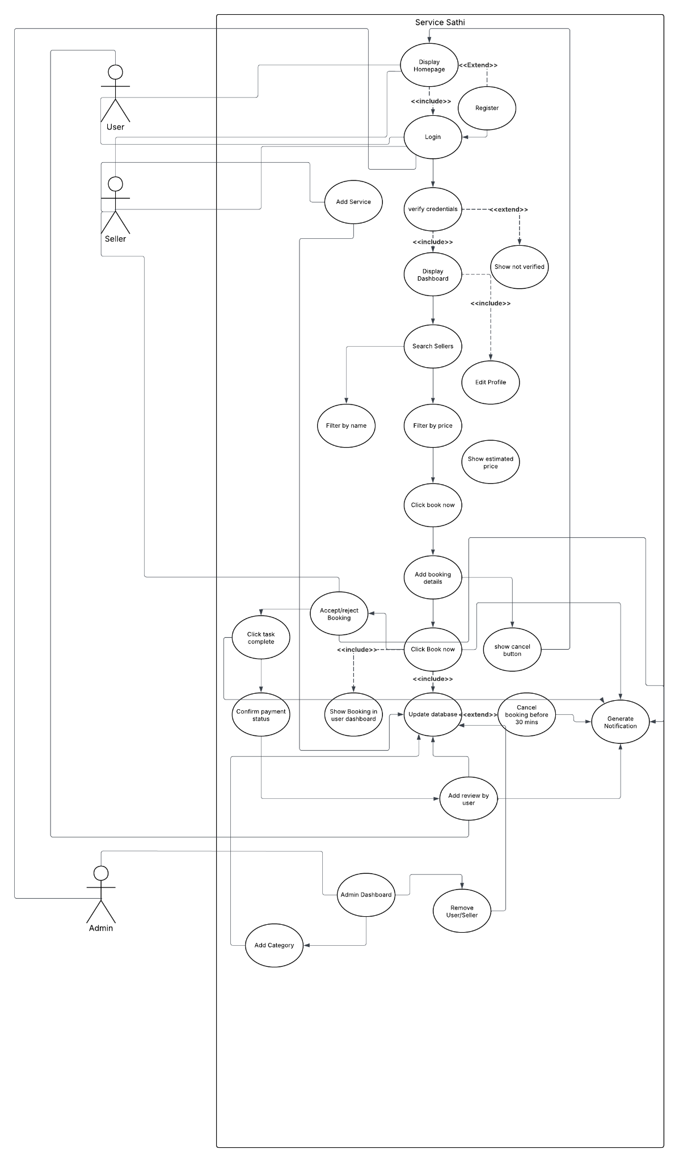

2.Activity diagrams

1. US06 :Accept reject booking
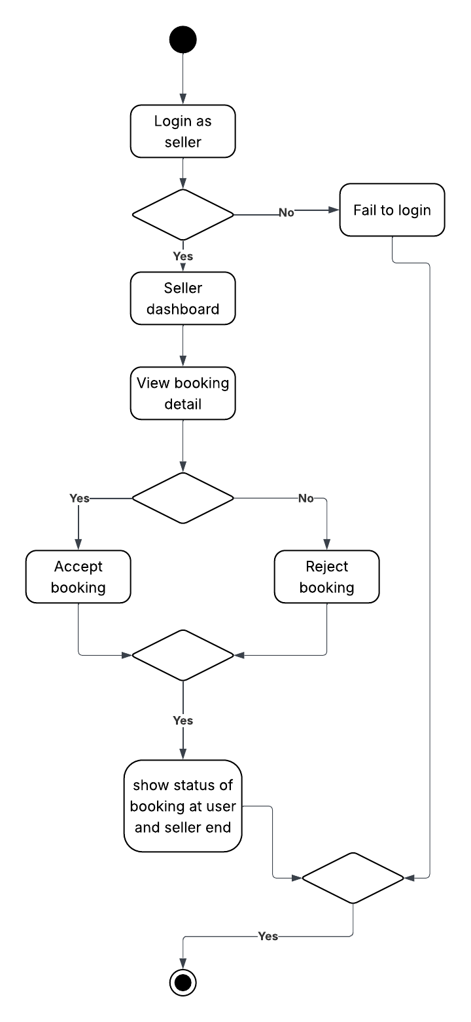

2. US02: Book Service

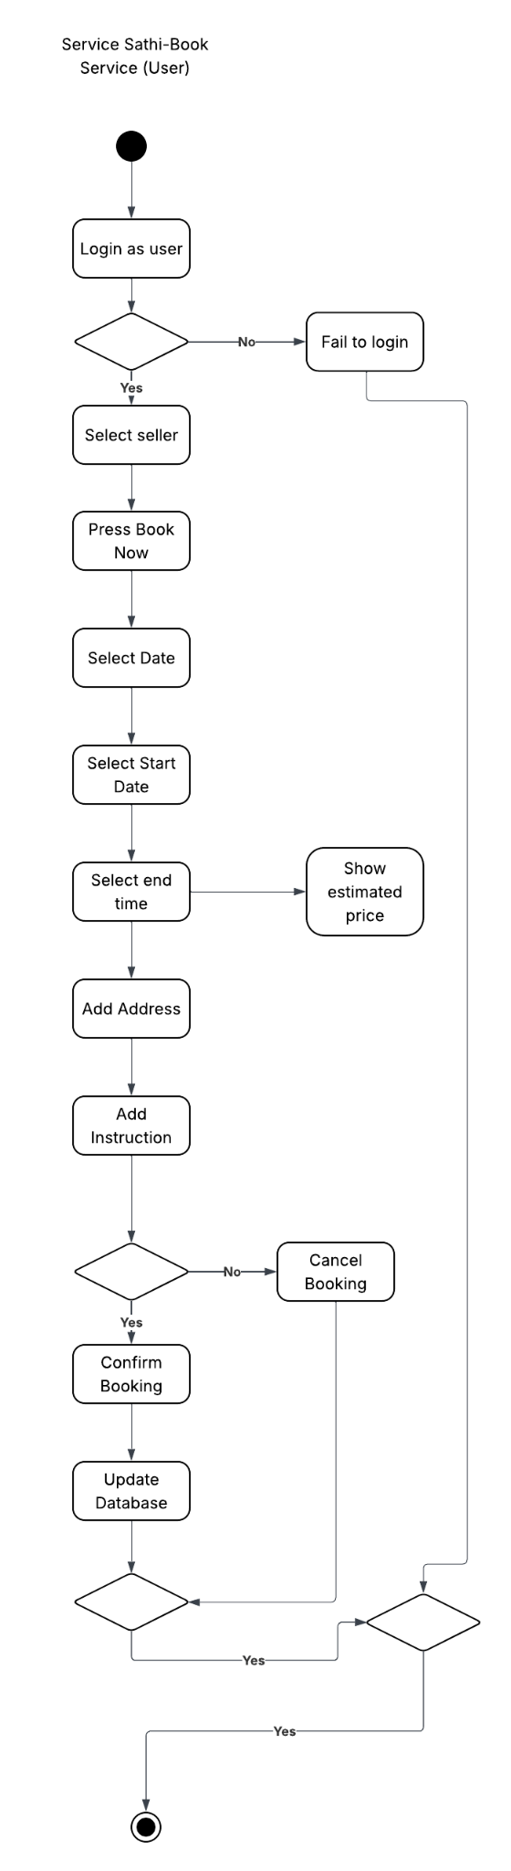
3.US04 : Add Category

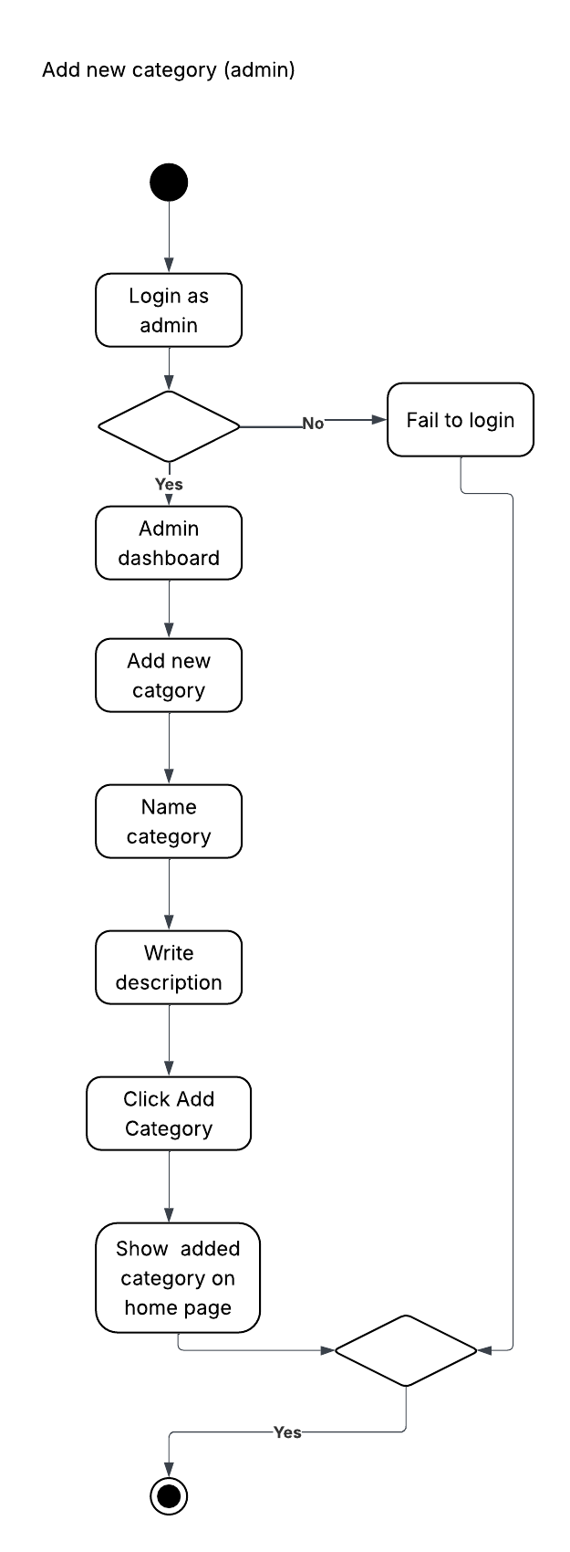

3.Class Diagram
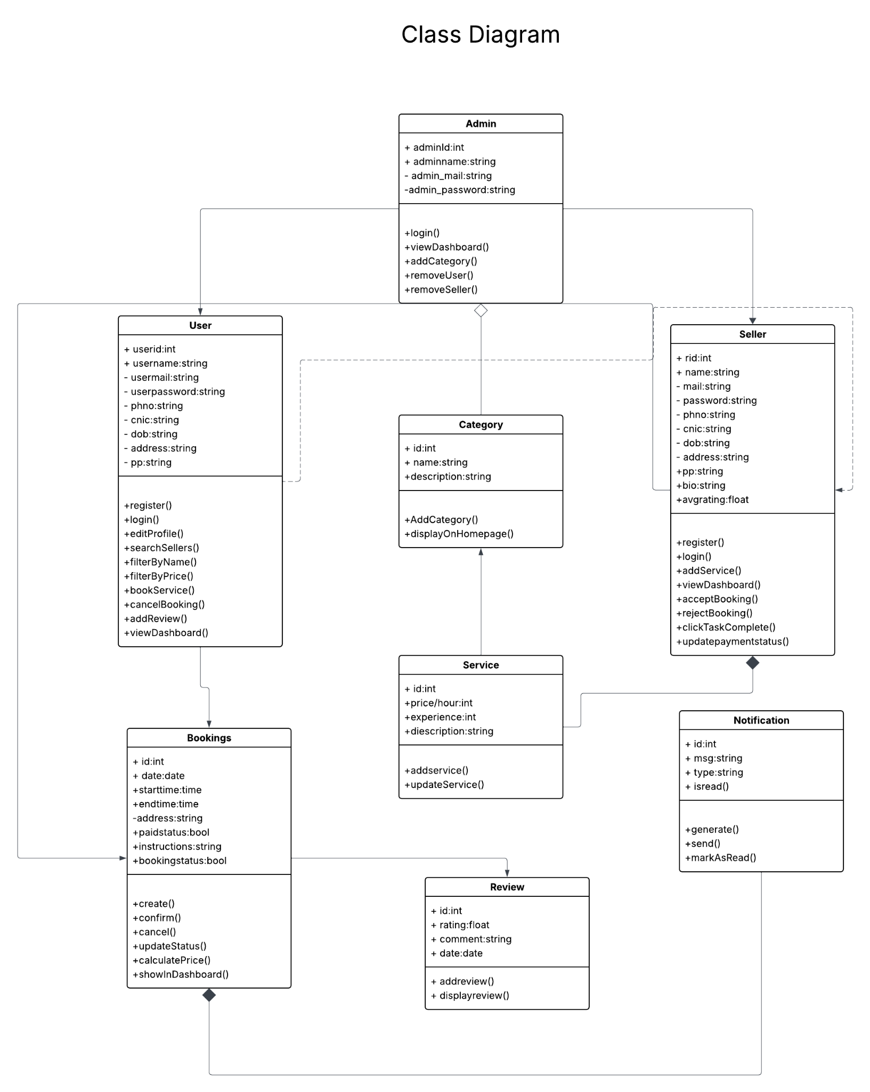

4. Sequence diagram
1.Book a service
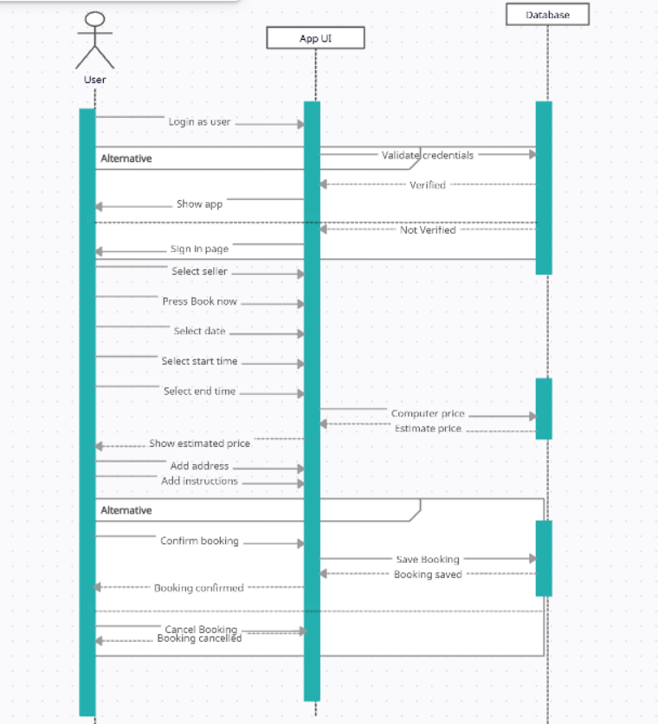
2.Accept/ reject booking
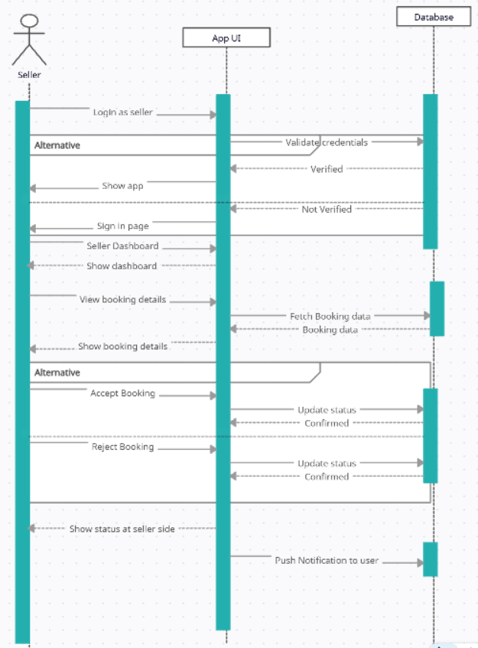
3 Add Category
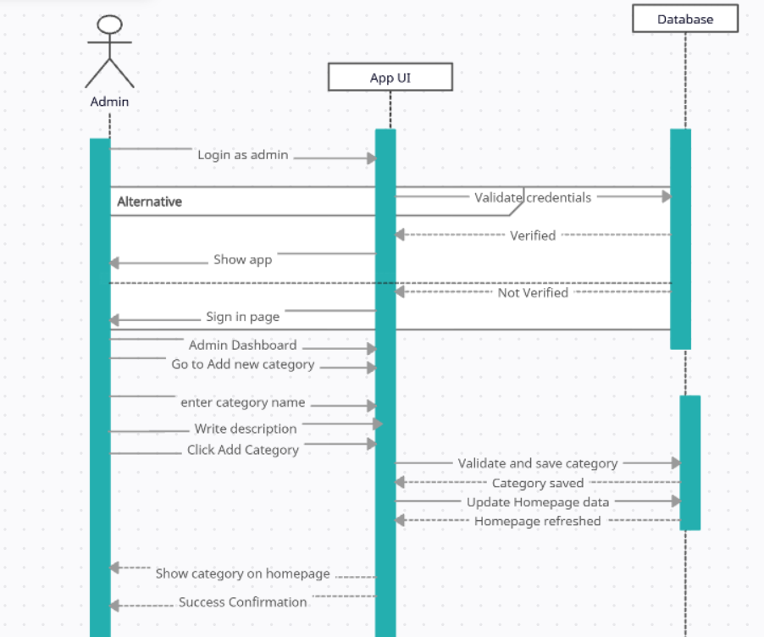

Implementation:
1.Search seller and price filter

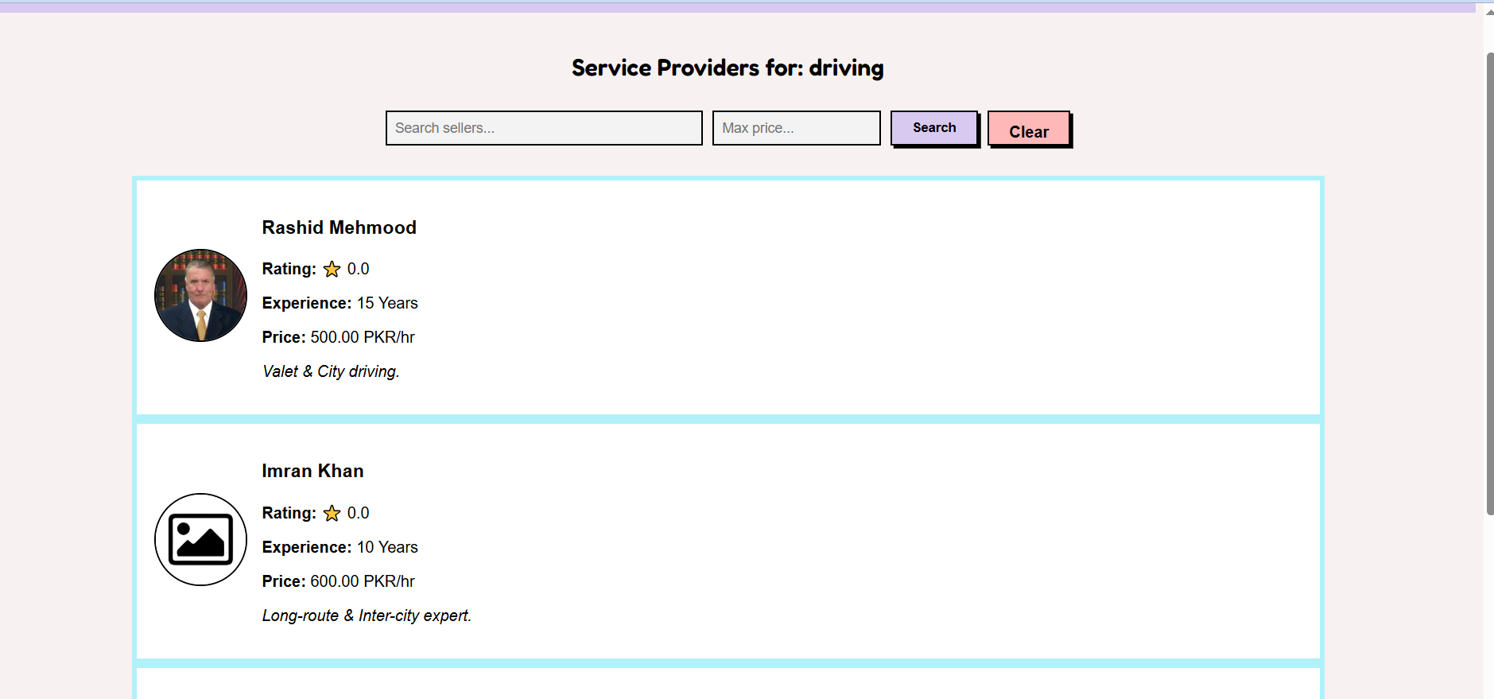
2.Book a seller
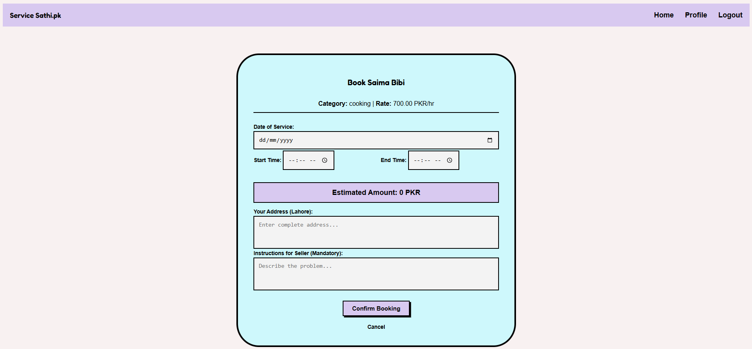
3.Cancel a booking
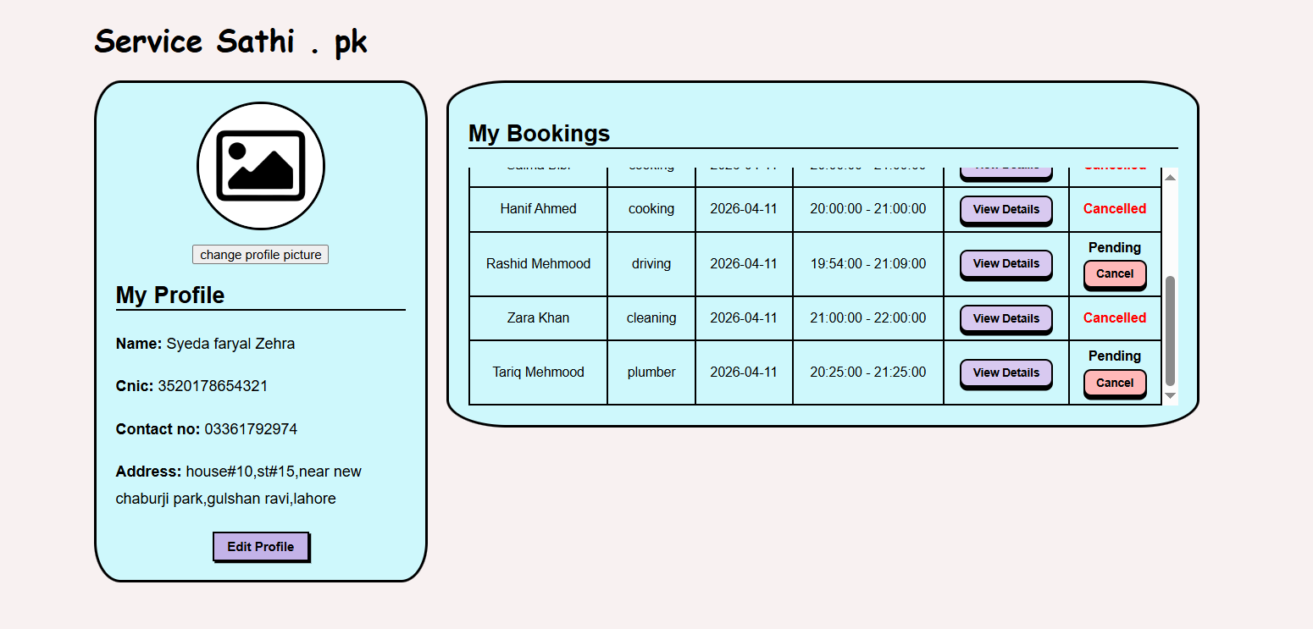
4.accept or reject a booking
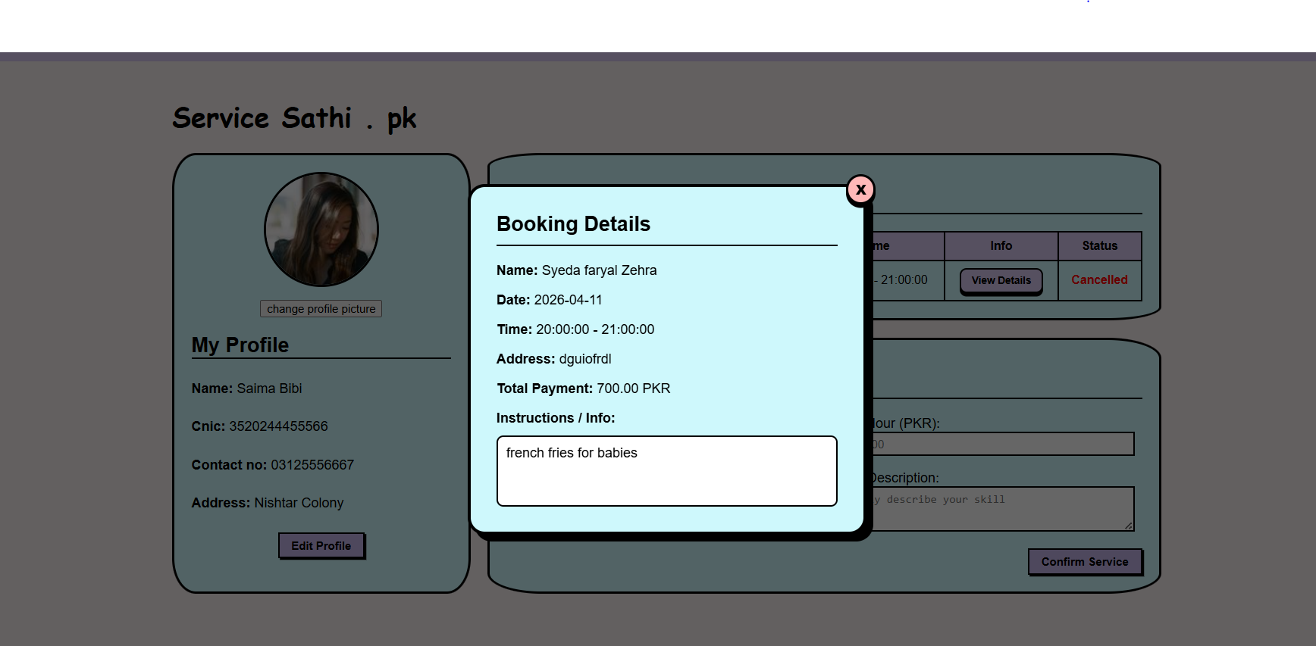
5. Remove sellers and add a category
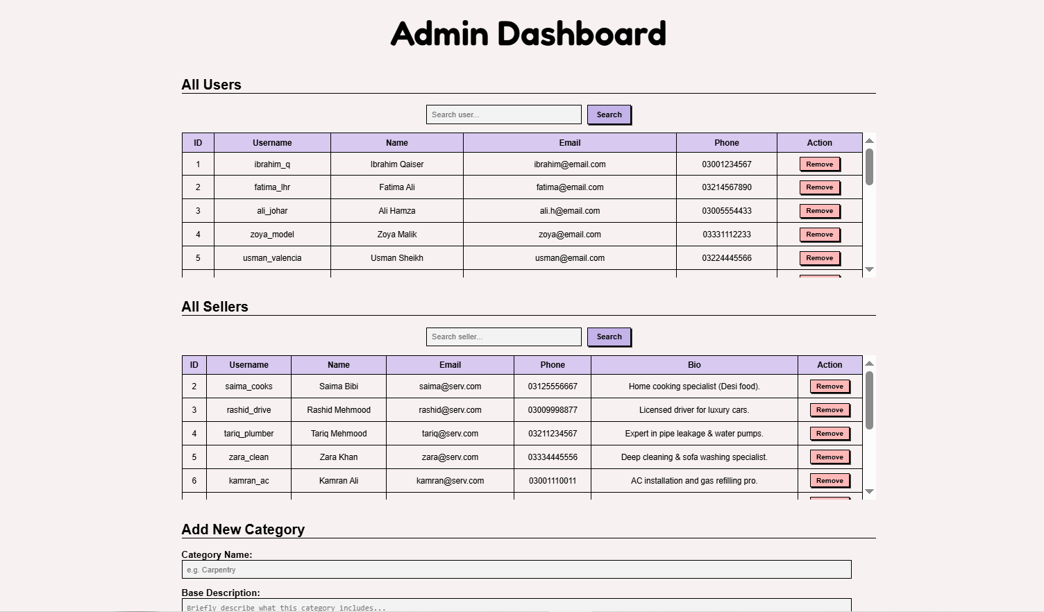

Work distribution

Team members | Tasks
Syeda Faryal Zehra | UI design for booking, search/filter, admin panel, and notifications interface; Documentation of Sprint 2; Scrum board (Trello) management; Burn-down chart creation; Ensuring UI consistency and usability
Ibrahim Qaiser | Flask backend implementation for booking system; Accept/Reject booking logic; Cancel booking with 30-minute constraint; Search and price filter functionality; API routes and database queries.
Syeda Ume Abeeha Naqvi | Database schema extension (booking, category, notifications); SQL queries for booking and filtering; Admin features (add category, remove users/sellers); System testing and validation; User stories refinement; UML Diagrams

