Bahria University,

Karachi Campus



LAB EXPERIMENT NO.

___11____

LIST OF TASKS

|  |  |
| --- | --- |
| TASK NO | OBJECTIVE |
| QUESTION NO.1 | **Write a program in MIPS assembly language that provide the sum from 1 to 99 using for Loop** |
| QUESTION NO.2 | **Write a program in MIPS assembly language that provide the subtraction from 20 to 10 using inverse for Loop.** |
| QUESTION NO.3 | **Write a program in MIPS assembly language that provide the subtraction from 50 to 1 using for Loop.** |
| QUESTION NO.4 |  |
| QUESTION NO.5 |  |
| QUESTION NO.6 |  |
| QUESTION NO.7 |  |
| QUESTION NO.8 |  |
| QUESTION NO.9 |  |
| QUESTION NO. |  |
| QUESTION NO. |  |
| QUESTION NO. |  |
| QUESTION NO. |  |
| QUESTION NO. |  |
| QUESTION NO. |  |

Submitted On:

___12/ 12/2019___

(Date: DD/MM/YY)

**Question-1: Write a program in MIPS assembly language that provide the sum from 1 to 99 using for Loop**.

**Code:**

.data

label1: .asciiz "Sum of all numbers under between 1 and 99\n"

.text

li $t0,99

li $s0,0

sum:

add $s0,$s0,$t0

subi $t0,$t0,1

beqz $t0, end

b sum

end:

la $a0,label1

li $v0,4

syscall

move $a0,$s0

li $v0,1

syscall

li $v0,10

syscall

**Output:**

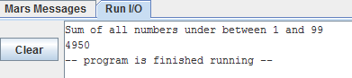

**Question-2: Write a program in MIPS assembly language that provide the subtraction from 20 to 10 using inverse for Loop.**

**Code:**

.data

num : .asciiz "Subtraction of all numbers between 20 - 10 : "

space : .asciiz "\n"

.text

la $a0,num

li $v0,4

syscall

li $t0,10

li $t1,20

li $t2,0

loop:

add $t2,$t2,$t1

addi $t1,$t1,-1

move $a0,$t2

li $v0,1

syscall

la $a0,space

li $v0,4

syscall

bne $t0,$t1,loop

li $v0,10

syscall

**Output:**

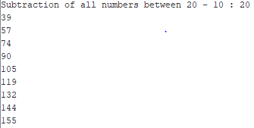

**Question-3: Write a program in MIPS assembly language that provide the subtraction from 50 to 1 using for Loop.**

**Code:**

.data

label1: .asciiz "Subtraction of all numbers under between 50 to 1\n"

.text

li $t0,50

li $s0,0

sum:

sub $s0,$s0,$t0

subi $t0,$t0,1

beqz $t0, end

b sum

end:

la $a0,label1

li $v0,4

syscall

move $a0,$s0

li $v0,1

syscall

li $v0,10

syscall

**Output:**

