**QUESTION :1** Take two inputs and Subtract.

**CODE:**

IN

STO 98

IN

STO 99

LDA 98

SUB 99

OUT

HLT

**OUTPUT:**

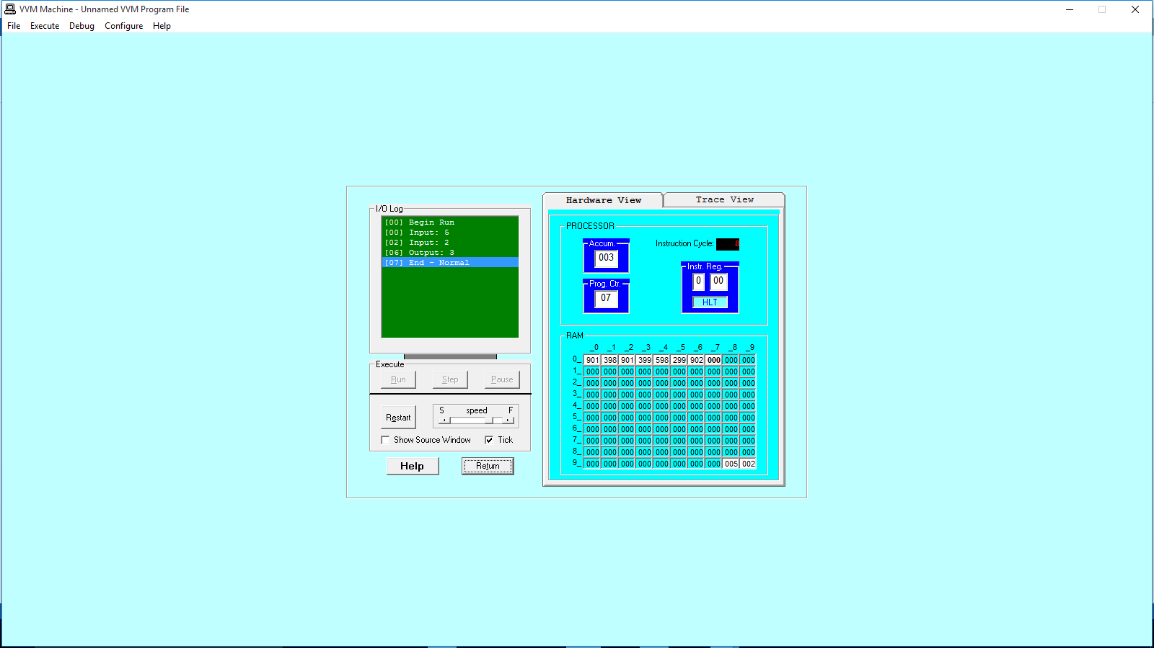

**QUESTION :2** To take two hardcoded input and Add them.

**CODE:**

IN

STO 98

IN

STO 99

LDA 98

ADD 99

OUT

HLT

**OUTPUT:** 