**QUESTION :1** Take two numbers as input and print the larger number.

**CODE:**

in

sto 98

in

sto 99

lda 98

sub 99

brp 10

lda 99

out

br 12

lda 98

out

hlt

**OUTPUT:**

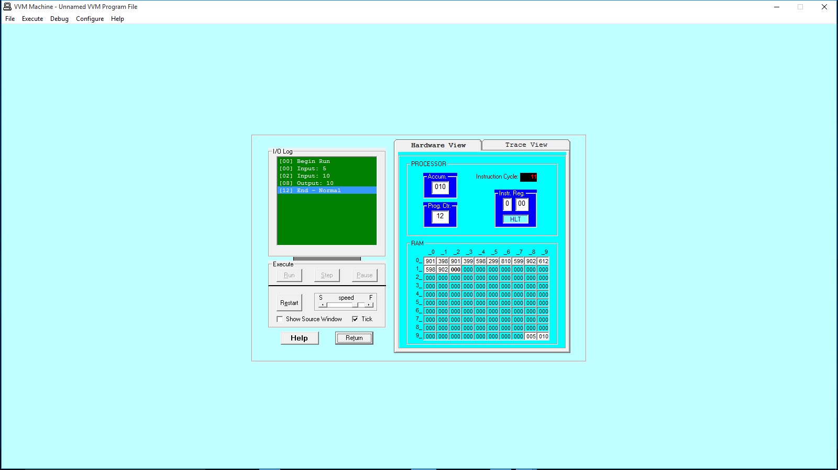

**QUESTION :2** Take any integer as input, if the number is greater than 5 print it

If a >5, print a

Else if a = 0, then Halt

Else if a < 5, then halt

**CODE:**

in

sto 99

lda 98

sub 99

brp 10

lda 99

out

br 09

out

hlt

*98

dat 005

**OUTPUT:**

