**QUESTION No. 1**

Write an assembly language program to divide two numbers?

**CODE:**

.data

number1 :.asciiz "Enter number1 : "

number2 :.asciiz "Enter number2 : "

li $v0,1

syscall

la $a0,remiander

li $v0,4

syscall

mfhi $t4

move $a0,$t4

li $v0,1

syscall

li $v0,10

syscall

Quotent:.asciiz "Quotient :"

remiander : .ascii "\nRemainder :"

.text

la $a0,number1

li $v0,4

syscall

li $v0,5

syscall

move $t0,$v0

la $a0,number2

li $v0,4

syscall

li $v0,5

syscall

move $t1,$v0

div $t0,$t1

la $a0,Quotent

li $v0,4

syscall

mflo $t3

move $a0,$t3

**OUTPUT:**

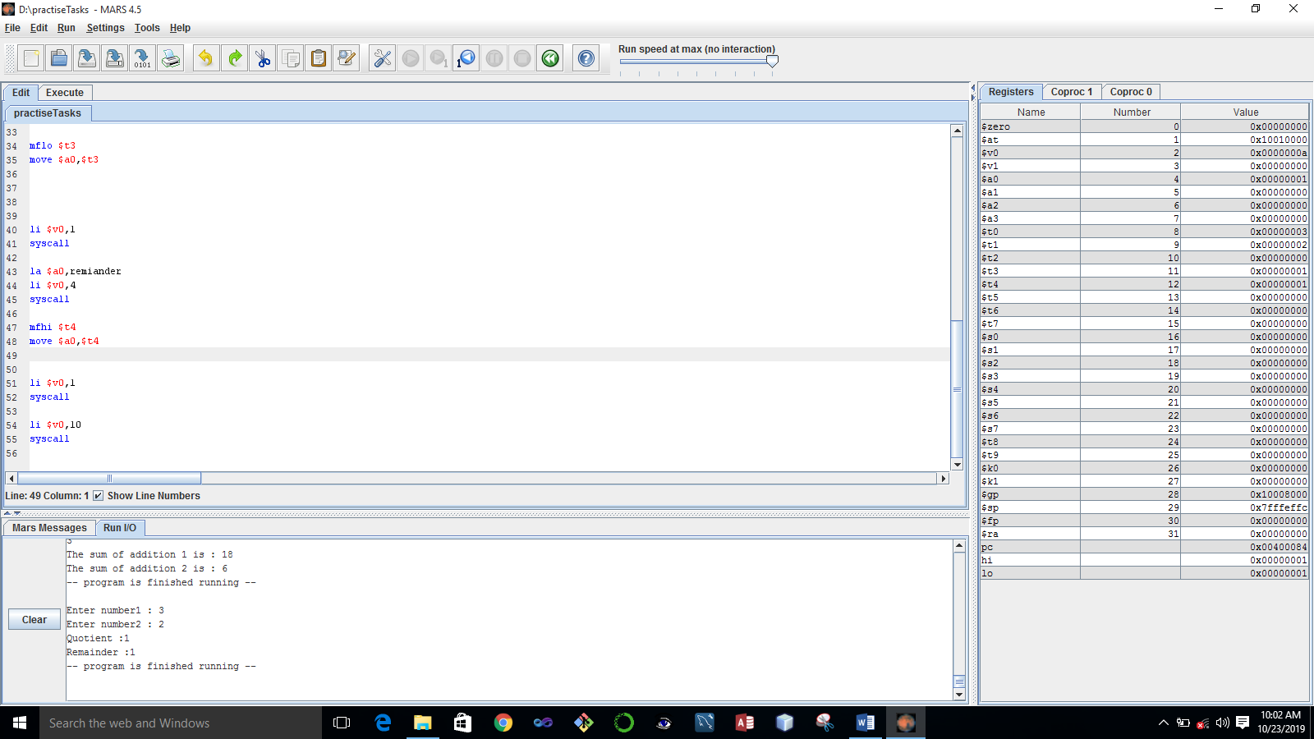

**Question 2:**

Write an assembly program that multiplies three numbers?

**Code:**

.data

num1 : .asciiz "Enter number 1: \n"

num2 : .asciiz "Enter number 2: \n"

num3 : .asciiz "Enter number 3: \n"

.text

la $a0,num1

li $v0,4

syscall

li $v0,5

syscall

move $t0,$v0

la $a0,num2

li $v0,4

syscall

li $v0,5

syscall

move $t1,$v0

la $a0,num3

move $a0,$a1

li $v0,1

syscall

li $v0,10

syscall

li $v0,4

syscall

li $v0,5

syscall

move $t2,$v0

mul $a0,$t0,$t1

mul $a1,$a0,$t2

**OUTPUT**

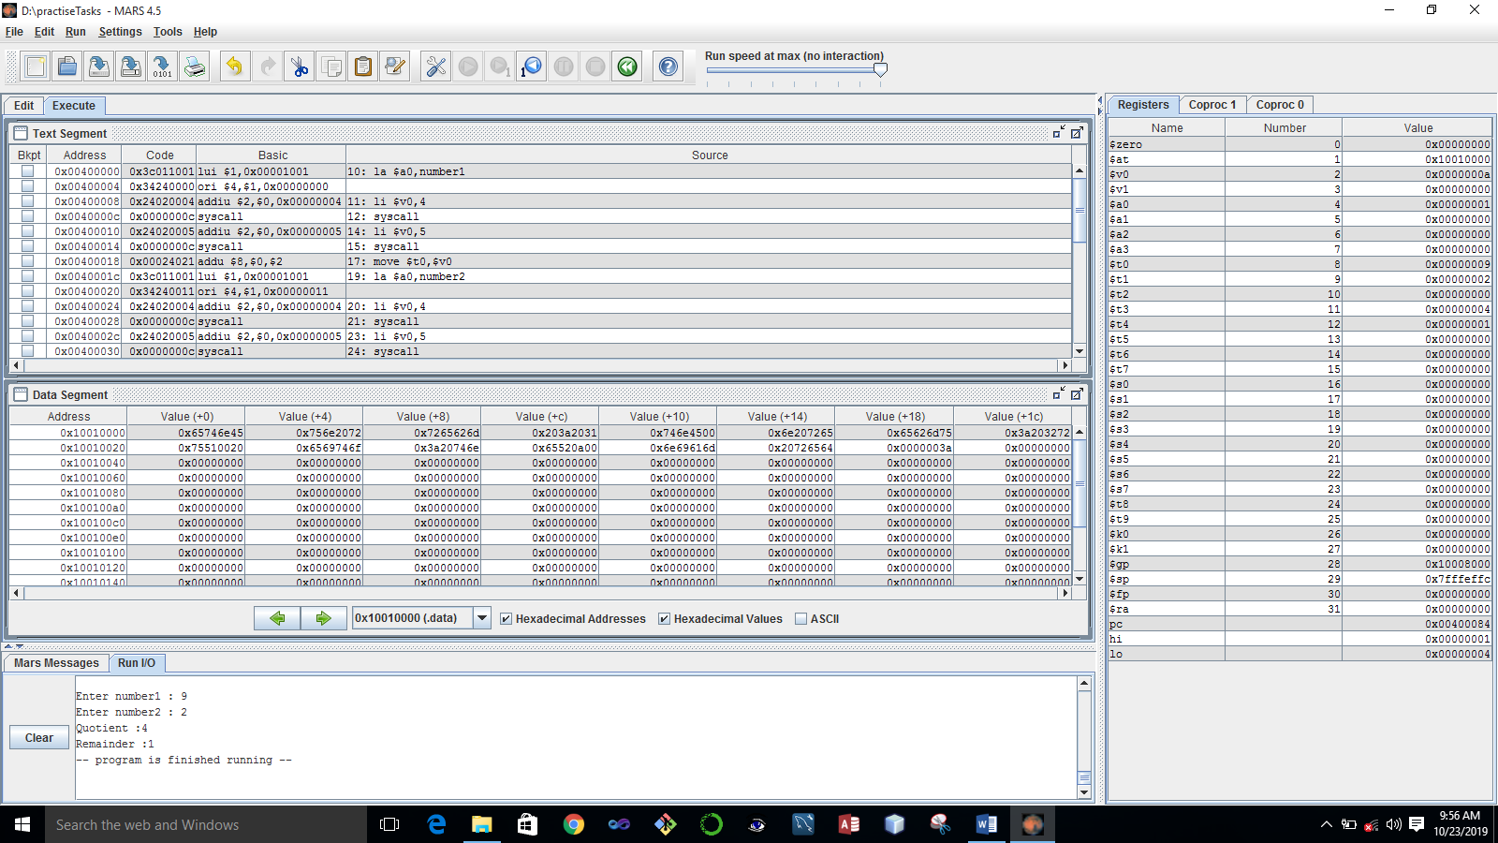

**QUESTION No. 3:**

Write the same program with small varitation i.e. this time the program will ask for 3 integers twice and display the result for each addition seperatly; Output will look like as follows:

Enter 3 integers for 1st addition:

2

2

2

Enter 3 integers for 2st addition:

3

3

3

The sum of 1st addition is 6

The sum of 1st addition is 9

**CODE:**

.data

digit1: .asciiz "Enter three digits of part 1 :\n"

digit2: .asciiz "Enter three digits of part 2 :\n"

Result1: .asciiz "The sum of addition 1 is : "

Result2: .asciiz "\nThe sum of addition 2 is : "

.text

la $a0,digit1

li $v0,4

syscall

li $v0,5

syscall

move $t0,$v0

li $v0,5

syscall

move $t1,$v0

li $v0,5

syscall

move $t2,$v0

la $a0,digit2

add $t6,$t0,$t1

add $a0,$t6,$t2

li $v0,1

syscall

la $a0,Result2

li $v0,4

syscall

add $t7,$t3,$t4

add $a0,$t7,$t5

li $v0,1

syscall

li $v0,10

syscall

li $v0,4

syscall

li $v0,5

syscall

move $t3,$v0

li $v0,5

syscall

move $t4,$v0

li $v0,5

syscall

move $t5,$v0

la $a0,Result1

li $v0,4

syscall

**OUTPUT:**

