**QUESTION No. 1**

Write a MIPS assembly language program that takes an integer input and multiply that integer with 3 and display the message that is the result is even or odd.

**CODE:**

.data

input: .asciiz "Enter an integer \n"

even: .asciiz "Its an even number"

odd: .asciiz "Its an odd number"

.text

la $a0,input

li $v0,4

**OUTPUT:**

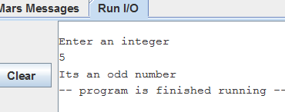

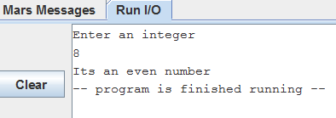

syscall

li $v0,5

syscall

move $t0,$v0

li $t1,3

mul $t2, $t1,$t0

li $t3,2

div $t2,$t3

mfhi $t0

beqz $t0,other

la $a0,odd

li $v0,4

syscall

li $v0,10

syscall

other:

la $a0,even

li $v0,4

syscall

li $v0,10

syscall