**Question No.1 Write an algorithm that finds the smallest and largest number in a list (an array) of n numbers.**

 **BAHRIA UNIVERSITY (KARACHI CAMPUS)**

**ASSGINMENT # 1 - FALL 2019**

# Data Structures and Algorithm (CSC-221)

Class: **BSE 3 B** Submission Deadline: 30**/31 October, 2019**

Submitted By: **SYED ALI ABBAS**

Lab Instructor: **Engr. Saniya Sarim** Max Marks: **10**

**INPUT:**

Console.WriteLine("How many integers do you want to add :");

int length = Convert.ToInt32(Console.ReadLine());

int[] arr = new int[length];

Console.WriteLine("Enter elements ");

for (int i = 0; i < length; i++)

{

arr[i] = Convert.ToInt32(Console.ReadLine());}

Console.WriteLine("Before Sorting :");

for (int i = 0; i < arr.Length; i++)

{

Console.WriteLine(arr[i]);

}

for (int i = 0; i < arr.Length; i++)

{

for (int j = 0; j < arr.Length - 1; j++)

{

int k = j + 1;

if (arr[j] > arr[k])

{

int temp = arr[j];

arr[j] = arr[k];

arr[k] = temp;

} } }

int min = arr[0];

for (int i = 0; i < arr.Length; i++)

{

if (arr[i]>min)

{

min = arr[0];

}

}

Console.Write("Smallest Value in this array is\t"+ min+"\n");

int max = arr[0];

for (int i = 0; i < arr.Length; i++)

{

if (arr[i] > max)

{

max = arr[i];

}}

Console.WriteLine("Highest Value in this array is \t" + max);

**OUTPUT:**

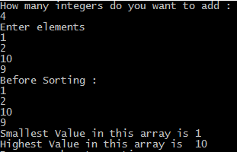

**QUESTION NO.2** **Write an algorithm that prints out all the subset of four elements of a set of n elements the elements of this set are sorted in a list that is input to the algorithm.**

**OUTPUT :**

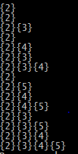

**INPUT:**

int[] arr = new int[] { 2, 3, 4, 5 };

int count = 0;

while (count <= 15)

{

int value = count;

string binary = Convert.ToString(value, 2);

char[] array= binary.ToCharArray();

for (int i = 0; i < array.Length; i++)

{

if (array[i] .Equals('1')) {

Console.Write("{"+arr[i]+"}");

}

}

Console.WriteLine();

count++;

}

**QUESTION NO.3** **Design a program where user gives one string argument and generate result.**

**Example:**

* **If input is “abc” then output should be “klm”.**
* **If input is “xyz” then output should be “HIJ”**
* **If input is “gsm” then output should be “qCw”**
* **If input is “XYZ” then output should be “hij”**

**INPUT:**

Console.WriteLine("Enter string");

string value = Console.ReadLine();

char[] arr = value.ToCharArray();

for (int i = 0; i < arr.Length; i++)

{

int asci = (int)arr[i];

int count = 0;

while (count < 10)

{

if (asci == 91)

{

asci = 97;

}

if (asci == 123)

{

asci = 65;

}

asci++;

count++;

}

arr[i] = (char)asci;

}

Console.WriteLine("After");

for (int i = 0; i < arr.Length; i++)

{

Console.Write(arr[i]);

}

Console.WriteLine();

}

}

**OUTPUT:**

   

**QUESTION NO.4 Take 10 inputs from the user and assign them into two string arrays (make 2 unsorted string arrays of 5 lengths each), merge those arrays and obtain the result in the sorted manner**.

**INPUT:**

String[] a = new String[5];

String[] b = new String[5];

String[] c = new String[a.Length + b.Length];

int count = 0;

Console.WriteLine("Elements of Array-1 :");

for (int i = 0; i < a.Length; i++)

{

a[i] = Console.ReadLine();

}

Console.WriteLine("Elements of Array-2");

for (int j = 0; j < b.Length; j++)

{

b[j] = Console.ReadLine();

}

Console.WriteLine("==============After Merging unsorted form is given below :================");

for (int i = 0; i < a.Length; i++)

{

c[i] = a[i];

count++;

}

for (int j = 0; j < b.Length; j++)

{

c[count++] = b[j];

}

for (int i = 0; i < c.Length; i++) Console.WriteLine((c[i] + " "));

Console.WriteLine("=========================================================================");

Console.WriteLine("Sorted form of given array is : ");

for (int i = 0; i <= c.Length; i++)

{

for (int j = 1; j < c.Length; j++)

{

int k = j - 1;

if (String.Compare(c[j], c[k]) < 1)

{

String temp = c[k];

c[k] = c[j];

c[j] = temp;

}

}

}

for (int i = 0; i < c.Length; i++)

{

Console.WriteLine(c[i]);

}

}

**OUTPUT:**

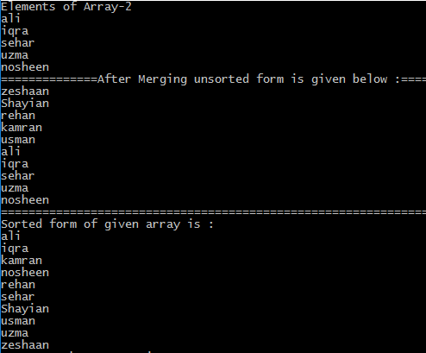

**QUESTION NO. 5 Delete the string (taken from the user) from the array of strings that was inserted by the user. Use searching algorithm.**

**INPUT:**

String[] arr = new String[9] { "Ali", "Bushra", "Chris", "Danny", "Erin", "Frank","George","Hank","Ian" };

int lb = 0;

int ub = arr.Length;

Console.WriteLine("Enter value to be searched : ");

String value = Console.ReadLine();

Console.WriteLine("Element is located on position : "+BinarySearch(arr, lb, ub, value));

Console.WriteLine("Do you want to delete any element :( Yes or No )");

String question = Console.ReadLine();

if (question == "Yes")

{

Console.WriteLine("Enter the Element Name to Delete : ");

String del_element = Console.ReadLine();

Console.WriteLine(deleteElements(arr, del_element));

}

else {

Console.WriteLine("Here is the List of Names Stored in Array : ");

for (int i = 0; i < arr.Length; i++)

{

Console.WriteLine(arr[i]);

}

}

}

public static String BinarySearch(String[] arr, int lb, int ub, String value)

{

int mid = (lb + ub) / 2;

if (arr[mid] == value)

{

String myString = mid.ToString();

return myString;

}

else if (String.Compare(arr[mid], value) > 0)

{

return BinarySearch(arr, lb, mid - 1, value);

}

else if (String.Compare(arr[mid], value) < 0)

{

return BinarySearch(arr, mid + 1, ub, value);

}

else {

return "Value Not Found";

}

}

public static String deleteElements(String[] arr,String del_element) {

for (int i = 0; i < arr.Length; i++)

{

if (arr[i]==del_element)

{

arr = arr.Except(new String[]{del_element}).ToArray(); }

}

Console.WriteLine("Here is the list of Elements Except the Deleted ones : ");

foreach (string names in arr)

{

Console.WriteLine(names);

}

Console.WriteLine("The Deleted Element is "+ del_element);

return "";

}

**OUTPUT :**

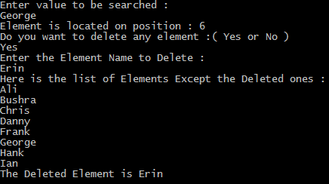

**QUESTION NO. 6 Write a program which takes two input values from user and sums up all the even numbers between these numbers. Using recursion.**

**INPUT:**

Console.WriteLine("Enter Starting Value :");

int start = Convert.ToInt32(Console.ReadLine());

Console.WriteLine("Enter the End Point :");

int end_point = Convert.ToInt32(Console.ReadLine());

int sum = add_Evens(start + 1, end_point, 0);

Console.WriteLine(""+sum);

}

public static int add_Evens(int start_Point, int end_point, int sum)

{

if (start_Point >= end_point)

{

return sum;

}

else

{

if (start_Point % 2 == 0)

{

sum += start_Point;

Console.WriteLine(start_Point);

}}return add_Evens(start_Point + 1, end_point, sum);

}

**OUTPUT :**

