

MSc Data Science Project
7PAM2002
Department of Physics, Astronomy and Mathematics

Data Science FINAL PROJECT REPORT

Project Title:
Classification of Breast Cancer Recurrence Events using clinical and pathological features
Student Name and SRN:
Syed Amir Sohail
24081884

Supervisor: Man-Lai Tang
Github Link: https://github.com/Syedamirsohail/DSFinalProject

DECLARATION STATEMENT
This report is submitted in partial fulfilment of the requirement for the degree of Master of Science in Data Science at the University of Hertfordshire.
I have read the detailed guidance to students on academic integrity, misconduct and plagiarism information at Assessment Offences and Academic Misconduct and understand the University process of dealing with suspected cases of academic misconduct and the possible penalties, which could include failing the project or course.
I certify that the work submitted is my own and that any material derived or quoted from published or unpublished work of other persons has been duly acknowledged. (Ref. UPR AS/C/6.1, section 7 and UPR AS/C/5, section 3.6)
I did not use human participants in my MSc Project.

I hereby give permission for the report to be made available on module websites provided the source is acknowledged.
Student Name printed: Syed Amir Sohail
Student Name signature: Syed Amir Sohail
Student SRN number: 24081884

Abstract
This paper explores how machine learning can predict the occurrence of breast cancer recurrence using clinical and pathological data. Breast cancer is one of the most significant health issues in the world, and the possibility to accurately predict the recurrence is extremely important in terms of better monitoring the patient and planning treatment. The study makes use of a dataset provided by the UCI Machine Learning Repository, which includes patient features, including age, tumour features, lymph node involvement, and treatment-associated features. The main goal is to identify whether these characteristics can be successfully used to classify the patients as recurring and non-recurring.
The research adheres to a systematic data science methodology, which consists of data preprocessing, feature encoding, exploratory data analysis and predictive modelling. Three classification models were created and tested in terms of accuracy, precision, recall, and F1 score: Logistic Regression, Decision Tree, and Random Forest. The results indicate that variables that are related to the tumours, which include tumour size and malignancy level, are important predictors of recurrence. Random Forest had the best balance of performance, with high overall accuracy and F1 score, whereas Logistic Regression proved to be limited by low recall. Based on the feedback from the tutor, Smote, ROC-AUC and Precision-Recall were added
The findings show that machine learning algorithms can be used to recognize trends in clinical data to predict breast cancer recurrence, though the effectiveness of this approach varies based on the model used. Regardless of the empirical constraints, including the small size of datasets and imbalance in the classes, the study shows the promise of ensemble approaches to the healthcare prediction tasks. Further studies can include larger datasets, which are multimodal and more sophisticated models to enhance predictive accuracy and aid clinical decision-making.
Contents
DECLARATION STATEMENT 2
Abstract 3
Introduction 5
Literature Review 6
Data Acquisition and Preprocessing Frameworks 6
Comparative Performance of Machine Learning Algorithms 7
Predicting Recurrence and Survival 7
Explainable AI (XAI) and Ethical Considerations 7
Methodology 8
Dataset Source 8
Dataset Attributes 8
Data Cleaning and Preparation 9
Feature Encoding 9
Exploratory Data Analysis 9
Model Development and Results 15
Discussion 24
Conclusion 26
References 28

Introduction
Breast cancer is regarded as one of the most prevalent diseases that affect women in all parts of the world and it still poses a serious health issue because of chances of cancer reappearing after treatment. Although medical processes and clinical management can be successful, a number of patients develop recurrence of the disease even after successful treatment and as a result, the risk of recurrence early detection becomes highly essential in enhancing patient monitoring and therapy. The prediction of breast cancer recurrence is thus a significant research issue in the field of healthcare data analysis as precise prediction would assist doctors in making the appropriate preventive decision in time and enhancing patient outcomes in the long term.
As clinical datasets continue to become more accessible, data-driven methods are becoming popular in analysing medical data and uncovering hidden trends which might not be presently obvious in the context of traditional statistical observation (Habehh and Gohel, 2021). The data science classification methods enable scientists to examine the correlation between clinical and pathological aspects of patients and probabilities of the recurrence events (Shailaja et al., 2018). Through the examination of such patterns, one can approximate a patient as being in recurrence or non-recurrence category based on past information on medical attributes recorded. The project aims at analysing Breast Cancer dataset acquired at the UCI machine learning repository that has a number of clinical variables including age group, tumour characteristics, lymph node involvement, and treatment related variables. This research will primarily focus on investigating how the attributes can be used to predict breast cancer recurrence events with classification techniques. The research tries to comprehend the impact of various patient and tumour related factors and the effectiveness with which recurrence outcomes can be predicted based on data analysis techniques.
The research question which informs this work is preoccupied with the need to find out whether clinical and pathological characteristics present in the records of historical patients can be utilized to proficiently categorize recurrence cases of breast cancer. This project will seek to bring an analytical understanding of recurrence prediction through systematic data preparation, exploratory analysis, and predictive modelling, as well as illustrate the practical implementation of the data science techniques in the context of healthcare.

Literature Review
Breast cancer is the most common malignancy in women worldwide with an estimated 25 per cent of all new cancer and 15 per cent of cancer deaths. The most important factor that affects the patient outcomes is the early detection with five-year survival rates being above 90 years compared to 15 years with late-stage diagnoses. The growing complexity of medical data, starting with structured electronic health records (EHR) and clinical signatures to high-dimensional gene expression profiles and medical imaging, has prompted machine learning (ML) to assist in making accurate diagnoses and predictive modeling (Abreu et al., 2016).

Data Acquisition and Preprocessing Frameworks
The conversion of raw clinical data to a format that can be processed by ML, usually a flattened table or a matrix, is technically challenging. Ferrao et al. (2016) suggested the EDPAI (Extract, Define, Process, Assess, and Integrate) framework to tackle the problem of interoperability barriers, redundancy of features, and missingness of data systematically. In clinical data, unspecified labels or different degrees of granularity in the codes of diagnosis are common, and they may adversely affect predictive ability.
One of the most widespread issues with medical data is that of class imbalance in which non-cancerous/non-recurrent cases vastly outnumber positive outcomes (Maiti et al., 2025). Two key mitigation strategies are identified in the research:
1. Data-level Resampling: Such methods as the Synthetic Minority Over-sampling Technique (SMOTE) create artificial samples of the minority group to make the dataset balanced and enhance model resilience.
2. Algorithmic Adjustments: Cost-sensitive learning changes the loss function to impose more severe loss on mistakes in minor classes, and has been shown to give better results on identifying highly-needed medical cases than basic resampling.

Comparative Performance of Machine Learning Algorithms
Breast cancer classification using different supervised learning models has been tested, such as Support Vector Machines (SVM), Random Forest (RF), Logistic Regression (LR), and Artificial Neural Networks (ANN) (Tachicart et al., 2025).
- SVM and Optimization: SVM is very useful in high dimensional feature space. Zhang et al. (2018) have shown that Particle Swarm Optimization (PSO) optimization of SVM parameters provides a high level of prediction performance when using gene expression data, which is better than the traditional grid search algorithms (Zhang et al., 2018).
- Ensemble and Neural Models: RF and ANN models often demonstrate better classification. RF models, a combination of predictions made by several decision trees, are especially effective with complex data sets and can be accurate in certain diagnostic groups (99 per cent).
- Deep Learning: CNNs have emerged as the new standard in unstructured data such as retinal or histopathological images and automatically identify complex features that a traditional model may overlook.

Predicting Recurrence and Survival
One of the primary motivations of clinical surveillance and treatment planning is prediction of disease recurrence. Research based on data like the Royston and Altman cohort has found lymph node status, recurrence-free survival time and hormone receptor levels (ER and PR) to be the most meaningful predictors of recurrence (Abbas et al., 2025). Although RF and LR models demonstrated excellent overall discrimination, researchers warn that little datasets might be overfitted and less generalized, and bigger cohorts of multiple working institutions are required.

Explainable AI (XAI) and Ethical Considerations
Complex algorithms have a black box character that prevents their adoption into clinical use in most cases because of distrust. Explainable AI (XAI) seeks to give rationales that can be understood by model decisions (van Leersum and Maathuis, 2025). Local and global predictions are explained using techniques like LIME (Local Interpretable Model-Agnostic Explanations) and SHAP (SHapley Additive exPlana-tions). According to research by Jansen et al. (2020), the ability to recognize so-called turning points, i.e. certain ranges within which a particular feature value will switch between survival and mortality (e.g. certain age ranges) can be helpful in boosting professional confidence and patient engagement with care. The most crucial aspect of XAI implementation is ethical and legal compliance. Models have to comply with regulations like GDPR and HIPAA in order to guarantee patient privacy and informed consent. Moreover, it is necessary to monitor bias to ensure AI will not increase the existing medical outcome disparity. ML integration in breast cancer care has the potential of transforming personalized medicine. Future studies are shifting towards the multimodal modeling that integrates clinical, genomic and imaging data in an attempt to make a more comprehensive prediction. Nonetheless, the discipline still needs to tackle standardization of the definitions of outcomes, transparency of algorithms, and model validation by prospective clinical trials to make the best use of their predictive accuracy in clinical practice.

Comparison
The results of this study fit in seamlessly with other studies exploring machine learning approaches to prediction of breast cancer recurrence. Ensemble-based models like Random Forest tend to outperform single classifiers, as they can capture complex interactions among clinical variables and minimize overfitting, according to Abbas et al. (2025). In this study, Random Forest model demonstrated the best overall performance with the highest ROC-AUC score (0.690) and Average Precision score (0.669), which is similar to the behaviour seen in the other studies.
Abreu et al. (2016) tested several machine learning algorithms to determine the best predictions for the Breast Cancer Recurrence dataset and found that the features of the tumour and aspects of the disease were the most important factors in determining whether the patient would recur. These findings are corroborated by the feature importance analysis performed in this study, which revealed that the most important predictive factors were tumour size, the presence of lymph node involvement, the degree of malignancy and the quadrant of the breast. The variables are clinically important because they represent disease progression and tumour aggressiveness, known risk factors for recurrence.
Class imbalance has also been noted as a difficulty in recurrence prediction datasets in previous research. Studies have demonstrated that using accuracy alone can lead to false conclusions because models can be very accurate but not be able to accurately identify cases that are recurrent. It was also observed in the present study that Logistic Regression had a reasonable accuracy but the initial results showed poor recall for the recurrence patients. Recall was significantly better after applying SMOTE compared to what was observed prior to the application, with recall improving from 31.25% to 56.25%, which is consistent with the literature, showing that oversampling minority classes can lead to better detection of clinically important events.
While the overall performance was best with the Random Forest model, the results of both ROC-AUC and Average Precision showed that predicting recurrence will be a difficult task. The dataset is relatively small (286 observations) and has a few categorical variables, which could make prediction less accurate than in other studies that use larger clinical data sets or more sophisticated ensemble methods. These indicate potential avenues for further development that could enhance the ability to predict recurrence, including the use of more comprehensive clinical parameters, different encoding strategies (e.g. One-Hot Encoding), and more sophisticated methods of explaining the predictions.
In conclusion, the findings of this study corroborate previous studies and show that ensemble learning techniques can be effective, that clinical parameters related to the tumour are important features to take into account when creating a prediction model for breast cancer recurrence, and that class imbalance must be taken into account when building such a model.

Methodology

Dataset Source
The data that has been used in this research is collected in the UCI Machine Learning Repository that is generally recognised as a good source of datasets applied in research in machine learning and data analytics. Breast Cancer dataset is a clinical and pathological data of patients who have been treated with breast cancer. The dataset is aimed at analysing the possibility of classifying cases as recurrence and non-recurrence events based on the specific patient characteristics and tumour related attributes.
The initial dataset has 286 observations and 10 variables, the same variables whose target variable shows whether the patient had a recurrence of the breast cancer after treatment. The rest of the variables are clinical characteristics that could affect a risk of recurrence.

Dataset Attributes
The dataset contains a number of categorical variables characterising patient characteristics and tumour related characteristics. They are age group, menopause status, tumour size, involved lymph nodes, presence of node caps, degree of malignancy, breast side, breast quadrant, and irradiation treatment. The target variable named Class refers to the recurrence events or non-recurrence events that a patient had. If the cancer cells have grown out of the capsule of a lymph node, this is called node caps. Caps on the nodes are a clinical sign of more advanced disease and increased risk of spread of cancer. This variable has therefore been listed as a key determinant of the likelihood of breast cancer recurrence.
Breast quadrant refers to the position of the tumour in the breast, on the left upper, left lower, right upper, right lower and central parts of the breast. Although this variable may give clinically important information, the categories do not have a natural order, and therefore it should be treated as nominal categorical data. These characteristics are clinically significant variables that could affect the risk of recurrence and thus could be predictors in the classification analysis.

Data Cleaning and Preparation
The dataset needed to be preprocessed before analytical procedures to guarantee the quality of data and its consistency. In the original data, the missing values were shown by the symbol of the question mark. These values were initially translated into null values in order to be identified with the help of data processing libraries.
Once the missing observations had been identified, the rows with missing data were eliminated in the dataset to prevent inaccuracies in the modelling phase. After this cleaning, 277 valid observations were available in the dataset and were used to further analyze.

Feature Encoding
As the data is categorical, it had to be transformed into numerical values so that machine learning algorithms can handle it. The label encoding in this research paper was used to convert every category into an integer.
The structural relationships between categories were kept as each categorical attribute was coded separately. This was done to the target variable where recurrence and non-recurrence results were coded numerically to be classified under outcomes. To convert categorical variables to numerical values for use in machine learning algorithms, Label Encoding was used. This method assigns a number to each category, allowing efficient processing of data by algorithms like Logistic Regression, Decision Tree or Random Forest. Label Encoding, however, can create spurious ordering between categories which may not necessarily have ordering. For instance, the breast quadrants are not ordered values, but rather an anatomical location. One-Hot Encoding is an alternative encoding approach for preserving the information of categories, which should be explored in future research.

Exploratory Data Analysis
The exploratory data analysis was conducted to comprehend the format of the data and to recognize the significant trends between clinical characteristics and breast cancer recurrence rates. A number of visualisations were created to analyse the classes, feature behaviour, relationship among the variables and initial feature importance.
First, the data in terms of classes were examined to see the percentage of recurrence and non-recurrence cases.
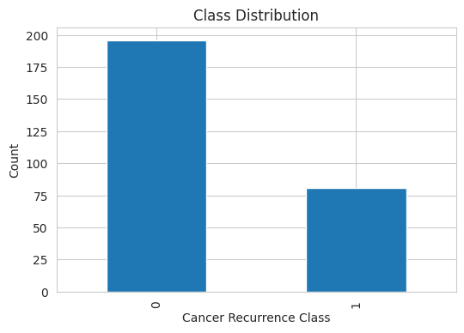
Based on the plot of the classes distribution, it is possible to note that the dataset is not evenly distributed. It has a great number of non-recurrence cases as compared to recurrence cases. This means that there is a problem of class imbalance in that the model can be biased towards forecasting the majority class (Maiti et al., 2025). This fact has significance as it influences the assessment of classification models and indicates the necessity to pay attention to measures like recall and F1 score at the subsequent stages. The class distribution analysis shows that the data are imbalanced, with many more non-recurrence cases than recurrence cases. This imbalance is crucial as machine learning models could be skewed towards the majority class, leading to false sense of accuracy and miss the true identification of cases of recurrence. Hence, evaluation metrics like recall, F1-score, ROC-AUC and Precision-Recall were also taken into account in addition to accuracy to get a comprehensive insight of the effectiveness of the model.
The feature distribution plots were further used to analyze the data to determine how each variable is represented in the dataset.
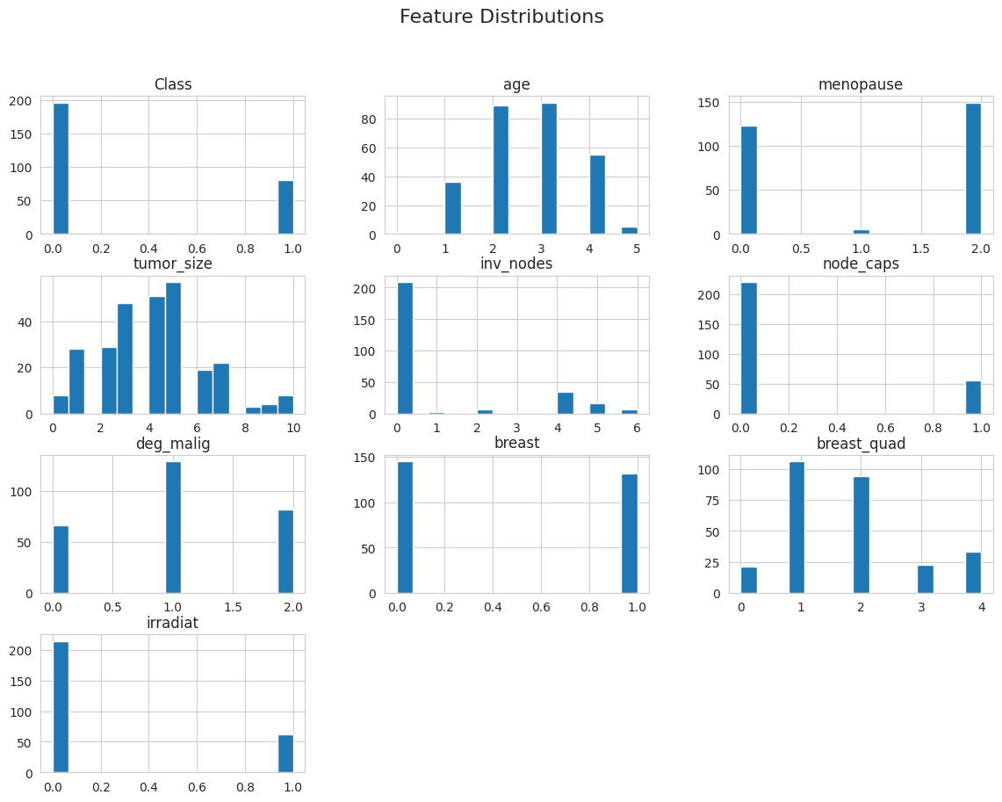
The plots of the features distributions indicate that the majority of the variables are discrete and were transformed into numbers. The age variable seems to be clustered in between categories, which means that the majority of patients are within the moderate age. The menopause variable has two predominant categories, indicating that the patients are largely divided into two categories. The distribution of tumour size demonstrates that it varies among different categories, revealing variability in tumour conditions in patients.
The involved nodes variable has high concentration on the lower ranges, that is, most patients have less involved lymph nodes. Equally, node_caps reveals that the majority of the cases lack node caps with a smaller percentage demonstrating positive indication. The variable of the degree of malignancy is distributed in three levels whereby there is a visible concentration of the middle level meaning that moderate cases of malignancy are widespread.
The spread of the breast and breast quadrant variables are categorical with no dominant presence of a given category whereas the irradiation variable depicts that the majority of the patients did not undergo the irradiation treatment. These observations are useful to get the overall picture of what the dataset consists of.
A correlation heatmap was created to analyse relationships among features.
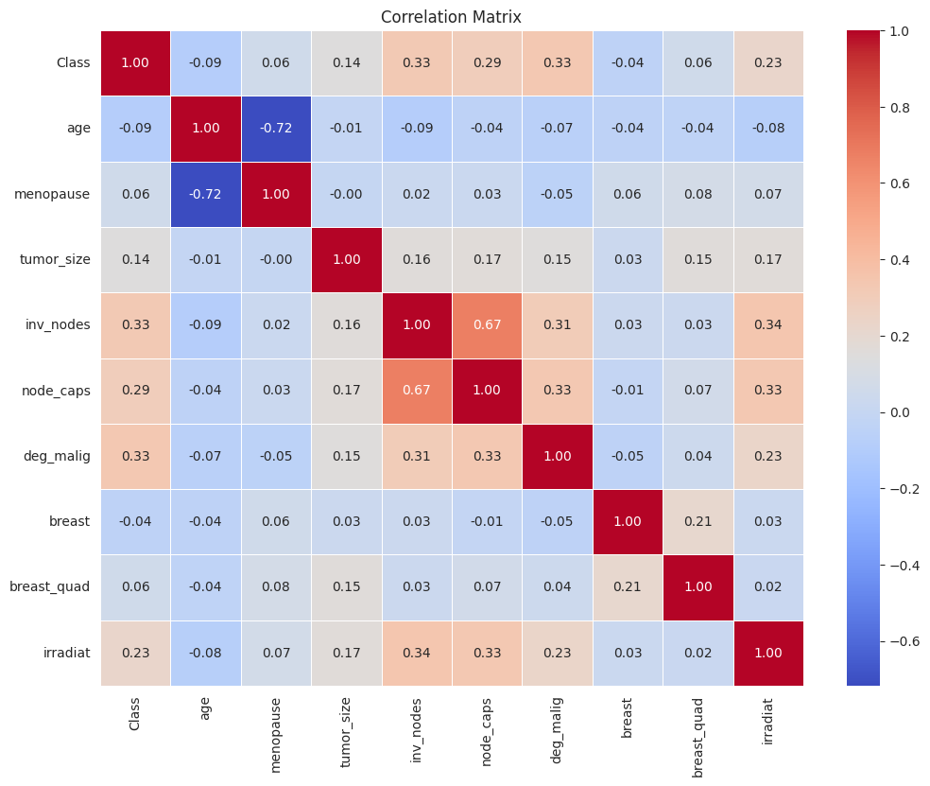
The heatmap of correlation displays the strength of the relationships between encoded variables. It may be seen that the variables like degree of malignancy, involved nodes and node caps are somehow stronger in their positive relationships with the outcome of recurrence than other features. This implies that the extent of tumour and involvement of the lymph node might have a significant role in recurrence prediction.
The relationships between involved nodes and node caps also show a significant correlation, which means that the two variables can be clinically related. But the majority of other variables have a weak correlation as it is expected since the data is categorical and is numerically encoded. Thus, these values are to be taken with caution and not as definite linear relations.
Besides correlation analysis, an initial feature importance analysis was done with the help of a Random Forest model.
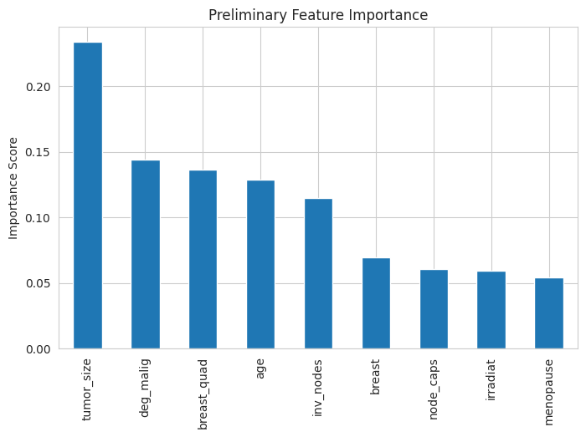
The feature importance plot shows that tumour size scores the highest importance score of all the variables. This implies that tumour size is a powerful predictor of recurrence. Next, the degree of malignancy and breast quadrant have also relatively high values of importance, which means that they also contribute to prediction.
The age and affected nodes also display moderate significance indicating that these factors have some effect on the recurrence classification. Conversely, other variables like menopause, irradiation and node caps have lower values of importance showing that they might have less predictive value than other characteristics. The feature importance analysis showed that tumour size was the most influential feature with the contribution of about 24% of the total feature importance. This corresponds to what has been observed in the clinic; larger tumors often have worse prognosis and higher recurrence rates. Other factors that were identified as important predictors were age, breast quadrant, invasive lymph nodes and degree of malignancy. On the contrary, menopause status, irradiation treatment and node caps were relatively less important in the decision making process of the model.
On the whole, the exploratory data analysis shows that tumour variables like tumour size, degree of malignancy, and involvement of lymph nodes are more predictive of recurrence than are demographic variables. These results can be useful in the modelling phase and aid in the choice of classification algorithms to analyze further.
Feature and Target Separation
Once the exploratory analysis stage was done, the dataset was split into predictor variables and the target variable. The clinical and pathological features were put together into a feature matrix represented by X and the recurrence outcome variable was isolated as the target variable represented by y.
This division enables classification algorithms to discover patterns amongst patient characteristics and recurrence results.
Training and Testing Data Split
To assess the predictive ability of the classification models, the dataset was split into training and testing samples. 80 percent to 20 percent proportion was implemented with most of the data being utilized in the training of the model and remaining was to be used in the performance assessment.
The splitting process was performed by stratified sample to make sure that the percentage of recurrence and non-recurrence cases is the same in the training and in the testing data. This will aid in generating a more accurate measure of model performance.
Evaluation Metrics
The efficiency of classification algorithms was measured in respect to a number of commonly used evaluation measures. These are accuracy, precision, recall and F1 score.
Accuracy is a measure of the fraction of the correctly classified observations, and precision is a measure of the fraction of the correctly predicted recurrence events in all the predicted recurrence events. Recall the capability of the model to appropriately recognize actual instances of recurrence. The F1 score is an integrated measure of precision and recall, a balanced measure of model.
These measures of evaluation give a holistic view of the ability of the classification algorithms to differentiate between recurrence and non-recurrence cases.

Model Development and Results
The section contains the modeling and analysis of classification models that are used to predict the occurrence of breast cancer recurrence based on clinical and pathological attributes. Three machine learning models were used, which are Logistic Regression, Decision tree and Random Forest (Tachicart et al., 2025). These models were chosen to reflect the various approaches to methodology such as linear classification, non-linear decision boundary, and ensemble learning. This stage is not only to check the individual model performance but also to analyse the behaviour of different learning mechanisms on a healthcare dataset of categorical features with imbalance between classes.
The data set ready in the previous step was split into training and test sets in an 8020 split. All the models were trained with the training data and tested with the testing data, to ensure that they are not biased in performance measurements. Besides conventional evaluation metrics, confusion matrices also were examined to gain a more comprehensive insight into the behaviour of classification, especially when determining recurrence cases. The hyperparameters were optimised with the help of the GridSearchCV that was used to determine whether the performance could be improved with the help of the optimisation.
Logistic Regression Model:
The basis model used was Logistic Regression because it is simple and easy to understand. The model takes the relationship between the input features and probability of recurrence to be linear. Although this assumption might not be able to fully reflect the complexity of clinical data, it gives a good point of reference to compare it with more sophisticated models.
The gridsearchcv was used to perform hyperparameter tuning and the best parameters found were C = 100, maxiter = 100 and solver = liblinear. Nonetheless, tuning did not lead to any performance improvement, which meant that the model was already in its optimal configuration with the given data set.
The results of the Logistic Regression model are as follows:
- Accuracy: 0.767857
- Precision: 0.714286
- Recall: 0.3125
- F1 Score: 0.434783
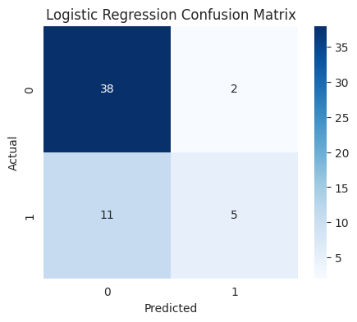
The confusion matrix indicates that the model is good in the classification of non-recurrence cases as indicated by the large number of true negatives. Nevertheless, it does not properly categorize a considerable amount of cases of recurrence which leads to a large number of false negatives. Such behaviour causes a low recall value, a significant constraint in medical prediction tasks where it is important to determine positive cases.
The model has a fairly high accuracy, which means that the predicted recurrence cases are usually accurate, but since it is not possible to identify the actual recurrence cases, it makes the model less useful in practical application. This weakness can be explained by the linear character of the model, which is not expected to help to consider more complicated associations between clinical features.
Decision Tree Model:
The Decision Tree model was adopted to model non-linear relationships among features. This model is a hierarchical decision rule rather than a logistic regression, in that unlike the latter, it can easily model the interaction of variables.
Results of the initial Decision Tree model were as follows:
- Accuracy: 0.660714
- Precision: 0.421053
- Recall: 0.5000
- F1 Score: 0.457143
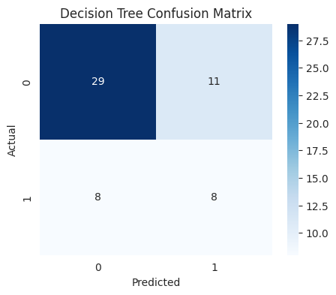
The confusion matrix shows that the model has a more balanced performance than Logistic Regression. It accurately recognizes more recurrence cases, which leads to a better recall. But this enhancement is at the expense of more false positives, decreasing precision. This trade-off is typical to classification tasks in which sensitivity is enhanced to the disadvantage of specificity.
Decision Tree model was optimised using hyperparameter tuning. The parameters that yielded the best results were max depth =None, min samples split =10 and min samples leaf =4. The model performance after tuning was as follows:
- Accuracy: 0.660714
- Precision: 0.384615
- Recall: 0.3125
- F1 Score: 0.344828
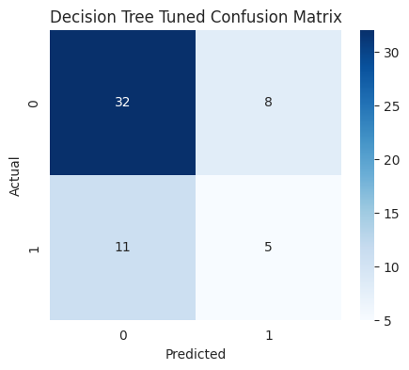
The tuned confusion matrix shows change of behaviour of the model. Although the false positives went down suggesting more effective classification of the non-recurrence cases, the false negatives went high. This led to a significant decrease in the recall, i.e. the model was less efficient in detecting recurrence cases.
Upon comparing the original and tuned Decision Tree models, one can easily notice that tuning resulted in the decrease of the model sensitivity. The limitations imposed in the tuning made the tree structure simpler, which minimized overfitting but also restricted the model in the capability to learn significant recurrence-related patterns. Consequently, the tuned model was not as effective as the original model especially in recall and F1 score.
Random Forest Model:
The Random Forest model was adopted as an ensemble model that uses several decision trees to enhance predictive accuracy. The model minimises variance and improves generalisation by consolidating the performances of multiple trees that are trained on various subsets of the data.
The confusion matrix shows that the Random Forest model offers a good balance in both the identification of the two classes correctly. It has a larger number of true positives than Logistic Regression and a smaller number of false positives than the Decision Tree model. This will lead to a more consistent performance on all the evaluation metrics.
The grid search methodology was utilized as Hyperparameter tuning with parameters such as n_estimators, max depth, minimum samples split and minimum samples leaf. The most optimal parameters were nestimators = 100, maxdepth = 10, min samples split =2 and min samples leaf =1. Nevertheless, there was no change in performance metrics with tuning, which means that the default model setting was optimal.
The initial Random Forest model resulted in the following results:
- Accuracy: 0.785714
- Precision: 0.666667
- Recall: 0.5000
- F1 Score: 0.571429
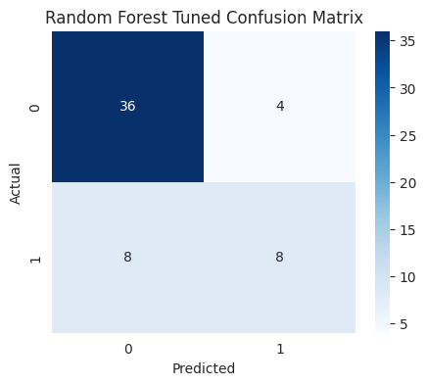
This stability indicates that in this dataset Random Forest is not too sensitive to the changes in parameters and can capture the underlying patterns effectively without a lot of tuning.
Model Comparison:
Comparison of all the models shows that there is a major variation in the way they classify recurrence events.
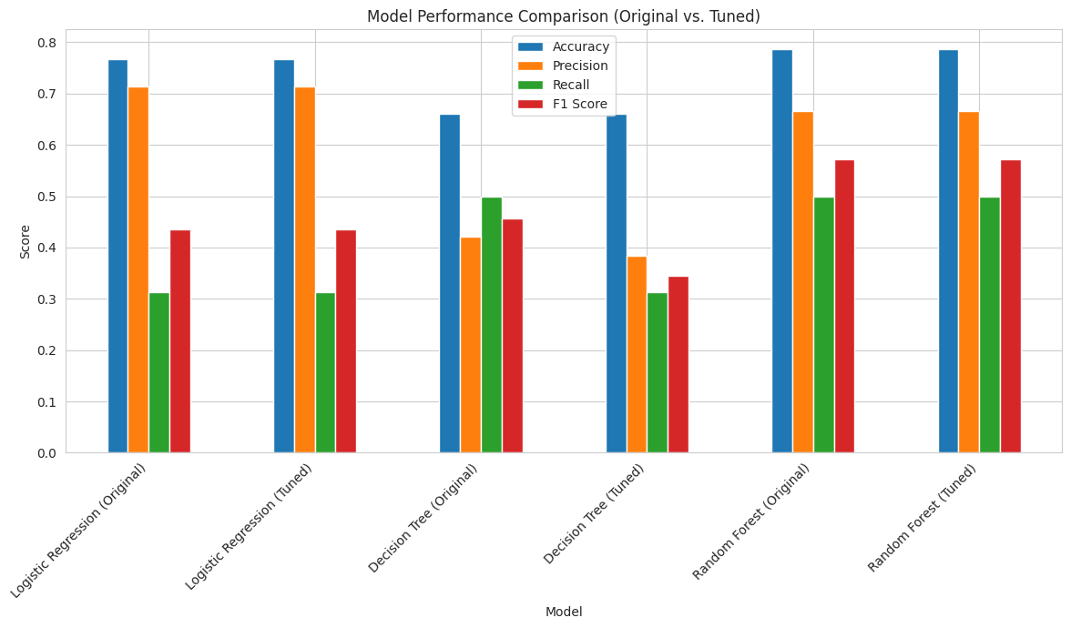
It is apparent that the results indicate that the overall balance of precision and recall will be higher with the help of the Random Forest as compared to both Logistic Regression and Decision Tree models. Logistic Regression is very accurate but the recall is very low and it is not suitable in detecting the case of recurrence. The Decision Tree model performs moderately but is not stable especially following tuning.
Conversely, Random Forest has a steady performance on all measures and has the highest F1 score, which means that it has an improved trade-off between the numbers of correctly recognized recurrence cases and the numbers of false predictions. The comparison of the three models offers valuable information regarding the performance of the various machine learning methods when used on clinical data with categorical variables and class imbalance. Although each of the models proves to learn patterns in the dataset, they differ in effectiveness based on the extent to which they balance the trade-off between learning cases of recurrences and false predictions.
One of the most important results is that there is a difference in recall among the models. The issue of recall is of special concern in this research due to the fact that the capability of the model to recognize recurrence cases rightly is measured. In medical use, a false negative on a recurrence can be very costly, so higher-recall models are preferred although they may have a few more false positives. Logistic regression model is the lowest recall with the rest of the models meaning that it does not actually capture many instances of recurrence. It is also evident in the confusion matrix where we have observed that there are many false negatives. It is likely that the model will prefer the majority group and this implies that the model is sensitive to the class imbalance in the data.
The Decision Tree model shows a varying behaviour. Its original version has a greater recall than the Logistic Regression, which implies that it is more sensitive to cases of recurrence. But this comes at the expense of decreasing accuracy, that is, the model is falsely declaring more non-recurrence cases to be recurrence. This trade-off illustrates the nature of decision trees because they are more likely to have loose boundaries that are capable of capturing more patterns but can also cause noise in predictions. Hyperparameter tuning makes the Decision Tree model more restrictive; thereby decreasing the false positives and boosting the false negatives. This leads to a large decrease in recall and total F1 score. This result implies that the tuning procedure has overfitted the model, making it unable to learn significant associations on the data.
Random Forest model is the most consistent and balanced in terms of performance of all the models. It has a greater accuracy and F1 score with a fair recall value. It does not give significant bias to the majority class as compared to the Logistic Regression, nor is it vulnerable to instability once tuned as compared to the Decision Tree. Random Forest ensemble nature enables it to integrate multiple decision boundaries that aid in capturing feature-complex interactions. This is especially useful in clinical databases where the relationships among variables are not necessarily linear.
The correlation between the results of the exploratory data analysis and model performance is another aspect that should be considered. The preceding discussion showed that tumour related factors like tumour size, level of malignancy and lymph node involvement are highly related to recurrence. It is hoped that models which can capture interactions between these variables will work better. Logistic Regression, being linear, might not be able to completely model these interactions and this is why it has low recall. Decision Trees are able to learn such relationships but are susceptible to parameter settings, so they produce varying performance. By aggregating several trees, Random Forest can stabilise these patterns, and make more reliable predictions.
The results also show that hyperparameter tuning did not significantly improve the performance of Logistic Regression and Random Forest models. It implies that the dataset might not be very complex in its configurations, or that the parameter search space was not very large. The default settings already gave a good balance between bias and variance in the case of Random Forest. In the case of Logistic Regression, the very structure of the model does not allow it to keep getting better beyond a certain threshold. Tuning however influenced the Decision Tree model in that it points out that optimisation does not necessarily result in improved results and should be implemented with caution.
Another factor to consider is the effect of dataset size and structure on the results. The dataset has a relatively few observations, and it is not a big limitation of models to generalise effectively. Also, categorical variables using label encoding result in an artificial ranking, which can change the interpretation of feature relationships in models. These variables have the potential to affect the model performance and should be taken into consideration when discussing the results.
Practically, the Random Forest model is the most appropriate to use in predicting breast cancer recurrence in the study. It offers an appropriate balance between the detection of cases of recurrence and the overall accuracy. Although Logistic Regression is interpretable, it has lower recall and hence it is not the most appropriate in this application. The Decision Tree model has moderate performance with no consistency post tuning.
In general, the results emphasize the significance of the proper choice of models when it comes to healthcare prediction tasks. Random Forest and other models that are able to model complex relationships and be stable are more appropriate to use in clinical datasets where a number of factors come together to affect outcomes. These findings give a solid basis to further research and to use ensemble techniques in medical prediction problems.

Impact of Class Imbalance Mitigation Using SMOTE
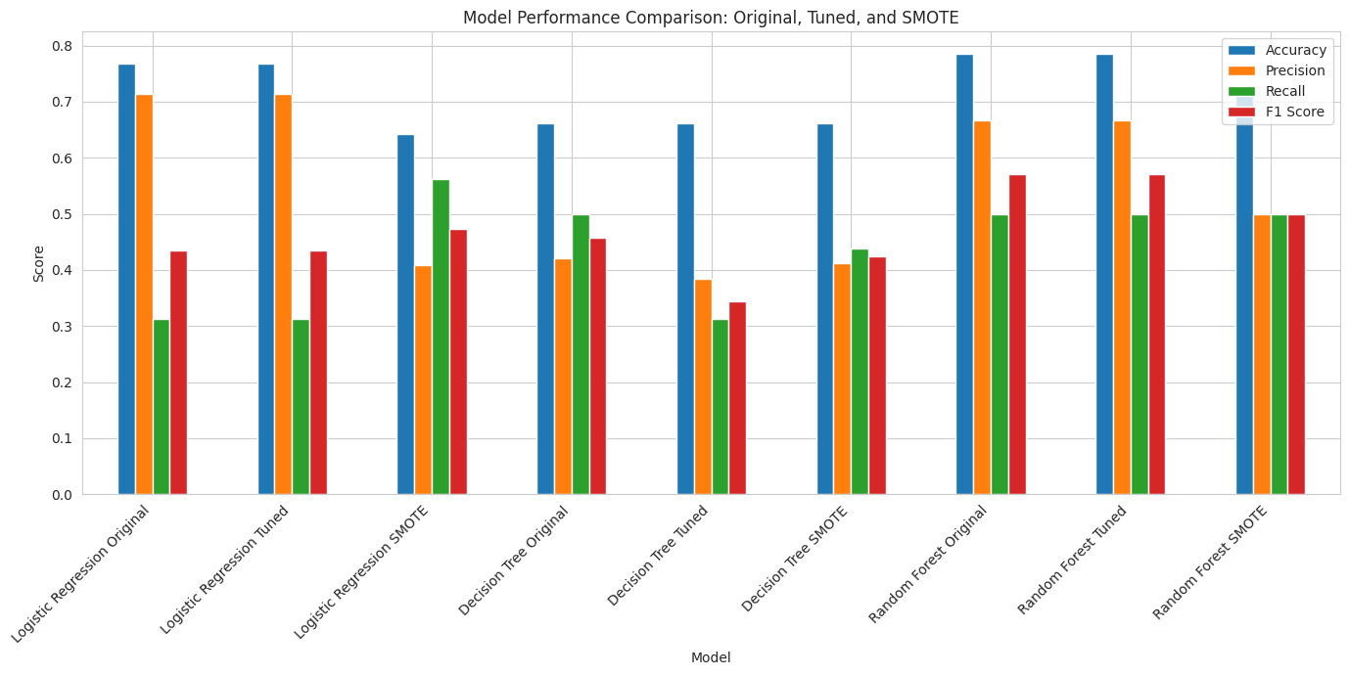
The class imbalance issue that was discovered in the exploratory analysis was overcome by using the Synthetic Minority Oversampling Technique (SMOTE) for the training data set. By synthesizing examples of the minority class, SMOTE enables algorithms to better learn how the minority class is recurring.
This suggests that Logistic Regression had a better recall with SMOTE (56.25% vs 31.25%) and was more effective at correctly identifying recurrence cases. This improvement also came at the expense of overall accuracy and precision. For other models, such as Decision Tree and Random Forest, SMOTE had little impact on performance, indicating that these models might not have been overly sensitive to the imbalance in the data. The results show that when dealing with imbalanced data, there is a compromise between overall accuracy and the minority class detection.

ROC Curve Analysis
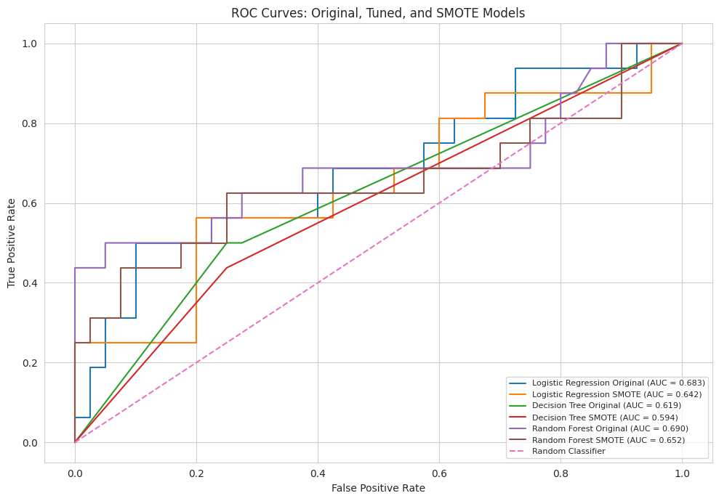
Receiver Operating Characteristic (ROC) analysis was used to assess the discriminatory power of each model at various classification thresholds for distinguishing between the cases of recurrence and non-recurrence. The model with the highest ROC-AUC score was the Random Forest model (0.690), which suggests this model had the best overall discriminative performance from the models tested. Logistic Regression gave an ROC-AUC score of 0.683 and Decision Tree gave a lower ROC-AUC score of 0.619.
After applying SMOTE value, ROC-AUC scores were reduced a bit for all models. This is an indication that SMOTE might have helped to detect minority class samples in some instances, but did not boost the discriminative ability. Thus, the original Random Forest model was the most effective model based on the ROC analysis.

Precision-Recall Analysis
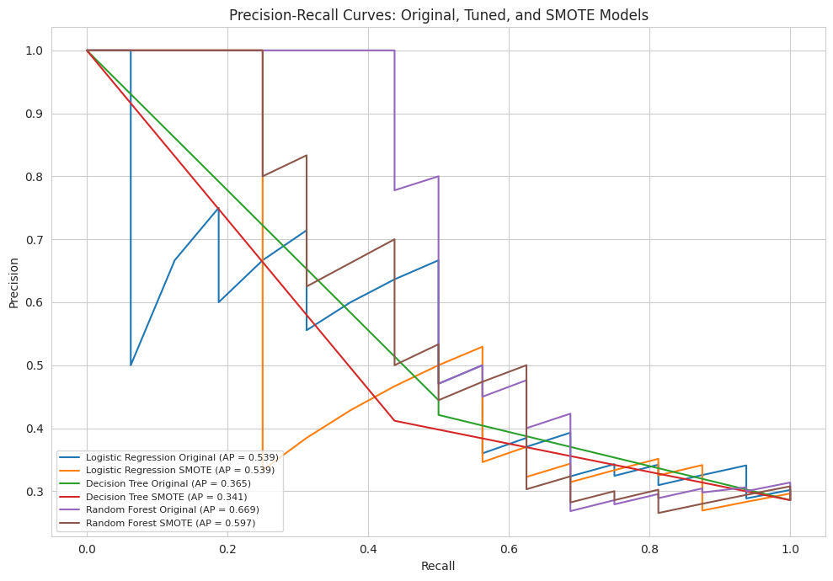
To gain further insight into the model performance when dealing with class imbalance, Precision-Recall analysis was performed. While accuracy measures the model's accuracy in determining whether a case is recurring or not, Precision-Recall metrics are concerned with the model's accuracy in determining a case is recurring and minimizing false positive predictions.
The model with the highest Average Precision score (0.669) is the Random Forest, which has the best balance between precision and recall. Logistic Regression gave an Average precision score of 0.539, Decision Tree gave 0.365. Like the ROC-AUC results, the use of SMOTE did not lead to an improvement in Average Precision performance, and led to scores that were slightly lower on all models. This further validates the choice of Random Forest as the best model for prediction of recurrence.

Discussion
The main objective of this research was to investigate the possibility of predicting the recurrence events in breast cancer using classification with the help of clinical and pathological features. The results of this study give a valuable answer to this question and show that predictive modelling can determine the patterns in relation to recurrence, though the degree of accuracy and reliability is different, based on the type of model applied.The exploratory data analysis was significant to comprehend the dataset and determine essential variables that affect recurrence. It was noted that tumour characteristics like tumour size, malignancy and involvement of lymph nodes demonstrated stronger correlations with recurrence. These results agree with the available literature, which indicates that the severity and spread of tumours are crucial signs of the risk of recurrence ( Abreu et al., 2016). This observation was also supported by the feature importance analysis which identified tumour size and malignancy as the most important predictors.Model development results indicate that all the three models could learn patterns in the dataset to some degree, but the degree of effectiveness varied greatly. Despite its simplicity and interpretability, Logistic Regression proved to have weaknesses in the ability to capture the complexity of the data. It was relatively accurate but very low recall which means that it could not recognize many recurrence cases. This indicates that linear modelling might not be adequate in datasets whose associations between variables are complicated and non-linear.
Decision Tree model presented had better recall in its original form in the sense that it was more effective in recognizing recurrence cases than Logistic Regression. This was however at the expense of reduced accuracy meaning that there were more false positive predictions. Following hyperparameter optimization, the model was more restricted, leading to decreased recall and performance in general. This emphasises the fact that model optimisation is not necessarily a good improvement as it may also diminish the capacity of the model to capture significant patterns.
Random Forest model showed the highest overall performance of all the models. It obtained the best accuracy and F1, but with a balanced recall. This shows that it was more useful in identifying correctly both recurrence and non-recurrence cases. Random Forest was able to do this because of the ensemble nature of the model which enabled it to capture feature interactions that were not present in the linear Logistic Regression model. This is the reason why it performed better than the other models in this study.
Using these findings, a balanced conclusion can be provided to the research question. It is indeed true that clinical and pathological aspects may be used to predict the recurrence events of breast cancer; but this depends on the modelling technique that is applied. Although less complex models may give some degree of prediction, more sophisticated models like the Random Forest are more applicable to the complexity of clinical data and are able to give more reliable results.
Irrespective of such results, some limitations should be taken into account. The sample that is used in this research is quite small and this limits the generalisation of models to large populations. Also, the nature of the data used is categorical and label encoding can be used, so the representation of relationships between variables might be weak. Class imbalance also affected the model performance and especially the Logistic Regression which did not identify the cases of the minority classes.
The other aspect that is also worth considering is that the predictive performance in this study is only based on clinical variables and pathological variables. In practice, other information like genetic data, imaging data, and treatment history can be used to further enhance prediction accuracy. Hence, future studies may discuss the multidimensional integration of data to improve the work of the model.
This paper shows that machine learning methods can be successfully used to estimate the recurrence of breast cancer based on clinical data (Habehh and Gohel, 2021). Random Forest among the models considered was the most reliable and balanced. The results underscore the significance of choosing the right modelling methods and emphasize the importance of data-driven methods in healthcare decision-making.

Conclusion
The goal of the study was to determine the possibilities of predicting the occurrence of breast cancer recurrence by clinical and pathological features based on classification methods. The findings of data analysis and model assessment prove that it is possible to find meaningful patterns in clinical data, and that they can be adopted to assist predictive modelling. The results validate that machine learning methods can process structured medical data and give valuable information on the risk of recurrence (Shailaja et al., 2018).
It started by analysing the data with data preprocessing and exploratory analysis, which helped obtain a clear picture of the dataset structure and feature behaviour. It was noted that tumour variables, including tumour size, stage of malignancy, and lymph node involvement are more influential on recurrence outcomes than demographic variables. These results are in line with clinical knowledge and justify the applicability of the chosen data set to the research. Class imbalance also turned out to be a feature of the exploratory stage, with certain effects on the model performance and the necessity to use the proper evaluation metrics.
Three classification models were created and tested, such as Logistic Regression, Decision Tree, and Random Forest. All the models had various advantages and disadvantages. The Logistic Regression was a simple and easy to interpret method but it did not perform well in detecting recurrence cases due to low recall. This indicates that complex relationships in clinical data might not be adequately represented using linear models.
In the original form, the Decision Tree model demonstrated a better capacity in identifying recurrence cases, but was not consistent, especially following hyperparameter tuning. The tuned model was found to be more limited and less useful in detecting cases of recurrence and this means that sometimes loss of valuable information may occur due to model simplification. This highlights the need for careful consideration when applying optimisation techniques.
Random Forest model was the best performing model in general. It gave the best accuracy and F1 score and had a balanced recall. The ensemble method enabled it to model the complicated interactions among features and make more consistent predictions. This shows how ensemble techniques can be used to work with clinical data whose relationships are nonlinear and have categorical variables (Abbas et al., 2025).
Judging by the general findings it can be concluded that the research question has been answered. It is possible to predict the recurrence events of breast cancer using clinical and pathological features, however, this cannot be effectively predicted based on the model applied. More advanced models like the Random Forest would be more applicable to this task since it can cover intricate data patterns and deliver a balanced performance.
In spite of these positive results, there are several limitations of this study. The dataset used is relatively small, which may limit the generalisability of the results. Also, categorical variables that are defined through label encoding might not capture all the relationships between categories. Class imbalance also influenced the capacity of models to make correct recurrence identifications. These shortcomings indicate that some additional progress may be achieved by incorporating larger datasets, involving more sophisticated encoding, and resampling or cost-sensitive to overcome the issue of class imbalance.
This research can be expanded in future studies with the inclusion of other data sources like genetic data, imaging data and the past history of the patient to enhance the accuracy of prediction. It is also possible to use more sophisticated models, such as deep learning techniques, to achieve improved performance. In addition, the incorporation of explainable processes can assist in enhancing interpretability of predictions and contribute to the trust in machine learning models in clinical practice.
To sum up, this paper identifies the potential of machine learning in healthcare applications, especially predicting breast cancer recurrence. The results prove that clinical decision-making could be supported by data-based methods that could help to recognize high-risk cases and provide early intervention. Such models can be used to develop more effective and personalised healthcare solutions with additional improvements and validation.

References
Abbas, N.R., Alkattan, H. and Aldallal, I.B., 2025. Machine Learning Approaches for Predicting Breast Cancer Recurrence: A Comparative Analysis. Mesopotamian Journal of Artificial Intelligence in Healthcare, 2025, pp.208-218.
Abreu, P.H., Santos, M.S., Abreu, M.H., Andrade, B. and Silva, D.C., 2016. Predicting breast cancer recurrence using machine learning techniques: a systematic review. ACM Computing Surveys (CSUR), 49(3), pp.1-40.
Amin, M. and Ali, A., 2018. Performance evaluation of supervised machine learning classifiers for predicting healthcare operational decisions. Wavy AI Research Foundation: Lahore, Pakistan, 90.
Ferrao, J.C., Oliveira, M.D., Janela, F. and Martins, H.M., 2016. Preprocessing structured clinical data for predictive modeling and decision support. Applied clinical informatics, 7(04), pp.1135-1153.
Habehh, H. and Gohel, S., 2021. Machine learning in healthcare. Current genomics, 22(4), pp.291-300.
Jansen, T., Geleijnse, G., Van Maaren, M., Hendriks, M.P., Ten Teije, A. and Moncada-Torres, A., 2020, June. Machine learning explainability in breast cancer survival. In 30th Medical Informatics Europe Conference, MIE 2020 (pp. 307-311). IOS.
van Leersum, C.M. and Maathuis, C., 2025. Human centred explainable AI decision-making in healthcare. Journal of Responsible Technology, 21, p.100108.
Maiti, A., Hanini, M. and Abarda, A., 2025. Resolving Class Imbalance in Medical Classification: Technique Comparison and Performance Evaluation. Journal of Information Systems and Telecommunication (JIST), 3(51), p.177.
Shailaja, K., Seetharamulu, B. and Jabbar, M.A., 2018, March. Machine learning in healthcare: A review. In 2018 Second international conference on electronics, communication and aerospace technology (ICECA) (pp. 910-914). IEEE.
Tachicart, R., Rezki, H., Korchi, A. and Abatal, A., 2025. A comparative study of machine learning algorithms for breast cancer diagnosis. Journal of Medical Artificial Intelligence, 8, p.58.
Zhang, Y., Deng, Q., Liang, W. and Zou, X., 2018. An efficient feature selection strategy based on multiple support vector machine technology with gene expression data. BioMed research international, 2018(1), p.7538204.

