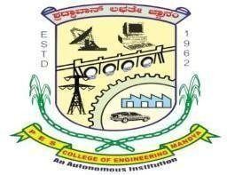
P.E.S COLLEGE OF ENGINEERING.
(People’s Education Trust, Mandya)

INTERNSHIP REPORT
Submitted for the requirements of Internship-I program of IV semester.

SUBMITTED BY:
Pranav A 4PS23CI042

Mentor: Prof. Sindhu P.
Department of Computer Science and Engineering(Artificial
Intelligence and Machine Learning).
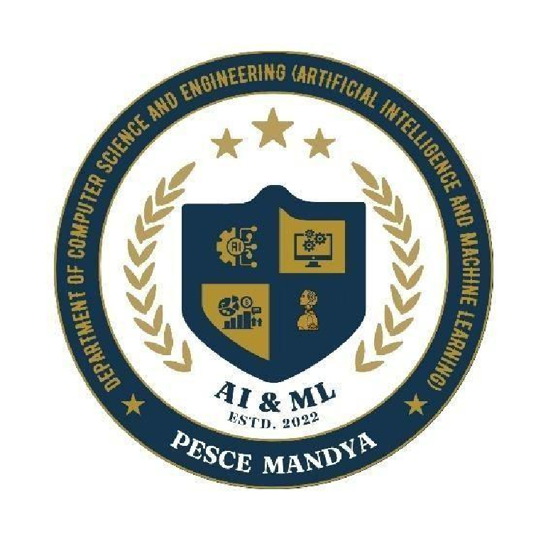

Acknowledgement.

It gives me immense pleasure to express my profound sense of gratitude to all those who have extended their valuable support and encouragement in the successful completion of this internship.
First and foremost, I would like to convey my sincere thanks to Dr. Murali Krishna, Principal,
PES College of Engineering, Mandya, for providing me with this opportunity to pursue the internship during skill development sessions and for ensuring a conducive academic environment throughout the duration of this program.
I am deeply grateful to Dr. D.R. Umesh, Professor and Head, Department of Artificial
Intelligence and Machine Learning, for his continued encouragement, academic leadership, and the motivation that helped me stay focused and committed during the entire course of the internship.
I owe special thanks to my mentor, Ms. Sindhu P, Assistant Professor, Department of AIML, for her invaluable guidance, timely feedback, and persistent support. Her mentorship was instrumental in helping me understand the learning objectives and in navigating through the technical aspects with clarity and confidence.
This internship has not only enriched my technical skills but also contributed significantly to my personal and professional growth. I am grateful for the opportunity to be a part of this enriching experience.

Introduction:

The Department of Computer Science and Engineering (Artificial Intelligence and Machine Learning), in collaboration with TechSaksham, organized two skill development programs in the third and fourth semesters respectively. The initiative was focused on equipping students with the technical capabilities required for Industry 4.0 through hands-on exposure in areas like Linux, Python programming, data analysis, database management, OpenCV, and Power BI.

OBJECTIVE

The primary objective of the six-day technical session was to equip participants with both foundational and advanced skills in Linux, Python programming, database management, web scraping, and data visualization. The program was structured to offer practical exposure to essential tools and technologies widely used in the software and data analytics industry. By the end of the session, participants were expected to:
- Develop a strong understanding of operating system fundamentals with a focus on the Linux environment.
- Gain familiarity with open-source tools and recognize the advantages of using Linux for development and deployment.
- Acquire practical skills in executing Linux commands and writing efficient shell scripts.
- Master core Python programming concepts and build command-line applications such as a task manager and calculator.
- Gain hands-on experience in Python-based data analysis using essential libraries and standard techniques.
- Learn and apply advanced Python concepts, including modules, packages, and file handling.
- Understand the fundamentals of relational databases, including installation and administration of MySQL.
- Integrate Python with MySQL to perform SQL queries and process query results effectively.
- Explore the significance of data analysis in Artificial Intelligence and Machine Learning projects.
- Learn web scraping fundamentals using Beautiful Soup and Selenium to extract data from websites for automation and analysis.
- Develop practical scripts to scrape structured information from dynamic web pages.
- Understand the role of data visualization and use Power BI to create interactive dashboards and reports from collected data.
- Strengthen problem-solving and analytical thinking through project-based learning, realworld scenarios, and data handling tasks.

DAY WISE SUMMARY:

- Day 1: Operating System and Linux Fundamentals

The inaugural session introduced participants to essential operating system concepts, highlighting the role of system-level architecture in modern computing. Students explored key OS responsibilities, including process management, memory allocation, and file systems.
- The session then focused on Linux, a widely adopted open-source operating system in development and enterprise environments. Participants examined the Linux
kernel's role, distinctions between user space and kernel space, and an overview of
system lifecycles.
- An interactive discussion compared popular Linux distributions such as Ubuntu, CentOS, and Debian, covering their unique features, use cases, and communities. Students were guided through installing Ubuntu on VirtualBox, enabling them to experiment with Linux in a safe, isolated environment.
- The open-source philosophy and its impact on software development were emphasized, including licensing models like the GPL and their implications. The session concluded with an introduction to shell environments like Bash, highlighting their role in scripting, system control, and automation.
- Learning Highlights:
- Role of open-source in driving innovation
- Core functionalities and structure of Linux systems
- Installation and configuration of Ubuntu using VirtualBox
- Differences between distributions and kernel structures
- Introduction to Linux command-line navigation and environment

- Day 2: Python Basics

The second session laid the foundation for developing logical thinking through Python programming. The session began with an introduction to the Python interpreter, interactive shell, and script execution processes. Students learned essential programming constructs, including variables, data types (integers, floats, strings, booleans), typecasting, and operators.
- A major focus was placed on control flow mechanisms. Conditional statements (if, elseif, else) and iterative structures (for, while loops) were thoroughly explained with practical demonstrations. Syntax clarity and logical application were emphasized through hands-on exercises.
- Participants implemented basic Python programs, including:
- A leap year checker utilizing nested conditions
- A multiplication table generator using loops
- A program to find the largest of three numbers with conditional logic
- A digit counter built with while loops
- A prime number checker based on divisibility rules
- The session emphasized practical problem-solving and scripting fundamentals, ensuring students gained confidence in writing and executing Python programs.
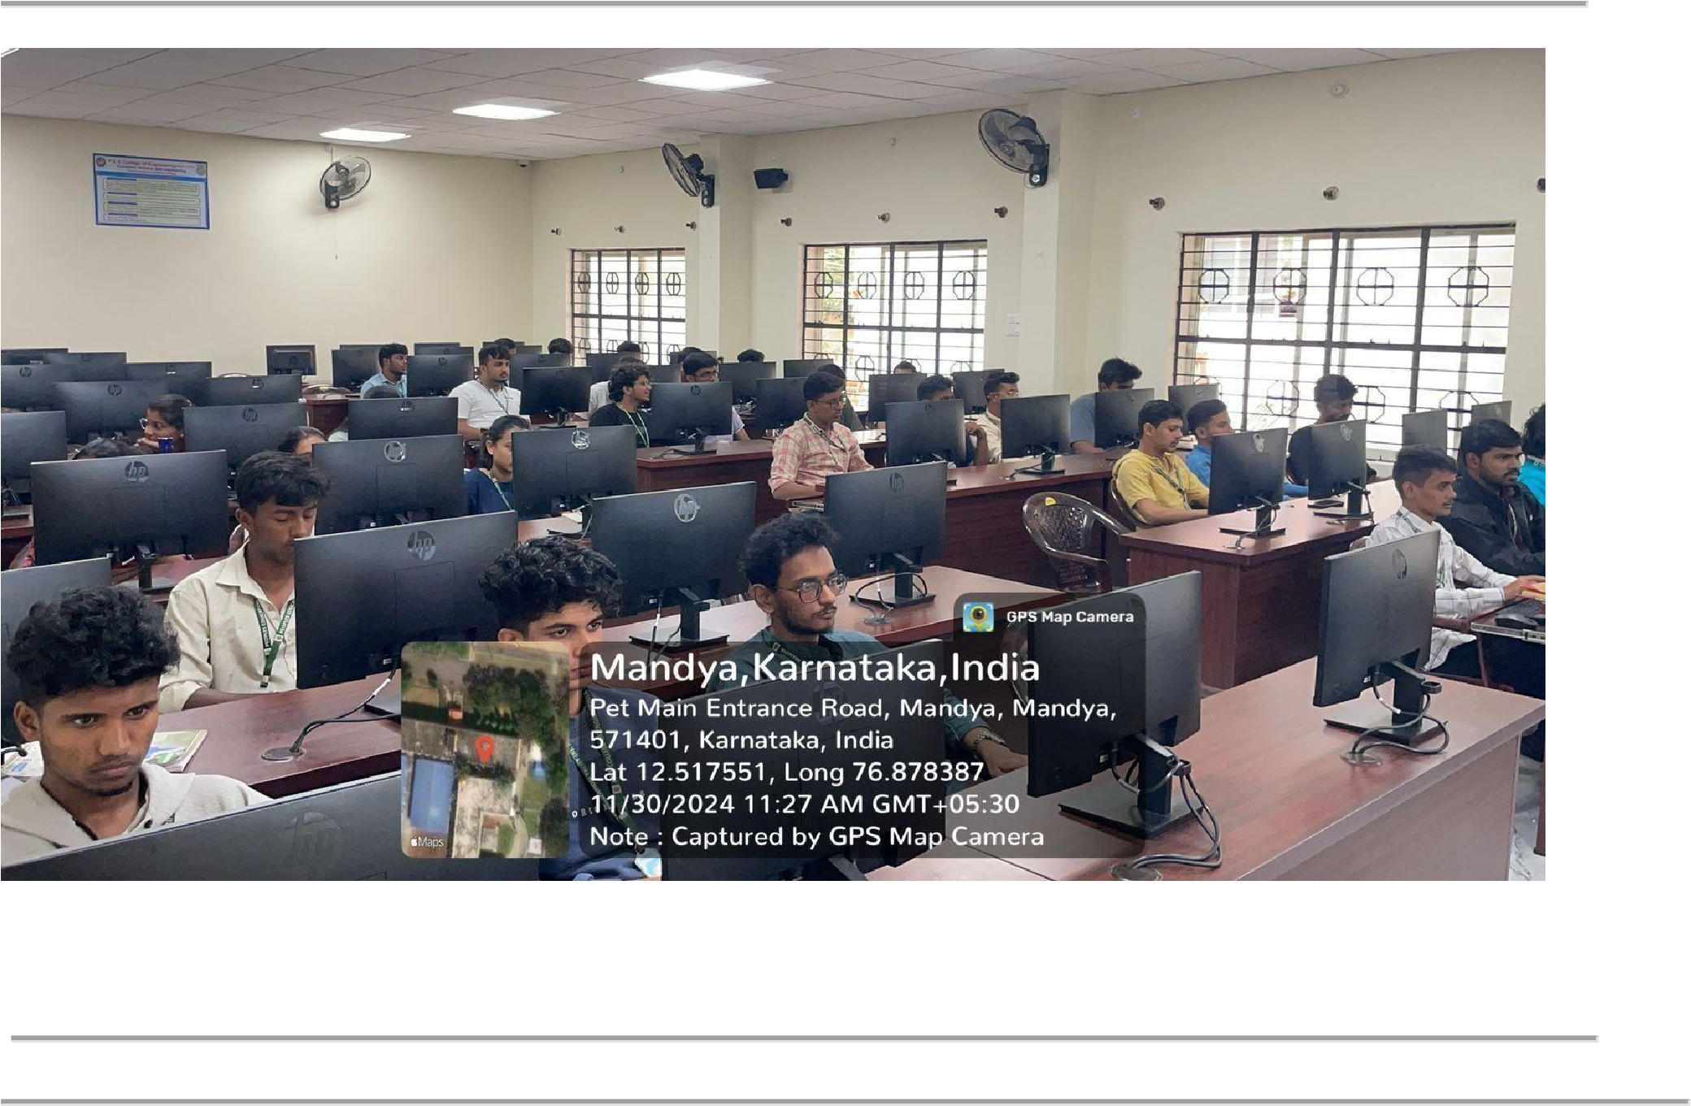

Day 3: Data Structures in Python

The third session focused on Python’s core data structures, essential for efficient programming, data organization, and problem-solving. Students explored sequences such as lists, tuples, and ranges through practical examples and interactive coding exercises.
Key topics included:
- Lists: Creation, indexing, slicing, appending elements, and list comprehension for concise data processing
- Tuples: Immutable sequences suitable for fixed data operations and safer coding practices
- Ranges: Application in loop constructs with customizable start, stop, and step parameters
The second half introduced Python’s mapping and set types, critical for managing structured data and ensuring uniqueness:
- Dictionaries: Key-value pairs for structured data storage, adding, updating, and iterating over entries
- Sets: Managing unique elements, performing operations like union, intersection, and difference
To apply these concepts, participants developed a command-line Task Manager Application, which included features such as:
- Adding tasks with relevant attributes
- Viewing pending and completed tasks
- Marking tasks as complete and deleting tasks
This hands-on project emphasized the practical role of data structures in real-world program design. The session also introduced basic considerations of data complexity and selecting suitable data types based on use cases.
Learning Highlights:
- Mastery of sequences (lists, tuples, ranges) and mappings (dictionaries, sets) for efficient data handling
- Developed a functional mini-project demonstrating real-world application
- Gained practical experience in efficient data manipulation and program structure

Day 4: Object-Oriented Programming (OOP)

The fourth session introduced participants to Object-Oriented Programming, a core paradigm for building scalable, maintainable applications. The session emphasized structuring code using classes and objects to promote reusability and logical organization.
Key OOP principles were explored through interactive examples:
- Encapsulation: Protecting data by restricting direct access to attributes using getter and setter methods
- Inheritance: Reusing and extending functionality by building child classes from parent classes
- Abstraction: Simplifying complexity by hiding internal implementation details using abstract base classes
- Polymorphism: Allowing method redefinition in child classes to enable dynamic, flexible behaviour
These concepts were reinforced through two hands-on case studies:
- Bank Account System: Designed using base and derived classes to handle different account types, balance management, and transaction tracking
- Library Management System: Implemented with class hierarchies for cataloging books, handling borrowing and returns
Participants coded both systems from the ground up, gaining practical experience in code reuse, modular structure, and logical design. The session also emphasized critical techniques such as the constructor, super() for inheritance, and method overriding.
Learning Highlights:
- Developed complex logic using class-based design
- Created interactive programs emphasizing code modularity and reusability
- Built a strong foundation in scalable, maintainable software architecture

Day 5: Advanced Python and MySQL Integration

The fifth session advanced participants' Python skills, focusing on modular coding, file operations, and database integration.
Key topics included:
- Creating and importing custom modules to organize reusable code
- Structuring projects into packages for better maintainability
- Performing File I/O operations with .txt and .csv files for reading and writing data
- Implementing exception handling using try, except, and finally blocks to build resilient programs
In the second half, students explored relational database fundamentals with MySQL. After installing MySQL locally, they practiced essential operations:
- Creating databases and tables
- Inserting, updating, and retrieving data
- Applying conditions, sorting, and performing table joins
Participants then connected Python to MySQL using the mysql-connector library. A hands-on miniproject involved analyzing a sales dataset, where students wrote Python scripts to extract insights, filter records, and generate summary reports.
Learning Highlights:
- Mastered modular programming and error-handling techniques
- Performed real-time data operations by integrating Python with MySQL
- Gained insight into the role of databases in application backends

Day 6: Shell Scripting and System Integration

The final session brought together knowledge from Linux, scripting, programming, and database concepts to demonstrate real-world system integration.
Participants began with practical Linux command-line exercises:
- File navigation and manipulation using ls, cd, mkdir, rm, chmod, and related commands The session then introduced Shell Scripting fundamentals:
- Writing .sh scripts to automate repetitive tasks
- Using variables, conditionals, and loops within Bash scripts
- Automating backups, capturing user inputs, and organizing files programmatically
Building on this, students explored basic full-stack integration:
- Frontend: Creating simple HTML/CSS forms for user data input
- Backend: Using Python scripts to process and handle logic
- Database: Sending, storing, and retrieving information with MySQL
The day concluded with a collaborative discussion on how these components function together in realworld applications, reinforcing system integration concepts.
Learning Highlights:
- Developed automation skills with practical shell scripting
- Simulated basic full-stack architecture combining frontend, backend, and database
- Gained a clear understanding of component integration in software systems
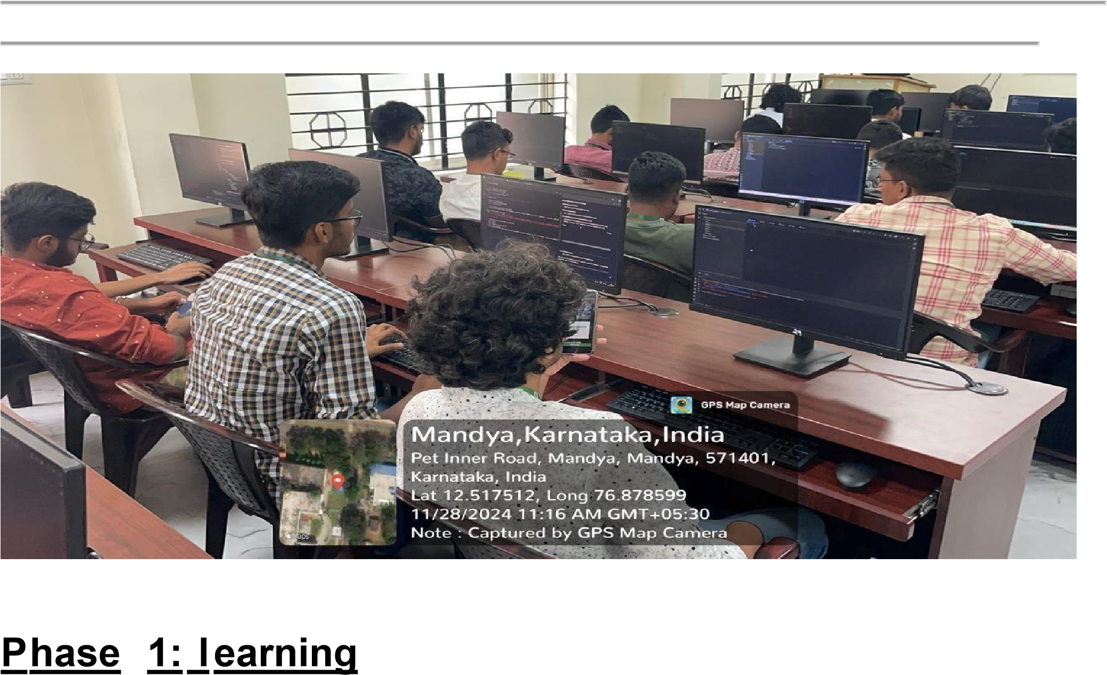

The first phase of the skill development program provided a solid foundation for students entering the fields of modern computing and AI. Through a balanced combination of theory and practical sessions, participants developed essential competencies in Linux, Python programming, data structures, and database integration.
From writing their first shell script to building modular Python applications and connecting them with MySQL, students not only learned core technical tools but also understood their application in real-world scenarios. This phase established the groundwork for deeper technical exploration while encouraging a mindset focused on problem-solving and practical implementation. Students are now well-prepared to progress into more advanced topics in the upcoming phase.

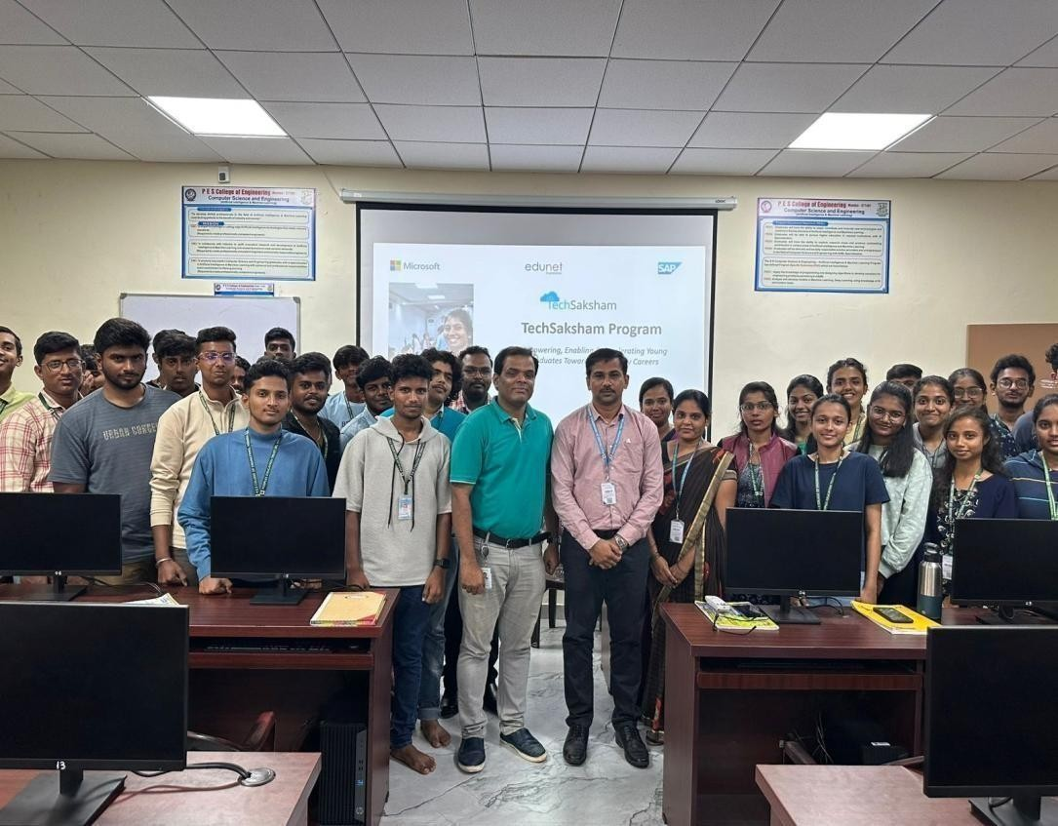
PHASE-II LEARNING CHRONICLE:

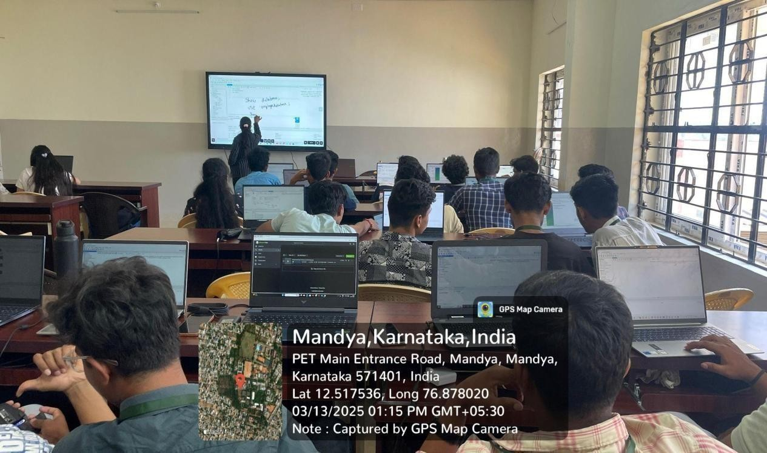

Day 1: Python Basics and OpenCV Integration

The first day of Phase 2 focused on reinforcing core programming concepts while introducing participants to the exciting field of computer vision. The session began with a concise revision of Python essentials, covering variables, data types, conditional logic, loops, and functions. This ensured participants had a solid foundation for integrating external libraries like OpenCV.
The session then transitioned to OpenCV, a popular open-source library for realtime image and video processing. Students learned to install OpenCV, configure it within their Python environment, and verify functionality through basic test scripts.
Once the setup was complete, participants practiced essential image manipulation techniques, including:
- Reading and displaying images
- Resizing images to custom dimensions
- Converting color images to grayscale
- Flipping images horizontally and vertically
- Saving modified image files
The next segment introduced edge detection using OpenCV’s Canny algorithm, demonstrating how boundaries within images can be identified. Real-world applications of these techniques were discussed, including facial recognition, number plate detection, and computer vision in robotics.
Hands-on exercises throughout the session reinforced understanding. Mentors provided guidance with installation troubleshooting, logic development, and the use of key OpenCV functions such as cv2.imread(), cv2.imshow(), cv2.cvtColor(), and cv2.Canny().
Learning Highlights:
- Reinforced Python fundamentals to support practical integrations
- Installed and configured OpenCV for image processing tasks
- Applied real-time image manipulation techniques
- Gained insight into computer vision’s role in AI-driven applications
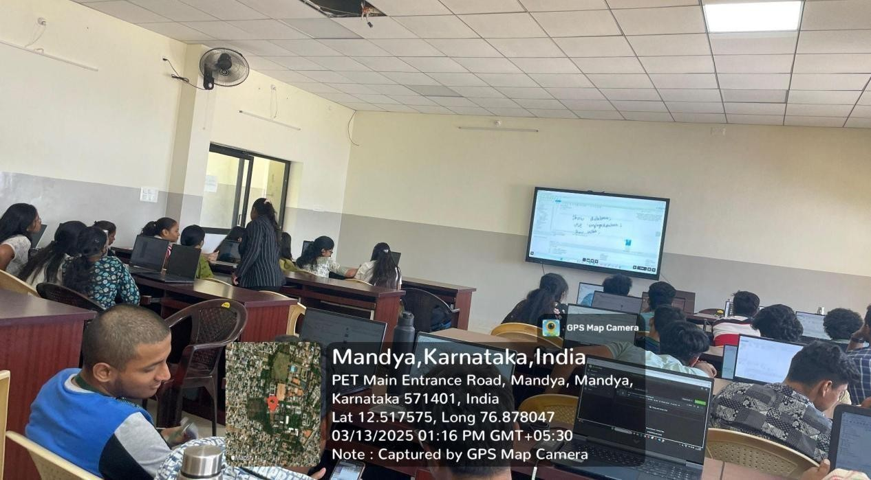

Day 2: Applied Data Analytics : Data Analysis and Visualization with Python

The second day focused on extracting meaningful insights from data using Python’s analytical capabilities. The session began with an introduction to the role of Exploratory Data Analysis (EDA) in uncovering patterns, detecting anomalies, and formulating data-driven hypotheses.
Students worked with essential Python libraries like Pandas and NumPy to load datasets, explore data structures, and manipulate rows and columns. The session covered core data-cleaning techniques, including:
- Handling missing values with fillna() and dropna()
- Detecting outliers using statistical thresholds
- Converting and transforming data types for consistency
Instructors demonstrated the use of built-in descriptive statistics methods, including mean(), median(), std(), and describe(), to summarize and interpret data distributions. Students applied these techniques to a dataset containing academic records, aiming to explore factors affecting student performance.
The second half emphasized data visualization, introducing tools like
Matplotlib and Seaborn to create effective graphical representations. Students produced:
- Bar graphs, histograms, and boxplots to explore distributions
- Heatmaps for visualizing correlations
- Scatter plots and pair plots to analyze relationships between variables such as attendance and exam scores
To consolidate their learning, participants formed small groups and completed miniprojects, applying all techniques to generate concise data analysis reports.
Learning Highlights:
- Cleaned, transformed, and explored real-world datasets
- Visualized trends, patterns, and correlations using Matplotlib and Seaborn
- Strengthened their ability to extract insights from structured data
- Gained practical exposure to workflows used in data science and analytics

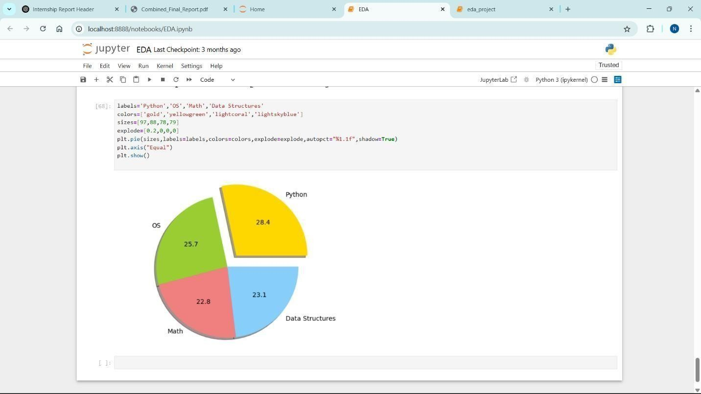

Day 3: Power BI for Data Visualization

The third day introduced participants to Power BI, a professional tool for interactive data visualization and reporting. The session began with a walkthrough of the Power BI interface, covering the workspace, data view, report view, and visualization pane.
Participants learned to import datasets from various sources, including Excel and CSV files. They used Power Query Editor to clean data by removing nulls, renaming columns, changing data types, and creating calculated columns.
Next, they built visualizations such as line graphs, clustered column charts, donut charts, and stacked bars. Emphasis was placed on adding interactivity using slicers and filters to enable real-time report exploration.
The session also covered basic DAX (Data Analysis Expressions), where students wrote measures and calculated fields for custom metrics like averages, conditional totals, and rankings.
The highlight was a project using an air quality dataset to create a comprehensive dashboard displaying pollutant trends by region, date, and type, integrating both aesthetic and functional design principles.
Learning Highlights:

- Utilized Power Query Editor for advanced data cleaning.
- Created dynamic dashboards with diverse visuals.
- Applied DAX for data customization.
- Learned business intelligence storytelling with data.

Day 4: Database Management System (MySQL) with Python

This day focused on relational databases and their integration with Python. It started with RDBMS fundamentals such as tables, keys, relationships, and data types.
Participants installed MySQL, configured local servers, and practiced SQL queries in MySQL
Workbench. They executed commands to create databases, define schemas, and perform INSERT, SELECT, UPDATE, and DELETE operations. Concepts of JOINs and table normalization were introduced to reduce redundancy.
The second session demonstrated connecting Python applications to MySQL using the mysqlconnector-python library. Students automated data insertion, queried results, and handled connection errors through Python scripts.
The day culminated with a CLI-based Task Manager project enabling users to add, delete, and view tasks stored in MySQL, illustrating backend database support for persistent data management.
Learning Highlights:
- Practiced database schema design and SQL syntax.
- Integrated Python programs with MySQL databases.
- Performed real-world data operations programmatically.
- Gained understanding of data persistence in applications.

Day 5: Project Implementation and Doubt Clearing Session

The final day was dedicated to project development, peer collaboration, and mentorship. Participants selected projects combining elements from prior days—Python, MySQL, OpenCV, and Power BI. Projects included:
- Automated student performance dashboards using Power BI.
- Task management applications with backend databases.
- Real-time image filters and edge detectors with OpenCV.
Instructors provided personalized support, assisting with debugging, query optimization, and dashboard refinement. The focus extended beyond execution to documentation, teamwork, and clear project explanation.
Students reflected on their learning journey, challenges, and the practical applications of these tools in academic and industry contexts. This session reinforced their confidence and motivation to further explore these technologies.
Learning Highlights:
✔️ Delivered full-cycle technical mini-projects.
✔️ Enhanced teamwork and problem-solving skills.
✔️ Integrated multiple technologies effectively.
✔️ Prepared for real-world AI-based solution deployment.
✔️ Gained hands-on experience in building real-world applications from scratch.
✔️ Learned how to debug code efficiently and handle runtime errors.
✔️ Improved understanding of how front-end and back-end technologies work together.
✔️ Strengthened logical thinking through practical problem-solving.
✔️ Understood the importance of clean code, version control, and proper documentation.
✔️ Learned how to translate user requirements into working technical solutions.
✔️ Experienced collaborative development through peer code reviews and team discussions.
✔️ Understood how to present a technical project confidently, focusing on both process and results.
✔️ Explored the potential of tools like OpenCV and Power BI for real-time applications.
✔️ Developed a growth mindset by overcoming technical and conceptual challenges with mentor support.

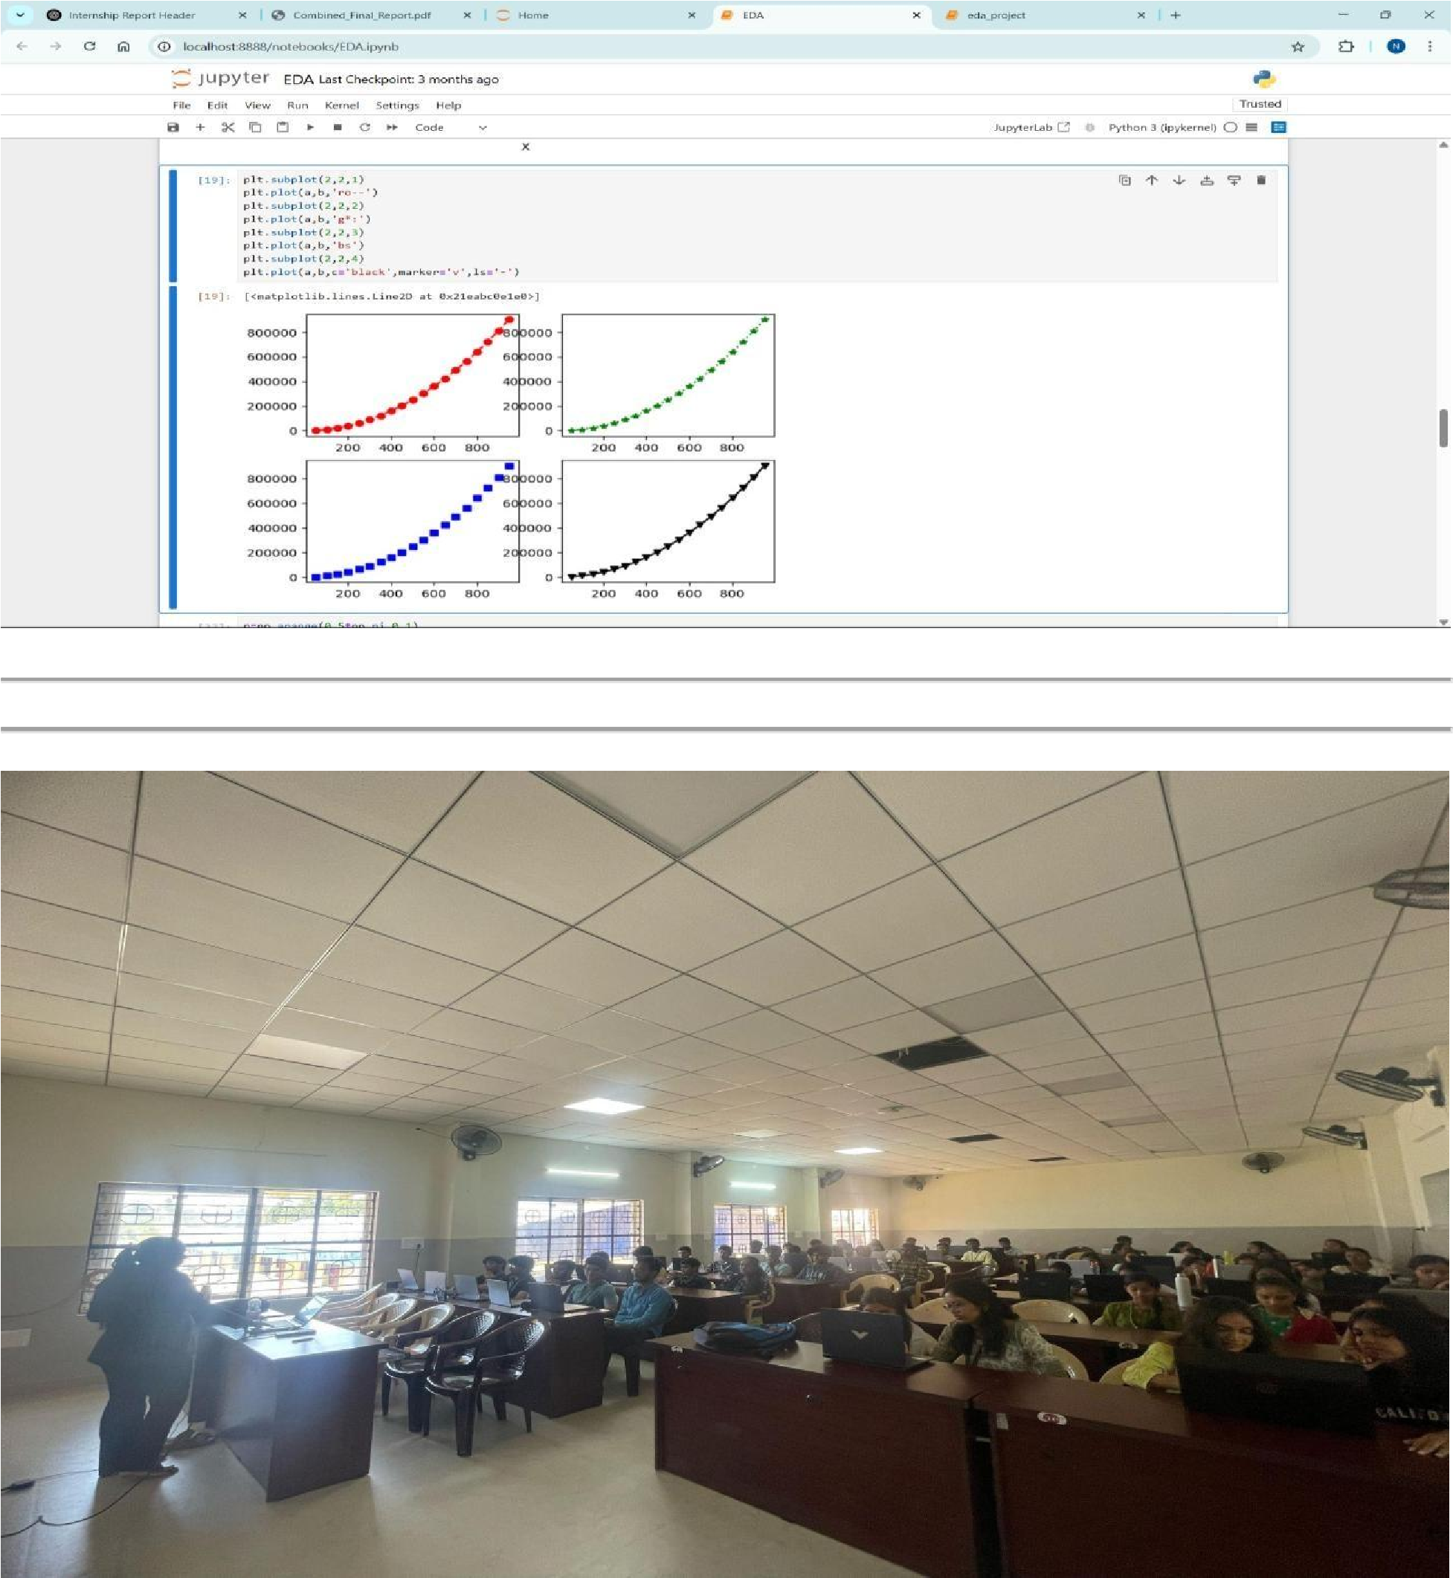
Tools & Technologies Used
Linux (Ubuntu)
- Python 3.x
- MySQL
- OpenCV
- Pandas, NumPy, Matplotlib, Seaborn
- Selenium, BeautifulSoup
- Power BI
- Shell Scripting

functionality strictly using external files for both questions and answers, without
Mini Project – Python Quiz Application
As part of the mid-program activity, a Python-based quiz application was developed with the objective of applying concepts such as file handling, control structures, and user interaction in a real-world scenario. The specific requirement of the task was to implement the entire embedding any data directly within the script. Project Overview
The quiz application was designed as a command-line tool that tested the user’s knowledge in General Knowledge (G.K.) through a series of randomly selected questions. Two text files were used as input sources:
- questions.txt – containing a list of multiple-choice G.K. questions.
- answers.txt – storing the correct answers corresponding to each question, line by line.
Using Python’s random.sample() function, a set of 10 unique questions were selected for each session. The user was prompted to input answers (in text or numeral format), which were compared against the correct ones from the answers file.
The program provided instant feedback after each question and calculated the final score. Based on the score, a motivational message was displayed, encouraging further learning and exploration.
Key Features and Concepts Applied
- File Handling: Used open() and readlines() methods to read data from text files, ensuring data is externalized and easily editable.
- Randomization: Selected non-repetitive random questions from a list using random.sample() to maintain variety in each run.
Control Structures: Managed flow using for loops and if-else conditions to evaluate user responses and score.
- User Interaction: Delivered real-time feedback after each answer and a summary at the end.
- Data Processing: Applied .strip() and .lower() functions for clean, case-insensitive comparison between user input and correct answers. Learning Outcomes
- Strengthened practical understanding of file operations and modular program design.
- Improved ability to design user-interactive command-line applications.
- Reinforced Python fundamentals through integration of logic, loops, and string operations.
- Learned to work within constraints — using only file input — which simulated real project limitations in professional scenarios.
This project was not only technically enriching but also provided a sense of engagement and creativity through content personalization (G.K. based quiz) and interactive logic building.

THE QUIZ PROJECT:

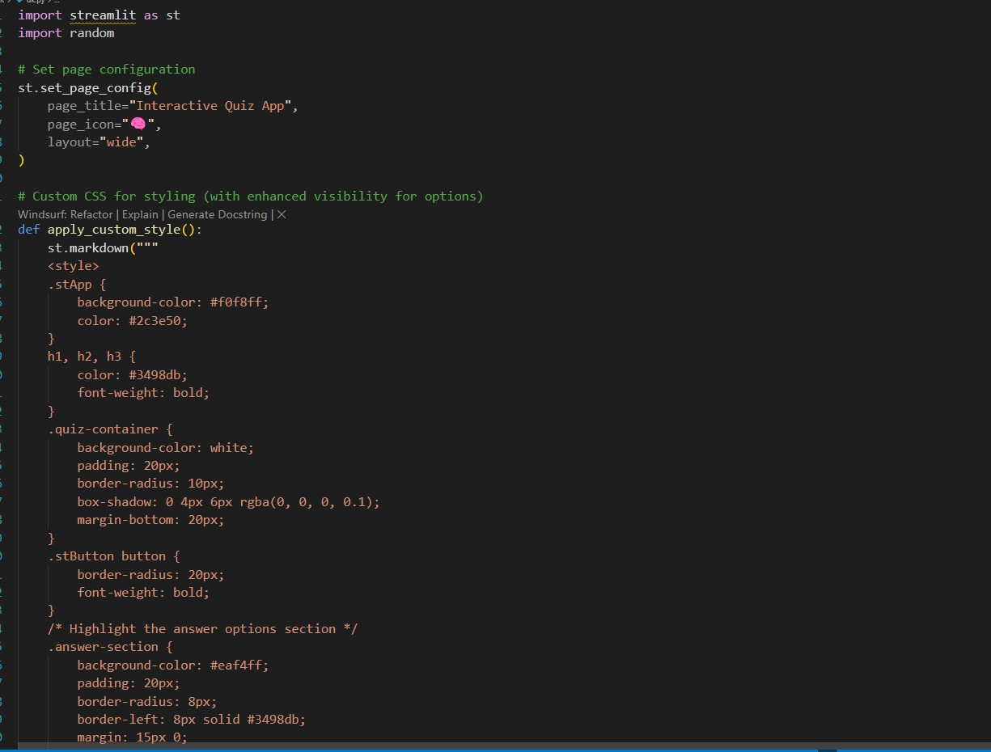

THE OUTCOME OF QUIZ PROJECT WHEN EXECUTED:

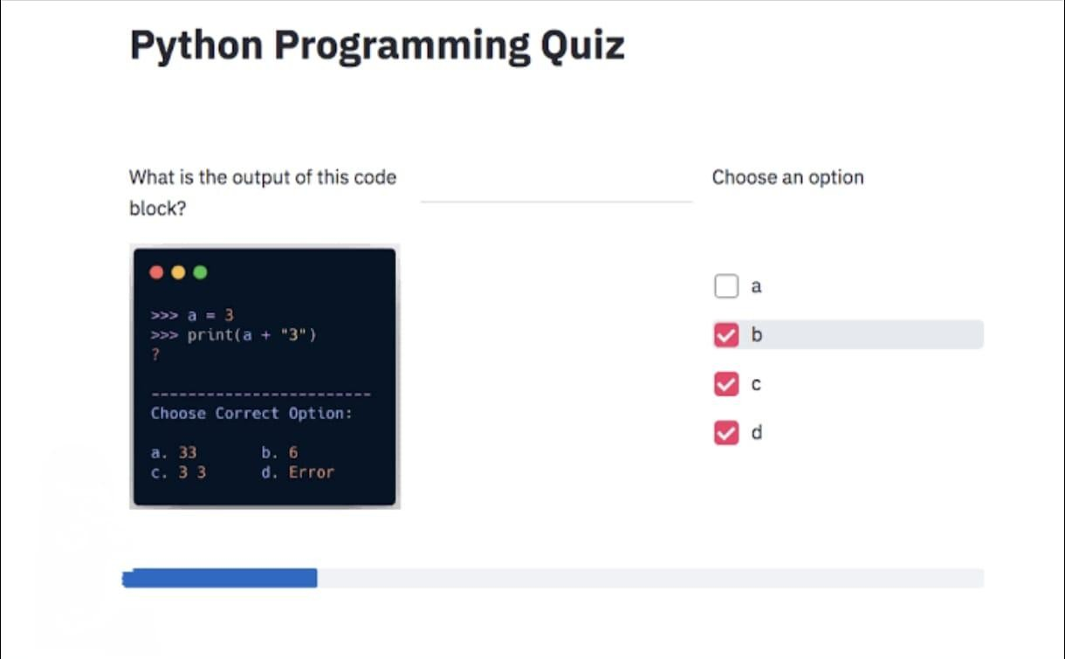

MID TERM PROJECT; 📘 Project Report: Times Jobs Web Scraper using Python

Objective of the Project:

The objective of this project was to automate and simplify the job search process by building a web scraper for the TimesJobs platform using Python. The scraper helps filter out job listings that require skills the user is unfamiliar with, presenting only the most relevant and recently posted job opportunities.
The focus was on real-time updates, intelligent filtering, and clear job presentation through terminal output.

Website & Scope:
- The scraper targets the Python job listings section of TimesJobs.com and extracts:
- Company Name
- Required Skills
- Posting Date
- Job Details Link

The project is designed to run continuously, refreshing results every 10 seconds, and filters jobs based on the user's self-declared unfamiliar skills.

Technologies & Libraries Used:
Python: Core scripting language for web scraping and filtering logic.
Requests: To fetch HTML content from the TimesJobs website.
BeautifulSoup: To parse and navigate HTML elements.

Regular Expressions (re): To extract the number of days from strings like "Posted 2 days ago".
Time: To add delay and automate real-time refresh of job listings.

Code Workflow:

- User Skill Input

The program first prompts the user to input unfamiliar skills (comma-separated).
These are stored in a list and converted to lowercase for consistent comparison.

- Fetching HTML Content

The script sends a GET request to the TimesJobs search results page with predefined keywords like "Python".
A User-Agent header is added to avoid bot detection.

- Parsing Job Listings

The HTML is parsed using BeautifulSoup.
All <li> tags with the job post class (job-bx) are selected.

Each job’s company name, skills, posting time, and details link are extracted.

- Filtering Unwanted Jobs

The script uses the any() function to check if any unfamiliar skill is present in the required skills.
If none are found, the job is added to the result list.

- Sorting & Displaying Results

Jobs are sorted based on how recently they were posted using sorted() with a lambda function.
Each job is displayed in the terminal with formatting that includes:
Company Name
Required Skills
Posting Age in Days
Link to Apply

- Real-Time Automation

The program runs in a continuous loop, refreshing the job list every 10 seconds using time.sleep(10).

Sample Output:

🧑‍💼 Company Name : XYZ Solutions
🛠 Required Skills : python, flask, sql
📅 Posted : 2 day(s) ago
🔗 More Info : https://www.timesjobs.com/job-detail/xyz-details

Key Features:

Smart filtering based on user-defined skill gaps
Real-time job updates every 10 seconds
Human-readable and sorted job listings
Lightweight, command-line-based, no need for UI

Challenges Faced:

Dealing with inconsistent formatting in HTML from job postings
Avoiding being blocked by the website (resolved using User-Agent header)
Matching partial or spaced skill names accurately (solved via string processing)

Insights & Interpretation:

Most job listings are cluttered with irrelevant skills for a beginner; this project simplifies that.
Filtering based on negative skill criteria (what you don’t know) gives users more control.
Web scraping can be extremely useful for job seekers when personalized effectively.

Learning Outcomes:

Gained hands-on experience in web scraping and automation.
Learned to clean, process, and filter HTML content using BeautifulSoup.
Improved understanding of condition checking (any(), string matching, regex).

Built a real-time Python application with loop-based data refreshing.

Scope for Future Improvement:
Adding a GUI using Tkinter or Streamlit.
Exporting filtered jobs to a CSV or Excel file.
Email or Telegram bot integration for job alerts.
Option to filter by location, company, or job title using user input.

CODE

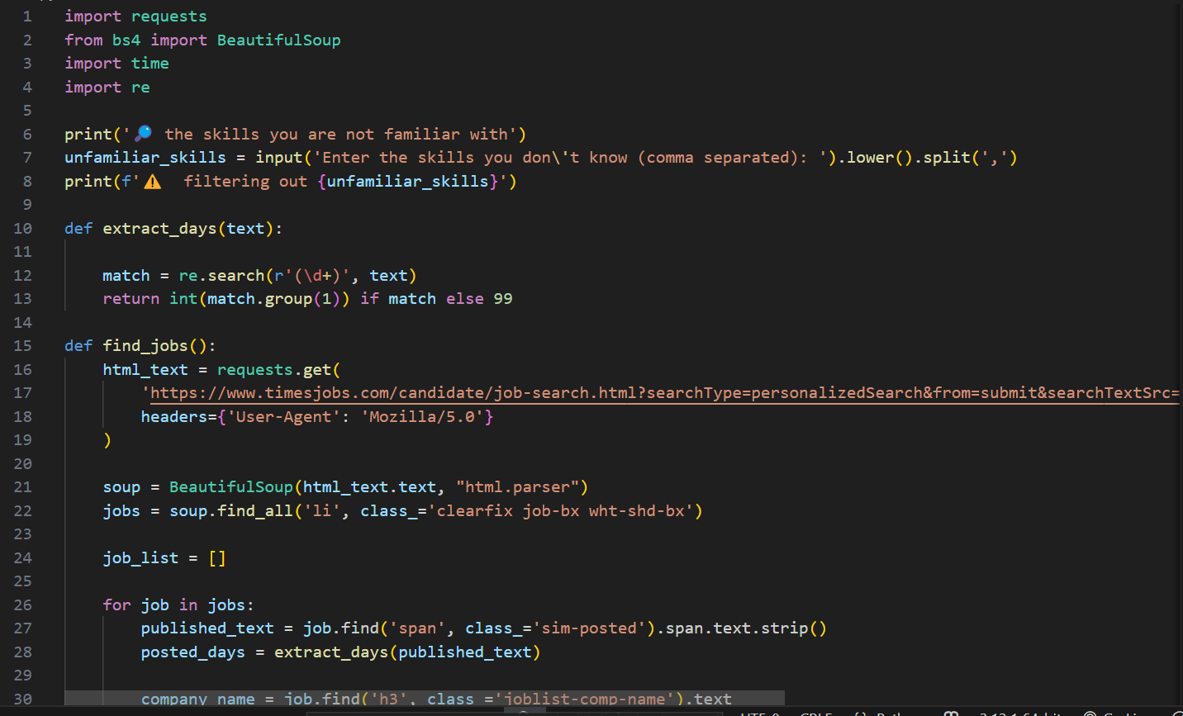

OUTPUT

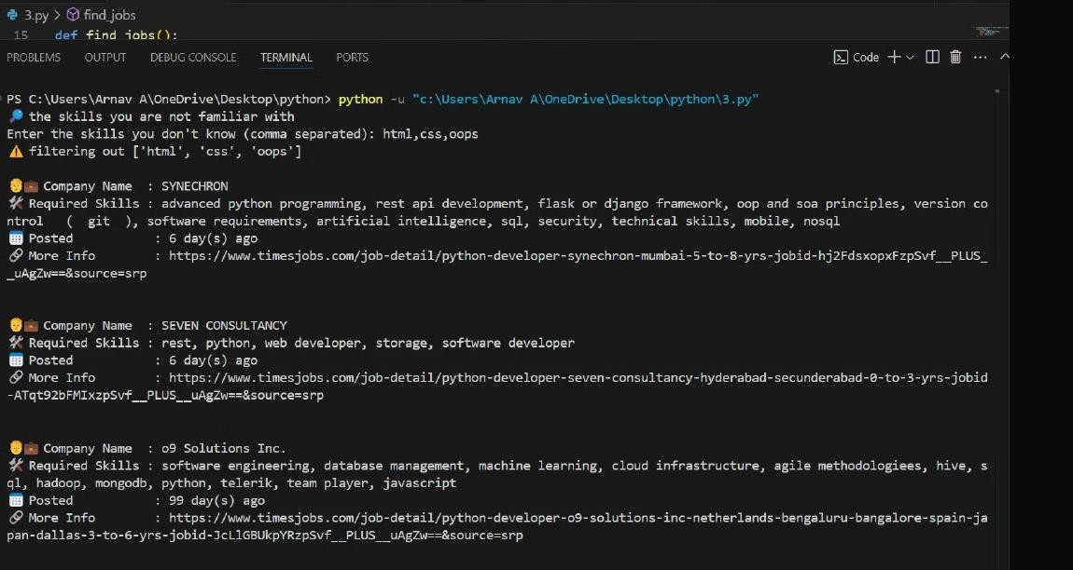

Conclusion and Reflections: Six Days of Skill Development
The Six-Day Skill Development Program was a transformative learning experience that provided participants with a well-rounded understanding of Linux systems, Python programming, Data Analysis, Database Management, and System Integration. This initiative not only imparted technical skills but also instilled confidence and curiosity to explore realworld technological challenges.
Throughout the program, students transitioned from understanding operating system fundamentals to building interactive Python applications, analyzing data, managing databases, and automating tasks using Linux tools. With each passing day, participants bridged the gap between theoretical knowledge and practical application.
The program emphasized the role of Industry 4.0, where technologies like AI, Automation, and Data Management are revolutionizing industries. Participants learned how foundational skills like Linux navigation, Python scripting, and Database operations contribute to building these advanced systems.
Key Highlights:
- Hands-on practice with Ubuntu and Linux system management.
- Developed functional Python programs and real-world mini-projects.
- Explored Data Structures, Object-Oriented Programming, and Modular Coding.
- Gained practical experience with MySQL databases and system automation.
- Understood the architecture of full-stack application development.
Beyond technical skills, the program fostered critical thinking, teamwork, and problem-solving—qualities essential for success in today's competitive tech landscape. Participants were encouraged to experiment, make mistakes, and learn through practical engagement.
A Glimpse into the Future:
As industries evolve with AI, IoT, and Cloud technologies, students with strong Linux, Python, and Database skills will be at the forefront of innovation. This program has laid the groundwork for participants to pursue internships, advanced projects, certifications, and careers in these emerging fields.

