#--1--

select concat(last_name," works in ",department_id," with the ",job_id) from employees;

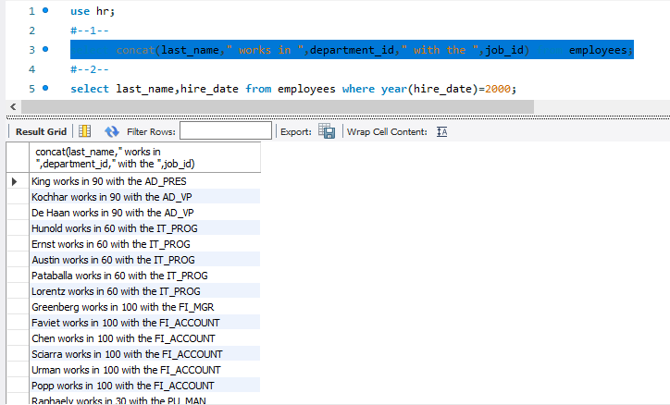

#--2--

select last_name,hire_date from employees where year(hire_date)=2000;

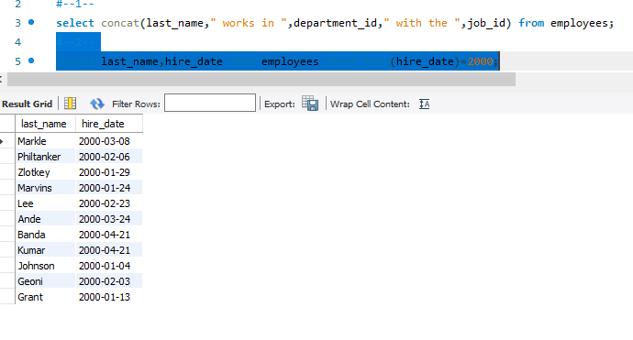

#--3--

SELECT last_name, date_format(hire_date, '%d-%m-%Y ') as date from employees where date_format(hire_date, '%Y-%d')>1996-01;

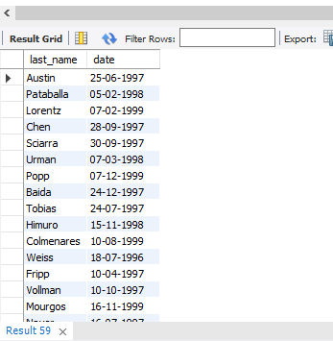

#--4--

select first_name from employees where first_name like 's%' or first_name like 'r%';



#5--;

select employee_id,last_name,manager_id from employees where manager_id in (200,201);

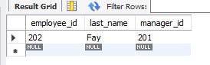

#--6--

select employee_id,last_name,job_id,salary from employees where salary>6000 and ( job_id like '%REP%' or job_id like '%MAN%');

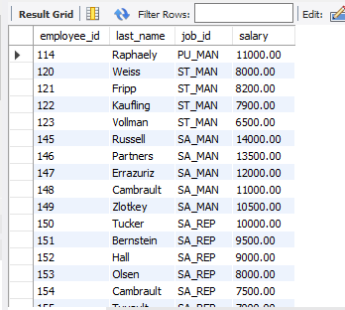

#--7--

select employee_id,last_name,(salary*12) annualsal from employees order by annualsal desc;

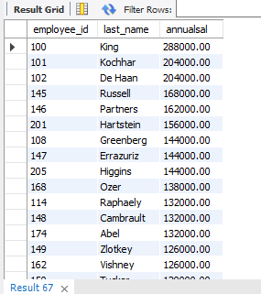

#--8--

select replace(last_name,'Landry' ,'jeo') repaced from employees where last_name='Landry';



#--9—

select last_name ,instr(last_name,'o') from employees;

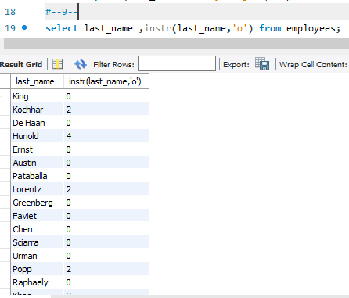

#--10--

select concat("2021_BC84 ",last_name) prifixed,department_id from employees where department_id=90;

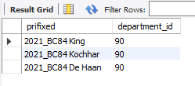

#--11--

SELECT CURRENT_TIMESTAMP;



--12--

select avg(commission_pct) avg_commission from employees;

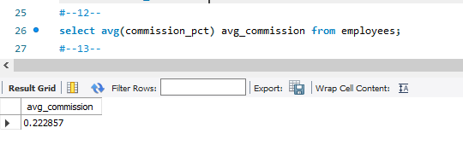

--13—

select avg(salary), max(salary) ,department_id from employees group by department_id having department_id in (80,90,100);

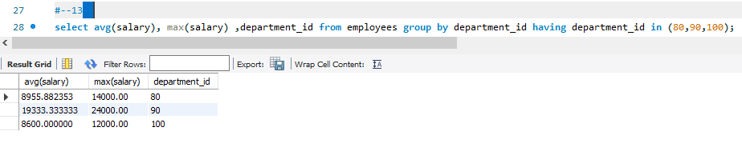

#--14--

select salary,department_id from employees group by department_id having (max(salary)>1000);

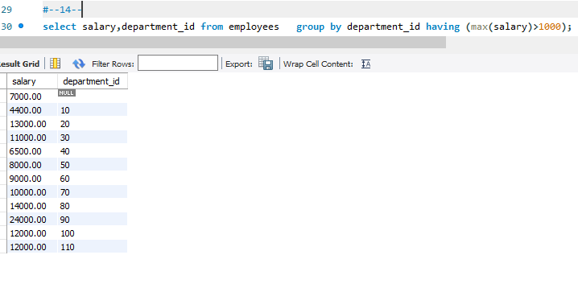

#--15--

select max(avgsal),department_id from (select (avg(salary)) avgsal,department_id from employees group by department_id) as avgdep ;

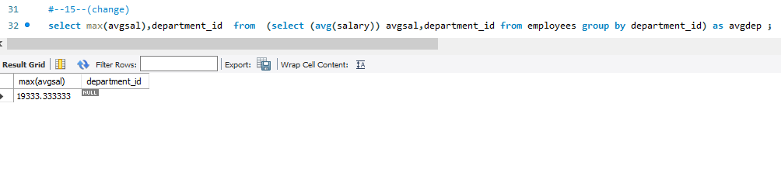

#--16--

select department_name,location_id from departments where department_id=(select department_id from employees where last_name="Ernst");

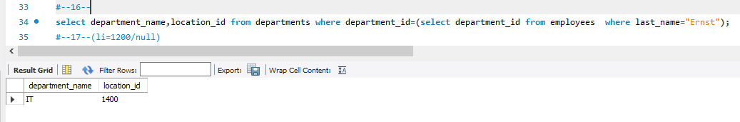

#--17--(locationid with =1200 is is not working any of the department) so output isnull

select first_name,last_name from employees where department_id=( select department_id from departments where location_id=( select location_id from locations where city="Tokyo")) ;

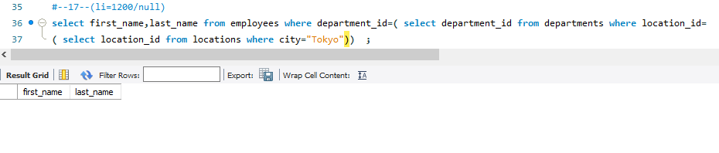

#--18--

select last_name,job_id from employees where job_id=( select job_id from jobs where max_salary=(select max(max_salary) from jobs)) ;

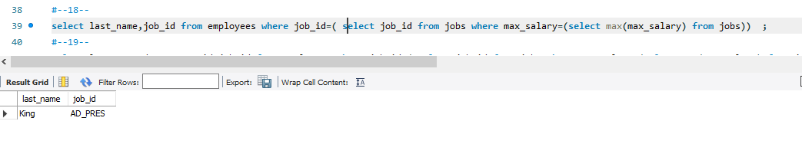

#--19--

select last_name,department_id,job_id,job_title,min(min_salary) from

(select e.last_name, e.department_id,e.job_id,j.job_title,j.min_salary from employees e inner join jobs j on e.job_id=j.job_id)as joined

group by department_id;

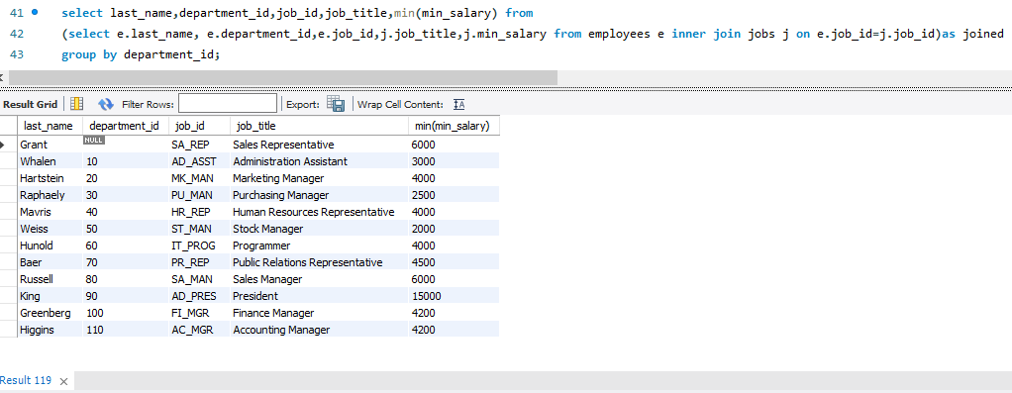

#--20--

select e.last_name, e.department_id,e.job_id,j.job_title from employees e inner join jobs j on e.job_id=j.job_id;

