

***LOGIC GATES***

A logic gate is an elementary building block of a digital circuit. Most logic gates have two inputs and one output.

There are some most common used logic gates.

1.NOT Gate.

2. AND Gate.

3. OR Gate.

4. NAND Gate.

5. NOR Gate.

6. XOR Gate.

7. XNOR Gate.

NOT GATE:

Definition:

A NOT gate (also often called Inverter) is a logic gate. Each NOT gate has only one input signal. Logically with NOT gates, the input and the output swap, so if you input 1 it outputs as 0; likewise if you input 0 it outputs as 1.

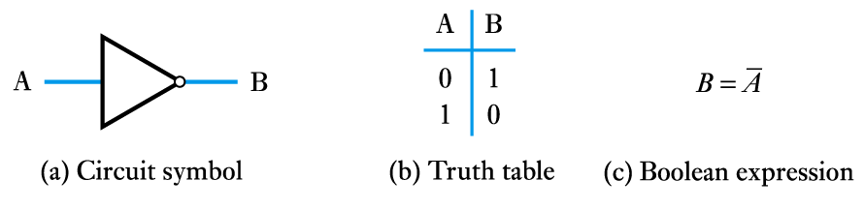

AND GATE:

DEFINITION:

An And gate as two inputs, and the working is it multiplies the inputs.

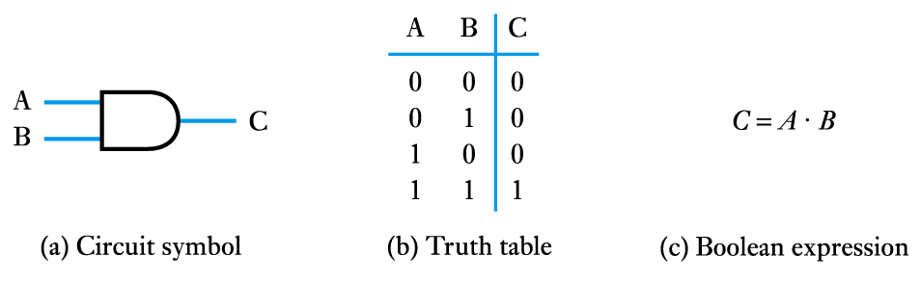

OR GATE:  
DEFINITION:

Or gate is also known as ADDER, Adds the iven inputs.

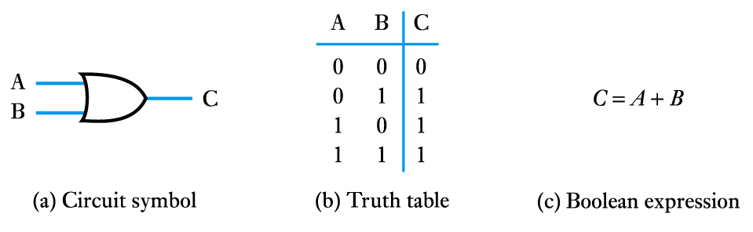

NAND GATE:

DEFINITIONS:

It multiplies the given inputs and then invert it.

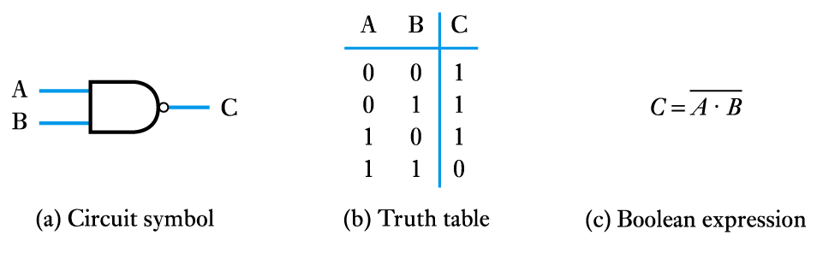

NOR GATE:

DEFINITION:

It adds the given inputs and then invert it.

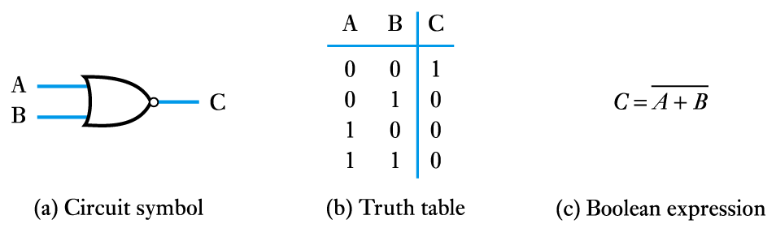

XOR GATE:  
DEFINITIONS:

It is built by combining standard logic gates such as the common NAND and NOR gates in order to produce the more complex function of this gate.

Same logic level = Low

Different logic level = high

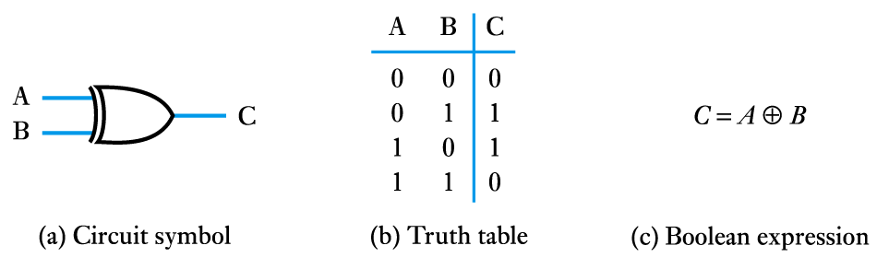

XNOR GATE:

DEFINITION:

The XNOR gate is a digital logic gate whose function is the logical complement of the exclusive OR (XOR) gate.

Same logic level = high

Different logic level = Low

