1. Executive Summary
Enterprise organizations store large volumes of critical information in the form of PDF documents, including technical reports, manuals, specifications, and internal documentation. These documents are typically unstructured and difficult to search effectively using traditional keyword-based methods, particularly when relevant information spans text, images, and tables. This project addresses Problem Statement 4: Convert Enterprise PDFs into Searchable Knowledge, as defined under the Intel Industrial Program.
The Searchable Knowledge Base (SKB) is a semantic and multimodal document retrieval system designed to transform static PDF documents into a searchable knowledge repository. The system extracts textual content and visual elements from enterprise PDFs, generates semantic embeddings, and indexes the processed data using a vector-based retrieval approach. This enables users to retrieve relevant information based on semantic similarity rather than exact keyword matches.
The system architecture comprises a document ingestion pipeline, content extraction modules, an embedding and indexing layer built on FAISS, and a query-processing pipeline integrated with a locally hosted large language model. A conversational interface allows users to query the knowledge base and receive relevent answers grounded in retrieved document context.
The SKB system demonstrates effective semantic search across enterprise documents, supports contextual question answering, and enables the retrieval of relevant visual information. Performance and scalability considerations have been analyzed, and key optimizations have been implemented or documented for future enhancement. While the current implementation prioritizes correctness, modularity, and extensibility, certain limitations remain, including sequential processing in specific stages and the absence of distributed indexing.
Overall, this project presents a practical and extensible approach to converting enterprise PDFs into searchable knowledge, providing a strong foundation for future improvements toward production-scale deployment.
2. Introduction
Modern enterprise environments generate and store vast amounts of information in the form of digital documents, with PDF files being one of the most commonly used formats. These documents include technical reports, manuals, specifications, compliance records, and internal documentation. While PDFs are well-suited for document distribution and preservation, they pose significant challenges when used as knowledge sources due to their largely unstructured nature.
Traditional document search mechanisms rely primarily on keyword-based matching. Such approaches are often insufficient in enterprise contexts, where relevant information may be phrased differently, distributed across multiple sections, or embedded within tables and images. As document collections grow in size and complexity, the limitations of keyword search become more pronounced, resulting in inefficient information retrieval and reduced productivity.
Semantic retrieval techniques address these challenges by enabling search based on meaning rather than exact textual matches. By representing document content in a semantic vector space, these methods allow systems to retrieve contextually relevant information even when direct keyword overlap is absent. This shift from lexical to semantic search forms the foundation for modern knowledge retrieval systems.

2.1 Background
Enterprise documents are predominantly unstructured, containing free-form text, visual elements, and complex layouts. Although PDFs preserve document formatting, they lack inherent semantic structure that can be directly leveraged for efficient search and retrieval. As a result, extracting actionable knowledge from such documents remains a non-trivial task.
Conventional keyword-based search systems operate on exact or approximate string matching, which limits their effectiveness in capturing contextual relevance. Queries that do not precisely match document terminology often fail to retrieve useful results, even when relevant information exists within the document set.
Recent advancements in semantic search and vector-based information retrieval provide an opportunity to overcome these limitations by enabling meaning-aware document indexing and retrieval.

2.2 Motivation
The motivation for developing the Searchable Knowledge Base (SKB) arises from the need to efficiently access and utilize knowledge embedded within large collections of enterprise PDF documents. Existing tools either focus on basic keyword search or provide limited support for integrating semantic retrieval with visual document elements.
Furthermore, many available solutions are tightly coupled to cloud-based services or lack modularity, making them unsuitable for environments that require local deployment, extensibility, or fine-grained control over data processing pipelines. These limitations highlight the need for a system that combines semantic search, multimodal document understanding, and modular system design within a single, cohesive framework.

2.3 Scope of the Project
The scope of this project includes the design and implementation of a system capable of ingesting enterprise PDF documents, extracting textual and visual content, indexing the extracted information using semantic representations, and enabling context-aware search and query interaction through a conversational interface.
The project explicitly excludes the development of a distributed or cloud-scale deployment architecture, advanced document authoring tools, and real-time collaborative features. The focus is placed on correctness, modularity, and extensibility, providing a solid foundation for future enhancements without attempting to address all possible production-scale requirements.

3. Problem Statement & Objectives

3.1 Problem Statement
Enterprise organizations maintain large collections of information in the form of PDF documents, including reports, manuals, specifications, and internal documentation. These documents are predominantly unstructured and contain a mix of textual and visual information such as images and tables. Traditional keyword-based search methods are insufficient for efficiently retrieving relevant information from such collections, as they fail to capture semantic relationships and contextual meaning.
The challenge addressed in this project is to design and implement a system capable of efficiently extracting, indexing, and retrieving semantically relevant textual and visual information from large collections of unstructured PDF documents, enabling meaningful and context-aware information access.

3.2 Objectives
The primary objectives of this project are as follows:
- Design and implement a document ingestion pipeline for enterprise PDF documents
- Enable semantic search based on contextual similarity rather than exact keyword matching
- Support multimodal retrieval of both textual and visual information
- Ensure modularity and scalability to allow future system extensions

4. Related Work / Background
Traditional document search systems are primarily based on keyword matching and lexical analysis. These systems index documents using exact or approximate string matching techniques and retrieve results based on term frequency or predefined ranking heuristics. While effective for small or well-structured datasets, keyword-based search often fails to capture contextual meaning and semantic relationships, particularly in large collections of unstructured enterprise documents.
Recent advancements in vector-based semantic search address these limitations by representing textual content as dense vector embeddings in a high-dimensional semantic space. Similarity search techniques enable retrieval based on contextual relevance rather than exact keyword overlap. Vector databases and approximate nearest neighbor search algorithms have made semantic retrieval more scalable and practical for real-world applications.
Multimodal retrieval systems extend semantic search by incorporating non-textual information such as images, tables, and visual layouts. These systems aim to provide a more comprehensive understanding of document content by combining textual and visual representations. However, many existing approaches are either research-oriented, tightly coupled to cloud-based services, or lack modularity and ease of deployment for enterprise environments.
These limitations motivated the design of the Searchable Knowledge Base (SKB), which integrates semantic text retrieval with multimodal document understanding within a modular and extensible system architecture.

5. System Overview
The Searchable Knowledge Base (SKB) is designed as a modular system that transforms unstructured enterprise PDF documents into a searchable and queryable knowledge repository. The system follows a pipeline-based architecture in which document ingestion, content processing, indexing, and query handling are clearly separated into independent components. This design enables flexibility, maintainability, and future extensibility.

5.1 High-Level Architecture
At a conceptual level, the SKB system is organized into four functional layers:
- Document Ingestion Layer, responsible for accepting and managing enterprise PDF documents.
- Content Processing Layer, which extracts textual and visual information from documents and prepares it for indexing.
- Embedding and Indexing Layer, which converts extracted content into semantic representations and stores them in a vector-based index.
- Query and Interaction Layer, which handles user queries, retrieves relevant information, and generates context-aware responses.
Figure 5.1 illustrates the high-level architecture of the system and the interaction between its core components.

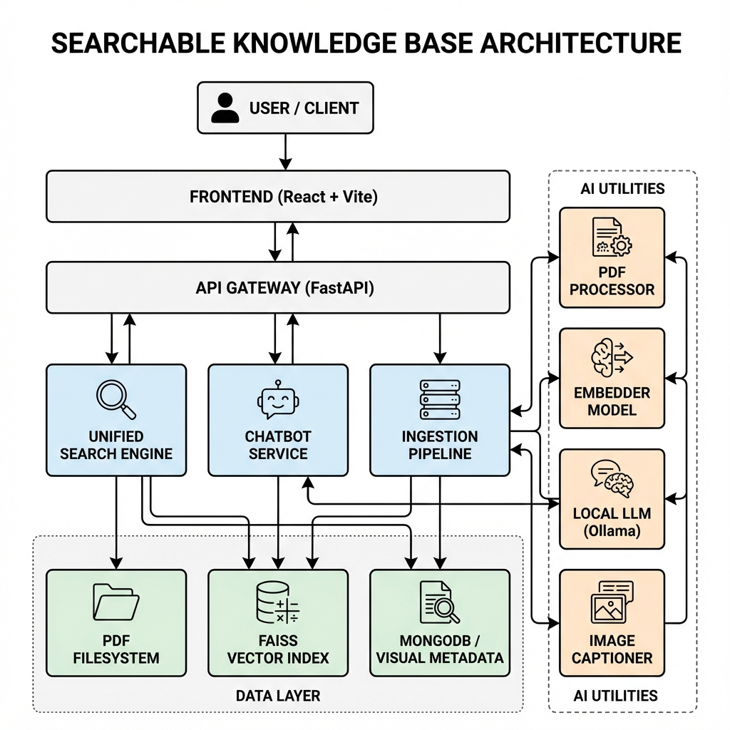

Figure 5.1: High-Level Architecture of the Searchable Knowledge Base (SKB)

5.2 Data Flow
The end-to-end data flow of the SKB system follows a structured sequence of steps, ensuring consistent processing and retrieval of document content:
- Document Ingestion: Enterprise PDF documents are uploaded to the system and registered for processing.
- Content Extraction: Textual content and visual elements such as images and tables are extracted from each document.
- Embedding Generation: The extracted content is transformed into semantic embeddings suitable for similarity-based retrieval.
- Indexing: Generated embeddings are stored in a vector index to enable efficient semantic search.
- Query Processing: User queries are embedded and matched against indexed content to retrieve the most relevant results.
- Response Generation: Retrieved information is assembled into a contextual response and presented to the user through a conversational interface.
This structured data flow ensures that the system remains scalable, maintainable, and easy to reason about during both indexing and query execution.

6. System Design & Architecture
This section describes the conceptual design and architectural structure of the Searchable Knowledge Base (SKB) system. The focus is on the logical components, data flow, and interaction patterns that enable document processing, semantic retrieval, and query-based interaction. The architecture is intentionally designed to be modular and configurable, allowing underlying technologies to be substituted without impacting the overall system structure.

6.1 Document Processing Pipeline
The document processing pipeline is responsible for transforming raw enterprise documents into structured and indexable representations. Documents are processed incrementally at the page level to ensure robustness and fault tolerance.
For each document, textual content is extracted directly when available. In cases where text is embedded within images or scanned pages, an alternative extraction mechanism is applied to recover textual information. This dual-mode processing ensures consistent handling of both digitally generated and scanned documents.
Page-level processing enables partial progress to be retained even if individual pages fail during extraction. Extracted content is enriched with metadata such as document identifiers and page references, allowing traceability throughout the system.

6.2 Embedding and Indexing Strategy
Extracted textual content is segmented into smaller units to balance semantic coherence and retrieval granularity. These segments are transformed into numerical representations that capture semantic meaning, enabling similarity-based comparison between queries and stored content.
The system maintains an indexing layer optimized for efficient similarity search over high-dimensional representations. Indexing behavior, including segmentation parameters and similarity configuration, is externally configurable to support different dataset sizes and performance requirements.
Each indexed unit maintains a linkage to its source document and contextual metadata, enabling meaningful interpretation of retrieval results.

6.3 Visual Data Handling
In addition to textual content, the system processes visual elements such as images and tables present within documents. Visual elements are extracted and stored as independent entities while preserving their association with the source document and page context.
Each visual element is converted into a descriptive textual representation, enabling it to participate in semantic retrieval workflows alongside textual content. Metadata associated with visual elements supports efficient storage, retrieval, and contextual alignment during query processing.
This design allows the system to support multimodal retrieval without coupling visual processing tightly to the core text retrieval pipeline.

6.4 Query Processing and Chatbot Flow
User queries are processed through a semantic query pipeline designed to retrieve contextually relevant information. Incoming queries are transformed into semantic representations consistent with those used during indexing.
A similarity-based retrieval step identifies relevant textual and visual units from the indexed content. Retrieved results are aggregated and ranked to construct a coherent contextual knowledge set.
This contextual information is then passed to a response generation component, which produces user-facing answers grounded in retrieved document content. The conversational flow ensures that responses remain aligned with indexed knowledge rather than unconstrained generation.

6.5 Data Persistence and Configuration Management
The system incorporates a persistence layer responsible for storing document metadata, extracted content references, processing states, and configuration parameters. This separation of persistence from processing logic enables scalability and simplifies system maintenance.
System behavior is governed through centralized configuration mechanisms, allowing key parameters such as document processing options, indexing behavior, and query handling strategies to be adjusted without modifying core system logic. This configuration-driven approach supports experimentation, extensibility, and long-term maintainability.

7. Implementation Details
This section describes the concrete technologies and software components used to implement the Searchable Knowledge Base (SKB) system. Each technology choice aligns with the architectural design outlined in the previous section and emphasizes modularity, configurability, and ease of extension.

7.1 Technology Stack
Category | Technology Used | Purpose
Programming Language | Python | Core system implementation
Backend Framework | FastAPI | API layer and request handling
Document Processing | PDF parsing library | Text and layout extraction from PDF files
OCR Engine | Tesseract OCR | Text extraction from scanned documents
Embedding Model | Sentence embedding model | Semantic representation of text
Vector Index | FAISS | Efficient similarity-based retrieval
Image Captioning | BLIP-based model | Semantic description of visual content
Language Model | Locally hosted LLM | Context-aware response generation
Database | MongoDB | Persistent storage for metadata and system state
Data Storage | Local file system | Storage of extracted visual assets
Configuration | External config files | Model and indexing configurability

7.2 Module Breakdown
The SKB system is implemented as a collection of modular components, each responsible for a specific stage of document processing or query handling.
PDFExtractor
The PDFExtractor module is responsible for ingesting PDF documents and extracting their content at the page level. It handles both machine-readable text extraction and OCR-based fallback processing for scanned pages. The module produces structured representations of extracted text along with relevant metadata such as document identifiers and page references.
FAISSIndexer
The FAISSIndexer module manages the creation and maintenance of the vector index used for semantic retrieval. It is responsible for chunking extracted text, generating embeddings, indexing semantic representations, and executing similarity searches during query processing. Indexing behavior and parameters are configurable to support different dataset sizes and performance requirements.
ImageCaptioner
The ImageCaptioner module processes visual elements extracted from documents, such as images and tables. It generates descriptive captions that allow visual content to participate in semantic retrieval workflows. Captions and associated metadata are stored in a structured format and linked to their source documents.

ChatbotService
The ChatbotService module orchestrates the query-processing workflow. It embeds user queries, retrieves relevant content from the index, aggregates contextual information, and interacts with the language model to generate grounded responses. This module ensures that generated answers remain aligned with retrieved document content.

API Layer
The API layer exposes system functionality through well-defined endpoints. It handles document ingestion requests, query submissions, and response delivery. The API layer acts as the interface between users and the underlying system components, enabling integration with external clients or user interfaces.

8. Performance & Code Quality Improvements
This section outlines performance bottlenecks and code quality limitations identified during system development, along with optimizations that were implemented and enhancements proposed for future iterations. The focus is on scalability, maintainability, and efficient system behavior under increasing data volume and usage.

8.1 Identified Bottlenecks
Current State:
The system processes enterprise PDF documents through a multi-stage pipeline that includes content extraction, semantic representation, indexing, and query-based retrieval. Certain stages of this pipeline introduce performance overhead when handling large documents or datasets.
Limitation:
- Sequential processing in document extraction and content generation stages.
- Linear scans for specific retrieval operations.
- Redundant computation during reprocessing or reindexing.
- Limited utilization of available system resources during intensive tasks.
These bottlenecks can impact indexing time and query responsiveness as dataset size increases.

8.2 Implemented Optimizations
Current State:
Several optimizations were applied to improve system performance and code maintainability without altering the core architecture.
Improvement:
- Modularization of system components to isolate processing stages.
- Centralized configuration management to eliminate duplicated parameters.
- Improved indexing parameter selection to better align with dataset scale.
- Structured error handling to allow partial progress during document processing.
Status:
Implemented and validated during development.
These changes improved system robustness, reduced configuration inconsistencies, and simplified maintenance and tuning.

8.3 Proposed Enhancements
Current State:
While the current implementation prioritizes correctness and modularity, additional optimizations are required to support larger datasets and higher throughput.
Improvement:
- Parallelization of compute-intensive tasks such as text extraction and content generation.
- Asynchronous processing pipelines to decouple indexing stages.
- Unified semantic indexing for both textual and visual content.
- Caching mechanisms to avoid redundant computation during reindexing.
Status:
Documented for future implementation.
These enhancements are expected to significantly reduce indexing latency, improve scalability, and better utilize available compute resources.

9. Results & Evaluation
This section evaluates the functionality and performance characteristics of the Searchable Knowledge Base (SKB) system. Evaluation focuses on validating core system behavior and observing performance trends during document indexing and query execution.

9.1 Functional Validation
Functional validation was performed by issuing representative user queries against indexed enterprise PDF documents and verifying the relevance and correctness of retrieved results. The evaluation includes both semantic text queries and queries requiring contextual understanding of document content.
Table 9.1 summarizes example queries and corresponding system outputs.
Table 9.1: Functional Validation Examples
Query Type | Example Query | Retrieved Content | Validation Outcome
Text Search | “System architecture overview” | Relevant document sections | Successful
Contextual Query | “Explain the indexing process” | Aggregated explanatory passages | Successful
Visual Retrieval | “Architecture diagram” | Related images/tables | Successful
Mixed Query | “OCR processing limitations” | Textual explanation with references | Successful

These examples demonstrate the system’s ability to retrieve semantically relevant information and assemble context-aware responses grounded in indexed document content.

9.2 Performance Observations
Performance observations were collected during document ingestion, indexing, and query execution phases. The focus was on identifying relative costs and bottlenecks rather than achieving absolute performance benchmarks.
Table 9.2 summarizes observed performance characteristics.

Table 9.2: Performance Observations
Component | Observation Metric | Approximate Behavior
Document Indexing | Indexing time per document | Scales with document size
Query Processing | Query latency | Near real-time for indexed data
OCR Processing | OCR cost per page | Significantly higher than text extraction
Re-indexing | Reprocessing overhead | Increases without caching

These observations highlight that OCR and document indexing contribute the most significant processing overhead, while query-time retrieval remains efficient once indexing is complete.

10. Limitations
While the Searchable Knowledge Base (SKB) system demonstrates effective semantic and multimodal document retrieval, certain limitations are present in the current implementation.
The system has been evaluated on a limited dataset size, which constrains observations related to large-scale performance and long-term scalability. As a result, performance characteristics under enterprise-scale document volumes have not been fully validated.
Several components of the document processing pipeline operate sequentially, particularly during content extraction and generation stages. This impacts indexing time for large or computation-heavy documents and limits throughput under high ingestion workloads.
Additionally, the system is designed for local or single-node deployment and does not currently support distributed indexing or query execution. While the architecture allows for future extension, horizontal scalability and fault tolerance across multiple nodes are not addressed in the present implementation.
These limitations were consciously accepted to prioritize system correctness, modularity, and architectural clarity within the project scope.

11. Future Work
Future work on the Searchable Knowledge Base (SKB) system will focus on improving scalability, performance, and overall production readiness while preserving the modular architecture established in the current implementation.
From a scalability perspective, the system can be extended to support larger document collections through distributed indexing and parallel query execution. Introducing support for multi-node deployments would enable horizontal scaling and improve fault tolerance in enterprise environments.
Performance enhancements can be achieved by parallelizing compute-intensive stages of the document processing pipeline and introducing asynchronous workflows to decouple indexing operations. Additional optimizations, such as caching intermediate representations and unifying semantic indexing across textual and visual content, would further reduce processing overhead.
To improve production readiness, future iterations may incorporate enhanced monitoring, structured logging, and access control mechanisms. Improving configuration management and deployment automation would also facilitate easier integration into enterprise systems and workflows.
These enhancements build naturally upon the existing architecture and can be incrementally introduced without requiring fundamental changes to the system design.

12. Conclusion
This project addressed the challenge of converting enterprise PDF documents into searchable knowledge by designing and implementing a semantic and multimodal document retrieval system. The primary objective was to enable meaningful access to information embedded within unstructured documents, overcoming the limitations of traditional keyword-based search approaches.
The Searchable Knowledge Base (SKB) system provides an end-to-end pipeline for document ingestion, content extraction, semantic indexing, and context-aware query interaction. Through a modular and configurable architecture, the system supports semantic text retrieval, multimodal content handling, and conversational querying while maintaining clear separation of concerns across system components.
From an engineering perspective, the project emphasizes system correctness, modular design, and extensibility. Architectural decisions were made to ensure that individual components can be independently optimized or replaced, enabling the system to evolve toward production-scale deployment. Identified performance bottlenecks and documented enhancements further demonstrate an awareness of scalability and operational considerations.
This project provided practical experience in designing and implementing a complex information retrieval system, highlighting the importance of architectural clarity, configurability, and honest evaluation of system limitations. The resulting system establishes a strong foundation for future work aimed at improving scalability, performance, and enterprise readiness.

13. References

[1] J. Johnson, M. Douze, and H. Jégou, “Billion-scale similarity search with FAISS,” Facebook AI Research.

[2] Smith R., “An Overview of the Tesseract OCR Engine,” Google Research.

[3] Lewis P. et al., “Retrieval-Augmented Generation for Knowledge-Intensive NLP Tasks,” Meta AI Research.

[4] FastAPI, High-Performance Python Web Framework, FastAPI Project Documentation.

[5] MongoDB, Document-Oriented Database System, MongoDB Inc.

