
Post-Default Recovery Optimization: Predicting Collection Outcomes in Unsecured Lending

Milestone 2: Literature Review,
Data Description, and Approach

Student Name: Syed Muzammil Iqbal
ID: 501410187
Supervisor: Ceni Bobaoglu
Submitted: February 22, 2026

Table of Contents
- Abstract 3
- Literature Review 3

The Regulatory Shift: From Default to Recovery 3

Benchmarking Methodologies: Linear vs. Non-Linear Models 4

The Challenge of "Zero-Inflated" Data 4

Implication for this Project: 4

The Gap: Collection Efficiency and Fees 5

Identifying the Gap: 5

Justification of Approach: 5
- Dataset Description 5

Dataset Source and Selection 5

Descriptive Statistics & Target Variable Analysis 6

Data Constraints and Handling 6
- Project Approach 7

Research Methodology Framework 7

Phase 1: Preprocessing and Feature Engineering 7

Phase 2: Predictive Modeling 7

Phase 3: Strategic Segmentation (Clustering) 8

Evaluation Metrics 8
- Visual Representation 9
- GitHub Repository 10
- References 11

Abstract

In the domain of unsecured consumer lending, the "Charged Off" status represents a critical financial loss event. Traditional credit risk modeling focuses primarily on the Probability of Default (PD), often treating the subsequent recovery process as a static outcome. When Loss Given Default (LGD) is modeled, it typically predicts gross recovery, ignoring the significant operational costs associated with third-party collection fees. This project addresses that inefficiency by developing a profit-driven framework to predict Net Recovery (Gross Recoveries minus Collection Fees).
Leveraging a dataset of approximately 268,000 charged-off loans from LendingClub (2007–2018), this study navigates the challenge of "zero-inflated" data—where a significant proportion of defaults result in zero recovery. The methodology employs Random Forest Regressors to capture non-linear borrower behaviors and interactions between loan grade and recovery likelihood. Furthermore, K-Means Clustering is applied to segment borrowers into actionable "Recovery Personas." The anticipated contribution of this research is a strategic decision-support model that enables lenders to distinguish between "High-Yield" recoveries and "Unprofitable" accounts, allowing for optimized resource allocation between in-house collection and debt sales.

Literature Review

The Regulatory Shift: From Default to Recovery
Historically, credit risk management has focused predominantly on the Probability of Default (PD)—predicting the likelihood of a borrower failing to repay. However, the introduction of the Basel II and Basel III regulatory frameworks necessitated a paradigm shift. Financial institutions are now required to model Loss Given Default (LGD)—the percentage of exposure lost if a default occurs—with the same rigor as default probability (Basel Committee on Banking Supervision, 2005).
While PD is a binary classification problem (Default/Non-Default), LGD is a continuous, bounded regression problem (0% to 100% loss). This distinction renders traditional scoring models insufficient. As noted by the Basel Committee, accurate LGD estimation is critical not only for regulatory capital compliance but also for economic capital allocation. This project aligns with this regulatory evolution, focusing specifically on the post-default recovery phase of the credit lifecycle.

Benchmarking Methodologies: Linear vs. Non-Linear Models
A central debate in existing literature concerns the choice of algorithm for LGD modeling. Traditional banking models have relied heavily on Linear Regression and Tobit Models due to their interpretability. However, the complex nature of borrower behavior suggests that linear assumptions may be flawed.
Loterman et al. (2012) conducted a comprehensive benchmark of 24 regression algorithms for LGD prediction. Their study compared industry-standard techniques (Linear Regression, Ridge Regression) against machine learning approaches (Support Vector Machines, Neural Networks). The findings were conclusive: non-linear techniques consistently outperformed linear models. Loterman et al. attributed this to the fact that recovery data is rarely linear; for example, the relationship between a borrower’s Debt-to-Income (DTI) ratio and their recovery amount often exhibits "cliff effects" rather than a smooth decline.
Critical Analysis & Justification:
Based on Loterman’s findings, this project rejects the use of simple Linear Regression as the primary modeling tool. Instead, it adopts the Random Forest Regressor. As supported by Pedregosa et al. (2011) in their documentation of machine learning frameworks, Random Forests offer the ability to capture non-linear interactions (e.g., how high interest rates interact with low income) without the "black box" opacity of Neural Networks, striking a balance between performance and explainability.

The Challenge of "Zero-Inflated" Data
One of the most significant constraints identified in LGD research is the distribution of the data itself. Recovery datasets are typically "zero-inflated" and bimodal.
Bellotti and Crook (2012) analyzed LGD for credit cards and observed a massive concentration of observations at $0 (total loss) and a smaller cluster at 100% (full recovery). Standard regression models, which assume a normal (Bell Curve) distribution, struggle with this structure. They often predict the "mean," resulting in a forecast of partial recovery for everyone, even though most borrowers will pay nothing.

Implication for this Project:
To address this structural missingness, this project draws on the work of Brown and Mues (2012), who examined classification algorithms for imbalanced datasets. Their research supports a segmented approach. Consequently, this project will utilize K-Means Clustering to separate the "Zero-Recovery" population from the "Positive Recovery" population, ensuring that the predictive model is not biased by the overwhelming number of total losses.

The Gap: Collection Efficiency and Fees
While the aforementioned studies focus on maximizing the gross amount recovered, there is a distinct gap in the literature regarding the cost of that recovery.
Mays (1998), in her seminal work on credit scoring for risk managers, distinguishes between "Risk Scoring" (predicting default) and "Collection Scoring" (predicting the outcome of collection efforts). Mays argues that a successful recovery strategy must consider the "Net Present Value" of the collection activity. A strategy that recovers $500 but costs $600 in agency fees is a technical success but an operational failure.

Identifying the Gap:
Most modern LGD research ignores the collection_recovery_fee variable, focusing solely on the revenue side of the equation. This leads to models that recommend aggressive collection actions on accounts that are ultimately unprofitable.

Justification of Approach:
This project fills that gap by engineering a new target variable: Net Recovery (Recoveries - Fees). By integrating the cost-benefit analysis proposed by Mays into a modern machine learning framework (Random Forest), this research moves beyond simple recovery prediction to profitability optimization.

Dataset Description

Dataset Source and Selection
The dataset utilized for this research is the LendingClub Loan Data (2007–2018), publicly available via Kaggle (George, 2019). The original repository contains over 2 million loan records representing the complete loan lifecycle.
To align with the research objective of "Post-Default Recovery Optimization," the data was filtered to include only loans with a loan_status of 'Charged Off'. This filtering process isolates the borrowers who have already defaulted, creating a focused dataset for Loss Given Default (LGD) analysis.
- Final Dataset Size: Approximately 268,000 rows.
- Time Period: 2007 to 2018.
- Source Reference: George, N. (2019). All Lending Club Loan Data. Kaggle.

Descriptive Statistics & Target Variable Analysis
Metric | Loan Amount (Original Loan Size) | Recoveries (Gross Recovery) | Collection Recovery Fee
Count | 268,559 | 268,559 | 268,559
Mean | $15,565.06 | $1,209.46 | $201.53
Standard Deviation | $8,814.56 | $1,847.30 | $329.32
Minimum | $900.00 | $0.00 | $0.00
25th Percentile (Q1) | $9,000.00 | $0.00 | $0.00
Median (50th Percentile) | $14,350.00 | $592.20 | $80.10
75th Percentile (Q3) | $20,400.00 | $1,723.81 | $283.56
Maximum | $40,000.00 | $39,859.55 | $7,174.72

The primary focus of this study is the recoveries variable and the engineered Net_Recovery metric.
- Average Gross Recovery: $1209.46
- Average Collection Fee: $201.53
- Zero-Recovery Constraint: A critical characteristic of this dataset is the high prevalence of unrecoverable loans. Analysis reveals that 31.23% of charged-off loans have a recovery value of $0.00. This "zero-inflated" distribution confirms the need for the Two-Stage modeling approach proposed in the methodology.
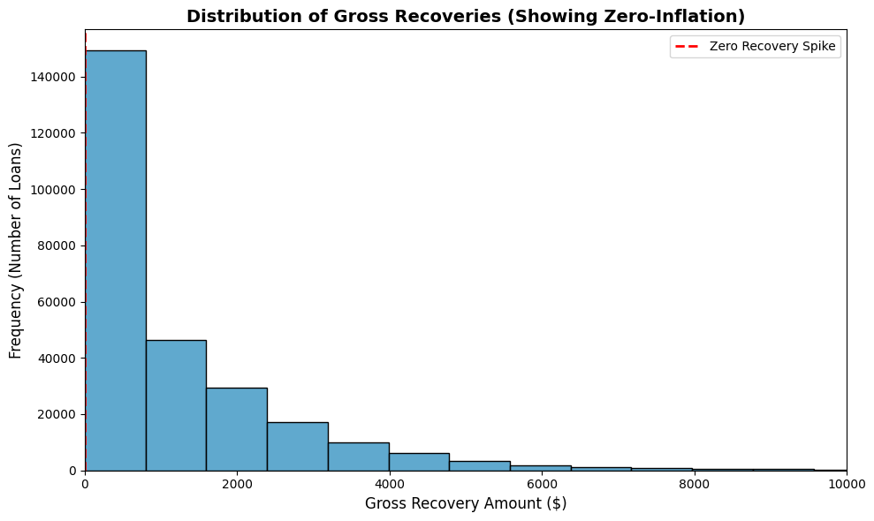
Figure 1: Distribution of Gross Recoveries. This histogram illustrates the severe "zero-inflation" present in the dataset, with a massive spike at $0.00 indicating total loss. The highly skewed, non-normal distribution visually justifies the departure from traditional linear regression models in favor of tree-based and clustering algorithms.

Data Constraints and Handling
- Missing Values (Structural Missingness): The variable mths_since_last_delinq (Months Since Last Delinquency) exhibits significant missingness. In the context of credit risk, a missing value indicates that the borrower has never been delinquent prior to this loan.
  - Handling: Instead of dropping these rows, which would bias the data toward "bad" borrowers, we impute these missing values with -1 to preserve the signal of "clean credit history."
- Outliers (Fee Anomalies): Preliminary analysis identified cases where collection_recovery_fee exceeded the recoveries amount.
  - Handling: These records are retained as they represent valid "negative net recovery" scenarios, which are crucial for training the model to recognize unprofitable collection efforts.
- Data Leakage Prevention: Variables such as total_pymnt and last_pymnt_d contain future information not available at the time of default. These features will be excluded from the predictive model to ensure a realistic operational simulation.

Project Approach

Research Methodology Framework
This project adheres to the CRISP-DM lifecycle, adapted specifically for credit risk modeling. The approach is structured into four sequential phases: Data Preparation, Feature Engineering, Predictive Modeling, and Strategic Segmentation.

Phase 1: Preprocessing and Feature Engineering
To transition from raw transactional data to actionable insights, the following transformations will be applied:

- Handling Structural Missingness:
As identified in the Data Description, the variable mths_since_last_delinq contains ~50% missing values. These will be imputed with a value of -1. This specific encoding preserves the "information value" of missingness, distinguishing borrowers with clean histories from those with recent delinquencies.

- Target Variable Construction (The "Net Recovery" Metric):
Standard LGD models predict gross recoveries. This project introduces a custom target variable to account for operational costs:
Net_Recovery = Recoveries - Collection_Recovery_Fee

Additionally, a Net Recovery Rate will be calculated (Net_Recovery / Funded_Amount) to normalize performance across varying loan sizes.

- Categorical Encoding:
Ordinal variables such as grade and sub_grade (e.g., A1, B2) will be mapped to numerical values to retain their hierarchical risk ranking. Nominal variables like home_ownership will be one-hot encoded.

Phase 2: Predictive Modeling
To answer the research question "Can we predict the profitability of a collection effort?", two distinct modeling approaches will be evaluated:
- Baseline Model: Linear Regression
A standard Ordinary Least Squares (OLS) regression will be established to create a performance baseline. This serves as the control to measure the "lift" provided by advanced machine learning.
- Champion Model: Random Forest Regressor
A Random Forest ensemble will be deployed as the primary predictive tool.
  - Justification: Unlike linear models, Random Forests are immune to multicollinearity (a common issue between interest_rate and grade) and can capture non-linear "cliff effects" where recovery potential drops precipitously for high-risk borrowers.
  - Handling Zero-Inflation: Tree-based models naturally partition data, allowing them to handle the bimodal distribution (the spike at $0 recovery) more effectively than regression techniques without requiring a complex two-stage architecture.

Phase 3: Strategic Segmentation (Clustering)
Beyond prediction, the project aims to optimize strategy using unsupervised learning.
- Algorithm: K-Means Clustering.
- Input Features: Net_Recovery, collection_recovery_fee, dti, and loan_amnt.
- Objective: To classify borrowers into distinct "Recovery Personas" (e.g., High-Yield/Low-Effort vs. Toxic Assets). This segmentation allows for the recommendation of differentiated collection strategies rather than a one-size-fits-all approach.

Evaluation Metrics
Models will be validated using a 70/30 Train-Test split with 5-Fold Cross-Validation to ensure stability. Performance will be assessed using:
- RMSE (Root Mean Squared Error): To measure the average deviation of the predicted Net Recovery from the actual value.
- R-Squared (R²): To determine the proportion of variance in recovery outcomes explained by the model.
- Silhouette Score: To evaluate the quality and separation of the K-Means clusters.

Visual Representation
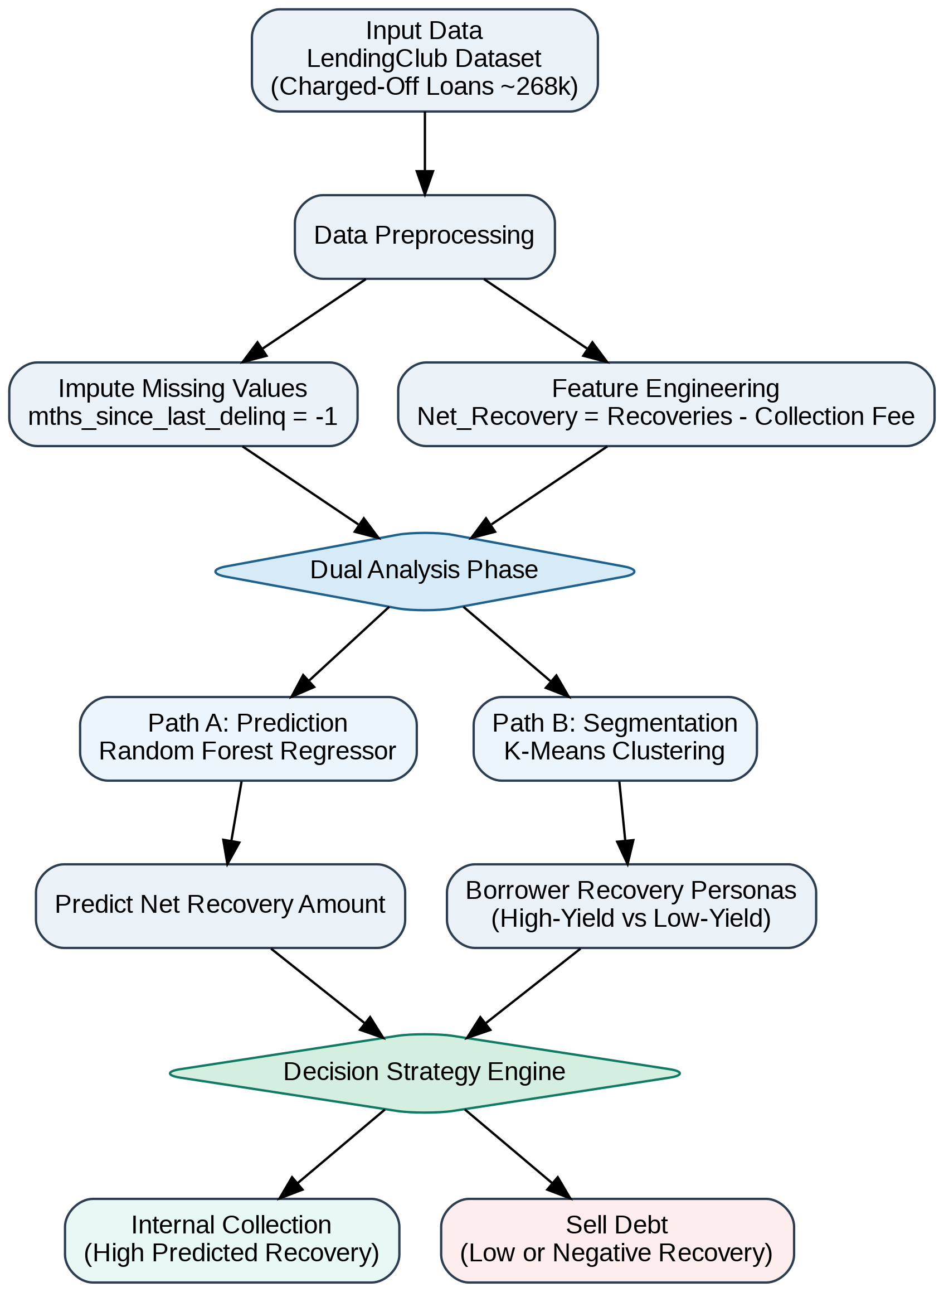

GitHub Repository

Project Repository: https://github.com/Syedi6900/CIND820_Capstone_Recovery_Optimization

References
- Basel Committee on Banking Supervision. (2005). An Explanatory Note on the Basel II IRB Risk Weight Functions. Bank for International Settlements.
- Bellotti, T., & Crook, J. (2012). Loss given default models incorporating macroeconomic variables for credit cards. International Journal of Forecasting, 28(1), 171-182.
- Brown, I., & Mues, C. (2012). An experimental comparison of classification algorithms for imbalanced credit scoring data sets. Expert Systems with Applications, 39(3), 3446-3453.
- Loterman, G., Brown, I., Martens, D., Mues, C., & Baesens, B. (2012). Benchmarking regression algorithms for loss given default modeling. International Journal of Forecasting, 28(1), 161-170.
- Mays, E. (1998). Credit Scoring for Risk Managers: The Handbook for Lenders. Fitzroy Dearborn.
- Pedregosa, F., et al. (2011). Scikit-learn: Machine learning in Python. Journal of Machine Learning Research, 12, 2825-2830.
- George, N. (2019). All Lending Club Loan Data. Kaggle. Retrieved from https://www.kaggle.com/wordsforthewise/lending-club

