
Post-Default Recovery Optimization: Predicting Collection Outcomes in Unsecured Lending

Milestone 3: Initial Results and Code

Student Name: Syed Muzammil Iqbal
ID: 501410187
Supervisor: Ceni Bobaoglu
Submitted: March 23, 2026

Table of Contents
- Introduction 3
- Data Analysis 3

Descriptive Statistics and Initial Findings 3

Visualizations and The Zero-Inflation Phenomenon 4

Implications of Identified Patterns 4
- Data Preperation 5

Dataset Source and Selection 5

Target Variable Engineering and Leakage Preventions 6

Handling Structural Missingness 6
- Model Evaluation 7

Phase A: Predictive Modeling 7

Phase B: Strategic Segmentation 7
- GitHub Repository & Code Documentation 9
- References 10

Introduction

In the domain of unsecured consumer lending, the "Charged Off" status represents a critical financial loss event. Traditional credit risk frameworks, governed heavily by Basel II accords (Basel Committee on Banking Supervision, 2005), emphasize the Probability of Default (PD). However, the subsequent recovery process—modeled as Loss Given Default (LGD)—is frequently treated as a static, homogenous outcome (Bellotti & Crook, 2012; Loterman et al., 2012). Furthermore, standard LGD models often predict gross recovery, ignoring the significant operational drag and contingency fees associated with third-party collections.
This project addresses that operational inefficiency by proposing a profit-driven predictive framework. Utilizing a dataset of charged-off loans from LendingClub (2007–2018) (George, 2019), this milestone details the data analysis, preprocessing, and dual-phase model evaluation designed to optimize post-default collection outcomes. By predicting net yield and clustering borrowers into strategic "Recovery Personas," lenders can make data-driven, account-level decisions regarding internal retention versus immediate debt sale.
(Note: During the development of this codebase, an AI coding assistant, Google Gemini, was employed to enhance productivity, troubleshoot Python syntax constraints, and assist in structuring the data visualizations.)

Data Analysis

Descriptive Statistics and Initial Findings
The isolated dataset consists of approximately 268,000 defaulted borrower records. Initial descriptive statistics reveal an average Gross Recovery of $1,209.46 across the portfolio, which is immediately offset by an average Collection Recovery Fee of $201.53.
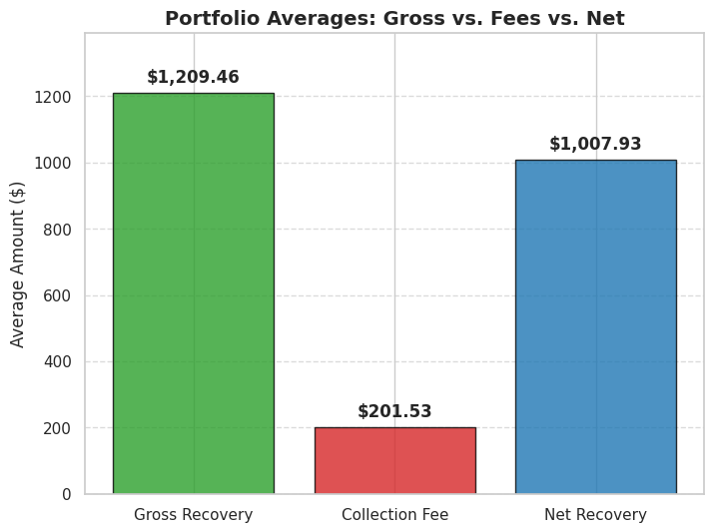
Crucially, a comparative analysis of these two variables confirmed a strict contingency-fee operational model: in zero instances did the collection fee exceed the gross recovery. This mathematically frames the business problem around opportunity cost (the time value of money wasted on fruitless collection efforts) rather than direct out-of-pocket financial loss.
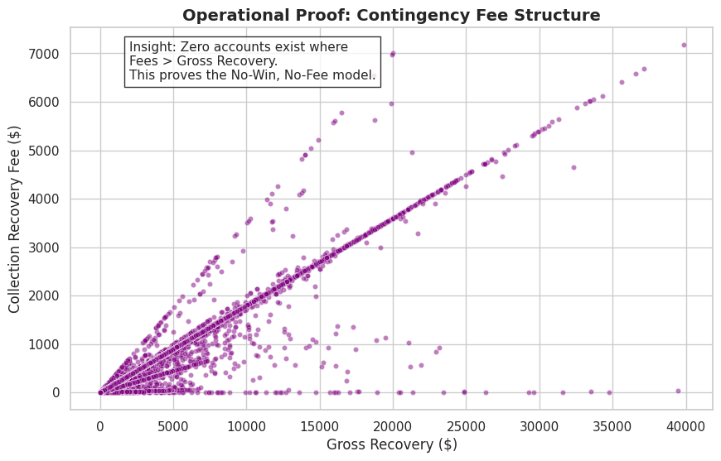

Visualizations and The Zero-Inflation Phenomenon
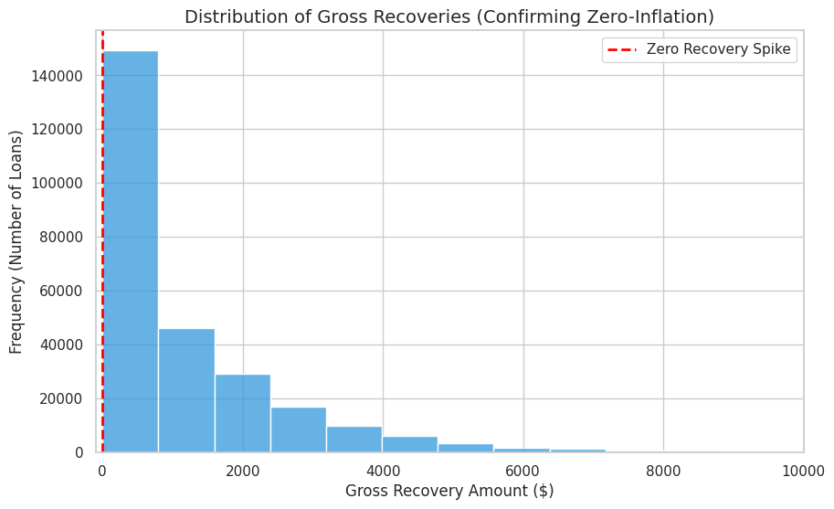 Exploratory Data Analysis (EDA) uncovered a severe "zero-inflation" phenomenon inherent to unsecured debt recovery. Analysis indicates that 31.23% of charged-off loans result in a recovery value of exactly $0.00. The resulting histogram illustrates a highly right-skewed, bimodal distribution.

Implications of Identified Patterns
This severe skewness presents a unique modeling challenge. Standard Ordinary Least Squares (OLS) regression models assume a normal distribution of residuals and a linear relationship between variables. Applying OLS to this data would erroneously predict partial, non-zero recoveries for the vast majority of borrowers, completely failing to capture the reality that nearly a third of the portfolio will yield nothing. This statistical reality justifies the exploration of non-linear, tree-based machine learning algorithms in the evaluation phase.

Data Preparation

Dataset Source and Selection
To ensure the dataset was primed for machine learning algorithms, rigorous preprocessing was conducted following the CRISP-DM methodology.

Target Variable Engineering and Leakage Prevention
To shift the analytical focus from top-line revenue to actual profitability, the continuous target variable was engineered as Net_Recovery = recoveries - collection_recovery_fee. To prevent data leakage—where the model inadvertently trains on data that would not be available at the exact moment of default—hindsight variables such as total_pymnt and last_pymnt_d were structurally removed from the feature matrix.

Handling Structural Missingness
The dataset exhibited significant missingness in the mths_since_last_delinq feature. In the context of credit data, a null value here is not a random system error (Missing Completely at Random); rather, it indicates the borrower has never been delinquent prior to this specific loan. Dropping these records would obliterate valuable historical context. Therefore, these nulls were imputed with a constant of -1 to explicitly signal a "clean prior credit history" to the algorithm. Financial ratio features containing random missing values, such as dti (Debt-to-Income), were imputed using the dataset median to avoid distortion from extreme outliers.

Transformations, Encoding, and Scaling
Categorical string variables (term, int_rate) were cleaned of text characters and cast to float datatypes. The ordinal categorical feature grade was encoded hierarchically (A=1 through G=7) to preserve the original risk weighting assigned by LendingClub underwriters. Finally, prior to distance-based clustering, the feature space was normalized using a StandardScaler. This ensured that variables with massive numerical ranges, such as loan_amnt (measured in tens of thousands), did not computationally overpower ratio metrics like dti (measured in double digits
All mathematical data manipulations and array programming were executed using NumPy (Harris et al., 2020).

Model Evaluation
Model development utilized a 70/30 Train-Test split to ensure predictions were evaluated strictly on unseen data. The process was broken into two distinct analytical phases:

Phase A: Predictive Modeling (Supervised Regression)
To predict the exact continuous Net_Recovery dollar amount, an OLS Linear Regression was established as a baseline to benchmark against a Champion Random Forest Regressor.
- Linear Regression (Baseline): RMSE: $1,381.44 | R-Squared: 0.1710
- Random Forest (Champion): RMSE: $1,380.30 | R-Squared: 0.1723
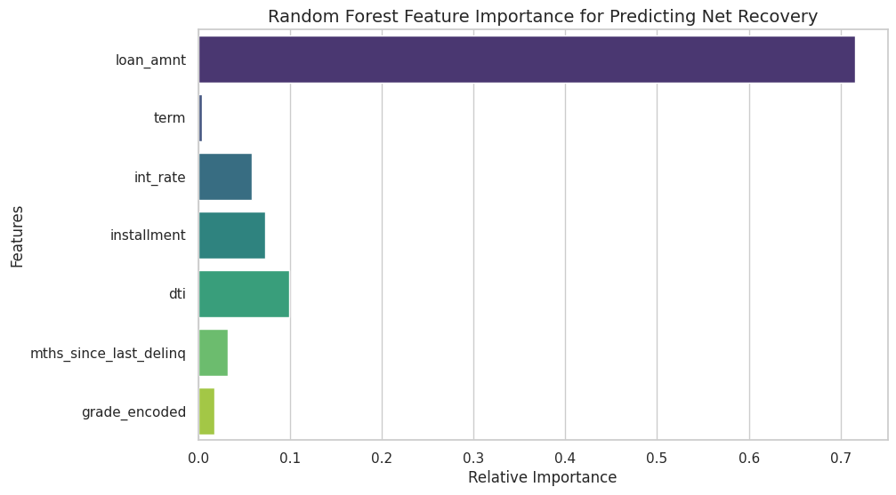Evaluation Insights: As hypothesized during the data analysis phase, the non-linear Random Forest marginally outperformed the linear baseline. While an R² of ~17.2% appears modest in traditional forecasting, it is considered highly respectable when predicting volatile human financial behavior using solely origination data. The Random Forest better captures the "cliff effects" of default (e.g., the sudden drop-off in repayment probability once DTI crosses a certain threshold). Feature importance extraction revealed that Loan Amount and Interest Rate were the heaviest drivers of predicted recovery.
Model training and algorithmic evaluations were conducted utilizing the Scikit-learn framework (Pedregosa et al., 2011), with all visual distributions generated via Matplotlib (Hunter, 2007) and Seaborn (Waskom, 2021).

Phase B: Strategic Segmentation (Unsupervised Clustering)
Because operational debt recovery relies heavily on strategic triage, K-Means clustering was applied to the scaled dataset to group borrowers based on loan_amnt, dti, int_rate, and actual Net_Recovery. Evaluating the clusters yielded a Silhouette Score of 0.24, indicating well-defined groupings for highly noisy behavioral data.
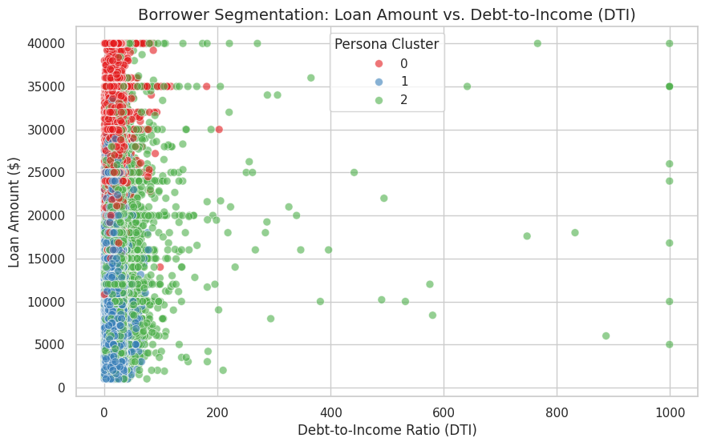
Analysis of the cluster centroids identified three distinct, actionable "Recovery Personas":
- Persona 0 (High-Yield Whales): Characterized by high loan balances ($27,720) and moderate financial strain (DTI: 19.2), yielding the highest average recovery ($3,014). Operational Strategy: Retain these accounts internally or assign them to premium contingency agencies, as the yield justifies the time delay.
- Persona 1 (Small-Balance Nuisance): Characterized by lower credit risk (12.6% interest) but tiny loan balances ($11,217), yielding minimal net recovery ($480).
Operational Strategy: Package and sell immediately to debt buyers to avoid operational drag and administrative overhead.
- Persona 2 (Toxic Assets): Characterized by subprime interest rates (20.5%) and severe financial strain (DTI: 24.2), yielding low recoveries ($667) despite mid-sized loan balances.
Operational Strategy: Cut losses. The borrower's lack of disposable income guarantees fruitless collection efforts; sell immediately.

GitHub Repository

Project Repository: https://github.com/Syedi6900/CIND820_Capstone_Recovery_Optimization

References

Basel Committee on Banking Supervision. (2005). An explanatory note on the Basel II IRB risk weight functions. Bank for International Settlements.

Bellotti, T., & Crook, J. (2012). Loss given default models incorporating macroeconomic variables for credit cards. International Journal of Forecasting, 28(1), 171-182.

George, N. (2019). All Lending Club loan data. Kaggle. https://www.kaggle.com/wordsforthewise/lending-club

Harris, C. R., Millman, K. J., van der Walt, S. J., Gommers, R., Virtanen, P., Cournapeau, D., ... & Oliphant, T. E. (2020). Array programming with NumPy. Nature, 585(7825), 357-362.

Hunter, J. D. (2007). Matplotlib: A 2D graphics environment. Computing in Science & Engineering, 9(3), 90-95.

Loterman, G., Brown, I., Martens, D., Mues, C., & Baesens, B. (2012). Benchmarking regression algorithms for loss given default modeling. International Journal of Forecasting, 28(1), 161-170.

Pedregosa, F., Varoquaux, G., Gramfort, A., Michel, V., Thirion, B., Grisel, O., ... & Duchesnay, E. (2011). Scikit-learn: Machine learning in Python. Journal of Machine Learning Research, 12, 2825-2830.

Waskom, M. L. (2021). seaborn: statistical data visualization. Journal of Open Source Software, 6(60), 3021.

