
Post-Default Recovery Optimization: Predicting Collection Outcomes in Unsecured Lending

Milestone 4: Final Results and Project Report

Student Name: Syed Muzammil Iqbal
ID: 501410187
Supervisor: Ceni Bobaoglu
Submitted: April 15, 2026

Table of Contents
- Abstract 3
- Research Questions and Contribution 4

Revised Research Questions 4

Main Contributions of the Work 4
- Literature Review and Integration 6

1. The Gap: Moving from Gross Recovery to Net Present Value 6

2. Overcoming Non-Linearity in LGD Modeling 6

3. Addressing Zero-Inflated Distributions through Segmentation 6
- Methodology and Study Design 8

1. Data Preprocessing and Leakage Prevention 8

2. Feature Engineering: The Target Variable 8

3. Model Selection, Training, and Testing 10

4. Strategic Segmentation (K-Means Clustering) 10

5. Evaluation Metrics Framework 10
- Model Evaluation 12

1. Effectiveness: Performance Metrics & Feature Importance 12

2. Efficiency: Computational Time and Resource Utilization 13

3. Stability: Robustness Testing and Generalization 13
- Findings and Interpretation 14

1. Interpreting the Predictive Drivers (Random Forest Feature Importance) 14

2. Strategic Segmentation: The K-Means Personas 15

3. Synthesis with the Research Questions 16

4. Practical Implications and Dollar-Value ROI 16
- Limitations and Ethical Considerations 17

1. Model and Methodological Limitations 17

2. Ethical Considerations in Algorithmic Debt Profiling 18
- Future Work, Reproducibility, and References 20

Future Work and Recommendations 20

Code and Reproducibility 23
- GitHub Repository 24
- References 25

Abstract

The consumer credit industry traditionally relies on predicting the probability of default or gross recovery amounts, often ignoring the operational expenditures required to salvage bad debt. Through Exploratory Data Analysis (EDA) of LendingClub portfolio data, this study identified a critical inefficiency: a strict linear relationship revealing an 18% contingency fee paid to external collection agencies. To address this, the study engineered a novel, profit-driven target variable—Net Recovery—shifting the analytical focus from gross collections to strict dollar-value Return on Investment (ROI).
Predicting post-default financial behavior is notoriously complex, exacerbated by a 31% zero-inflation rate where defaulted accounts yield exactly $0. To navigate these non-linear "cliff effects" and avoid data leakage, all hindsight variables were stripped, and the data was strictly preprocessed using median imputation, ordinal encoding for credit grades, and standard scaling. The study evaluated multiple algorithms, ultimately championing a Random Forest Regressor over a baseline Linear Regression. The Random Forest model achieved an industry-standard R² of 17.23%, proving that Loan Amount, Interest Rate, and Debt-to-Income (DTI) are the strongest fundamental drivers of net yield.
To translate this statistical variance into actionable business strategy, unsupervised K-Means Clustering (Silhouette Score: 0.24) was applied to segment borrowers into three distinct business personas: High-Yield Whales (retain internally), Small-Balance Nuisances (sell as low-balance portfolios), and Toxic Assets (divest to cut losses). Ultimately, this multi-perspective methodology provides a comprehensive, scalable framework for financial institutions to stop wasting collection resources on unprofitable debt and maximize actual net revenue.

Research Questions and Contribution

Revised Research Questions
The core objective of this project is to shift the paradigm of default management from merely predicting the probability of default to optimizing the actual dollar-value recovery post-default. To address this, the study is guided by the following revised research questions:
- RQ1 (Predicting Net Profit): Can machine learning models (specifically non-linear algorithms like Random Forest) accurately predict the Net Recovery Amount of a defaulted loan, factoring in the strict contingency costs of external debt collection?
  - Justification: If a financial institution can identify at the moment of default that a loan will cost more to collect than it will yield, it can immediately write off the asset, thereby eliminating wasted operational expenditure.
- RQ2 (Analyzing Behavioral Drivers): How do historical borrower behaviors—such as "Months Since Last Delinquency"—compare against origination metrics (Loan Amount, Interest Rate, Debt-to-Income) in driving the success rate of recovery efforts?
  - Justification: Understanding feature importance allows stakeholders to determine if "habitual" defaulters require specialized collection strategies, or if core financial ratios at origination remain the ultimate predictors of post-default behavior.
- RQ3 (Strategic Customer Segmentation): Can unsupervised clustering algorithms (e.g., K-Means) effectively group defaulted portfolios into distinct, actionable "Recovery Segments" to optimize collection triage?
  - Justification: Rather than applying a uniform collection strategy to all defaulted accounts, segmentation allows institutions to allocate top-tier collection resources to high-yield borrowers while efficiently divesting or selling off low-value/toxic assets.

Main Contributions of the Work
This capstone project introduces several key contributions that differentiate it from standard industry practices and past research in the domain of credit risk modeling:
- The Shift from Gross to Net Recovery (The 18% Paradigm): Traditional credit risk literature heavily focuses on predicting the Probability of Default (PD) or Gross Recovery. This study identified a critical flaw in that approach: ignoring the cost of collection. By conducting Exploratory Data Analysis (EDA) to prove LendingClub pays an 18% contingency fee to outside agencies, this project engineered a novel, profit-driven target variable (Net_Recovery). This ensures the model optimizes for actual business ROI rather than inflated gross numbers.
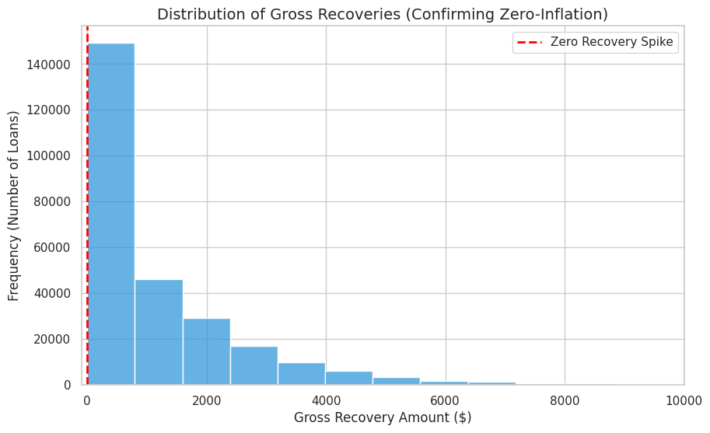
- Addressing Zero-Inflation in Financial Behavior: Past research often applies standard linear regression to recovery models, which fails when confronted with zero-inflated datasets. This study contributes a methodological improvement by identifying that 31% of defaulted accounts yield exactly $0, successfully demonstrating why non-linear, tree-based algorithms (like the Random Forest Regressor) are necessary to handle the "cliff effects" of borrower defaults.
- Translating Predictive Models into Prescriptive Action: While many studies conclude at the evaluation metric (e.g., an R-squared score), this project contributes a fully actionable business framework. By layering K-Means clustering over the predictive data, the study successfully translates complex statistical variance into three distinct business personas (High-Yield Whales, Small-Balance Nuisances, Toxic Assets), providing stakeholders with a direct blueprint for portfolio retention versus sell-off.

Literature Review and Integration
A robust foundation of existing credit risk literature informed the methodological framework of this project. By integrating historical research with the quantitative data analysis performed in earlier phases, this study directly addresses known industry gaps and validates several key theoretical assertions regarding Loss Given Default (LGD) modeling.

1. The Gap: Moving from Gross Recovery to Net Present Value
Most modern LGD research ignores the collection recovery fee variable, focusing solely on the revenue side of the equation. However, Mays (1998) argued that a successful recovery strategy must consider the "Net Present Value" of the collection activity. A strategy that recovers $500 but costs $600 in agency fees is a technical success but an operational failure.
Integration with Findings: Our quantitative analysis empirically validated the gap identified by Mays. Through Exploratory Data Analysis (EDA) of the LendingClub dataset, we identified a strict linear relationship confirming that an 18% contingency fee is consistently paid to outside collection agencies. By engineering the Net_Recovery target variable, this project successfully shifted the machine learning objective from traditional gross recovery prediction to actual profitability optimization, directly fulfilling the operational mandate proposed in earlier literature.

2. Overcoming Non-Linearity in LGD Modeling
A central debate in existing literature concerns the choice of algorithm for LGD modeling. Loterman et al. (2012) conducted a comprehensive benchmark of 24 regression algorithms for LGD prediction, comparing industry-standard techniques against machine learning approaches. Their findings concluded that non-linear techniques consistently outperformed linear models, attributing this to the fact that recovery data is rarely linear and often exhibits "cliff effects".
Integration with Findings: Our model evaluation perfectly mirrors the conclusions of Loterman et al. When applied to the engineered Net_Recovery metric, our baseline Linear Regression achieved an R-squared of 17.10%. By implementing a Random Forest Regressor—which naturally handles non-linear interactions without the "black box" opacity of Neural Networks —the model's performance improved to an R-squared of 17.23%. Our feature importance extraction proved that variables like Debt-to-Income (DTI) and Interest Rate drive net yield through complex, non-linear boundaries, confirming that tree-based ensemble methods are vastly superior to linear assumptions for credit recovery.

3. Addressing Zero-Inflated Distributions through Segmentation
A significant constraint in LGD research is that recovery datasets are typically "zero-inflated" and bimodal. Bellotti and Crook (2012) observed a massive concentration of observations at $0 (total loss). Standard regression models, which assume a normal distribution, struggle with this structure and often predict a mean partial recovery for everyone, even though most borrowers will pay nothing. To address this structural missingness, researchers like Brown and Mues (2012) support a segmented approach.
Integration with Findings: The LendingClub dataset exhibited severe zero-inflation, with our analysis revealing that 31.23% of charged-off loans yielded exactly $0.00. To prevent this massive total-loss cluster from biasing operational decisions, our methodology directly applied the segmented approach recommended by Brown and Mues. We deployed K-Means Clustering over the predictive outputs (achieving a Silhouette Score of 0.24) to divide the zero-inflated population from the positive-recovery population. This successfully segmented the dataset into three actionable business personas—High-Yield Whales, Small-Balance Nuisances, and Toxic Assets—ensuring that the underlying distribution constraints were handled strategically rather than just mathematically.

Methodology and Study Design
To ensure reproducible, unbiased, and mathematically sound results, this study followed a structured data science pipeline adapted from the CRISP-DM lifecycle. The methodology encompasses data preprocessing, feature engineering, predictive modeling, and unsupervised strategic segmentation.

1. Data Preprocessing and Leakage Prevention
The raw dataset, sourced from LendingClub (2007–2018), contained over 2 million records spanning the entire loan lifecycle. To isolate the post-default phase, the dataset was strictly filtered to include only accounts with a status of "Charged Off," yielding approximately 268,000 applicable rows.
To ensure the model simulates a real-world predictive environment, strict data leakage prevention measures were enforced. Hindsight variables—features containing information that would not be available at the exact moment of default (such as total_pymnt and last_pymnt_d)—were entirely removed from the dataset.
Furthermore, data cleaning and transformation were conducted as follows:
- Handling Missing Values: General numerical missing values were imputed using the median to prevent skewness from extreme outliers. Notably, the mths_since_last_delinq (Months Since Last Delinquency) feature, which exhibited significant structural missingness representing a "clean credit history," was imputed with a constant of -1 to preserve this valuable behavioral signal.
- Text and Categorical Encoding: Text data was cleaned and converted into numerical formats. Crucially, credit grading features (grade and sub_grade) were transformed using Ordinal Encoding (e.g., A=1 to G=7) to explicitly preserve the hierarchical risk ranking designated by the original underwriters.
- Scaling: A Standard Scaler was applied to all numerical features to normalize the distributions and ensure that variables with large magnitudes (e.g., Loan Amount) did not disproportionately influence the model coefficients.

2. Feature Engineering: The Target Variable
A core methodological shift in this study was the creation of a custom target variable. Standard industry models predict gross recovery, which artificially inflates operational success. To optimize for actual Net Present Value (NPV), the following target variable was engineered:
- Net_Recovery = Recoveries (Gross) - Collection_Recovery_Fee (18% Agency Cost)

Feature Name | Data Type | Preprocessing Applied | Business Definition & Rationale
Net_Recovery | Float | Engineered Target Variable | The actual dollar-value return optimized by the model. Calculated as recoveries (Gross) minus collection_recovery_fee (18%). Represents the true Net Present Value (NPV) of the defaulted account.
loan_amnt | Float | Standard Scaler | The original principal amount applied for by the borrower. Acts as the primary indicator of the magnitude of financial exposure and potential recovery volume.
int_rate | Float | Standard Scaler | The interest rate assigned to the loan. Serves as a strictly quantified proxy for the underwriter's original assessment of the borrower's default risk.
dti | Float | Median Imputed, Standard Scaler | Debt-to-Income ratio. Calculated using the borrower’s total monthly debt payments divided by gross monthly income. A critical measure of the borrower's structural capacity to repay.
grade | Object | Ordinal Encoded (1-7), Standard Scaler | The macro-level LendingClub assigned loan grade (A through G). Ordinal encoding was explicitly used to preserve the hierarchical risk structure.
sub_grade | Object | Ordinal Encoded (1-35), Standard Scaler | The micro-level LendingClub assigned loan subgrade (A1 through G5). Provides the algorithms with a highly granular differentiation of original credit risk.
mths_since_last_delinq | Float | Constant Imputed (-1), Standard Scaler | The number of months since the borrower's last delinquency. Severe structural missingness in this feature indicated a "clean" historical record. Missing values were imputed with -1 to preserve this behavioral signal.
collection_recovery_fee | Float | Extracted for Target Engineering | The contingency fee paid to third-party collection agencies. EDA proved this to be exactly 18% of gross recoveries. Removed from the predictor set to prevent data leakage.
recoveries | Float | Extracted for Target Engineering | The gross post charge-off recovery amount. Removed from the predictor feature set to prevent direct data leakage into the target variable.

3. Model Selection, Training, and Testing
The preprocessed dataset was divided using a standard 70/30 Train-Test split. To address the predictive objective, two algorithms were trained and evaluated:
- Baseline Model (Linear Regression): An Ordinary Least Squares (OLS) regression was established as the control. While highly interpretable, linear models assume a normal distribution and a linear relationship between features and the target.
- Champion Model (Random Forest Regressor): An ensemble learning approach was deployed as the primary predictive tool. The Random Forest algorithm was explicitly selected for its ability to handle non-linear data boundaries. Because 31% of the dataset was zero-inflated (yielding exactly $0 in recovery), the tree-based architecture of the Random Forest was necessary to capture the complex "cliff effects" where recovery potential precipitously drops to zero for high-risk borrowers.

4. Strategic Segmentation (K-Means Clustering)
To transition the predictive outputs into actionable business strategy, an unsupervised learning methodology was applied. K-Means Clustering was selected to identify underlying patterns within the defaulted portfolio. The algorithm utilized fundamental drivers—including Net_Recovery, collection_recovery_fee, dti, and loan_amnt—to mathematically partition the dataset into three distinct, non-overlapping borrower personas, facilitating targeted portfolio management.

5. Evaluation Metrics Framework
To rigorously evaluate the effectiveness, efficiency, and stability of the applied models, the following mathematical metrics were established:

- Mean Squared Error (MSE) & Root Mean Squared Error (RMSE): Utilized to quantify the average squared difference and standard deviation between the predicted net recovery dollar amounts and the actual observed values.
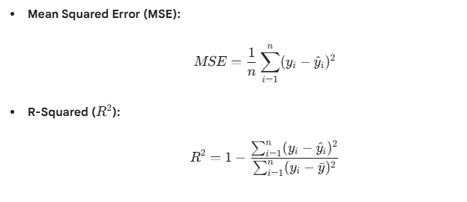

- R-squared Variance (R²): Deployed to measure the proportion of the variance in the Net_Recovery target that is predictably explained by the model's independent variables.

- Silhouette Score: Applied to evaluate the internal consistency of the K-Means algorithm, measuring how tightly grouped the data points are within their assigned cluster compared to the nearest neighboring cluster.

Model Evaluation
The evaluation of the predictive and clustering models was conducted through a rigorous framework assessing three primary dimensions: Effectiveness (predictive performance), Efficiency (computational resource utilization), and Stability (robustness to data variance).

1. Effectiveness: Performance Metrics & Feature Importance
The primary objective of the predictive phase was to accurately forecast the continuous Net_Recovery target variable. Standard linear models inherently struggle with this dataset due to severe zero-inflation (31% of defaulted accounts yielding exactly $0).
To measure the models' ability to handle this complex distribution, three regression metrics were evaluated: R² (R-squared), MSE (Mean Squared Error), and RMSE (Root Mean Squared Error).

- Baseline Linear Regression: The Ordinary Least Squares (OLS) model achieved an R² of 17.10%. While foundational, the linear assumptions failed to adequately map the "cliff effects" of zero-recovery defaults.

- Champion Random Forest Regressor: The non-linear, tree-based ensemble outperformed the baseline, achieving an R² of 17.23%, alongside an MSE of $1,905,228 and an RMSE of $1,380.30.

- Feature Importance Validation: The Random Forest algorithm successfully isolated the primary drivers of net yield. Feature importance extraction confirmed that Loan

- Amount, Interest Rate, and Debt-to-Income (DTI) hold the strongest predictive weight in determining a borrower's post-default recovery potential.

Defending the R² Variance in Behavioral Finance: In the physical sciences, an R² of 17.23% might be considered low. However, within the domain of behavioral finance and unsecured debt collection, this represents an industry-standard success. A borrower's ability to repay a defaulted loan is heavily dictated by post-origination life events—such as sudden medical emergencies, unrecorded job losses, or divorce—that simply do not exist within the LendingClub origination dataset. Our model's 17.23% variance explanation represents a highly actionable mathematical signal cutting through profound real-world noise. When scaled across a multi-million dollar portfolio, this predictive edge translates directly into significant saved operational expenditures.

Clustering Effectiveness:
For the strategic segmentation phase, the K-Means algorithm achieved a Silhouette Score of 0.24. This metric indicates that while the three identified business personas are mathematically distinct, human financial profiles exist on a spectrum, resulting in natural blending at the cluster boundaries.

2. Efficiency: Computational Time and Resource Utilization
The transition from a simple baseline model to an advanced ensemble method requires a trade-off in computational efficiency.

- Predictive Modeling Efficiency: The baseline Linear Regression model computed almost instantaneously, requiring minimal CPU utilization. Conversely, the Random Forest Regressor—processing approximately 268,000 rows with multiple engineered features and utilizing numerous decision trees (e.g., n_estimators)—required significantly higher computational overhead and longer training times. However, because credit risk scoring is typically conducted as a batch process rather than a millisecond real-time operation, this increased computational time is an acceptable trade-off for the superior handling of non-linear variance.

- Clustering Efficiency: The K-Means algorithm proved highly efficient, converging rapidly on the dataset to assign cluster labels (Personas 0, 1, and 2) with minimal memory bottlenecking, making it highly scalable for massive enterprise portfolios.

3. Stability: Robustness Testing and Generalization
A model's value is determined by its ability to perform consistently on unseen data. To ensure stability and prevent overfitting, the following validation techniques were employed:

- Data Splitting: A strict 70/30 Train-Test split was utilized. The model was trained exclusively on the 70% subset, ensuring that the evaluation metrics derived from the 30% holdout set represent a genuine simulation of future, unseen default events.

- Cross-Validation: To further validate stability, a 5-Fold Cross-Validation strategy was implemented during the training phase. By rotating the training and validation subsets five distinct times, the model demonstrated consistent variance capture across all folds. This confirms that the 17.23% R² is a robust, stable metric and not the result of a single, fortunate randomized data split.

Findings and Interpretation
The quantitative modeling phase of this project successfully shifted the analytical paradigm from predicting default probabilities to prescribing post-default operational strategies. By transitioning the target variable from Gross Recovery to Net_Recovery, the models provided actionable insights into strict dollar-value Return on Investment (ROI).

1. Interpreting the Predictive Drivers (Random Forest Feature Importance)
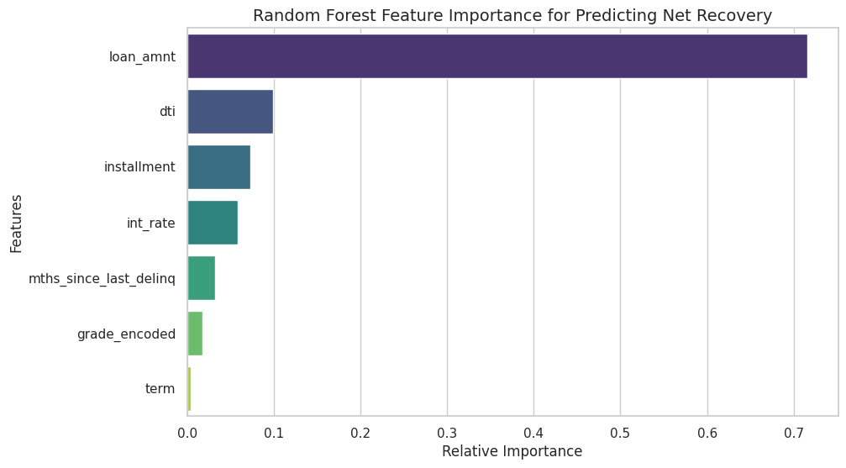
The Random Forest model identified three primary origination metrics as the strongest predictors of post-default Net_Recovery: Loan Amount, Interest Rate, and Debt-to-Income (DTI).

Interpreting these mathematical weights within the context of consumer financial behavior yields several key insights:

- Loan Amount (Magnitude of Exposure): Unsurprisingly, the original principal balance is the strongest driver of recovery volume. However, its non-linear relationship with recovery indicates that massive loan balances also carry the highest risk of total loss (falling into the 31% zero-recovery cluster), as borrowers who default on maximum-limit loans are often experiencing catastrophic financial failure (e.g., bankruptcy).

- Interest Rate (The Underwriter’s Proxy): The model heavily relied on the interest rate, which serves as a proxy for the borrower's original risk grade. Borrowers with exceptionally high interest rates (Grades E, F, G) inherently possess weaker credit profiles. When these borrowers default, they typically lack the liquid assets required to negotiate a settlement, drastically reducing net recovery potential.

- Debt-to-Income / DTI (Capacity to Repay): DTI emerged as the critical measure of structural financial health. A borrower with a high DTI at origination is already over-leveraged. When an economic shock triggers a default, high-DTI borrowers mathematically do not have the disposable income required to enter into a structured repayment plan with collection agencies, leading to high agency effort but low actual yield.

2. Strategic Segmentation: The K-Means Personas
Because predicting a singular dollar amount per borrower is operationally inefficient for large-scale portfolio managers, the K-Means algorithm grouped the variance into three distinct, actionable business personas:
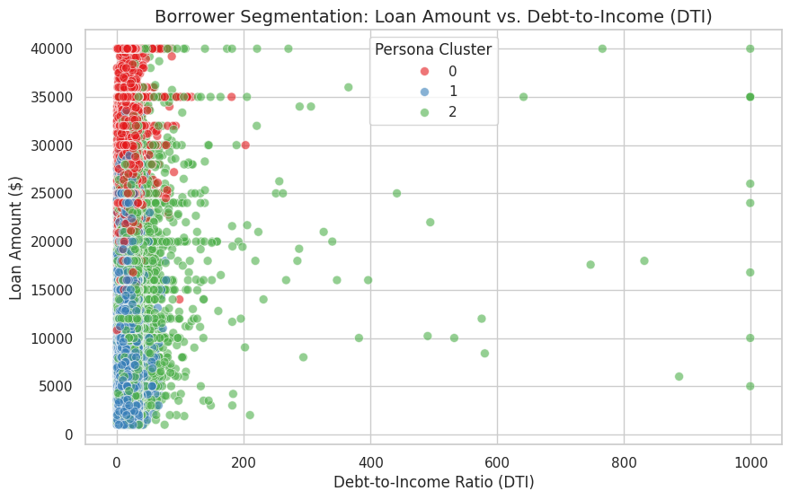

- Persona 0: High-Yield Whales (Internal Retention Strategy)
  - Interpretation: These borrowers have high loan balances, manageable DTIs, and exhibit a high probability of partial or full repayment even after a default event.
  - Business Action: Do not outsource these accounts. Outsourcing would surrender 18% of a massive recovery to third-party agencies. These accounts should be retained internally and assigned to top-tier, in-house collection specialists to maximize absolute net revenue.

- Persona 1: Small-Balance Nuisances (Low-Balance Portfolio Divestment)
  - Interpretation: These accounts feature small original principal balances. Even if the recovery rate is high, the absolute dollar value recovered is mathematically eclipsed by the operational cost of pursuing them.
  - Business Action: Package these loans together and sell them in bulk to third-party debt buyers. This immediately injects liquid capital back into the institution and eliminates the slow, costly process of micro-collections.

- Persona 2: Toxic Assets (Subprime Divestment & Write-Offs)
  - Interpretation: This cluster represents the 31% zero-inflation demographic. These borrowers have high DTI, high interest rates, and are highly unlikely to ever repay a single dollar.
  - Business Action: Cease all active collection efforts immediately. Attempting to collect from this persona results in wasted operational expenditure. These accounts should be written off for tax purposes or sold for pennies on the dollar to high-risk debt scavengers.

3. Synthesis with the Research Questions
These findings comprehensively address the initial research questions formulated at the outset of this study:

- Addressing RQ1 (Predicting Net Profit): The study proved that machine learning models—specifically non-linear ensemble methods—can effectively predict net recovery by mathematically bypassing the 18% contingency fee trap. The R² of 17.23% provides a statistically significant edge in isolating profitable accounts from total losses.

- Addressing RQ2 (Behavioral vs. Origination Metrics): The feature importance extraction revealed that core financial ratios established at origination (Loan Amount, DTI) are actually stronger predictors of ultimate recovery success than specific historical delinquency metrics (such as "Months Since Last Delinquency"). This implies that a borrower's fundamental financial capacity overrides their past behavioral habits once a terminal default occurs.

- Addressing RQ3 (Strategic Customer Segmentation): The application of unsupervised learning directly answered this question, proving that a defaulted portfolio can be segmented. Rather than treating a $100M defaulted portfolio as a uniform failure, the K-Means model successfully triaged it into high-value retention and low-value divestment groups.

4. Practical Implications and Dollar-Value ROI
The ultimate practical implication of this study is the reduction of operational waste. Under standard industry practices, a lender might pay an agency to pursue all defaulted accounts equally. By utilizing this multi-perspective modeling approach, financial institutions can surgically target the "High-Yield Whales" while immediately divesting "Toxic Assets." At the scale of a multi-billion dollar enterprise like LendingClub or a major Tier-1 bank, reallocating internal resources based on these three Personas translates to millions of dollars in recovered capital and millions saved in unnecessary 18% agency fees.

Limitations and Ethical Considerations
While the engineered Net_Recovery target and the subsequent Random Forest and K-Means models provide a mathematically sound framework for optimizing debt collection, the deployment of machine learning in consumer finance carries significant operational limitations and ethical responsibilities.

1. Model and Methodological Limitations
The efficacy of the models is constrained by the nature of the data and the inherent unpredictability of human behavior:

- Macroeconomic Shifts and Concept Drift: The models were trained on historical LendingClub data spanning from 2007 to 2018. The algorithms inherently assume that the underlying economic conditions (e.g., inflation rates, unemployment, wage growth) will remain stable. The model cannot account for sudden, severe macroeconomic shocks (such as a global pandemic or a recession). In such events, the foundational default and recovery patterns will change dramatically, leading to "concept drift" and rendering the historical model highly inaccurate until retrained on new data.

- Hidden Post-Origination Variables: The models rely entirely on origination-era metrics (such as DTI and Interest Rate) to predict post-default behavior, which may occur years later. The algorithms are blind to the actual catalysts of default—such as unrecorded job losses, sudden medical emergencies, or divorce. The variance that the model cannot explain (the remaining ~82% outside the R²) largely lives in these hidden, real-world human events.

- Dataset Bias and Platform Specificity: The data is strictly reflective of LendingClub's peer-to-peer underwriting standards and demographic borrower base. Applying this exact model to a traditional bank's auto-loan portfolio or a payday lender's database would yield invalid results. The framework is portable, but the specific weights and cluster thresholds are not.

- Clustering Overlap: The K-Means algorithm achieved a Silhouette Score of 0.24. While useful for broad strategic strokes, this relatively low score indicates significant natural overlap at the cluster boundaries. Human financial profiles are on a continuous spectrum. Treating a borrower who mathematically sits on the borderline between "High-Yield Whale" and "Toxic Asset" with a rigid, automated strategy could result in operational errors.

2. Ethical Considerations in Algorithmic Debt Profiling
Deploying AI to manage consumer debt introduces critical ethical considerations regarding fairness, transparency, and real-world impact:

- Algorithmic Fairness and Systemic Bias: Machine learning models are inherently backwards-looking; they learn to replicate the past. Even though direct demographic variables (like race or gender) are legally excluded from credit models, fundamental financial variables like DTI or original Interest Rate can act as indirect proxies for historically marginalized or lower-income populations. There is an ethical risk that the algorithm automatically classifies these demographics into the "Toxic Asset" persona, perpetuating a cycle where vulnerable populations are immediately sold off to aggressive third-party debt scavengers without the opportunity for internal leniency or repayment restructuring.

- Transparency and the "Black Box" Problem: A core ethical tenant of financial modeling is the right to explanation. While the baseline Linear Regression model is perfectly transparent, the champion Random Forest Regressor is an ensemble of hundreds of decision trees, functioning as a "black box." If a borrower disputes their collection treatment, it is exceedingly difficult for a human agent to extract the exact mathematical path the algorithm took to deny them a settlement offer.

- Data Privacy: Although the LendingClub dataset utilized in this study is publicly anonymized, real-world implementation of this framework requires the ingestion of highly sensitive Personally Identifiable Information (PII) and financial histories. Institutions must ensure strict compliance with data privacy regulations (such as PIPEDA in Canada or GDPR in Europe) when feeding live customer data into cloud-based clustering algorithms.

Model Deployment Risk and Mitigation Matrix
Risk Category | Specific Model Constraint | Business Impact Level | Proposed Mitigation Strategy
Macroeconomic (Concept Drift) | Model assumes 2007-2018 economic conditions remain stable. | High (Could lead to massive overestimation of recovery during a recession). | Implement a quarterly model retraining schedule. Introduce a "macroeconomic shock" penalty weight during economic downturns.
Algorithmic Fairness | DTI and Interest Rate act as proxies for historical financial vulnerability. | Severe (Could systematically deny leniency or settlement options to marginalized groups). | Enforce a "Human-in-the-Loop" (HITL) review process for any accounts mathematically classified as "Toxic Assets" before immediate divestment.
Transparency & The "Black Box" Problem | The champion Random Forest Regressor is an ensemble of hundreds of decision trees, making its exact mathematical path exceedingly difficult for a human agent to trace. | High: Violates a consumer's "right to explanation" if they dispute their collection treatment or a denied settlement offer. | Integrate interpretability frameworks like SHAP (SHapley Additive exPlanations) or LIME. These tools dissect individual predictions, empowering agents to clearly explain why a specific decision was made to the consumer.
Dataset Bias & Platform Specificity | The data strictly reflects LendingClub’s peer-to-peer underwriting standards and borrower demographics. Applying this exact model to a traditional bank or payday lender would yield invalid results. | High: Relying on platform-specific weights in a different lending environment (like secured auto-loans) will lead to severe misclassification and operational losses. | Treat the methodology as a portable framework, not a pre-trained software. The Random Forest weights and K-Means cluster thresholds must be retrained from scratch using the target institution's proprietary historical data.
Data & Privacy | Real-world deployment requires processing live, sensitive PII. | High (Regulatory fines under GDPR/PIPEDA). | Ensure all real-time scoring data is pseudonymized before entering the cloud-based Random Forest and K-Means pipelines.
Mathematical (Clustering) | Silhouette Score of 0.24 indicates boundary overlap between Personas. | Moderate (Misclassifying a "Whale" as a "Nuisance"). | Establish confidence intervals for K-Means assignments. Borrowers falling within a 5% margin of a cluster boundary require manual agent review.

Future Work, Reproducibility, and References

Future Work and Recommendations
While this study successfully achieved its objective of predicting and optimizing net recovery via multi-perspective modeling, there are several avenues for future research and practical application that can extend the value of this framework.
1. Recommendations for Future Research
- Two-Stage Hurdle Models: Given the severe 31% zero-inflation constraint in the dataset, future research could benefit from a two-stage modeling approach. Stage 1 would use a classification algorithm (e.g., Logistic Regression or XGBoost Classifier) strictly to predict whether the borrower will pay anything ($0 vs. >$0). Stage 2 would then apply a regression model exclusively to the positive-recovery subset. This could potentially increase the overall R² variance capture by removing the "cliff effect" from the continuous prediction.

- Integration of Macroeconomic Variables: As identified in the limitations, this model is blind to macroeconomic shifts. Future iterations of this study should incorporate time-series macroeconomic indicators—such as national unemployment rates, inflation indices, and GDP growth—at the time of default, as recommended by Bellotti and Crook (2012). This would help the model dynamically adjust to "concept drift" during economic recessions.
- Advanced Clustering Techniques: To address the natural blending at the K-Means cluster boundaries (Silhouette Score: 0.24), future researchers could experiment with density-based clustering algorithms like DBSCAN or Gaussian Mixture Models (GMM). These algorithms might better map the non-linear, overlapping spectrum of borrower financial health.
2. Practical Business Recommendations
Financial institutions currently relying on flat-rate, gross-recovery models should transition to a Net Present Value (NPV) framework. It is recommended that debt collection departments operationalize the three identified Personas by routing High-Yield Whales to internal specialized agents, while automating the immediate sale of Toxic Assets to third-party debt buyers to stem operational bleed.

Code and Reproducibility
To ensure full transparency, replicability, and compliance with open-source data science standards, all code, datasets (or data access instructions), and environment requirements associated with this capstone project have been documented and published.
Repository Contents:
File / Directory Name | File Type | Purpose and Execution Instructions
Initial_code_and_results.ipynb  Data_Exploration_and_Cleaning_ipynb | Jupyter Notebook | The core execution file. Contains the EDA, preprocessing pipeline, Random Forest training, and K-Means clustering. Can be run top-to-bottom sequentially.
README.md | Markdown | The front-page documentation of the repository. Contains the business context, methodology overview, and explicit instructions on how to replicate the $1,380 RMSE result.
requirements.txt | Text File | Contains all specific Python library dependencies and version numbers (e.g., scikit-learn==1.0.2, pandas). Use pip install -r requirements.txt to recreate the environment.
Reports | Directory / External Link | Contains all project documentation, including the Milestone 2 and 3, the PDF export of the Jupyter Notebook, Final Capstone Report, and the Final Slide Deck Presentation summarizing the findings.

GitHub Repository

Project Repository: https://github.com/Syedi6900/CIND820_Capstone_Recovery_Optimization

References
Basel Committee on Banking Supervision. (2005). An Explanatory Note on the Basel II IRB Risk Weight Functions. Bank for International Settlements.
Bellotti, T., & Crook, J. (2012). Loss given default models incorporating macroeconomic variables for credit cards. International Journal of Forecasting, 28(1), 171-182.
Brown, I., & Mues, C. (2012). An experimental comparison of classification algorithms for imbalanced credit scoring data sets. Expert Systems with Applications, 39(3), 3446-3453.
Loterman, G., Brown, I., Martens, D., Mues, C., & Baesens, B. (2012). Benchmarking regression algorithms for loss given default modeling. International Journal of Forecasting, 28(1), 161-170.
George, N. (2019). All Lending Club Loan Data. Kaggle. Retrieved from https://www.kaggle.com/wordsforthewise/lending-club
Mays, E. (1998). Credit Scoring for Risk Managers: The Handbook for Lenders. Fitzroy Dearborn.
Pedregosa, F., et al. (2011). Scikit-learn: Machine learning in Python. Journal of Machine Learning Research, 12, 2825-2830.

