Exploratory Data Analysis Report
Employee Attrition Analysis Project

1. Key HR KPIs
Computed from the cleaned dataset (1,470 employees). Live versions of these formulas are in the accompanying Excel workbook's "KPI Summary" tab.
KPI | Value
Total employees | 1,470
Employees who left | 237
Overall attrition rate | 16.1%
Avg. monthly income — stayed | $6,833
Avg. monthly income — left | $4,787
Avg. tenure (years) — stayed | 7.4
Avg. tenure (years) — left | 5.1
Attrition rate — works overtime | 30.5%
Attrition rate — no overtime | 10.4%
Avg. years since last promotion — left | 1.9

2. Overall Attrition
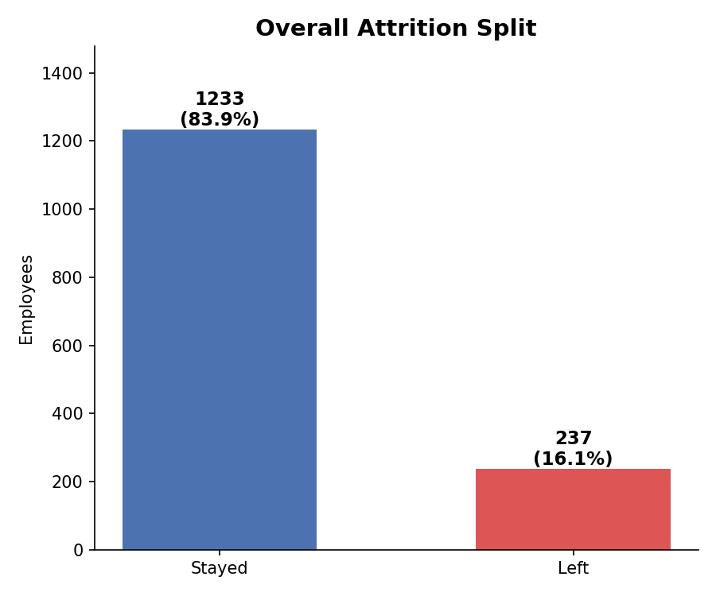
Figure 1 — Of 1,470 employees, 237 (16.1%) left the company.

3. Attrition by Department & Job Role
Sales has the highest departmental attrition rate (20.6%), followed by Human Resources (19.0%) and R&D (13.8%). At the role level, the pattern is sharper: Sales Representatives lose nearly 4 in 10 employees.
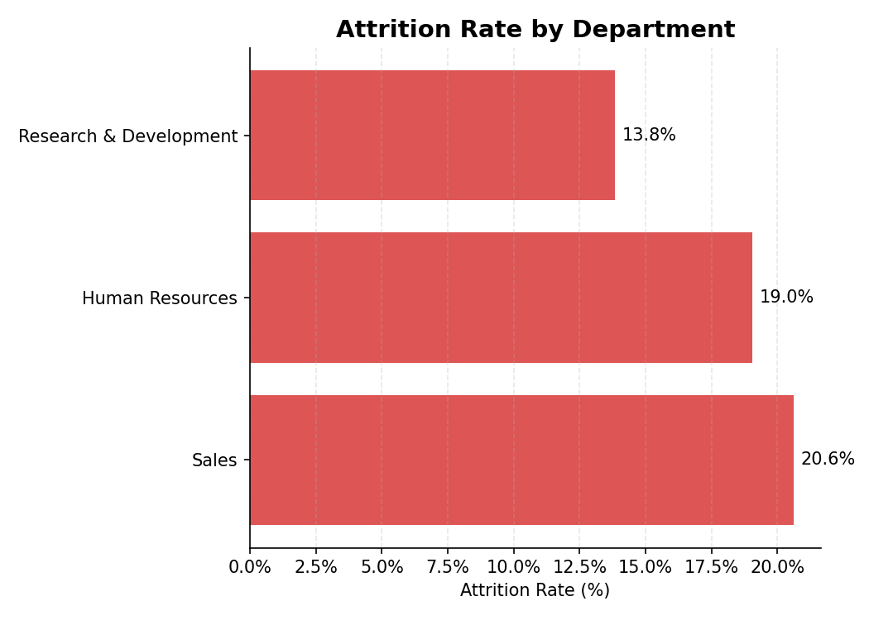
Figure 2 — Attrition rate by department.
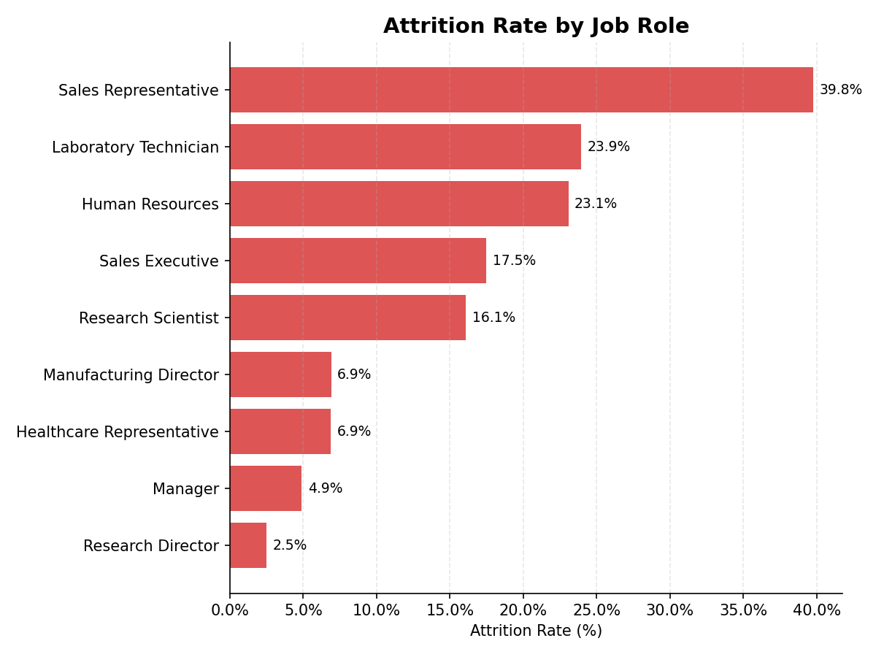
Figure 3 — Attrition rate by job role. Sales Representative (39.8%), Laboratory Technician (23.9%), and HR (23.1%) are the highest-risk roles; Research Director (2.5%) and Manager (4.9%) are the most stable.

4. Overtime — the Single Strongest Driver
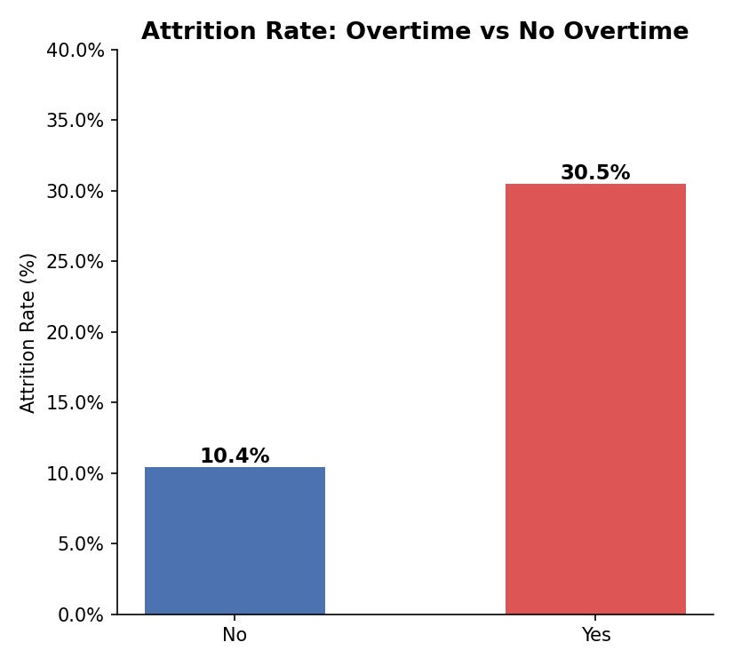
Figure 4 — Employees who work overtime leave at nearly 3× the rate of those who don't (30.5% vs 10.4%).

5. Compensation & Tenure
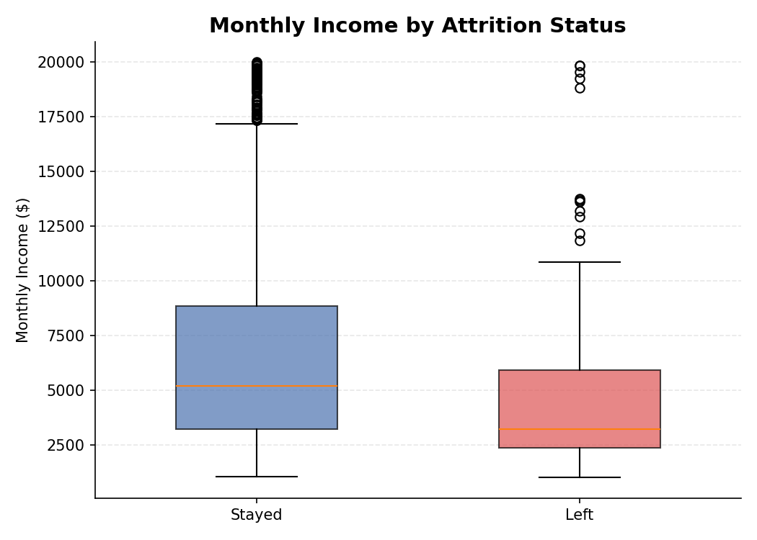
Figure 5 — Employees who left earned a lower median and had a much tighter income range than those who stayed.
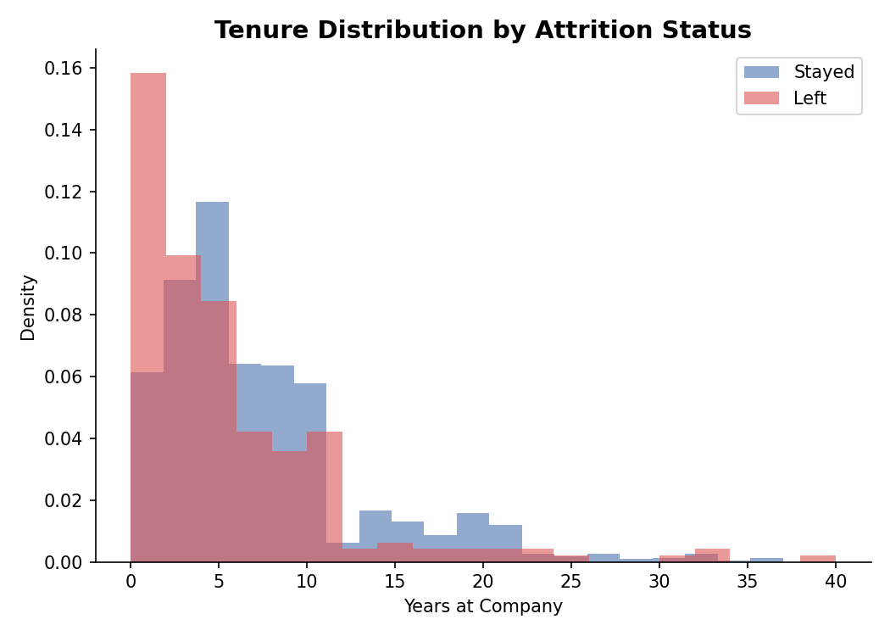
Figure 6 — Attrition is heavily concentrated in the first ~3 years of tenure.

6. Satisfaction & Work-Life Balance
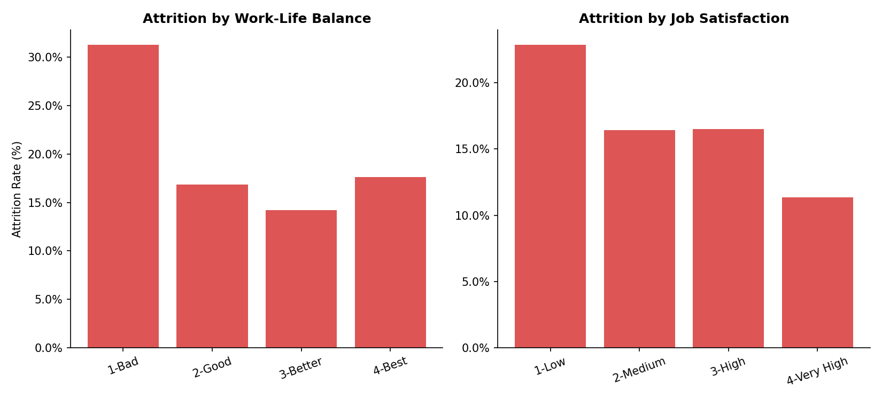
Figure 7 — Both poor work-life balance and low job satisfaction correlate with sharply higher attrition; a "Bad" work-life balance rating nearly doubles the average attrition rate.

7. Demographics & Travel
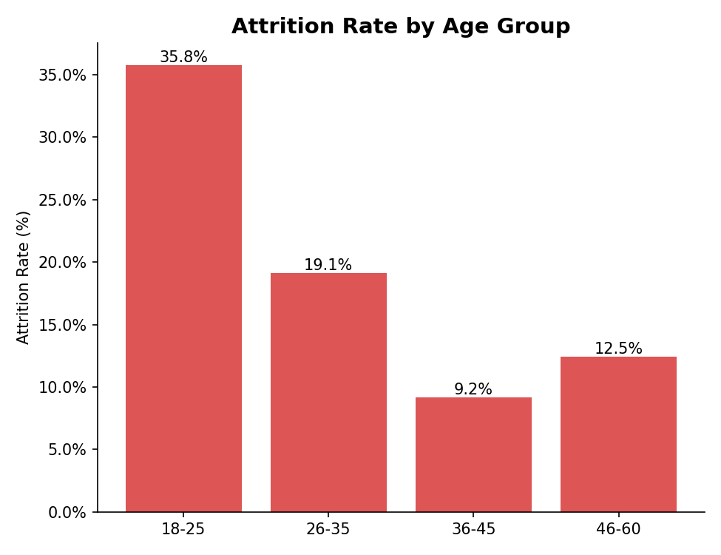
Figure 8 — Employees aged 18–25 leave at more than double the overall rate (35.8%).
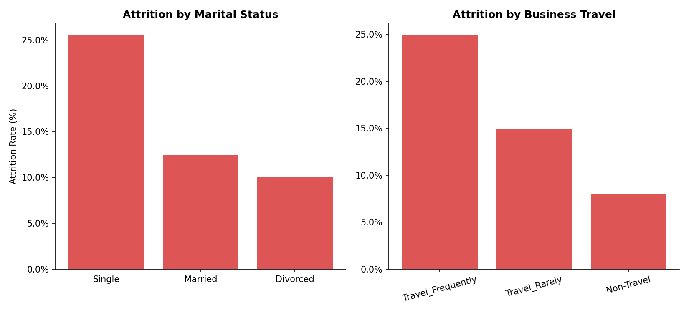
Figure 9 — Single employees and frequent travelers show the highest attrition.

8. Overall Driver Ranking
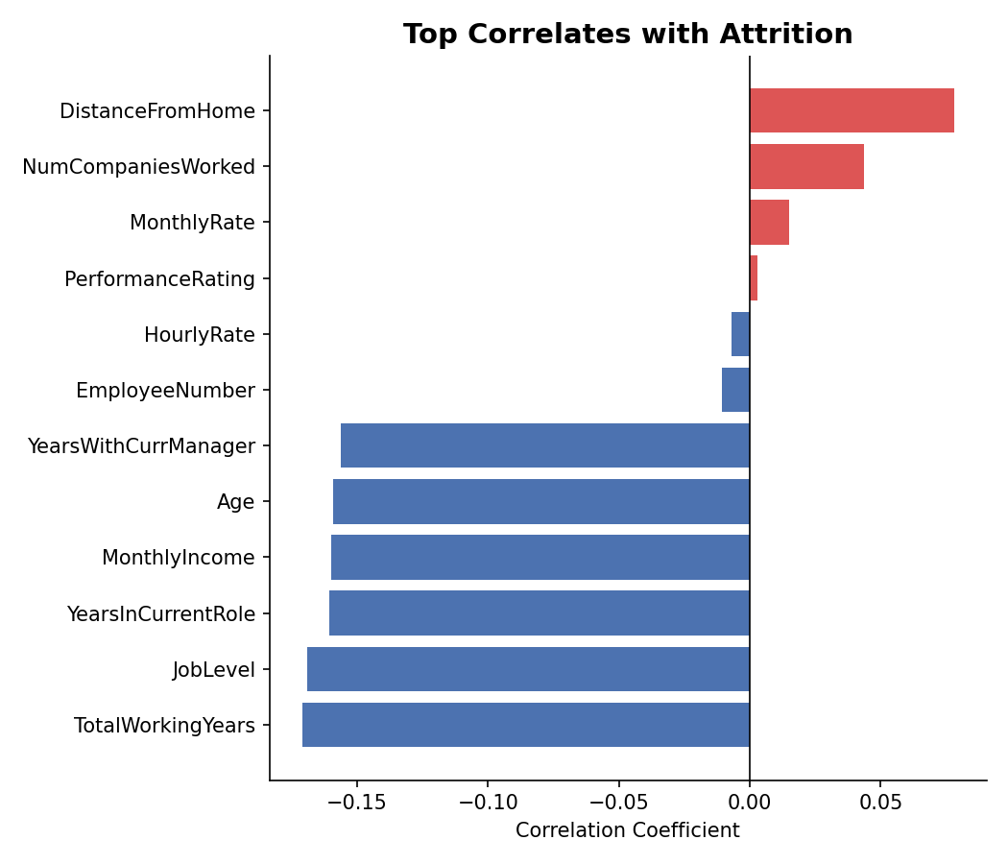
Figure 10 — Correlation of numeric fields with attrition. Longer tenure, higher job level, more experience, higher income, and older age all associate with lower attrition; number of prior companies and distance from home associate with higher attrition.

9. Segment Analysis Summary
Segment | Higher-risk group | Attrition rate | Lower-risk group | Attrition rate
Overtime | Works overtime | 30.5% | No overtime | 10.4%
Age | 18–25 | 35.8% | 36–45 | 9.2%
Marital Status | Single | 25.5% | Divorced | 10.1%
Business Travel | Travel Frequently | 24.9% | Non-Travel | 8.0%
Job Role | Sales Representative | 39.8% | Research Director | 2.5%
Work-Life Balance | Bad (1) | 31.3% | Better (3) | 14.2%
Job Satisfaction | Low (1) | 22.8% | Very High (4) | 11.3%

