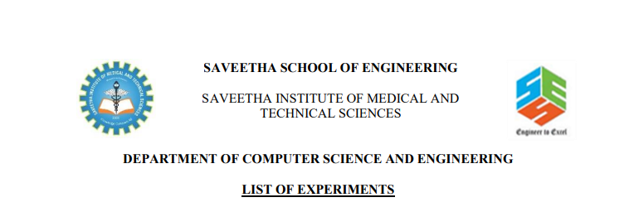

NAME:-SYED.MANSOOR BASHA

REG.NO:-192111385

SUB.CODE:-CSA1555

SUB.NAME:-DATABASE

FACULTY NAME:-SHAKILA

Ex.No. 1:- **DDL Commands – CREATE, ALTER, DROP**

**Aim:-** To Create, Alter and Drop the table using Data Definition Language.

1. Create a table name STUDENT with following structure.

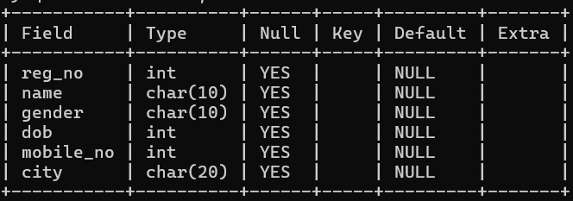

**2.** Create a table name FACULTY with following structure.

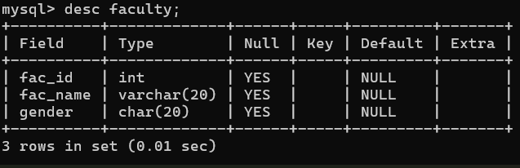

**3.** Create a table name DEPARTMENT with following structure.

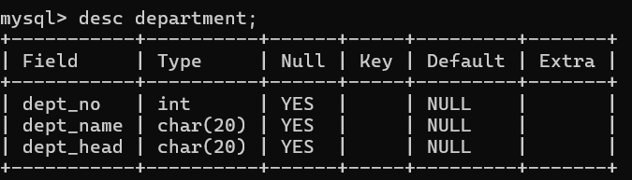

**4.** Create a table name COURSE with following structure.

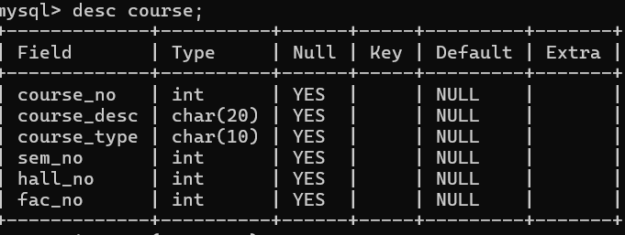

**5.** Modify the table FACULTY by adding a column name DeptNo of datatype VARCHAR(4)

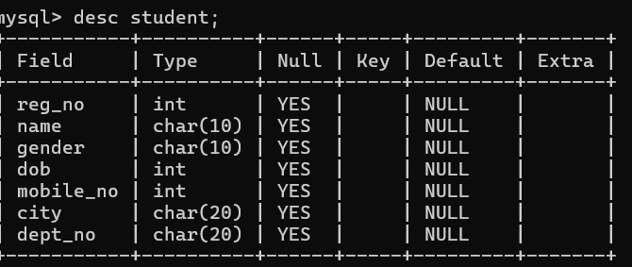

**RESULT:**Tables are created, altered and modified using DDL commands.

Ex.No. 2:- **DDL Commands with Constraints – PRIMARY, FOREIGN KEY, UNIQUE, CHECK**

**AIM:-** To add the constraints like primary key, foreign key, unique key and check using DDL commands.

**1.** Alter the table STUDENT with following structure.

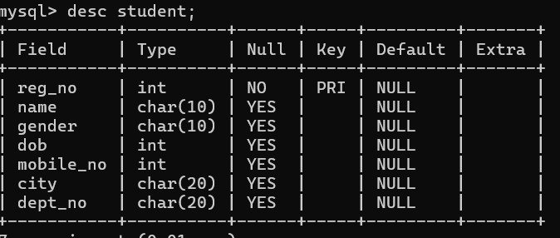

**2.** Alter the table name FACULTY with following structure. The DeptNo in this table refers the DeptNo in the DEPARTMENT table.

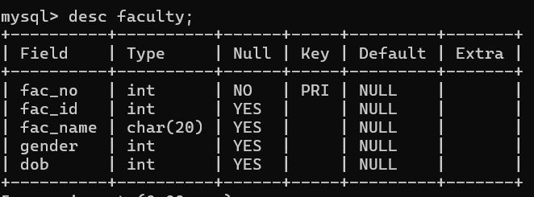

**4.** Alter the table name DEPARTMENT with following structure.

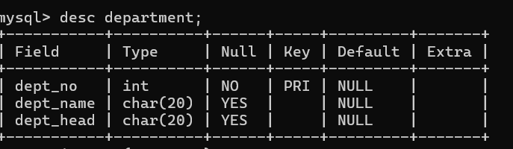

**5.** Alter the table name COURSE with following structure.

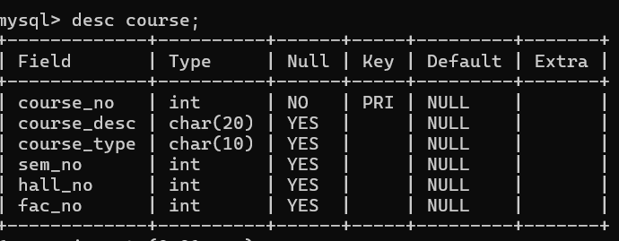

**Result:**DDL Commands with Primary, Foreign, Unique, Check constraints are updated and verified.

Ex.No. : 3:- **DML Commands – INSERT, SELECT, UPDATE, DELETE**

**Aim:**To perform Data Manipulation Language (DML) Commands such as INSERT, SELECT, UPDATE, DELETE in the table.

1. Populate all the five tables with your own data.

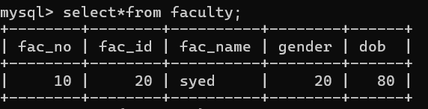

2. Update the value of student name whose register number is ‘191711342’

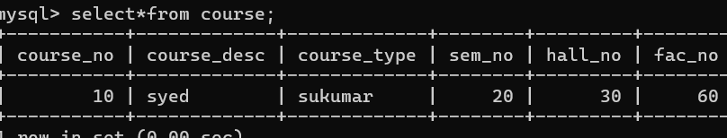

3. Delete the record in the table FACULTY, who resigned her job

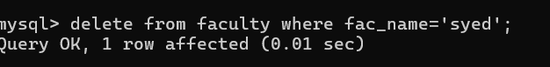

4. Modify the date of birth for the faculty whose name is 'RAM' with a value ‘1983-05-01’.

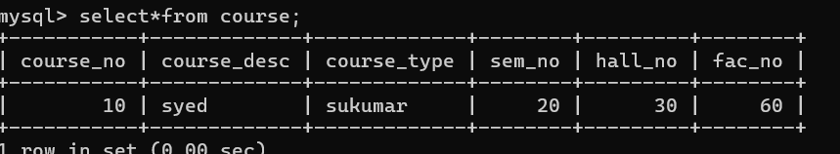

5. remove all faculty who are having over 65 years

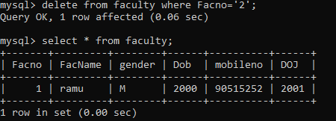

**RESULT**:Data Manipulation Language (DML) Commands such as INSERT, SELECT, UPDATE, DELETE are performed in the five tables.

Ex. No.: 4:- **SELECT with various clause – WHERE, pattern matching**

**AIM:**To view the records from the tables using SELECT commands with WHERE Clause and Pattern matching.

1.The student counsellor wanted to display the registration number, student name and date of birth for all the students.

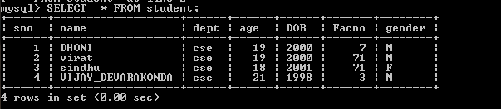

2.The controller of examinations wanted to list all the female students

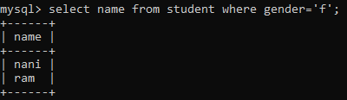

3.Who are the boy students registered for course with the course number “C001“

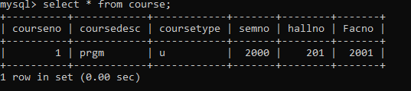

4.Display all faculty details joined before “November 2014”



5. Display all the courses not allotted to halls

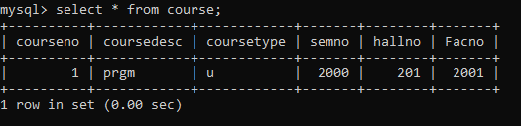

**RESULT**:The records from the tables are displayed using SELECT commands with WHERE Clause and Pattern matching.