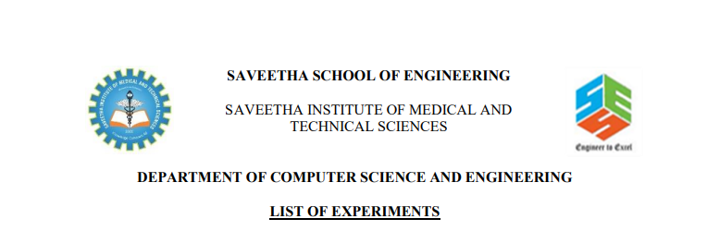

NAME:-SYED.MANSOOR BASHA

REG.NO:-192111385

SUB.CODE:-CSA1555

SUB.NAME:-DATABASE

FACULTY NAME:-SHAKILA

Ex. No. : 5:- **SELECT with various clause – BETWEEN, IN, Aggregate function**

**AIM:**To view the records from the tables using SELECT commands with BETWEEN, IN, Aggregate functions.

1.Find the average mark of “C002”.

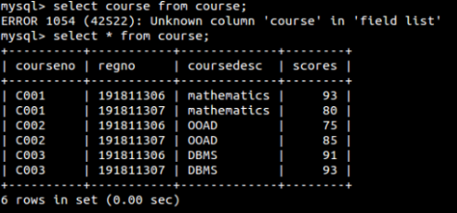

2. List the maximum, minimum mark for “C021”

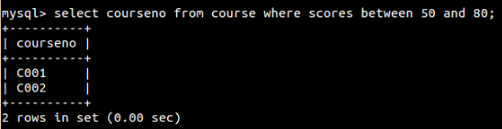

3. List the maximum, minimum, average mark for each subject in 5th semester

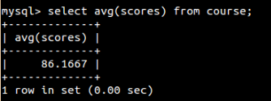

4. List the name of the courses and average mark of each courses.

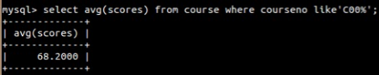

5. Calculate the sum of all the scores.

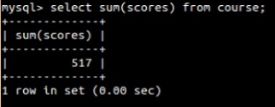

**RESULT**:The records from the tables are displayed using SELECT commands with WHERE Clause and Pattern matching.

Ex. No.: 6:- **SELECT with various clause – GROUP BY, HAVING, ORDER BY**

**AIM:**To view the records from the tables using SELECT commands with Group By, Having, Order By

**1.**How many students are registered for each course? Display the course description and the number of students registered in each course.

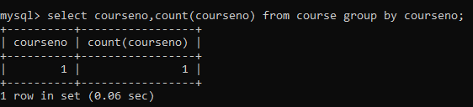

2. Retrieve Name, Gender, MobileNo of all the students in ascending order of RegNo.

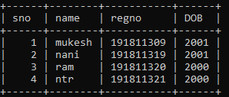

3. List the faculty members in the order of older faculty first.

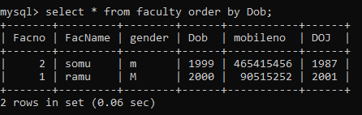

**RESULT**:The records from the tables are displayed using SELECT commands with GROUP BY, HAVING and ORDER BY.

Ex. No.: 7:- **SubQuery& Correlated Query**

1.Which of the student’s score is greater than the highest score?

**AIM:**To perform subquery and correlated query on the given relation.

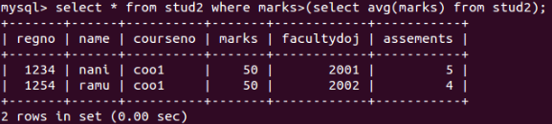

2.Which of the students’ have written more than one assessment test?

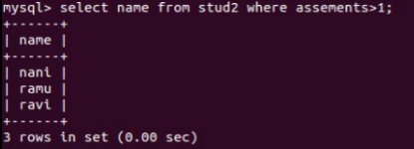

3.Which faculty has joined recently and when?

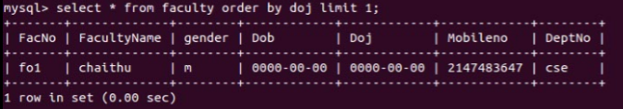

**RESULT**:The records from the tables are displayed using Sub-Query and Correlated Sub-Query.

Ex. No.: 8:- **Joins – EquiJoin, InnerJoin, OuterJoin**

**AIM:**To perform JOIN using EquiJoin, InnerJoin, OuterJoin on the given relation.

1.List the departments where the faculty members are working.

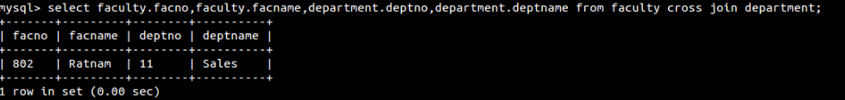

2. Find the student who has no score in any of the courses. List student name and course number.

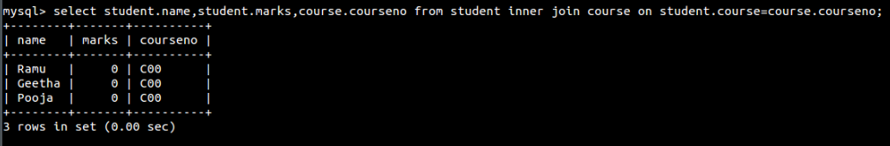

3. The office clerk needs the names of the courses taken by the faculty belonging to ‘ECE department’ whose name is ‘Kamal’

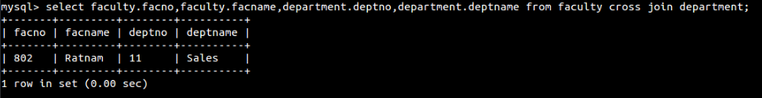

**RESULT**: The records from the tables are displayed using JOIN using EquiJoinInnerJoin, OuterJoin.