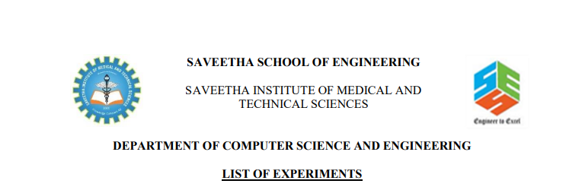

NAME:-SYED.MANSOOR BASHA

REG.NO:-192111385

SUB.CODE:-CSA1555

SUB.NAME:-CLOUD COMPUTING

FACULTY NAME:-YUVARAJ

EXP NO 1: CREATE A SIMPLE CLOUD SOFTWARE APPLICATION AND PROVIDE IT AS A SERVICE USING ANY CLOUD SERVICE PROVIDER TODEMONSTRATE SOFTWARE AS A SERVICE (SAAS).

AIM:- To create a simple cloud software application and provide it as a service using any cloud service provider to demonstrate software as a service (saas).

PROCEDURE:-

STEP1: GOTO ZOHO.COM

STEP 2: LOGIN TO THE ZOHO.COM

STEP 3: SELECT ONE APPLICATION

STEP 4: ENTER APPLICATION NAME

STEP 5: CREATED NEW APPLICATION

STEP 6: SELECT ONE FORM

STEP 7: THE SOFTWARE HASE BEEN CREATED.

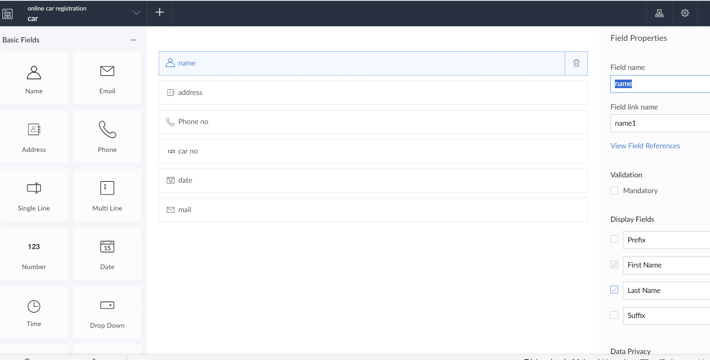

EXP NO 2: CREATE A SIMPLE CLOUD SOFTWARE APPLICATION FOR FLIGHT RESERVATION SYSTEM USING ANY CLOUD SERVICE PROVIDER TO DEMONSTRATE SAAS.

AIM: To create a simple cloud software application for flight reservation system using any cloud service provider to demonstrate saas.

PROCEDURE:

step1: Go to zoho.com.

step 2: Log into the zoho.com.

step 3: Select one application

step4: Enter application name as flight reservation system.

step 5: Created new application flight reservation system.

step 6: Select one form

step 7: The software has been created.

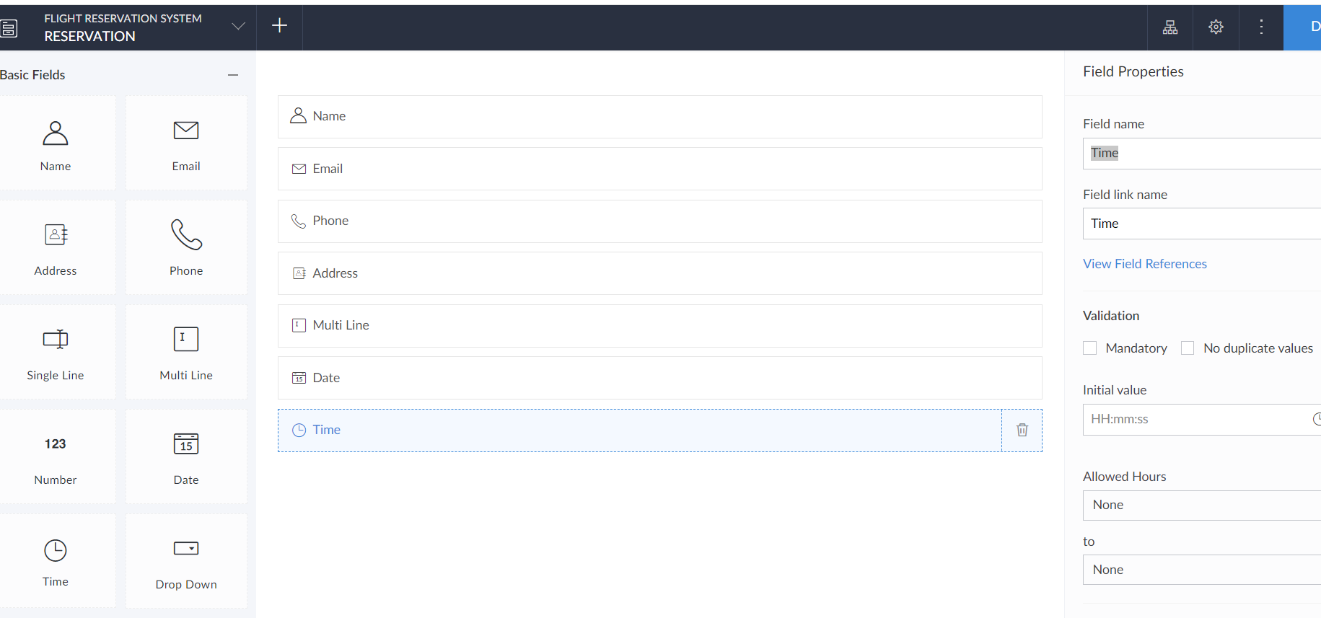

EXP NO 3: CREATE A SIMPLE CLOUD SOFTWARE APPLICATION FOR PROPERTY BUYING & RENTAL PROCESS (IN CHENNAI CITY) USING ANY CLOUD SERVICE PROVIDER TO DEMONSTRATE SAAS.

AIM: To Create a simple cloud software application for Property Buying & Rental process (In Chennai city) using any Cloud Service Provider to demonstrate SaaS.

PROCEDURE:

step1: Go to zoho.com.

step 2: Log into the zoho.com.

step 3: Select one application.

step4: Enter application name as property buying & rental.

step 5: Created new application as property buying & rental.

Step 6: Select one form

step 7: The software has been created.

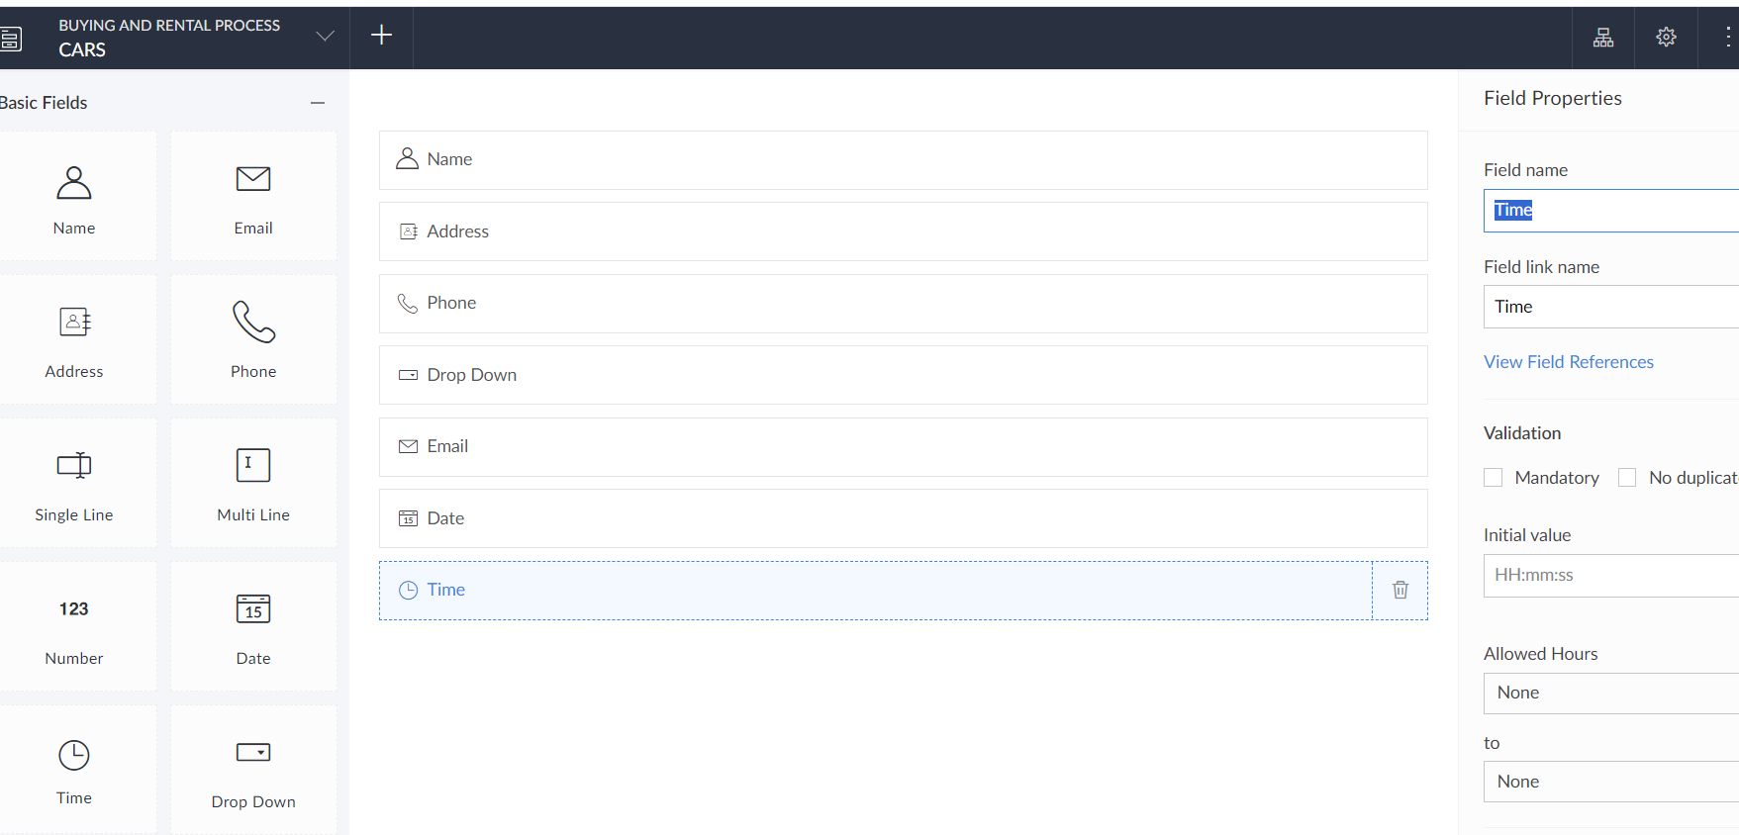

EXP NO 4: CREATE A SIMPLE CLOUD SOFTWARE APPLICATION FOR CAR BOOKING RESERVATION SYSTEM USING ANY CLOUD SERVICE PROVIDER TO DEMONSTRATE SAAS.

AIM: To Create a simple cloud software application for Car Booking Reservation System using any Cloud Service Provider to demonstrate SaaS.

PROCEDURE:

step1: Go to zoho.com.

step 2: Log into the zoho.com.

step 3: Select one application.

step4: Enter application name as Car Booking Reservation System.

step 5: Created new application as Car Booking Reservation System.

step 6: Select one form

step 7: The software has been created.

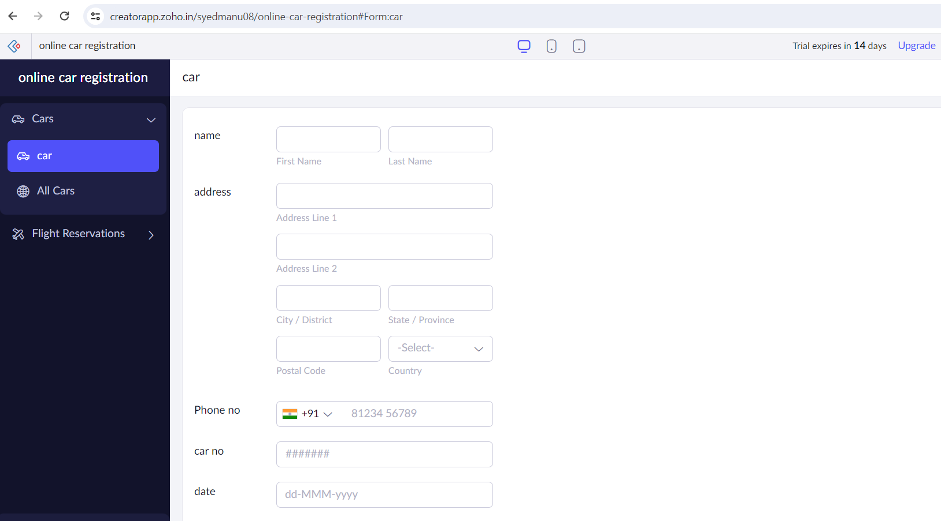

EXP NO 5: CREATE A SIMPLE CLOUD SOFTWARE APPLICATION FOR LIBRARY BOOK RESERVATION SYSTEM FOR SIMATS LIBRARY USING ANY CLOUD SERVICE PROVIDER TO DEMONSTRATE SAAS

AIM: To create a simple cloud software application for Library book reservation system for SIMATS library using any Cloud Service Provider to demonstrate SaaS

PROCEDURE:

step1: Go to zoho.com.

Step 2: Log into the zoho.com.

Step 3: Select one application.

step4: Enter application name as library book reservation system.

Step 5: Created new application as library book reservation system.

Step 6: Select one form

Step 7: The software has been created.

