

NAME:-SYED.MANSOOR BASHA

REG.NO:-192111385

SUB.CODE:-CSA1555

SUB.NAME:-CLOUD COMPUTING

FACULTY NAME:-YUVARAJ

EXP NO 6: CREATE A SIMPLE CLOUD SOFTWARE APPLICATION FOR PRODUCT SELLING USING ANY CLOUD SERVICE PROVIDER TO DEMONSTRATE SAAS.

AIM: To create a simple cloud software application for product selling using any cloud service provider to demonstrate saas.

PROCEDURE:

step1: Go to zoho.com.

Step 2: Log into the zoho.com.

Step 3: Select one application.

step4: Enter application name as product selling.

Step 5: Created new application as product selling.

Step 6: Select one form

Step 7: The software has been created.

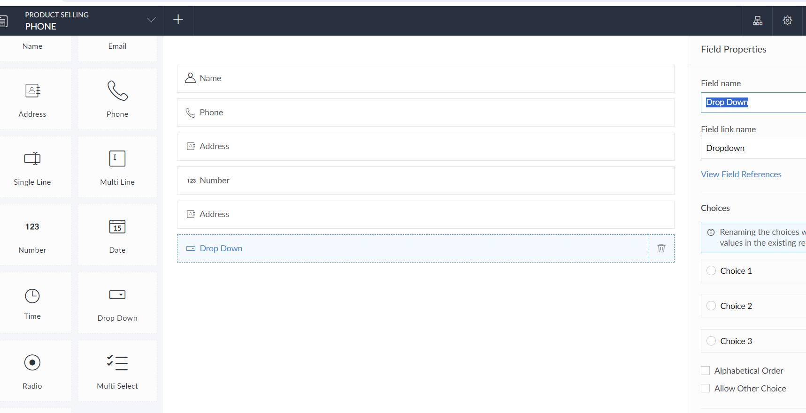

EXP NO 7: DEMONSTRATE VIRTUALIZATION BY INSTALLING TYPE-2 HYPERVISOR IN YOUR DEVICE, CREATE AND CONFIGURE VM IMAGE WITH A HOST OPERATING SYSTEM (EITHER WINDOWS/LINUX).

AIM: To demonstrate virtualization by installing type-2 hypervisor in your device, create and configure VM image with a host operating system (either windows/linux).

PROCEDURE:

STEP 1: Dowload VMware workstation and installed as type 2hypervisor.

STEP2:Dowload ubuntu or tiny OS as iso image file.

STEP 3: In VMware workstation->create new VM.

STEP 4: Do the basic configuration settings.

STEP 5: Created tiny OS virtual machine.

STEP 6: Launch the VM.

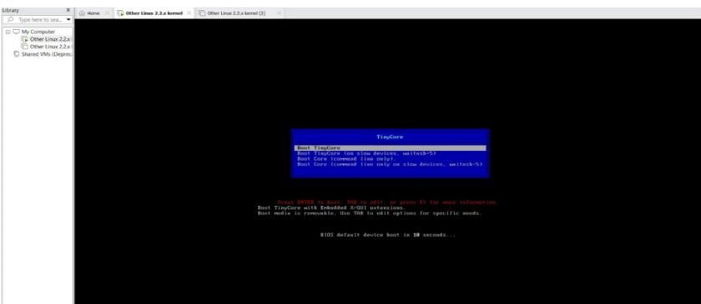

EXPNO 8: CREATE A VIRTUAL MACHINE WITH 1 CPU, 2GB RAM AND 15GB STORAGE DISK USING A TYPE 2 VIRTUALIZATION SOFTWARE.

AIM: To create a virtual machine with 1 cpu, 2gb ram and 15gbstorage disk using a type 2 virtualization software.

PROCEDURE:

STEP 1:Dowload VMware workstation and installed as type 2hypervisor.

STEP2:Dowload ubuntu or tiny OS as iso image file.

STEP 3: In VMware workstation->create new VM.

STEP 4: Do the basic configuration settings.

STEP 5: Created tiny OS virtual machine.

STEP 6: Launch the VM.

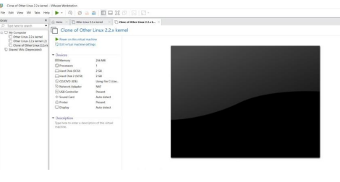

EXP 9: CREATE AVIRTUAL HARD DISK AND ALLOCATE THE STORAGEUSING VM WARE WORKSTATION. DATE:

AIM: To create a virtual hard disk and allocate the storage using vm ware workstation

PROCEDURE:

STEP 1:GOTO VM WARE WORKSTATION.

STEP2: RIGHT CLICK THE VM AND GOTO THE SETTINGS.

STEP 3: ADD HARDWARE WIZARD AND SELECT SCSI AND CLICK NEXT.

STEP 4: CREATE NEW VIRTUAL DISK.

STEP 5: SELCT THE DISK SIZE AS 2.0. AND SELCT SPLIT VIRTUAL DISK INTOMULTIFILES.

STEP 6: GIVE NAME AND CLICK THE FINISH.

