EXPNO 11: CREATE A CLONING OF A VM AND TEST IT BY LOADING THE PREVIOUS VERSION/CLONED VM. DATE:

AIM: To create a cloning of a vm and test it by loading the previous version/cloned vm.

PROCEDURE:

STEP 1: GO TO VM AND GOTO MANAGE AND CLICK CLONE

STEP 2: CLICK CLONE

STEP 3: SELECT THE FULL CLONE

STEP 4: AFTER CLONE AGAIN OR VM IS OPENED.

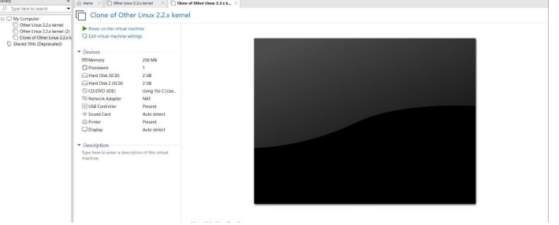

EXP 12: CHANGE HARDWARE COMPATIBILITY OF A VM (EITHER BY CLONE/CREATE NEW ONE) WHICH IS ALREADY CREATED AND CONFIGURED. DATE:

AIM: To Change Hardware compatibility of a VM (Either by clone/create new one) which is already created and configured.

PROCEDURE:

STEP 1:GOTO VM WARE WORKSTATION.

STEP2: RIGHT CLICK THE VM AND GOTO THE SETTINGS.

STEP 3: ADD HARDWARE WIZARD AND SELECT SCSI AND CLICK NEXT.

STEP 4: CREATE NEW VIRTUAL DISK.

STEP 5: SELCT THE DISK SIZE AS 2.0. AND SELCT SPLIT VIRTUAL DISK INTOMULTIFILES.

STEP 6: GIVE NAME AND CLICK THE FINISH.

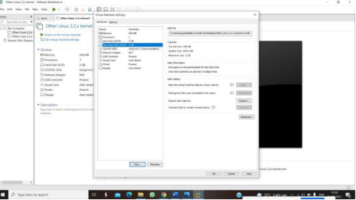

EXP13. DEMONSTRATE INFRASTRUCTURE AS A SERVICE (IAAS) BY CREATING A VIRTUAL MACHINE USING A PUBLIC CLOUD SERVICE PROVIDER (AZURE), CONFIGURE WITH REQUIRED MEMORY AND CPU.

AIM: To demonstrate infrastructure as a service (iaas) by creating a virtual machine using a public cloud service provider (azure), configure with required memory and cpu.

PROCEDURE:

STEP1: CREATE AN ACCOUNT IN MICROSOFT AZURE.

STEP2: GOTO RESOURCE GROUPAND CREATE A RESOURCE GROUP.

STEP3: GIVE NECESSARY THINGS FOR RESOURCE GROUP.

STEP4: CREATE AVIRTUAL NETWORK FOR TO CREATE AVIRTUALMACHINE .

STEP5: NOW CREATE A VIRTUAL MACHINE WITH UR IPADDRESS ANUSERNAME AND PASSWORD FOR YOUR VIRTUAL MACINE.

STEP6: AND YOUR VIRTUAL MACHINE IS DEPLOYED.

STEP7: NOW CONNECT THE VIRTUAL MACHINE AND DOWNLOAD THE RDP FILETO OPEN YOUR WINDOWS VIRTUAL MACHINE.

STEP8: NOW RESIZE THE VIRTUAL MACHINE SIZE.

STEP9: CREATED ANEW WINDOWS VIRTUAL MACHINE

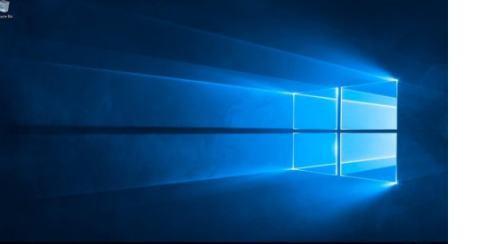

EXP 17 .DEMONSTRATE INFRASTRUCTURE AS A SERVICE(IAAS) BY CREATING AVIRTUAL MACHINE USING A PUBLIC CLOUD SERVICE PROVIDER(AZURE/GCP/AWS) CONFIGURE WITH MINIMUM CPU, RAM ANDSTORAGE AND LAUNCH THE VM IMAGE. AIM: To demonstrate infrastructure as a service(iaas) by creating a virtual machine using a public cloud service provider(azure/gcp/aws) configure with minimum cpu,ram and storage and launch the vm image. PROCEDURE: STEP1: CREATE AN ACCOUNT IN MICROSOFT AZURE. STEP2: GOTO RESOURCE GROUPAND CREATE A RESOURCE GROUP. STEP3: GIVE NECESSARY THINGS FOR RESOURCE GROUP. STEP4: CREATE AVIRTUAL NETWORK FOR TO CREATE AVIRTUALMACHINE. STEP5: NOW CREATE A VIRTUAL MACHINE WITH UR IPADDRESS ANUSERNAME AND PASSWORD FOR YOUR VIRTUAL MACINE. STEP6: AND YOUR VIRTUAL MACHINE IS DEPLOYED. STEP7: NOW CONNECT THE VIRTUAL MACHINE AND DOWNLOAD THE RDP FILETO OPEN YOUR WINDOWS VIRTUAL MACHINE. STEP8: CREATED ANEW WINDOWS VIRTUAL MACHINE

