EXP20.CREATE A SQL STORAGE SERVICE AND PERFORM A BASIC QUERY USINGANY PUBLIC CLOUD SERVICE PROVIDER (AZURE/GCP/AWS) TO DEMONSTRATE DATABASE AS A SERVICE (DAAS)

AIM: CREATE A SQL STORAGE SERVICE AND PERFORM A BASIC QUERY USINGANY PUBLIC CLOUD SERVICE PROVIDER (AZURE/GCP/AWS) TO DEMONSTRATE DATABASE AS A SERVICE (DAAS)

PROCEDURE:

STEP1: GOTO AZURE AND GOTO SQLDATABASE.

STEP 02: Now Create a Sql Databse

STEP3: SELECT THE RESOURCE GROUPAND ENTER THE SERVERNAMETHATAPPLICABLE.

STEP4: IN NETWORKING SELECT ALLOW AZURE SERVICES AND RESOURCES TO ACCESS THIS SERVER.

STEP5: IN ADDITIONAL SETTINGS SELECT SAMPLE.

STEP6:AND THE SQL DATABASE IS DEPLOYED

STEP7: NOW GOTO QUERY EDITOR.

STEP8:NOWAGAIN LOGIN TO THE SQLDATADATABASE

STEP9: OUR TABLES WILL SHOWN AND TYPE THE QUERY TO EXCUTED

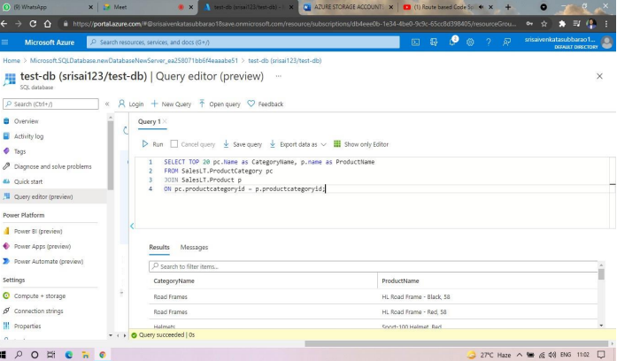

EXP. 22: PERFORM THE BASIC CONFIGURATION SETUP FOR INSTALLINGHADOOP 2.X LIKE CREATING THE HDUSER AND SSH LOCALHOST

AIM: PERFORM THE BASIC CONFIGURATION SETUP FOR INSTALLINGHADOOP 2.X LIKE CREATING THE HDUSER AND SSH LOCALHOST

PROCEDURE:

Step 1 – System Update $ sudo apt-get update

Step 2 – Install Java and Set JAVA_HOME //This first thing to do is to setup the webupd8 ppa on your system. Run the following command and proceed. $ sudo apt-add-repository ppa:webupd8team/java $ sudo apt-get update //After setting up the ppa repository, update the package cache as well. //Install the Java 8 installer $ sudo apt-get install oracle-java8-installer // After the installation is finished, Oracle Java is setup. Run the java command again to check the version and vendor. [or] $ sudo apt-get install default-jdk $ java -version

Step 3 – Add a dedicated Hadoop user $ sudo addgroup hadoop $ sudo adduser --ingroup hadoop hduser // Add hduser to sudo user group $ sudo adduser hduser sudo

Step 4 – Install SSH and Create Certificates $ sudo apt-get install ssh $ su hduser $ ssh-keygen -t rsa -P "" // Set Environmental variables $ cat $HOME/.ssh/id_rsa.pub >> $HOME/.ssh/authorized_keys

Step 5 – Check if SSH works $ ssh localhost

Step 6 – Install Hadoop // Extract Hadoop-2.7.2 $ sudo tar xvzf hadoop-2.7.2.tar.gz // Create a folder ‘hadoop’ in /usr/local $ sudo mkdir –p /usr/local/hadoop // Move the Hadoop folder to /usr/local/hadoop $ sudo mv hadoop-2.7.2 /usr/local/hadoop // Assigning read and write access to Hadoop folder $ sudo chown –R hduser:hadoop /usr/local/hadoop

