VISVESVARAYA TECHNOLOGICAL UNIVERSITY
“JnanaSangama”, Belgaum -590014, Karnataka.


LAB REPORT
on

ANALYSIS AND DESIGN OF ALGORITHMS

Submitted by

SYED MEHBOOB (1BM19CS169)

in partial fulfillment for the award of the degree of
BACHELOR OF ENGINEERING
in
COMPUTER SCIENCE AND ENGINEERING


B.M.S. COLLEGE OF ENGINEERING
(Autonomous Institution under VTU)
BENGALURU-560019
May-2022 to July-2022
B. M. S. College of Engineering,
Bull Temple Road, Bangalore 560019
(Affiliated To Visvesvaraya Technological University, Belgaum)
Department of Computer Science and Engineering


CERTIFICATE

This is to certify that the Lab work entitled “ANALYSIS AND DESIGN OF ALGORITHMS” carried out by SYED MEHBOOB (1BM19CS169), who is a bonafide student of B. M. S. College of Engineering. It is in partial fulfillment for the award of Bachelor of Engineering in Computer Science and Engineering of the Visvesvaraya Technological University, Belgaum during the year 2022. The Lab report has been approved as it satisfies the academic requirements in respect of a Analysis and Design of Algorithms - (19CS34PCADA) work prescribed for the said degree.

Dr.BASAVARAJ JAKKALI Dr. Jyothi S Nayak
Associate Professor Professor and Head
Department of CSE Department of CSE
BMSCE, Bengaluru BMSCE, Bengaluru

Index Sheet

Sl.  No. | Experiment Title | Page No.
01 | Write a recursive program to  a. Solve Towers-of-Hanoi problem b. To find GCD | 05-07
02 | Implement Recursive Binary search and Linear search and determine the time required to search an element. Repeat the experiment for different values of N and plot a graph of the time taken versus N. | 08-13
03 | Sort a given set of N integer elements using Selection Sort technique and compute its time taken. Run the program for  different values of N and record the time taken to sort. | 14-18
04 | Write program to do the following:  - Print all the nodes reachable from a given starting node in a digraph using BFS method.  - Check whether a given graph is connected or not  using DFS method. | 19-24
05 | Sort a given set of N integer elements using Insertion Sort  technique and compute its time taken. | 25-27
06 | Write program to obtain the Topological ordering of vertices  in a given digraph. | 28-30
07 | Implement Johnson Trotter algorithm to generate permutations. | 31-36
08 | Sort a given set of N integer elements using Merge Sort  technique and compute its time taken. Run the program for different values of N and record the time taken to sort. | 37-43
09 | Sort a given set of N integer elements using Quick Sort  technique and compute its time taken. | 44-47
10 | Sort a given set of N integer elements using Heap Sort  technique and compute its time taken. | 48-50
11 | Implement Warshall’s algorithm using dynamic programming. | 50-53
12 | Implement 0/1 Knapsack problem using dynamic programming. | 53-54
13 | Implement All Pair Shortest paths problem using Floyd’s  algorithm. | 54-56
14 | Find Minimum Cost Spanning Tree of a given undirected graph  using Prim’s algorithm | 56-58
15 | Find Minimum Cost Spanning Tree of a given undirected graph | 58-59

 | using Kruskals algorithm
16 | From a given vertex in a weighted connected graph, find  shortest paths to other vertices using Dijkstra’s algorithm | 59-61
17 | Implement “Sum of Subsets” using Backtracking. “Sum of Subsets” problem: Find a subset of a given set S =  {s1,s2,……,sn} of n positive integers whose sum is equal to a given positive integer d. For example, if S = {1,2,5,6,8} and d = 9 there are two solutions {1,2,6} and {1,8}. A suitable message is to be displayed if the given problem instance doesn’t have a  solution. | 61-63
18 | Implement “N-Queens Problem” using Backtracking | 63-64

Course Outcome

CO1 | Ability to analyze time complexity of Recursive and Non-Recursive algorithms using asymptotic notations.
CO2 | Ability to design efficient algorithms using various design techniques.
CO3 | Ability to apply the knowledge of complexity classes P, NP, and NP-Complete and prove certain problems are NP-Complete
CO4 | Ability to conduct practical experiments to solve problems using an appropriate designing method and find time efficiency.

LAB PROGRAM-01

Write a recursive program to
- Solve Towers-of-Hanoi problem

To find GCD

- #include<stdio.h> #include<conio.h
>
#include<math.h>
void hanoi(int x, char from, char to, char aux)
{

if(x==1)
printf("Move Disk From %c to
%c\n",from,to); else
{
hanoi(x-1,from,aux,to);
printf("Move Disk From %c to
%c\n",from,to); hanoi(x-1,aux,to,from);
}
}

void main( )
{
int disk; int moves; clrscr();
printf("Enter the number of disks you want to play with:"); scanf("%d",&disk);
moves=pow(2,disk)-1;
printf("\nThe No of moves required is=%d \n",moves); hanoi(disk,'A','C','B');
getch( );
}

OUTPUT:
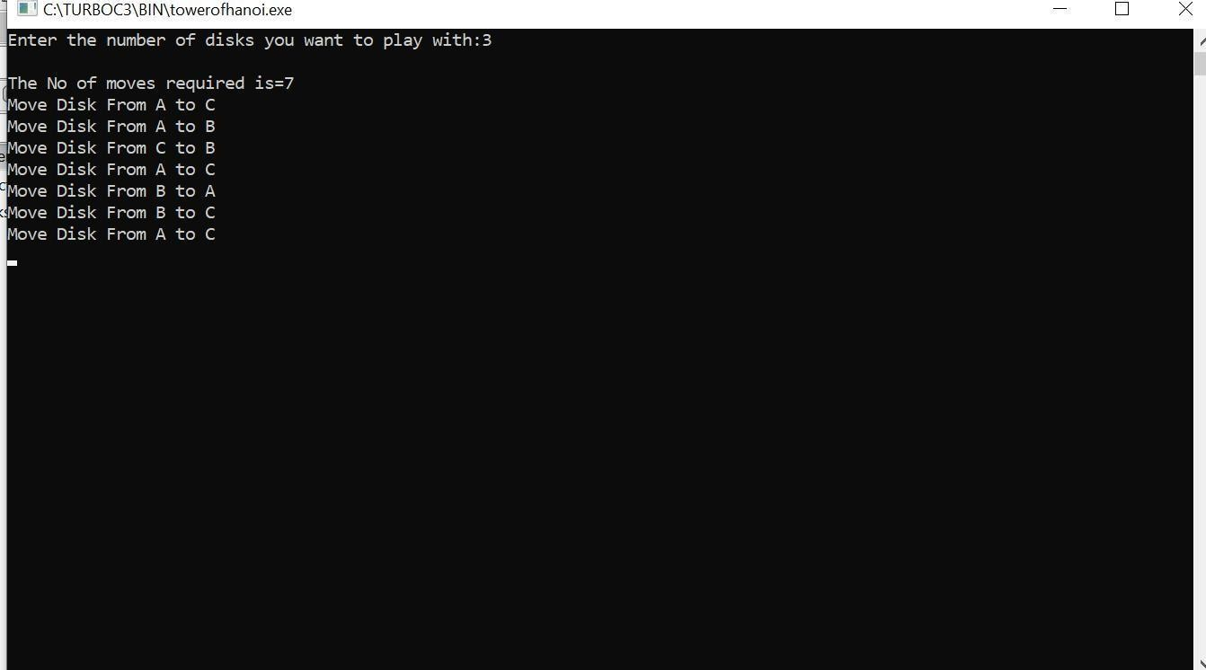

- #include <stdio.h>
int hcf(int n1, int n2); int main()
{
int n1, n2;
printf("Enter two positive integers:
"); scanf("%d %d", &n1, &n2);
printf("G.C.D of %d and %d is %d.", n1, n2, hcf(n1,n2)); return 0;
}

int hcf(int n1, int n2)
{
if (n2 != 0)
return hcf(n2, n1%n2); else
return n1;
}
OUTPUT:
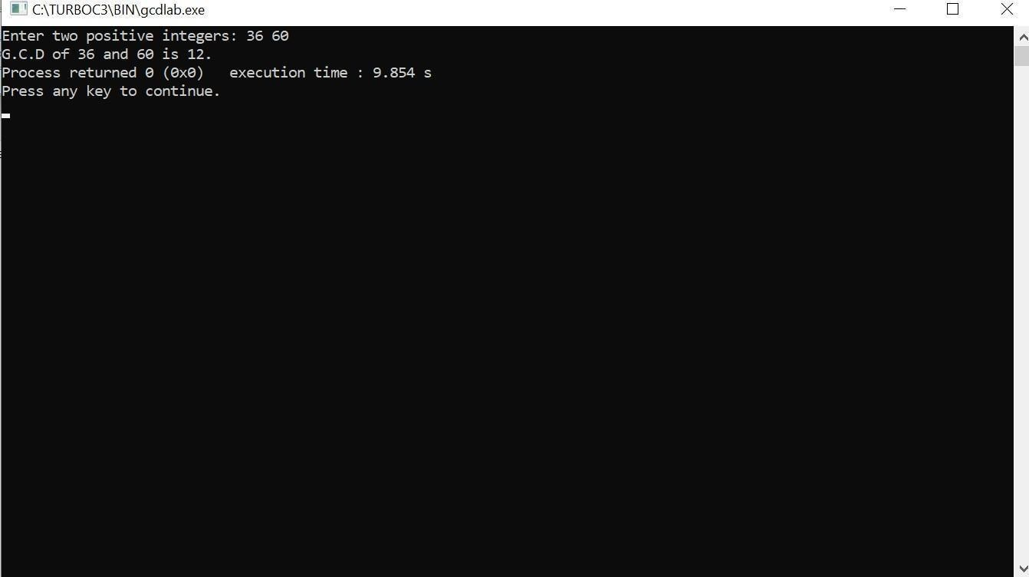

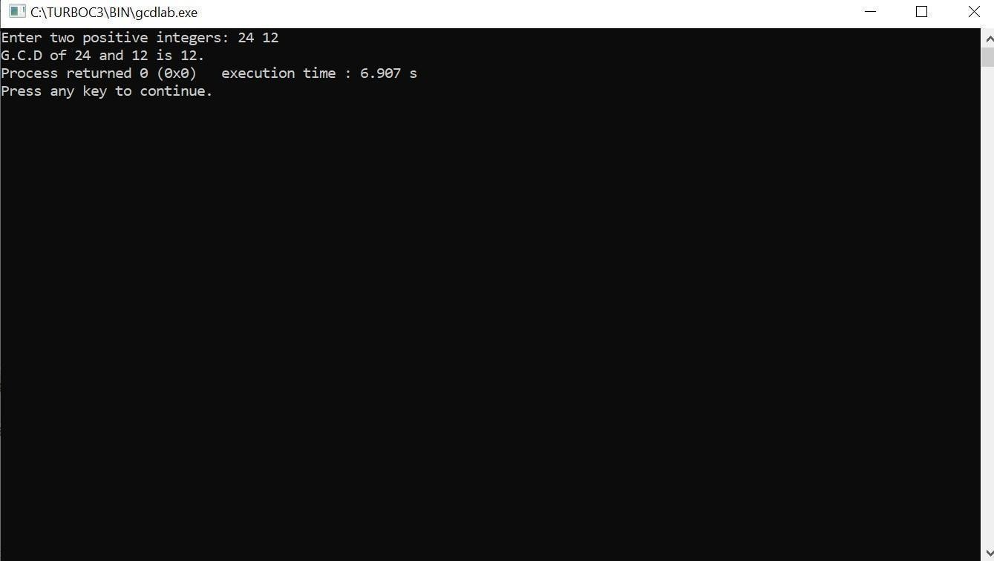

LAB PROGRAM-02

Implement Recursive Binary search and Linear search and determine the time required to search an element. Repeat the experiment for different values of N and plot a graph of the time taken versus N.
#include<stdio.h
>
#include<time.h>
#include<stdlib.h> /* To recognise exit function when compiling with gcc*/
int bin_srch(int [],int,int,int); int lin_srch(int [],int,int,int); void bub_sort(int[],int);
int n,a[10000]; int main()
{
int ch,key,search_status,temp; clock_t end,start;
unsigned long int i, j;

while(1)
{
printf("\n1: Binary search\t 2: Linear search\t 3: Exit\n"); printf("\nEnter your choice:\t");
scanf("%d",&ch)
; switch(ch)
{
case 1: n=1000;
while(n<=5000)
{
for(i=0;i<n;i++)
{
//a[i]=random(1000);
a[i]=i; //Insering numbers in Ascending order
}
key=a[n-1]; //Last element of the aray start=clock();
//bub_sort(a,n); //Sorting numbers in Ascending order using Bubble sort
search_status=bin_srch(a,0,n-1,key)
; if(search_status==-1) printf("\nKey Not Found");
else
printf("\n Key found at position %d",search_status);
//Dummy loop to create delay for(j=0;j<500000;j++){ temp=38/600;} end=clock();
printf("\nTime for n=%d is %f Secs",n,(((double)(end- start))/CLOCKS_PER_SEC));
n=n+1000;
}
break;
case 2:
n=1000;
while(n<=5000)
{
for(i=0;i<n;i++)
{
//a[i]=random(10000)
; a[i]=i;
}
key=a[n-1]; //Last element of the aray start=clock(); search_status=lin_srch(a,0,n-1,key);

if(search_status==-1)
printf("\nKey Not Found");
else
printf("\n Key found at position %d",search_status);//Dummy loop to create delay for(j=0;j<500000;j++){ temp=38/600;} end=clock();
printf("\nTime for n=%d is %f Secs",n,(((double)(end- start))/CLOCKS_PER_SEC));
n=n+1000;
}
break; default:
exit(0);

}
getchar();
}
}
void bub_sort(int a[],int n)
{
int i,j,temp; for(i=0;i<=n-2;i++)
{
for(j=0;j<=n-2-i;j++)
{
if(a[j]>a[j+1])
{
temp=a[j]; a[j]=a[j+1]; a[j+1]=temp;
}
}
}
}
int bin_srch(int a[],int low,int high,int key)
{
int mid; if(low>high
)
{
return -1;
}
mid=(low+high)
/2; if(key==a[mid])
{
return mid;
}
if(key<a[mid])
{
return bin_srch(a,low,mid-1,key);
}
else
{
return bin_srch(a,mid+1,high,key);
}
}

int lin_srch(int a[],int i,int high,int key)
{
if(i>high)
{
return -1;
}
if(key==a[i])
{
return i;
}
else
{
return lin_srch(a,i+1,high,key);
}
}
OUTPUT:

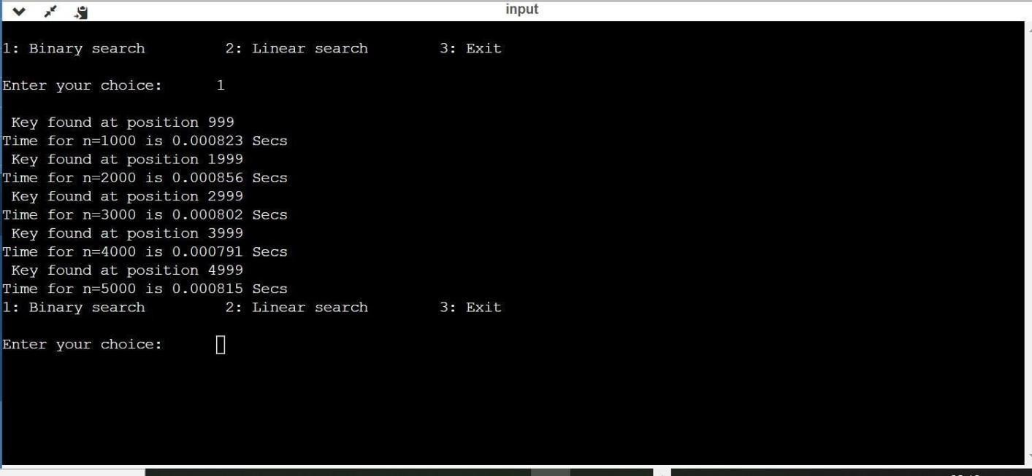

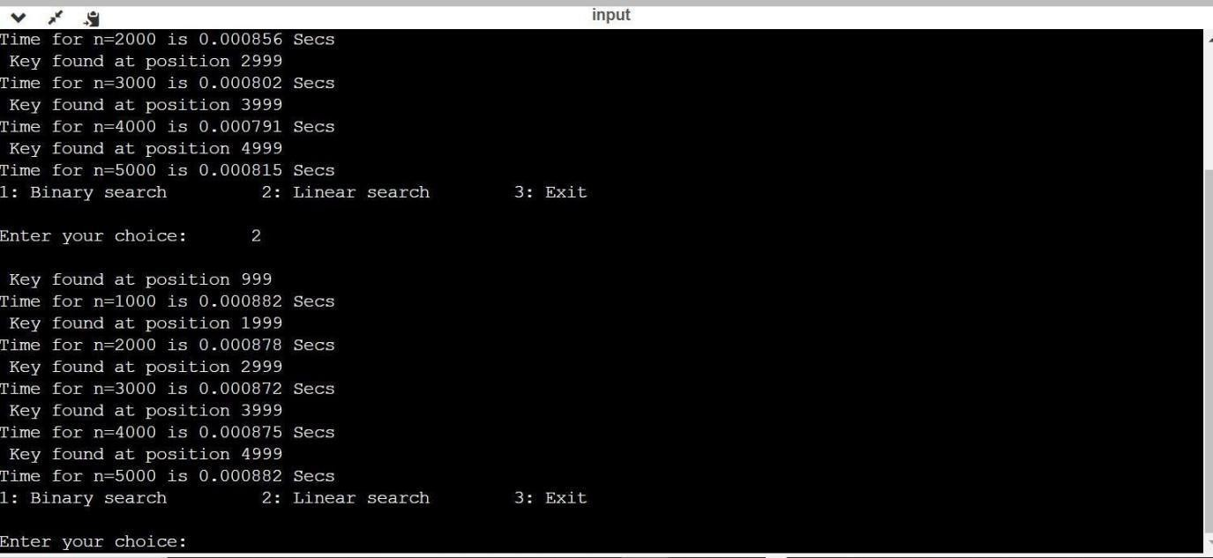

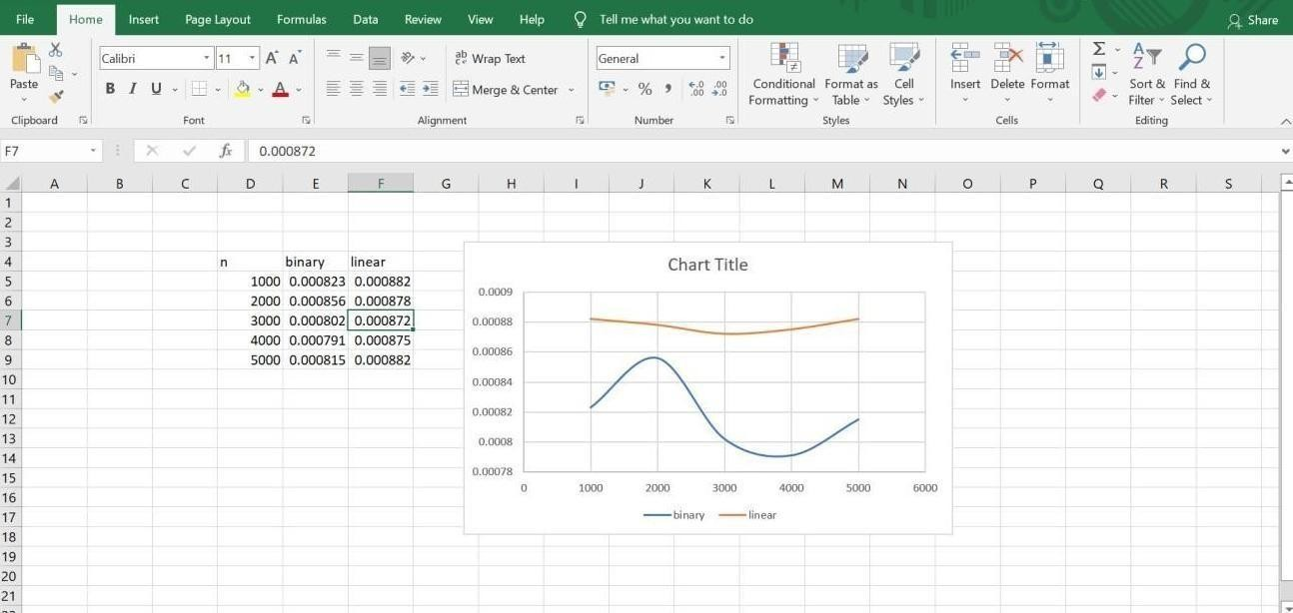

LAB PROGRAM-03

Sort a given set of N integer elements using Selection Sort technique and compute its time taken. Run the program for different values of N and record the time taken to sort.
#include<stdio.h> #include<time.h> #include<stdlib.h
>
void selsort(int n,int a[]); int main()
{

int a[15000],n,i,j,ch,temp; clock_t start,end; while(1)
{
printf("\n1:For manual entry of N value and array elements");
printf("\n2:To display time taken for sorting number of elements N in the range 1000 to 10000");
printf("\n3:To exit"); printf("\nEnter your choice:"); scanf("%d", &ch);
switch(ch)
{

case 1: printf("\nEnter the number of elements: "); scanf("%d",&n);
printf("\nEnter array elements:
"); for(i=0;i<n;i++)
{
scanf("%d",&a[i]);
}
start=clock(); selsort(n,a); end=clock(); printf("\nSorted array is:
"); for(i=0;i<n;i++)
printf("%d\t",a[i]);
printf("\n Time taken to sort %d numbers is %f Secs",n, (((double)(end- start))/CLOCKS_PER_SEC));
break;

case 2:
n=1000;
while(n<=10000)
{for(i=0;i<n;i++)
{

//a[i]=random(1000)
; a[i]=n-i;
}

start=clock(); selsort(n,a);
for(j=0;j<500000;j++){ temp=38/600;} end=clock();
printf("\n Time taken to sort %d numbers is %f Secs",n, (((double)(end- start))/CLOCKS_PER_SEC));
n=n+1000;
}
break; case 3: exit(0);
}
getchar(); return 0;
}

}
void selsort(int n,int a[])
{

int i,j,t,small,pos; for(i=0;i<n-1;i++)
{
pos=i; small=a[i]; for(j=i+1;j<n;j++)
{

if(a[j]<small)
{
small=a[j]; pos=j;
}
}

t=a[i]; a[i]=a[pos]; a[pos]=t;
}
}

OUTPUT:
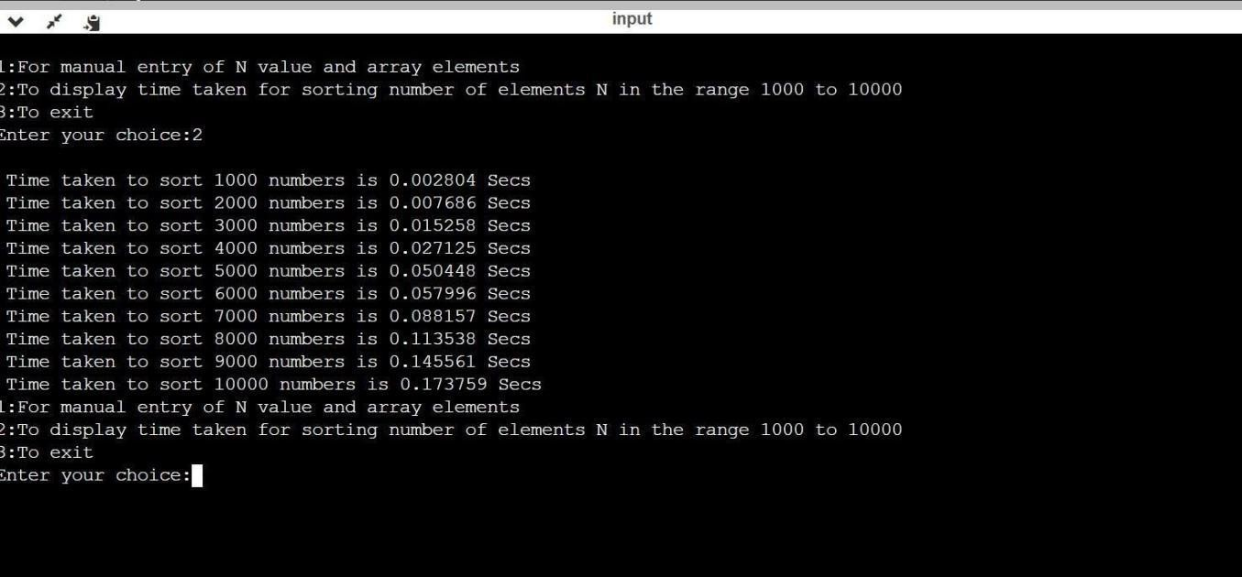
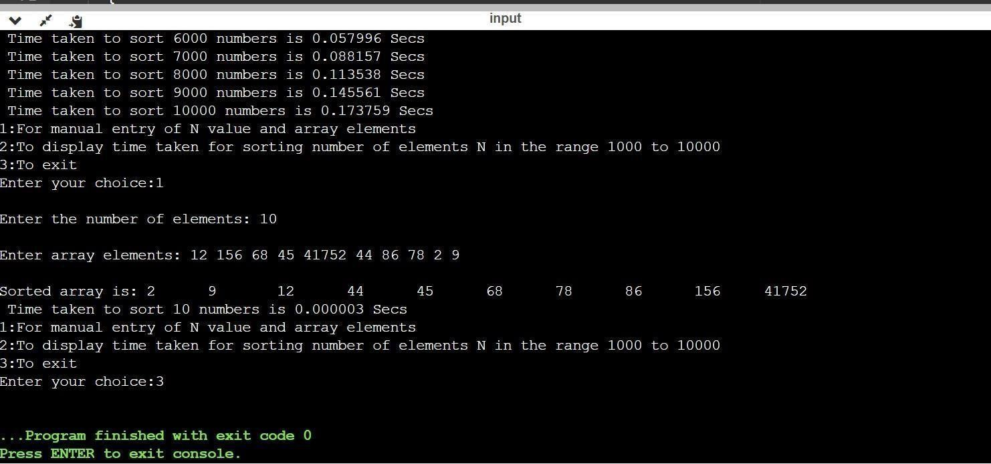

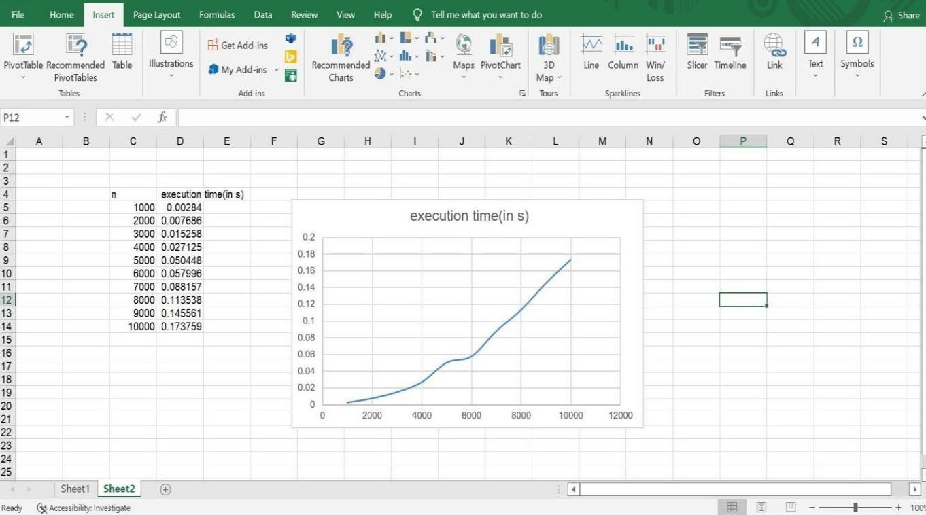

LAB PROGRAM-04

Write program to do the following:
- Print all the nodes reachable from a given starting node in a digraph using BFS method.

Check whether a given graph is connected or not using DFS method.

- #include<stdio.h> #include<conio.h
> int a[10][10],n; void bfs(int);
int main()
{
int i,j,src;
printf("\n enter the no of nodes:\t"); scanf("%d",&n);
printf("\n enter the adjacency matrix:\n"); for(i=1;i<=n;i++)
{
for(j=1;j<=n;j++)
{
scanf("%d",&a[i][j]);
}
}
printf("\nenter the source node:\t"); scanf("%d",&src); bfs(src);
return 0;

}

void bfs(int src)
{
int q[10],f=0,r=-1,vis[10],i,j; for(j=1;j<=n;j++)
{
vis[j]=0;
}
vis[src]=1; r=r+1; q[r]=src; while(f<=r)
{
i=q[f]; f=f+1;
for(j=1;j<=n;j++)
{
if(a[i][j]==1&&vis[j]!=1)
{
vis[j]=1; r=r+1; q[r]=j;
}
}
}
for(j=1;j<=n;j++)
{
if(vis[j]!=1)
{
printf("\nnode %d is not reachable\n",j);
}
else
{
printf("\nnode %d is reachable\n",j);
}
}
}

OUTPUT:
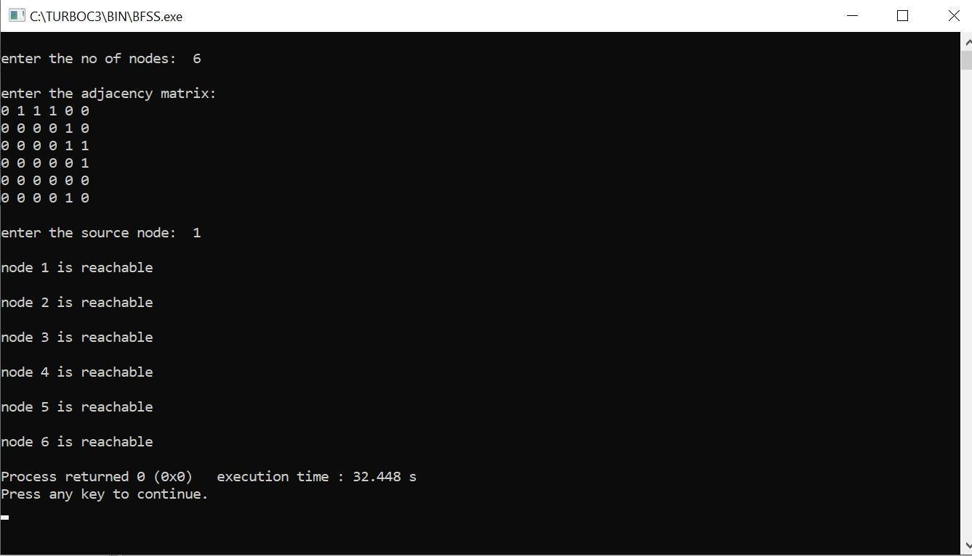
- #include<stdio.h> #include<conio.h
>
int a[10][10],n,vis[10]; int dfs(int);
void main()
{

int i,j,src,ans; for(j=1;j<=n;j++)
{

vis[j]=0;
}

printf("\nenter the no of nodes:\t"); scanf("%d",&n);
printf("\nenter the adjacency matrix:\n"); for(i=1;i<=n;i++)
{

for(j=1;j<=n;j++)
{

scanf("%d",&a[i][j]);
}
}

printf("\nenter the source node:\t"); scanf("%d",&src);
ans=dfs(src); if(ans==1)
{

printf("\ngraph is connected\n");
}

else
{

printf("\ngragh is not connected\n");
}

getch();
}

int dfs(int src)
{
int j; vis[src]=1;
for(j=1;j<=n;j++)
{
if(a[src][j]==1&&vis[j]!=1)
{
dfs(j);
}
}
for(j=1;j<=n;j++)
{
if(vis[j]!=1)
{
return 0;
}
}
return 1;
}
OUTPUT:

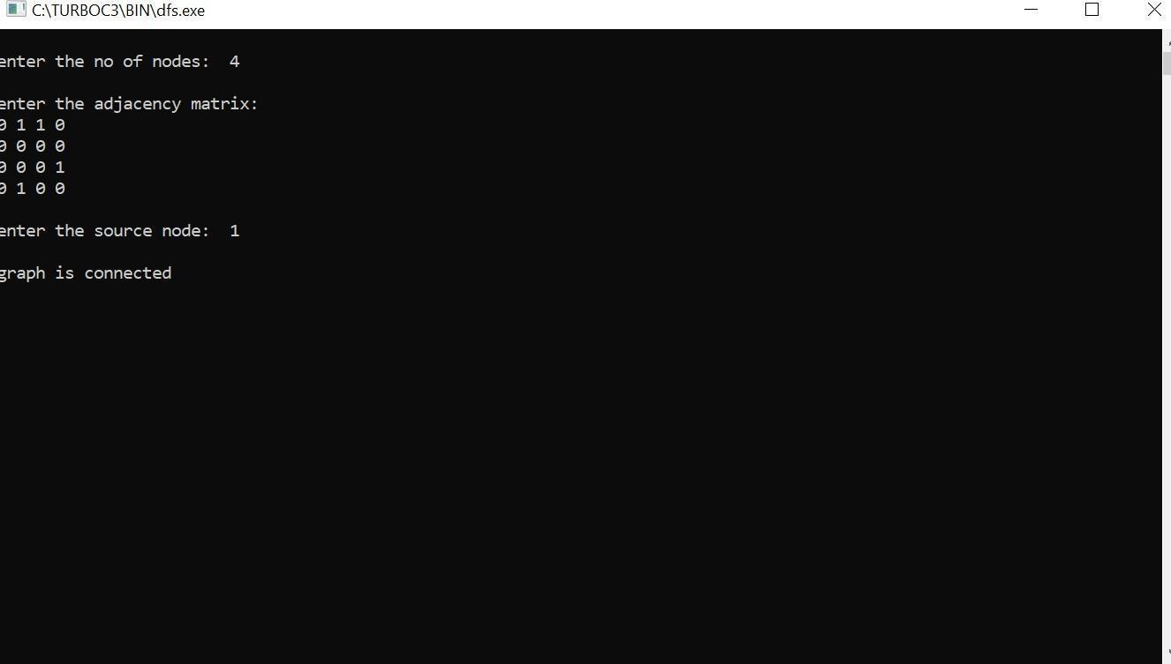

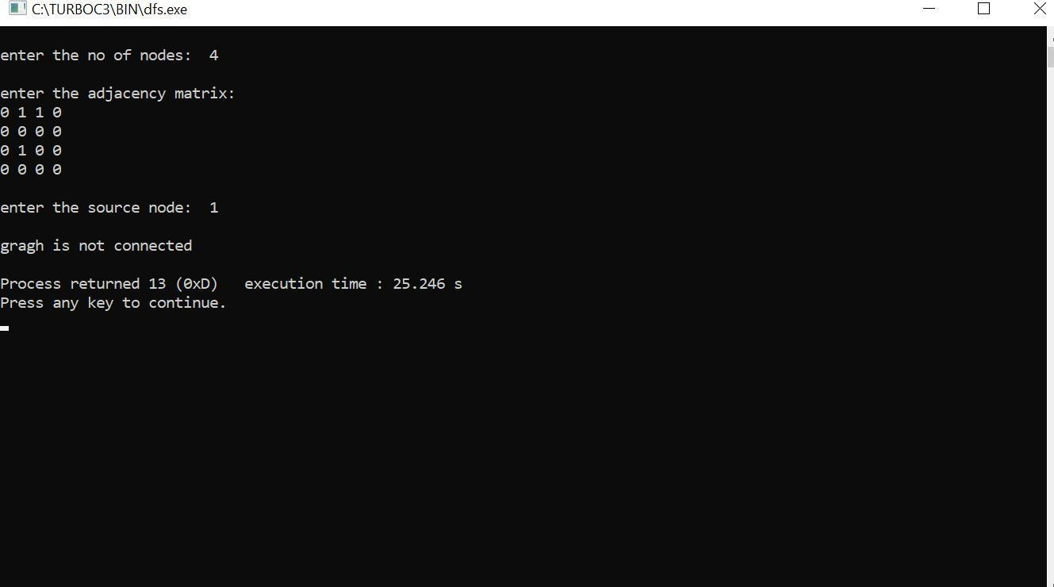

LAB PROGRAM-05

Sort a given set of N integer elements using Insertion Sort technique and compute its time taken. Run the program for different values of N and record the time taken to sort. Plot a graph of the time taken versus N using MS Excel. The program should allow both manual entry of the array elements and also reading of array elements using random number generator.

#include<stdio.h> #include<conio.h
>
#include<time.h>
void insertionsort(int n,int a[])
{

int i,j,val,temp; for(i=1; i<n; i++)
{
val=a[i]; j=i-1;
while(j>=0 && a[j]>val)
{

temp=a[j+1]; a[j+1]=a[j]; a[j]=temp;
j--;
}
a[j+1]=val;
}
}

void main()
{

clock_t start,end;
int a[15500],i,j,temp; int n=100; while(n<1300)
{

for(i=0; i<n; i++)
{

a[i]=n-i;
}

start=clock(); insertionsort(n,a); for(j=0; j<500000; j++)
{

temp=38/600;
}

end=clock();
printf("\n Time taken to sort %d numbers is %f Secs",n, (((double)(end-start))/CLOCKS_PER_SEC));
n=n+100;
}
}

Output:
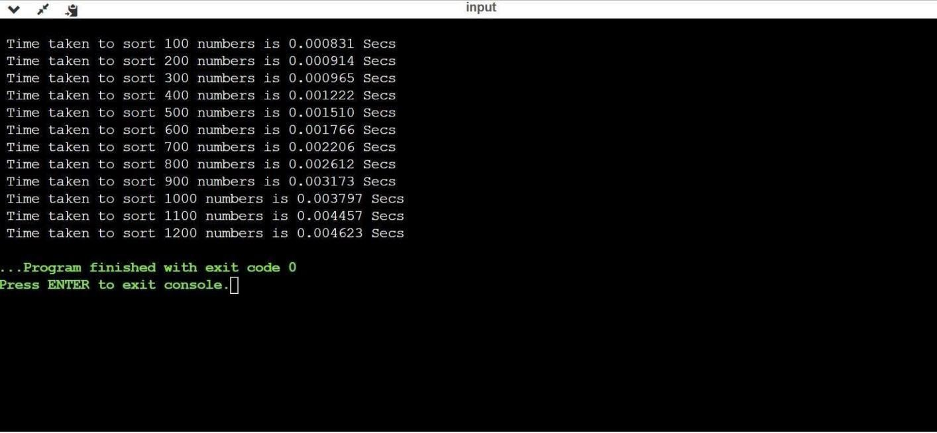

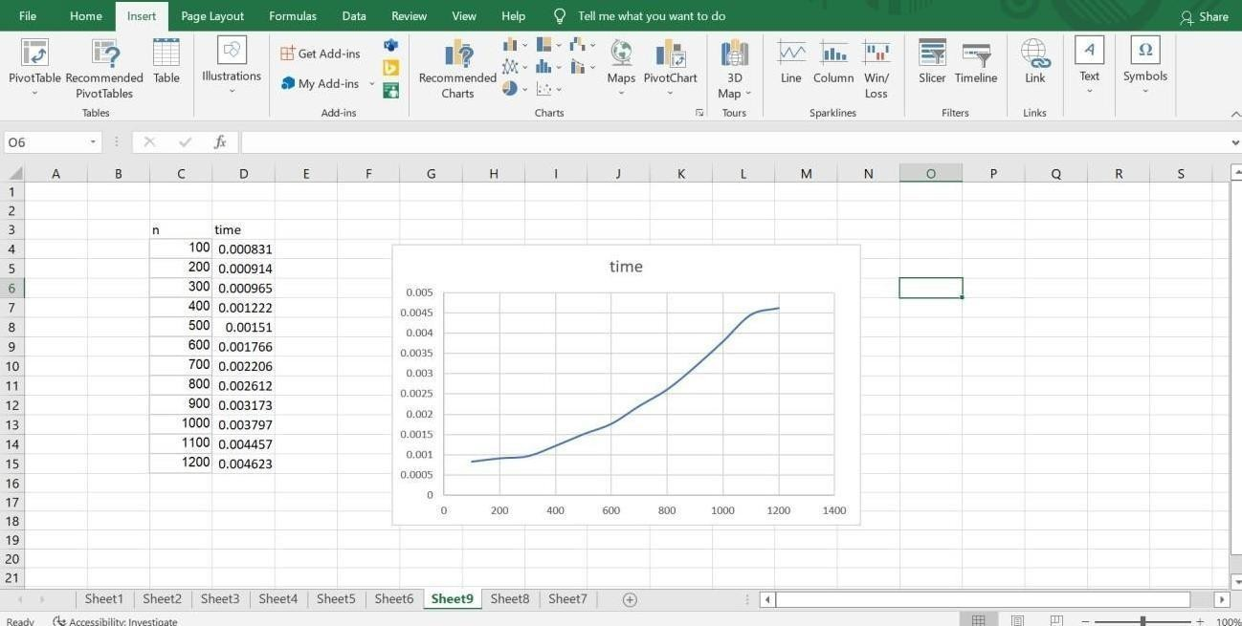

LAB PROGRAM-06

Write program to obtain the Topological ordering of vertices in a given digraph.
#include<stdio.h>

void dfs(int);

int a[10][10],n,e[10],vis[10],j=0; int main()
{

int m, u, v, i;
printf("Enter number of vertices : "); scanf("%d",&n); for(i=1;i<=n;i++)
{

for(j = 1; j<= n; j ++)
{
a[i][j] = 0;
}
}

printf("Enter number of edges : "); scanf("%d",&m); for(i=1;i<=m;i++)
{
printf("Enter an edge : "); scanf("%d%d",&u,&v);
a[u][v] = 1;
}

for(i=1;i<=n;i++) vis[i] = 0;
j=0;
for(i=1;i<=n;i++)
{
if(vis[i] == 0)
dfs(i);
}
printf("Topological order : "); for(i=n-1; i>=0;i--)
printf("%d ", e[i]);

return 0;
}

void dfs(int v)
{

int i; vis[v] = 1;

for(i=1;i<=n;i++)
{

if(a[v][i] == 1 && vis[i] == 0) dfs(i);
}
e[j++] = v;
}
Output:
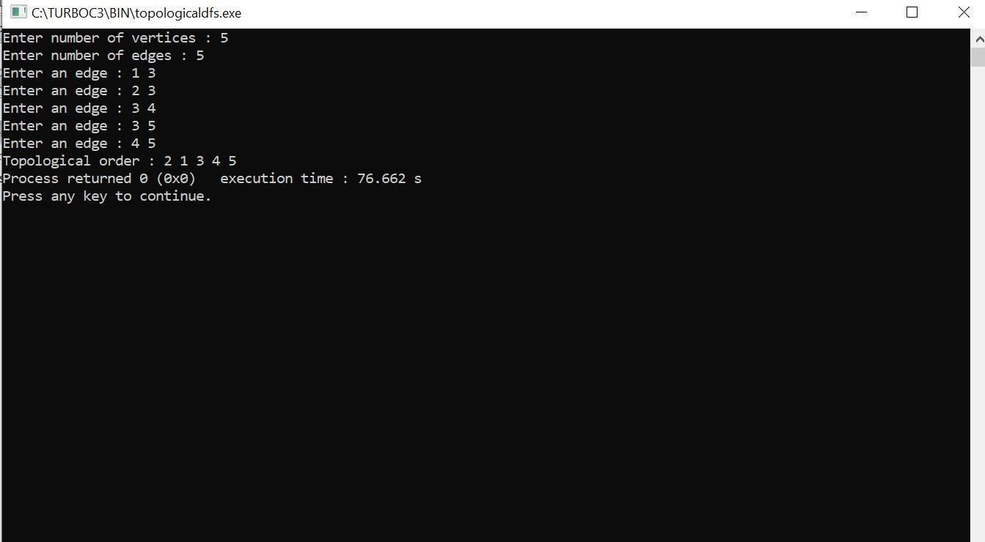

LAB PROGRAM-07

Implement Johnson Trotter algorithm to generate permutations.
#include<stdio.h> #include<conio.h>

int LEFT_TO_RIGHT = 1; int RIGHT_TO_LEFT
= 0;
int searchArr(int a[], int n, int mobile)
{for (int i = 0; i < n; i++) if (a[i] == mobile) return i + 1;
}
int getMobile(int a[], int dir[], int n)
{int mobile_prev = 0, mobile = 0; for (int i = 0; i < n; i++) {

if (dir[a[i]-1] == RIGHT_TO_LEFT && i!=0)
{if (a[i] > a[i-1] && a[i] > mobile_prev)
{ mobile = a[i]; mobile_prev = mobile;
}

}
if (dir[a[i]-1] == LEFT_TO_RIGHT && i!=n-1) {
if (a[i] > a[i+1] && a[i] > mobile_prev)
{
mobile = a[i]; mobile_prev = mobile;
}
}
}

if (mobile == 0 && mobile_prev == 0) return 0;
else
return mobile;
}
int printOnePerm(int a[], int dir[], int n)
{
int mobile = getMobile(a, dir, n); int pos = searchArr(a, n, mobile);

if (dir[a[pos - 1] - 1] == RIGHT_TO_LEFT)
{

printf("\n"); int temp;
temp = a[pos-1] ;
a[pos-1] = a[pos-2]; a[pos-2]= temp;
}

else if (dir[a[pos - 1] - 1] == LEFT_TO_RIGHT)
{
printf("\n"); int temp;
temp = a[pos] ; a[pos] = a[pos-1]; a[pos-1]= temp;
}
for (int i = 0; i < n; i++)
{
if (a[i] > mobile)
{
if (dir[a[i] - 1] == LEFT_TO_RIGHT) dir[a[i] - 1] = RIGHT_TO_LEFT;
else if (dir[a[i] - 1] == RIGHT_TO_LEFT) dir[a[i] - 1] = LEFT_TO_RIGHT;
}

}
for (int i = 0; i < n; i++) printf(" %d", a[i]);

}
int fact(int n)
{
int res = 1; int i;
for (i = 1; i <= n; i++) res = res * i; return res;
}
void printPermutation(int n)
{

int a[n]; int dir[n];
printf("\n");

printf("\n");
for (int i = 0; i < n; i++)
{
a[i] = i + 1;
printf("%d \n", a[i]); printf("\n");
}
printf("\n");
for (int i = 0; i < n; i++) dir[i] = RIGHT_TO_LEFT;
for (int i = 1; i < fact(n); i++)

printOnePerm(a, dir, n); printf("\n");
}
int main()
{
int n;
printf("\n Enter the value of n:N"); scanf("%d",&n); printf("\n"); printPermutation(n); printf("\n");
return 0;
}
Output:
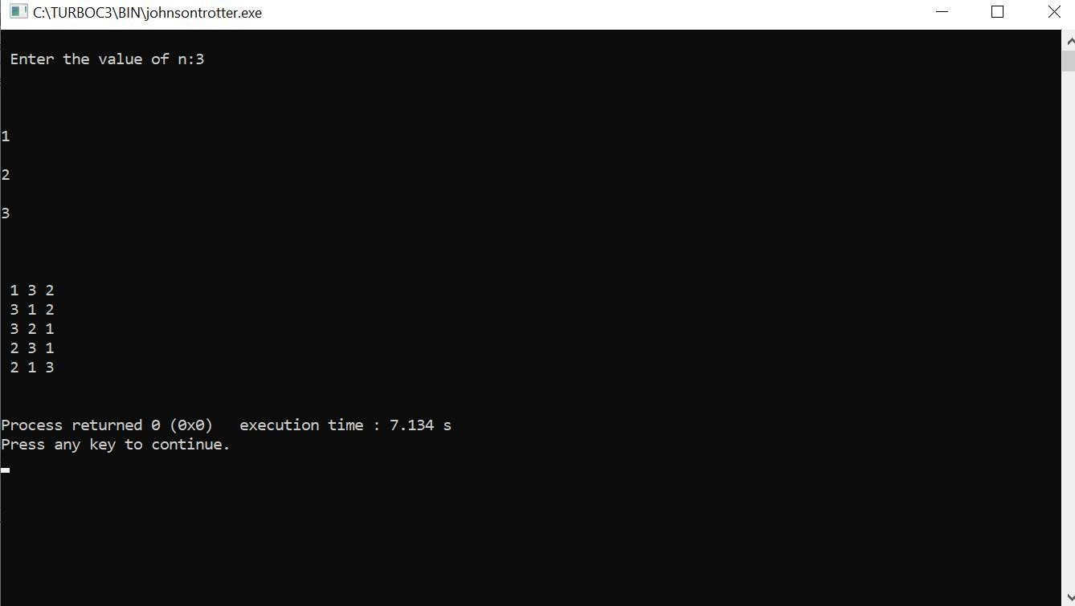

LAB PROGRAM-08

Sort a given set of N integer elements using Merge Sort technique and compute its time taken. Run the program for different values of N and record the time taken to sort.
#include<stdio.h> #include<time.h> #include<stdlib.h> void split(int[],int,int);
void combine(int[],int,int,int); void main()
{
int a[15000],n, i,j,ch, temp; clock_t start,end; while(1)
{
printf("\n1:For manual entry of N value and array elements");
printf("\n2:To display time taken for sorting number of elements N in the range 500 to 14500");
printf("\n3:To exit"); printf("\nEnter your choice:"); scanf("%d",&ch); switch(ch)
{
case 1: printf("\nEnter the number of elements:");

scanf("%d",&n);
printf("\nEnter array elements:"); for(i=0;i<n;i++)
{
scanf("%d",&a[i]);
}
start=clock(); split(a,0,n-1)
;
end=clock(); printf("\nSorted array is:"); for(i=0;i<n;i++)
printf("%d\t",a[i]);

printf("\n Time taken to sort %d numbers is %f Secs",n, (((double)(end- start))/CLOCKS_PER_SEC));

break;

case 2: n=500;
while(n<=14500)
{
for(i=0;i<n;i++)
{

a[i]=n-i;
}
start=clock(); split(a,0,n-1)
;
for(j=0;j<500000;j++){ temp=38/600;} end=clock();
printf("\n Time taken to sort %d numbers is %f Secs",n, (((double)(end- start))/CLOCKS_PER_SEC));

n=n+1000;
}
break;
case 3: exit(0);
}
getchar();
}
}
void split(int a[],int low,int high)
{
int mid; if(low<high)
{
mid=(low+high)/2; split(a,low,mid); split(a,mid+1,high); combine(a,low,mid,high);
}

}
void combine(int a[],int low,int mid,int high)
{
int c[15000],i,j,k;
i=k=low; j=mid+1;
while(i<=mid &&j<=high)
{
if(a[i]<a[j])
{
c[k]=a[i];
++k;
++i;
}
else
{
c[k]=a[j];
++k;
++j;
}
}
if(i>mid)
{
while(j<=high)
{
c[k]=a[j];
++k;
++j;
}
}
if(j>high)
{
while(i<=mid)
{
c[k]=a[i];
++k;
++i;
}
}
for(i=low;i<=high;i++)
{
a[i]=c[i];
}
}
Output:
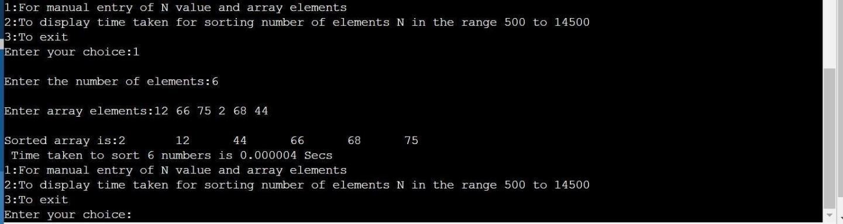

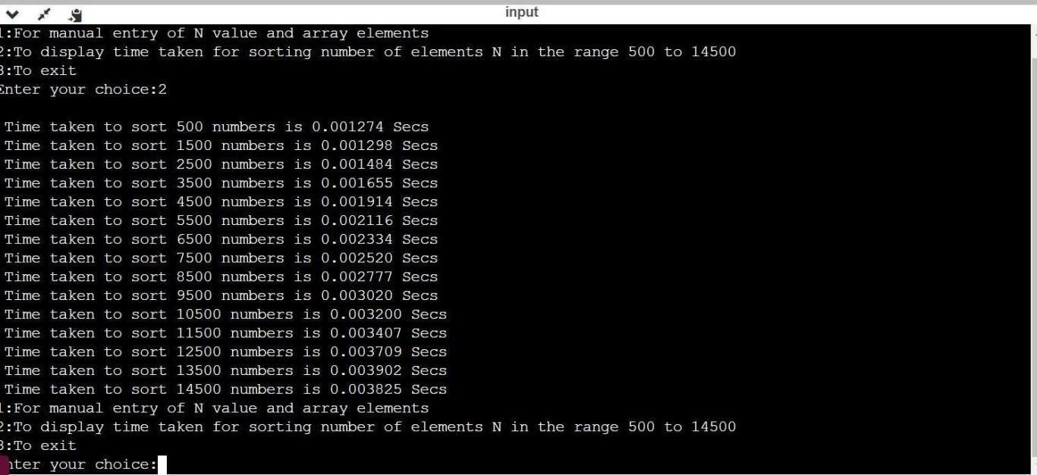
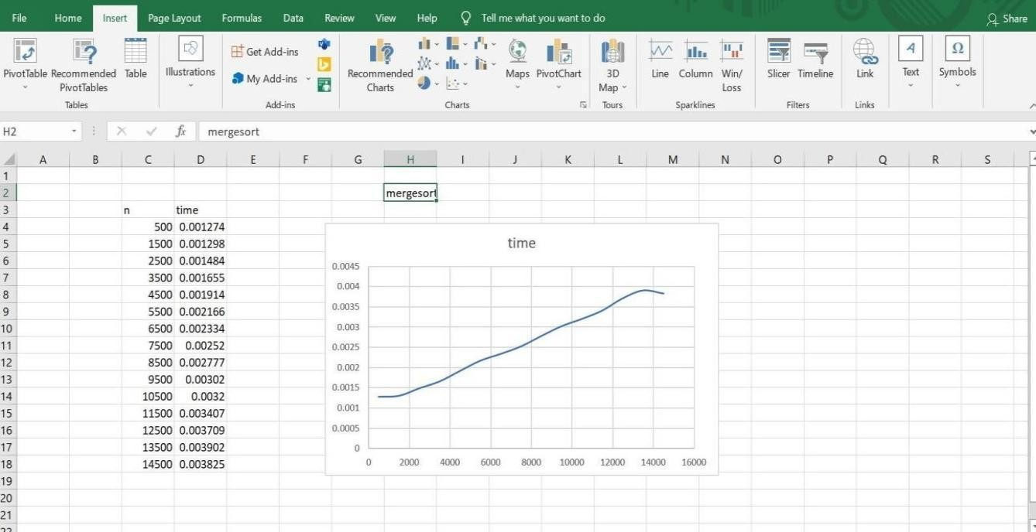

LAB PROGRAM-09

Sort a given set of N integer elements using Quick Sort technique and compute its time taken.
#include<stdio.h> #include<time.h> #include<stdlib.h> #define MAXINT 2000 void delay(int n)
{

int i; for(i=0;i<n;i++)
{
}
}
void quickSort(int number[],int first,int last){int i,j,pivot,temp; if(first<last){
pivot=first; i=first; j=last;
while(i<j){ while(number[i]<=number[pivot]& &i<last){i++;
}
while(number[j]>number[pivot]&&j>first)
{ j--;
}

if(i<j){ temp=number [i];
number[i]=number[j]
; number[j]=temp;
}
}
temp=number[pivot]; number[pivot]=number[j]; number[j]=temp; quickSort(number,first,j-1)
;
quickSort(number,j+1,last)
;
}
}
void main()
{
clock_t start,end; int i,datasize=1; long int n=10000; int *a;
while(datasize<=20){
a=(int
*)calloc(n,sizeof(int)); if(a==NULL){
printf("Insufficiant Memory"); exit(0);
}
for(i=0;i<=n- 1;i++){
a[i]=rand()%MAXI NT;
}
start=clock(); quickSort(a,0,n-1)
; end=clock();
free(a);
if((end-start)!=0){ printf("\n%d\t%f",n,(double)(end-start)/CLK_ TCK); datasize++;
} n+=10000;
}
return;
}

Output:
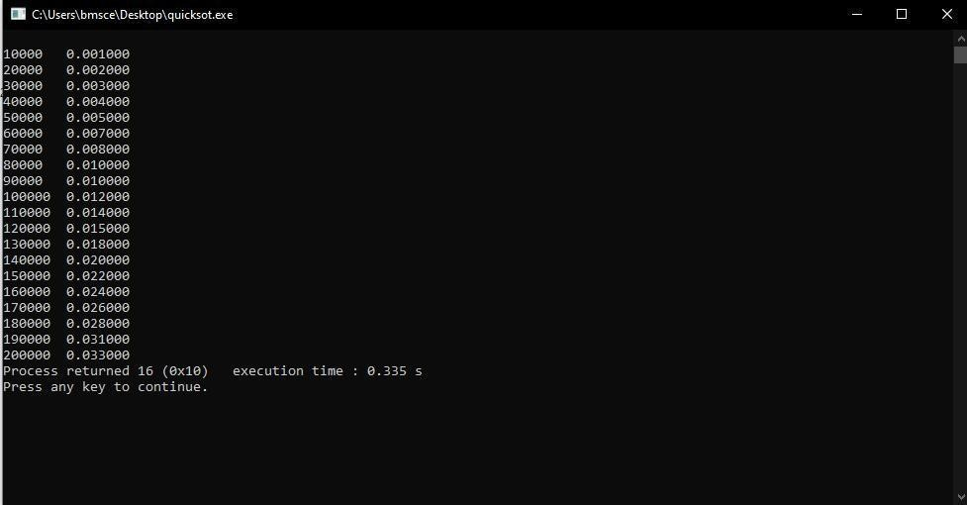

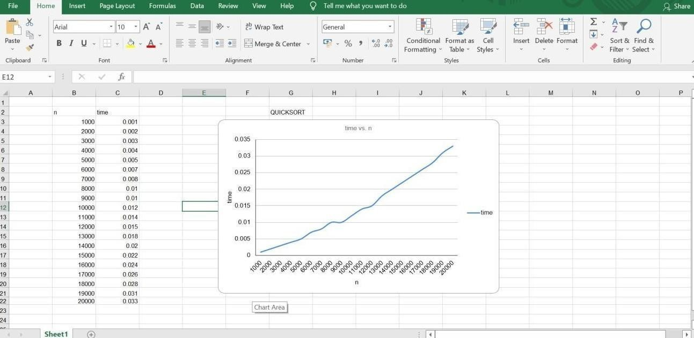
LAB PROGRAM-10

Sort a given set of N integer elements using Heap Sort technique and compute its time taken
#include <stdio.h> #include <time.h> #include <stdlib.h> #include <math.h> void swap(int *,int *);
void heapify(int [],int,int); void heapSort(int[], int);

int main()
{
int a[15000],n,i,j,ch,temp; clock_t start,end; while(1)
{
printf("\n 1: For manual entry of N values and array elements:"); printf("\n 2: To display time taken for sorting number of elements N in
the range 500 to 14500:"); printf("\n 3: To exit"); printf("\n Enter your choice:"); scanf("%d",&ch);
switch(ch)
{
case 1: printf("\n Enter the number of elements:"); scanf("%d",&n);
printf("\n Enter array elements:"); for(i=0;i<n;i++)
{
scanf("%d",&a[i]);
}
start=clock(); heapSort(a, n); end=clock();
printf("\n Sorted array is:");
for(i=n-1;i>=0;i--){
printf("%d\t",a[i]);
}
printf("\n Time taken to sort %d numbers is %f secs",n,((double)(end-start)/CLOCKS_PER_SEC));
break; case 2:
n=500;
while(n<=14500){ for(i=0;i<n;i++){
a[i]=n-i;

}
start=clock(); heapSort(a, n);
for(j=0;j<50000000;j++){
temp=38/600;

}
end=clock();
printf("\n Time taken to sort %d numbers is %f secs",n,((double)(end-start)/CLOCKS_PER_SEC));
n=n+1000;

}
break;

case 3: exit(0);
}

}
}
void swap(int *a, int *b)
{
int temp = *a;
*a = *b;
*b = temp;
}
void heapify(int arr[], int n, int i)
{
int largest = i;
int left = 2 * i + 1; int right = 2 * i + 2;
if (left < n && arr[left] > arr[largest]) largest = left;
if (right < n && arr[right] > arr[largest]) largest = right;
if (largest != i)
{
swap(&arr[i], &arr[largest]); heapify(arr, n, largest);
}
}
void heapSort(int arr[], int n)
{
for (int i = n / 2 - 1; i >= 0; i--) heapify(arr, n, i);
for (int i = n - 1; i >= 0; i--)
{
swap(&arr[0], &arr[i]); heapify(arr, i, 0);
}
}
OUTPUT:

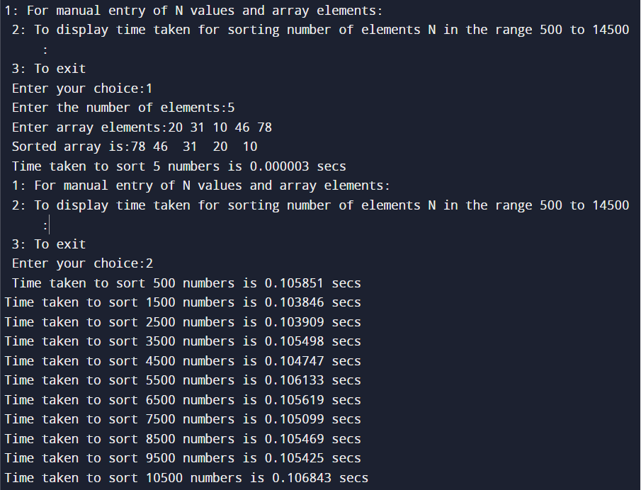

LAB PROGRAM-11

Implement Warshall’s algorithm using dynamic programming
#include<stdio.h> #include<conio.h> #include<math.h>

int max(int,int);

void warshal(int p[10][10],int n) { int i,j,k;
for (k=1;k<=n;k++) for (i=1;i<=n;i++) for (j=1;j<=n;j++)
p[i][j]=max(p[i][j],p[i][k]&&p[k][j]);
}
int max(int a,int b) {
;
if(a>b) return(a); else return(b);
}
void main() {
int p[10][10]= {
0
}
,n,e,u,v,i,j;
printf("\n Enter the number of vertices:"); scanf("%d",&n);
printf("\n Enter the number of edges:"); scanf("%d",&e);
for (i=1;i<=e;i++) {
printf("\n Enter the end vertices of edge %d:",i); scanf("%d%d",&u,&v);
p[u][v]=1;
}
printf("\n Matrix of input data: \n"); for (i=1;i<=n;i++) {
for (j=1;j<=n;j++) printf("%d\t",p[i][j]);
printf("\n");
}
warshal(p,n);
printf("\n Transitive closure: \n"); for (i=1;i<=n;i++) {
for (j=1;j<=n;j++) printf("%d\t",p[i][j]);
printf("\n");
}
getch();
}
OUTPUT:

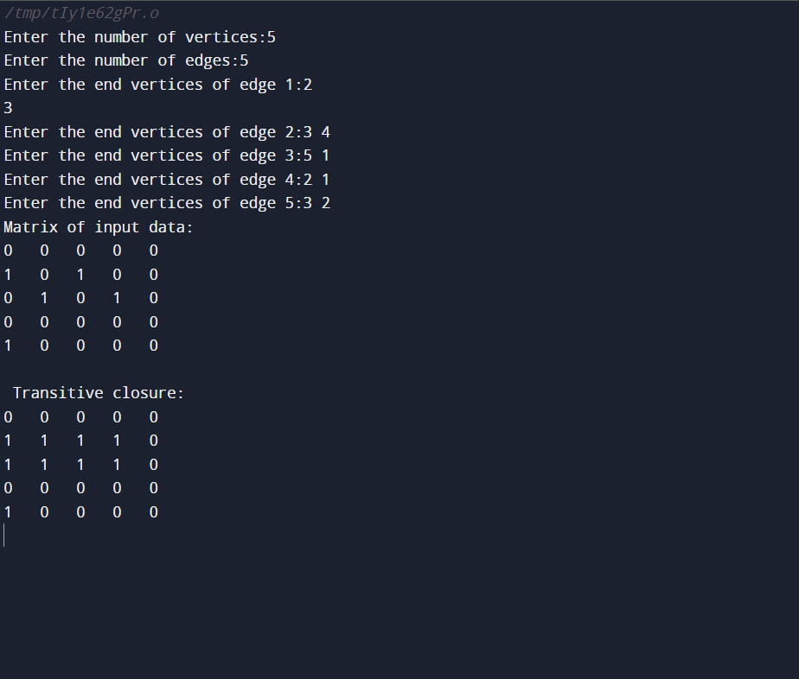

LAB PROGRAM-12

Implement 0/1 Knapsack problem using dynamic programming.

#include<stdio.h> void knapsack(); int max(int,int);
int i,j,n,m,p[10],w[10],v[10][10]; void main()
{
printf("\n enter the no. of items:\t"); scanf("%d",&n);
printf("\n enter the weight of the each item:\n "); for(i=1;i<=n;i++)
{
scanf("%d",&w[i]);
}
printf("\n enter the profit of each item:\n "); for(i=1;i<=n;i++)
{
scanf("%d",&p[i]);
}
printf("\n enter the knapsack's capacity:\t "); scanf("%d",&m);
knapsack();

}
void knapsack()
{
int x[10]; for(i=0;i<=n;i++)
{
for(j=0;j<=m;j++)
{
if(i==0||j==0)
{
v[i][j]=0;
}
else if(j-w[i]<0)
{
v[i][j]=v[i-1][j];
}
else
{
v[i][j]=max(v[i-1][j],v[i-1][j-w[i]]+p[i]);
}
}
}
printf("\n the output is:\n"); for(i=0;i<=n;i++)
{
for(j=0;j<=m;j++)
{
printf("%d\t",v[i][j]);
}
printf("\n\n");
}
printf("\nthe optimal solution is %d",v[n][m]); printf("\nthe solution vector is:\n"); for(i=n;i>=1;i--)
{
if(v[i][m]!=v[i-1][m])
{

x[i]=1;
m=m-w[i];
}
else
{ x[i]=0;
}
}
for(i=1;i<=n;i++)
{
printf("%d\t",x[i]);
}
}
int max(int x,int y)
{
if(x>y)
{
return x;
}
else
{
return y;
}
}

OUTPUT:

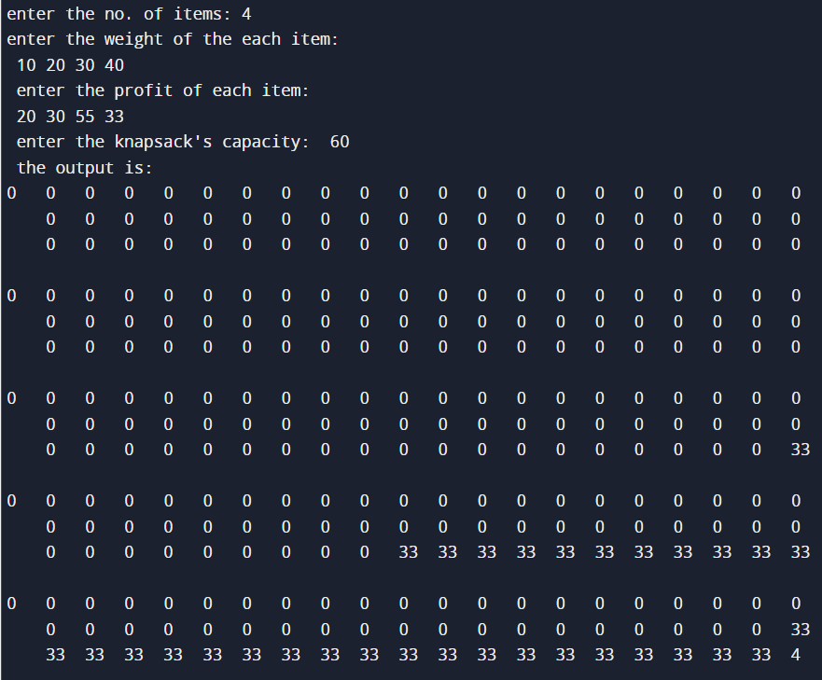

LAB PROGRAM-13

Implement All Pair Shortest paths problem using Floyd’s algorithm

#include<stdio.h>

int a[10][10],n; void floyds(); int min(int,int); void main()
{
int i,j;

printf("\n enter the no. of vertices:\t"); scanf("%d",&n);
printf("\n enter the cost matrix:\n"); for(i=1;i<=n;i++)
{
for(j=1;j<=n;j++)
{
scanf("%d",&a[i][j]);
}
}
floyds();

}
void floyds()
{
int i,j,k; for(k=1;k<=n;k++)
{
for(i=1;i<=n;i++)
{
for(j=1;j<=n;j++)
{
a[i][j]=min(a[i][j],a[i][k]+a[k][j]);
}
}
}
printf("\n all pair shortest path matrix is:\n"); for(i=1;i<=n;i++)
{
for(j=1;j<=n;j++)
{
printf("%d\t",a[i][j]);
}
printf("\n\n");
}

}
int min(int x,int y)
{
if(x<y)
{
return x;
}
else
{
return y;
}
}

OUTPUT:

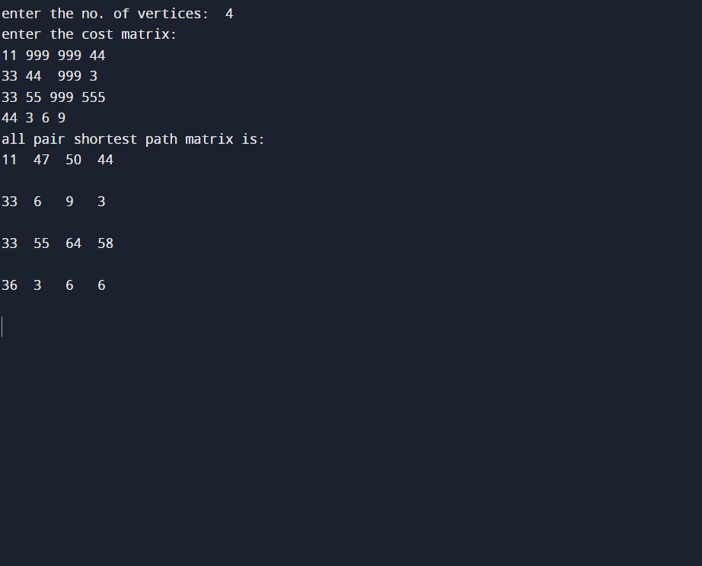

LAB PROGRAM-14

Find Minimum Cost Spanning Tree of a given undirected graph using Prim’s algorithm.

#include<stdio.h> void prims();
int c[10][10],n; void main()
{
int i,j;
printf("\nenter the no. of vertices:\t"); scanf("%d",&n);
printf("\nenter the cost matrix:\n"); for(i=1;i<=n;i++)
{
for(j=1;j<=n;j++)
{
scanf("%d",&c[i][j]);
}
}
prims();
}
void prims()
{
int i,j,u,v,min;
int ne=0,mincost=0; int elec[10]; for(i=1;i<=n;i++)
{
elec[i]=0;
}
elec[1]=1; while(ne!=n-1)
{
min=9999; for(i=1;i<=n;i++)
{
for(j=1;j<=n;j++)
{
if(elec[i]==1)
{
if(c[i][j]<min)
{
min=c[i][j]; u=i;
v=j;
}
}
}
}
if(elec[v]!=1)
{
printf("\n%d >%d=%d\n",u,v,min);
elec[v]=1;

ne=ne+1; mincost=mincost+min;
} c[u][v]=c[v][u]=9999;
}
printf("\nmincost=%d",mincost);
}

OUTPUT:

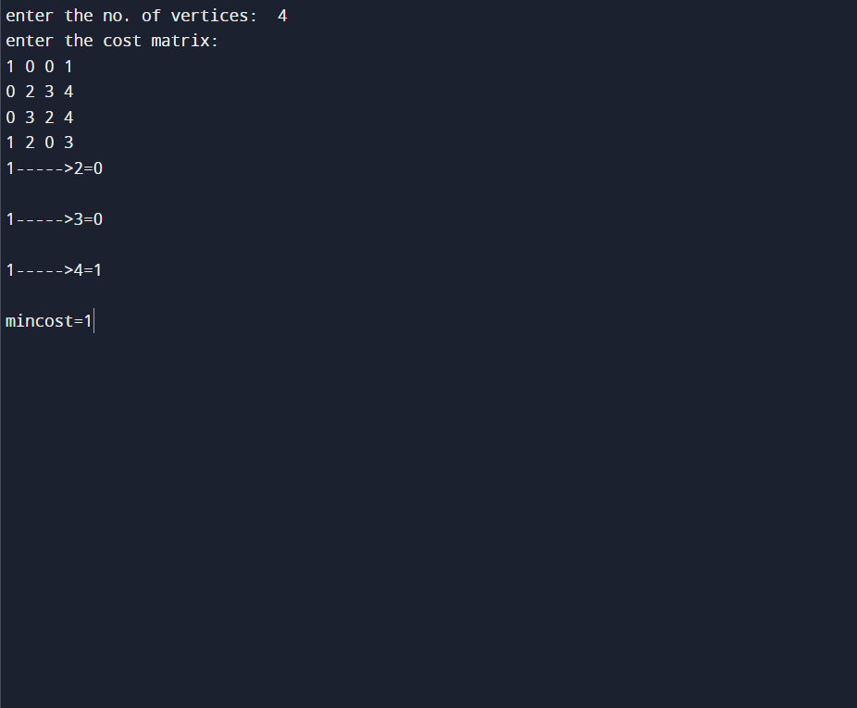

LAB PROGRAM-15

Find Minimum Cost Spanning Tree of a given undirected graph using Kruskals algorithm

#include<stdio.h>

void kruskals(); int c[10][10],n;

void main()
{
int i,j;

printf("\n enter the no. of vertices:\t"); scanf("%d",&n);
printf("\n enter the cost matrix:\n"); for(i=1;i<=n;i++)
{
for(j=1;j<=n;j++)
{
scanf("%d",&c[i][j]);
}
}
kruskals();
}
void kruskals()
{
int i,j,u,v,a,b,min; int ne=0,mincost=0; int parent[10]; for(i=1;i<=n;i++)
{
parent[i]=0;
}
while(ne!=n-1)
{
min=9999; for(i=1;i<=n;i++)
{
for(j=1;j<=n;j++)
{
if(c[i][j]<min)
{
min=c[i][j]; u=a=i; v=b=j;
}
}
}
while(parent[u]!=0)
{
u=parent[u];
}
while(parent[v]!=0)
{
v=parent[v];
}
if(u!=v)
{
printf("\n%d > %d=%d\n",a,b,min);
parent[v]=u; ne=ne+1;
mincost=mincost+min;
} c[a][b]=c[b][a]=9999;
}
printf("\n mincost=%d",mincost);
}
OUTPUT:

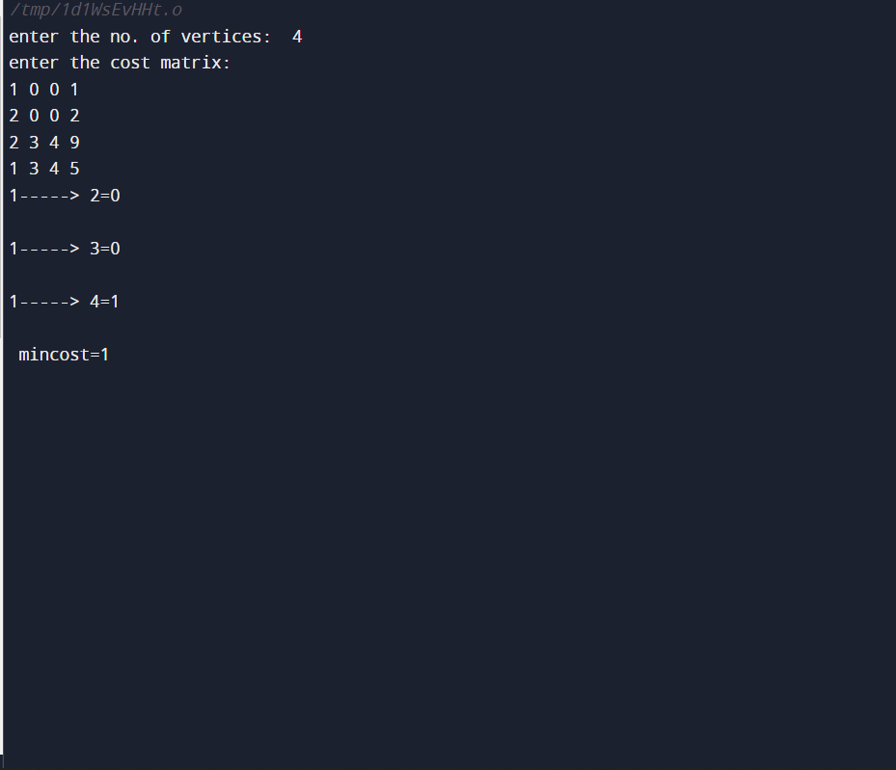

LAB PROGRAM-16

From a given vertex in a weighted connected graph, find shortest paths to other vertices using Dijkstra’s algorithm.

#include<stdio.h> #define infinity 999
void dij(int n,int v,int cost[10][10],int dist[100])
{
int i,u,count,w,flag[10],min; for(i=1;i<=n;i++) flag[i]=0,dist[i]=cost[v][i]; count=2;
while(count<=n)
{
min=99; for(w=1;w<=n;w++) if(dist[w]) min=dist[w],u=w; flag[u]=1;
count++; for(w=1;w<=n;w++) if(dist[u]+cost[u][w])
dist[w]=dist[u]+cost[u][w];
}
}
void main()
{
int n,v,i,j,cost[10][10],dist[10];

printf("\n Enter the number of nodes:"); scanf("%d",&n);
printf("\n Enter the cost matrix:\n"); for(i=1;i<=n;i++)
for(j=1;j<=n;j++)
{
scanf("%d",&cost[i][j]); if(cost[i][j]==0) cost[i][j]=infinity;
}
printf("\n Enter the source matrix:"); scanf("%d",&v);
dij(n,v,cost,dist);
printf("\n Shortest path:\n"); for(i=1;i<=n;i++)
if(i!=v)
printf("%d->%d,cost=%d\n",v,i,dist[i]);
}

OUTPUT:

