**Marketplace Technical Foundation - OutdoorGear Rentals**

## **NAME : syed Muhammad owais shah ROLL NO : 00229645 1. System Architecture Overview**

**High-Level Diagram Description**

Our system architecture consists of three primary layers:

1. **Frontend Interface**

**Users:** Adventure enthusiasts, travelers, and event organizers visit the website or mobile app.

**Pages:** Home, Product Listings, Product Details, Cart, Checkout, Order Confirmation, and User Profile.

**Interaction:** Communicates with backend APIs to display real-time data.

1. **Backend (Sanity CMS + Custom APIs)**

**Sanity CMS:** Acts as our central data store for product information, customer details, and order records. Custom schemas are built to mirror our Day 1 business data schema.

**Custom API Layer:** Provides endpoints for product retrieval, order management, rental-specific operations, and shipment tracking. These APIs serve as a bridge between the frontend and the Sanity CMS.

1. **Third-Party Services**

**Payment Gateway:** Processes secure payments during checkout.

**Shipment Tracking API:** Offers real-time updates for delivery status.

**Data Flow (Workflow)**

1. **User visits the site** → The frontend fetches product listings via a GET request to the /products endpoint.
2. **User selects items and initiates checkout** → Order details and customer data are submitted via a POST request to the /orders endpoint.
3. **Order processing** → Sanity CMS records the order; payment processing is triggered through the Payment Gateway.
4. **Shipment tracking** → Once the order is confirmed, a GET request to the /shipment endpoint retrieves real-time delivery updates from the third-party API.
5. **Rental-Specific Flow** → For rental transactions, additional fields such as rental duration, deposit, and condition status are managed via the /rental-duration endpoint.

**2. Key Workflows**

**2.1 User Registration & Profile Management**

* **Workflow:**
  1. User clicks "Sign Up."
  2. Registration form is filled out and submitted.
  3. Data is sent to Sanity CMS via a dedicated API endpoint.
  4. Confirmation email is dispatched.
  5. Profile is created in the CMS.

**2.2 Product Browsing & Details**

* **Workflow:**
  1. User navigates to the Product Listing page.
  2. Frontend sends a GET request to /products.
  3. Sanity CMS returns available products with details like name, price, availability, and images.
  4. User selects a product to view details on a dedicated Product Details page.

**2.3 Order Placement (Rental-Specific)**

* **Workflow:**
  1. User adds one or more items to the cart.
  2. Proceeds to checkout where rental duration, deposit, and pickup/delivery details are specified.
  3. Frontend sends order details via POST request to /orders.
  4. Payment is processed through the Payment Gateway.
  5. Order details (including rental duration) are saved in Sanity CMS.
  6. Confirmation and order tracking details are provided to the user.

**2.4 Shipment & Rental Equipment Tracking**

* **Workflow:**
  1. After order confirmation, the system queries the shipment tracking API via GET /shipment.
  2. Real-time updates (e.g., order status, expected delivery time) are fetched.
  3. Rental equipment pickup/delivery is monitored, and any issues are flagged for customer service follow-up.

**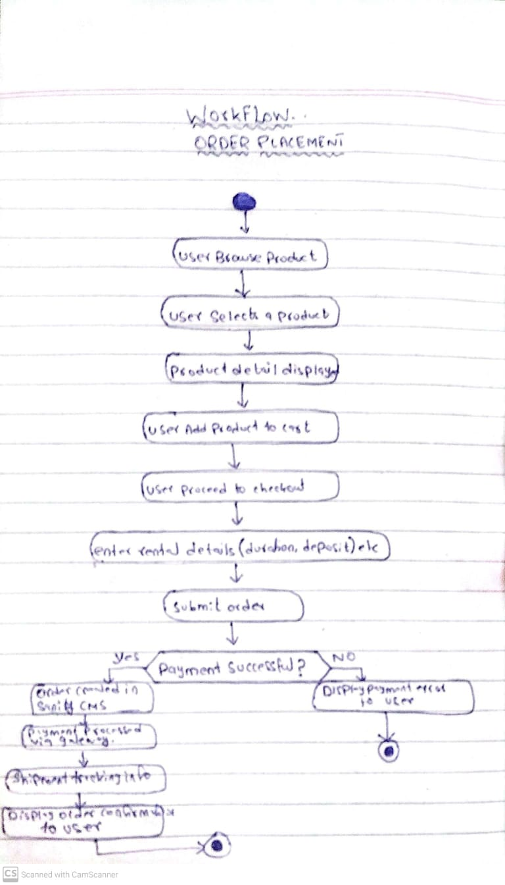  
3. API Requirements & Endpoints:**

|  |  |  |  |
| --- | --- | --- | --- |
| Endpoint | Method | Purpose | Payload/Response Example |
| /products | GET | Fetch all available products from Sanity CMS. | Response: [ { "product_id": 1, "name": "4-Person Camping Tent", "daily_price": 29.99, "availability_status": "Available", ... }, ... ] |
| /orders | POST | Create a new rental order. | Payload: { "customer_id": 123, "product_ids": [1, 2], "start_date": "2025-02-10", "end_date": "2025-02-15", "total_cost": 150.00 } |
| /rental-duration | POST | Specify rental duration and associated rental-specific details (deposit, condition). | Payload: { "order_id": 456, "rentalDuration": 5, "deposit": 50.00, "conditionStatus": "New" } |
| /shipment | GET | Retrieve shipment/tracking information via third-party API. | Response: { "orderId": 456, "shipment_id": "SH123456", "status": "In Transit", "ETA": "2025-02-12T15:00:00Z" } |

**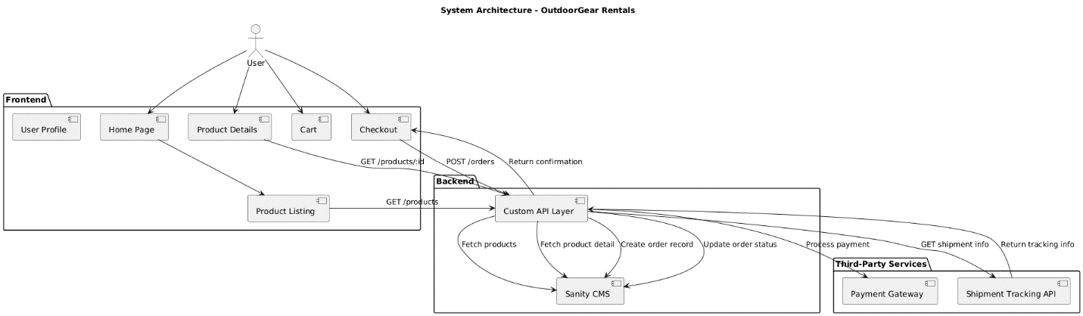  
  
Sanity CMS Schema  
Product Schema (Sanity)**export default {

name: 'product',

title: 'Product',

type: 'document',

fields: [

{ name: 'name', type: 'string', title: 'Product Name' },

{ name: 'category', type: 'string', title: 'Category' },

{ name: 'daily_price', type: 'number', title: 'Daily Rental Price' },

{ name: 'deposit', type: 'number', title: 'Security Deposit' },

{ name: 'availability_status', type: 'string', title: 'Availability Status' },

{ name: 'location', type: 'reference', to: [{ type: 'location' }], title: 'Pickup/Delivery Location' },

{ name: 'image', type: 'image', title: 'Product Image' }

]

}  
**Order Schema (Sanity)**export default {

name: 'order',

title: 'Order',

type: 'document',

fields: [

{ name: 'customer', type: 'reference', to: [{ type: 'customer' }], title: 'Customer' },

{ name: 'products', type: 'array', of: [{ type: 'reference', to: [{ type: 'product' }] }], title: 'Rented Products' },

{ name: 'start_date', type: 'datetime', title: 'Rental Start Date' },

{ name: 'end_date', type: 'datetime', title: 'Rental End Date' },

{ name: 'total_cost', type: 'number', title: 'Total Cost' },

{ name: 'status', type: 'string', title: 'Order Status', options: { list: ['Pending', 'Active', 'Returned', 'Canceled'] } },

{ name: 'rentalDuration', type: 'number', title: 'Rental Duration (days)' },

{ name: 'deposit', type: 'number', title: 'Deposit Amount' }

]

}  
**Customer Schema**export default {

name: 'customer',

title: 'Customer',

type: 'document',

fields: [

{

name: 'name',

type: 'string',

title: 'Customer Name'

},

{

name: 'email',

type: 'string',

title: 'Email Address'

},

{

name: 'phone',

type: 'string',

title: 'Phone Number'

},

{

name: 'address',

type: 'string',

title: 'Address'

},

{

name: 'payment_method',

type: 'string',

title: 'Preferred Payment Method'

}

]

}  
**Payment Schema**export default {

name: 'payment',

title: 'Payment',

type: 'document',

fields: [

{

name: 'order',

type: 'reference',

to: [{ type: 'order' }],

title: 'Associated Order'

},

{

name: 'amount',

type: 'number',

title: 'Payment Amount'

},

{

name: 'status',

type: 'string',

title: 'Payment Status',

options: { list: ['Paid', 'Refunded'] }

},

{

name: 'transaction_date',

type: 'datetime',

title: 'Transaction Date'

}

]

}  
  
**LOCATION SCHEMA:**export default {

name: 'location',

title: 'Location',

type: 'document',

fields: [

{

name: 'address',

type: 'string',

title: 'Address'

},

{

name: 'delivery_zone',

type: 'string',

title: 'Delivery Zone'

}

]

}