AI-Powered Network Anomaly Detection
Built with Cisco Packet Tracer, Python & Scikit-learn
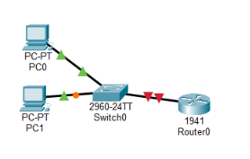
Figure 1 – Cisco Packet Tracer icon

Part 1 — Build the Network in Cisco Packet Tracer

Step 1 — Build the Basic Topology
Open Cisco Packet Tracer. From the bottom-left device menu, add:
- 2 × PCs
- 1 × Switch (2960)
- 1 × Router (1941)
Target topology:
PC1 ─── Switch ─── Router
PC2 ────┘

Connect the Devices
Use Copper Straight-Through cables:
- PC1 FastEthernet0 → Switch Fa0/1
- PC2 FastEthernet0 → Switch Fa0/2
- Switch Fa0/24 → Router GigabitEthernet0/0

Step 2 — Configure the Router
Click Router0 → CLI. Enter these commands one at a time:
enable
configure terminal
interface gigabitEthernet 0/0
ip address 192.168.1.1 255.255.255.0
no shutdown
exit
end
Note: After no shutdown, wait a few seconds — the link between the Switch and Router should turn green.
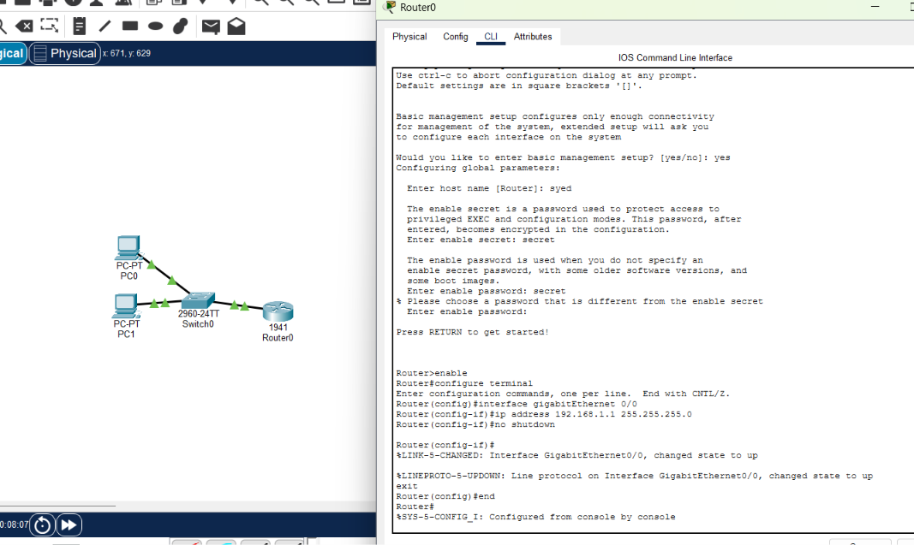
Figure 2 – Router interface brought up successfully

Step 3 — Configure PC0
Click PC0 → Desktop → IP Configuration and enter:
IP Address: 192.168.1.10
Subnet Mask: 255.255.255.0
Default Gateway: 192.168.1.1
Leave DNS empty for now. Don't configure PC1 yet.
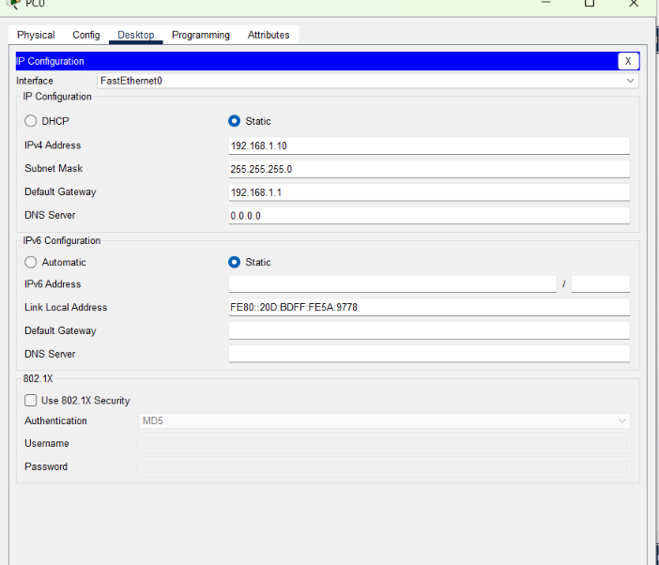
Figure 3 – PC0 IP configuration

Step 4 — Configure PC1
Click PC1 → Desktop → IP Configuration and enter:
IP Address: 192.168.1.11
Subnet Mask: 255.255.255.0
Default Gateway: 192.168.1.1
Leave DNS as-is.
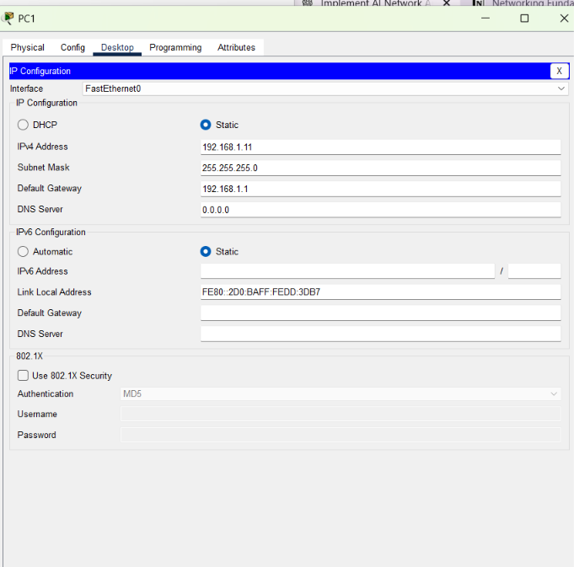
Figure 4 – PC1 IP configuration

Step 5 — Test the Network
Before touching anything AI-related, confirm the basic network works. On PC0 → Desktop → Command Prompt, type:
ping 192.168.1.11
Reply from 192.168.1.11: bytes=32 time<1ms TTL=128
Reply from 192.168.1.11: bytes=32 time<1ms TTL=128
Reply from 192.168.1.11: bytes=32 time<1ms TTL=128
A Reply response confirms the network is working. ✅
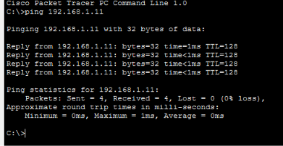
Figure 5 – Successful ping between PC0 and PC1

Part 2 — Generate Network Traffic Data

Step 6 — Generate Baseline Traffic
For the AI to detect an anomaly, we first need network data. On PC0 → Command Prompt, run:
ping 192.168.1.11 -n 20
This sends 20 packets to PC1. Wait until it finishes.
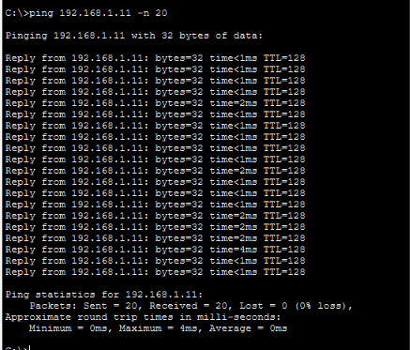
Figure 6 – 20-packet baseline ping

Step 7 — Read Router Traffic Statistics
Close the PC window, then go to Router0 → CLI:
enable
show interfaces gigabitEthernet 0/0
Look for the lines containing: packets input, bytes, packets output, errors.
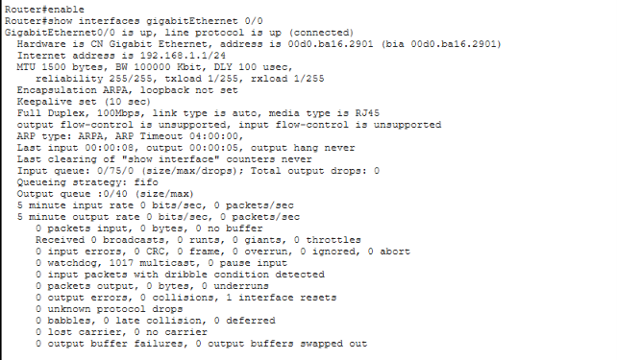
Figure 7 – Router interface counters

Step 8 — Create Abnormal Traffic
Now push the network to behave differently, so the AI model has something to detect. On PC0 → Desktop → Command Prompt, run:
ping 192.168.1.11 -n 100
Let it finish completely.
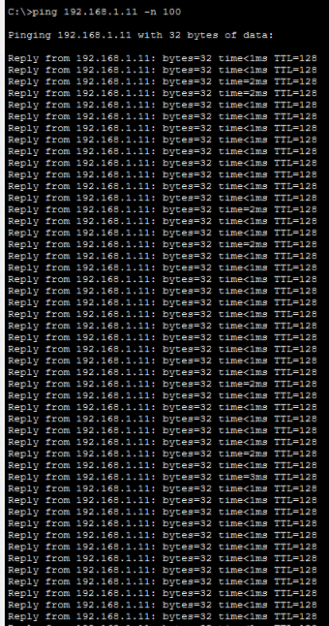
Figure 8 – 100-packet stress ping (part 1)
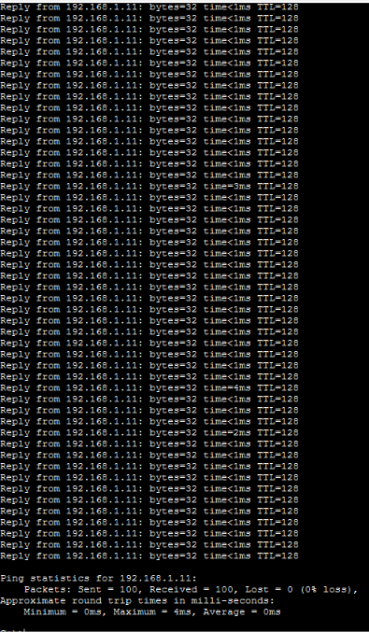
Figure 9 – 100-packet stress ping (part 2)

Step 9 — Check the Router Counters Again
Back on Router0 → CLI, run:
show interfaces gigabitEthernet 0/0
Look at: packets input, bytes, packets output, errors — especially 0 input errors, 0 output errors, 0 drops.
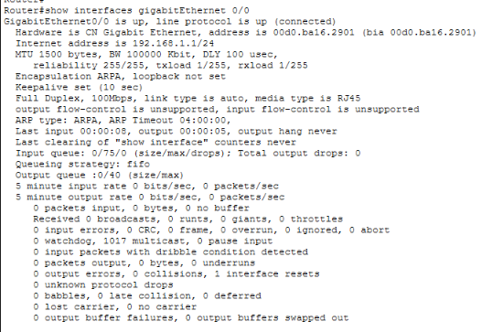
Figure 10 – Router counters after the stress ping
The router still shows 5-minute input/output rates of 0 bits/sec, 0 packets/sec. That's because PC0 → PC1 traffic stays inside the switch — it never passes through Router0. The 100-ping test therefore gave the router nothing to measure. We'll fix that next.

Step 10 — Route Traffic Through the Router
On PC0 → Desktop → Command Prompt, run:
ping 192.168.1.1 -n 100
PC0 (192.168.1.10)
↓
Switch
↓
Router (192.168.1.1)
This traffic reaches Router0, so its interface counters can finally record it.
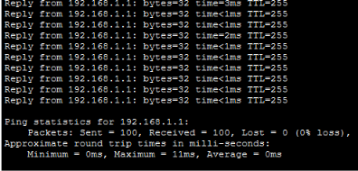
Figure 11 – Ping results routed through Router0

Step 11 — Collect the First Data Point
Open Notepad and create a file named network_data.csv with the header row and first sample:
sample,packets_input,bytes_input,packets_output,bytes_output,input_errors,output_errors,drops
1,100,12800,100,12800,0,0,0
This is the first normal network observation, taken from the router's interface counters:
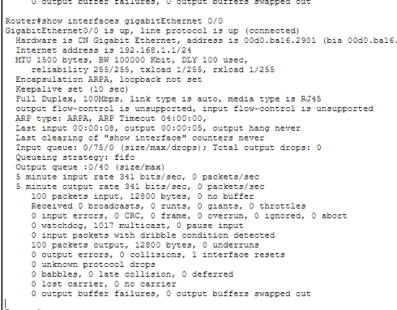
Figure 12 – Router counters used for sample 1

Step 12 — Collect the Second Data Point
Collect another normal traffic observation. On PC0 → Desktop → Command Prompt, run:
ping 192.168.1.1 -n 50
Then on Router0 → CLI, run:
show interfaces gigabitEthernet 0/0
and compare the updated packets input / bytes / packets output / errors.
Note: Router counters are cumulative — don't record the running total as the new sample. Use the difference between readings. For example, if the previous total was 100 packets input and the new total is 150, this sample generated 150 − 100 = 50 packets.
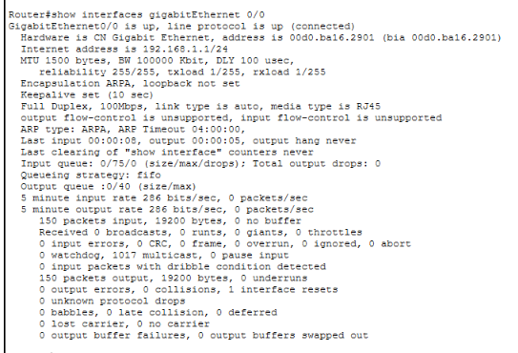
Figure 13 – Router counters for sample 2
For this project, a simulated dataset built from the same metrics observed in Packet Tracer is used to provide enough variety to train the model — this is documented as simulated / sample telemetry rather than a live capture.

Part 3 — Build the Dataset

Step 13 — Complete Dataset
The full 30-sample dataset saved to network_data.csv:
Sample | Packets In | Bytes In | Packets Out | Bytes Out | Input Errors | Output Errors | Drops
1 | 100 | 12800 | 100 | 12800 | 0 | 0 | 0
2 | 50 | 6400 | 50 | 6400 | 0 | 0 | 0
3 | 80 | 10240 | 80 | 10240 | 0 | 0 | 0
4 | 65 | 8320 | 65 | 8320 | 0 | 0 | 0
5 | 120 | 15360 | 120 | 15360 | 0 | 0 | 0
6 | 90 | 11520 | 90 | 11520 | 0 | 0 | 0
7 | 75 | 9600 | 75 | 9600 | 0 | 0 | 0
8 | 110 | 14080 | 110 | 14080 | 0 | 0 | 0
9 | 95 | 12160 | 95 | 12160 | 0 | 0 | 0
10 | 130 | 16640 | 130 | 16640 | 0 | 0 | 0
11 | 70 | 8960 | 70 | 8960 | 0 | 0 | 0
12 | 85 | 10880 | 85 | 10880 | 0 | 0 | 0
13 | 105 | 13440 | 105 | 13440 | 0 | 0 | 0
14 | 115 | 14720 | 115 | 14720 | 0 | 0 | 0
15 | 125 | 16000 | 125 | 16000 | 0 | 0 | 0
16 | 100 | 12800 | 100 | 12800 | 0 | 0 | 0
17 | 135 | 17280 | 135 | 17280 | 0 | 0 | 0
18 | 145 | 18560 | 145 | 18560 | 0 | 0 | 0
19 | 155 | 19840 | 155 | 19840 | 0 | 0 | 0
20 | 165 | 21120 | 165 | 21120 | 0 | 0 | 0
21 | 450 | 57600 | 440 | 56320 | 8 | 5 | 3
22 | 520 | 66560 | 510 | 65280 | 12 | 8 | 6
23 | 600 | 76800 | 590 | 75520 | 15 | 10 | 8
24 | 700 | 89600 | 680 | 87040 | 20 | 15 | 12
25 | 800 | 102400 | 780 | 99840 | 25 | 18 | 15
26 | 75 | 9600 | 75 | 9600 | 0 | 0 | 0
27 | 90 | 11520 | 90 | 11520 | 0 | 0 | 0
28 | 680 | 87040 | 660 | 84480 | 18 | 12 | 10
29 | 750 | 96000 | 730 | 93440 | 22 | 16 | 14
30 | 850 | 108800 | 820 | 104960 | 30 | 20 | 18
Rows shaded red contain non-zero errors or drops and represent abnormal traffic.
What the dataset represents:
- Samples 1–20: normal traffic
- Samples 21–25: abnormal traffic
- Samples 26–27: normal traffic again
- Samples 28–30: abnormal traffic
Normal: Anomaly:
100 packets 800+ packets
0 errors ──▶ 20+ errors
0 drops 10+ drops
This variation is what lets the model demonstrate real anomaly detection, instead of learning from only two or three points.
Project data flow so far:
Cisco Packet Tracer
↓
Simulated Network Metrics
↓
network_data.csv
↓
Python
↓
Machine Learning
↓
Anomaly Detection
↓
Normal / Anomaly

Part 4 — AI Analysis in Python

Step 14 — Install the Python AI Libraries
Open Command Prompt / PowerShell and run:
pip install pandas scikit-learn
- Pandas → reads network_data.csv
- Scikit-learn → runs the AI anomaly-detection algorithm
Then confirm the Python version:
python --version
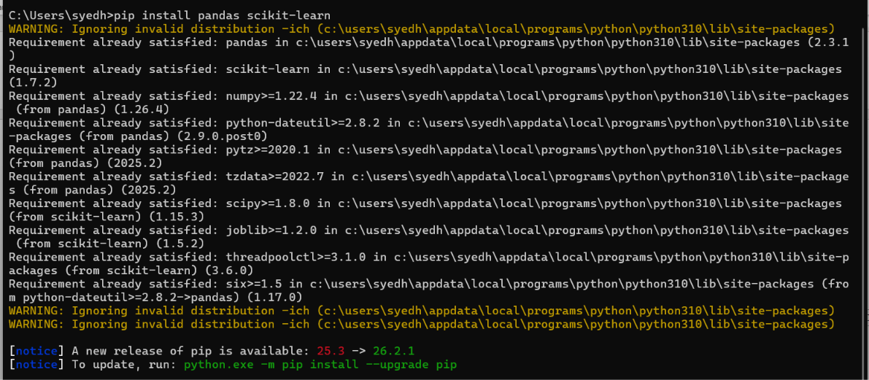
Figure 14 – Library installation confirmed

Step 15 — AI Anomaly Detection
Script: ai_network_analytics.py
Uses Isolation Forest to flag unusual network behavior from packet count, bytes, input/output errors, and packet drops, classifying each sample as NORMAL or ANOMALY.

Step 16 — Run Anomaly Detection
python ai_network_analytics.py
The script analyzes network_data.csv and writes the results to ai_results.csv.

Step 17 — Predictive Analytics
Script: predictive_analytics.py — uses Linear Regression to forecast future packet traffic:
Sample 31 → 590 packets
Sample 32 → 612 packets
Sample 33 → 633 packets
Sample 34 → 655 packets
Sample 35 → 677 packets
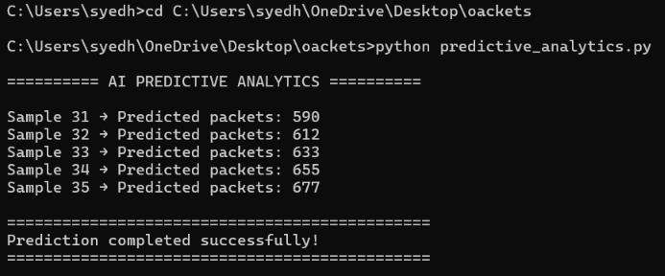
Figure 15 – Predictive analytics output

Step 18 — Combined AI Dashboard
Script: ai_network_dashboard.py — combines Anomaly Detection + Predictive Analytics into a single program.

Step 19 — Improved Anomaly Detection
Added a hybrid approach:
Isolation Forest
+
Network Behavior Thresholds
↓
Final Anomaly Decision
Each anomaly now includes a plain-language reason, such as:
- High packet volume
- High input errors
- Packet drops
- ML detected unusual pattern

Step 20 — Run the Final AI Dashboard
python ai_network_dashboard.py
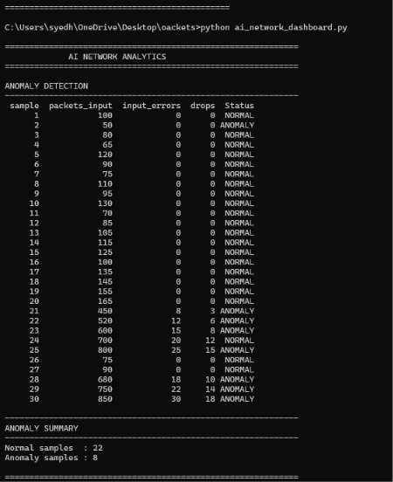
Figure 16 – Dashboard: anomaly detection table
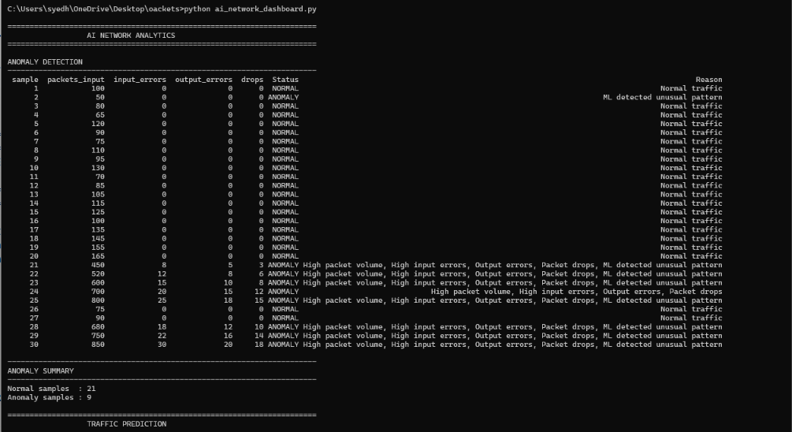
Figure 17 – Dashboard: detailed anomaly reasons
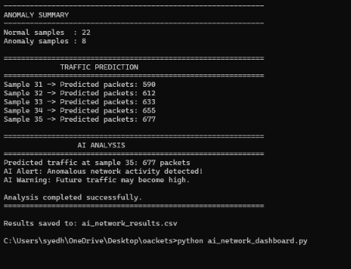
Figure 18 – Dashboard: summary, prediction & AI analysis
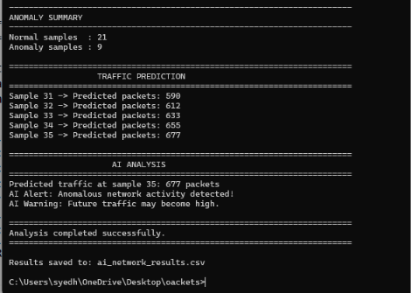
Figure 19 – Dashboard: final analysis output
Final result: 21 normal samples, 9 anomaly samples. The system also predicted increasing future traffic and raised an AI alert for anomalous activity.

Step 21 — Visualization
Script: network_graph.py — generates anomaly_detection.png and traffic_prediction.png.
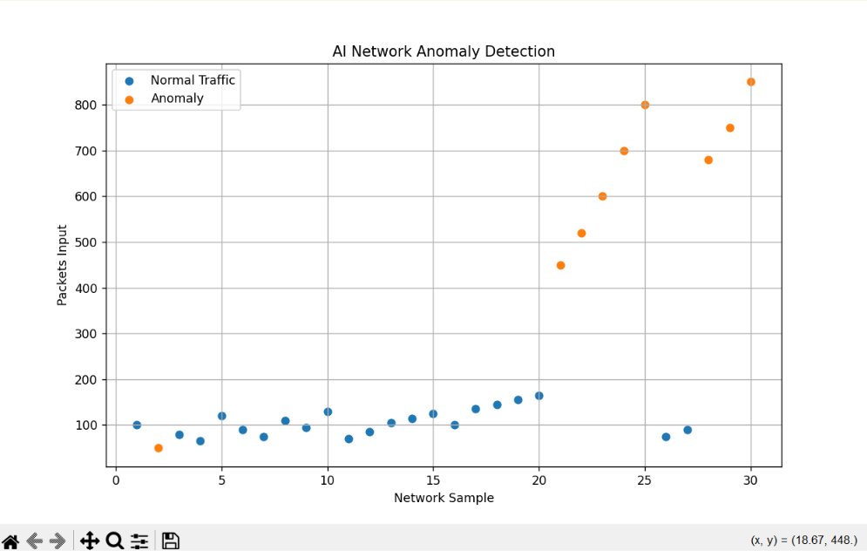
Figure 20 – Anomaly detection scatter plot (blue = normal, orange = anomaly)

Final Project Summary
Cisco Packet Tracer
↓
Network Simulation
↓
Network Dataset
↓
Python
↓
┌───────────────────────┐
│ AI Network Analytics │
├───────────────────────┤
│ Anomaly Detection │
│ Predictive Analytics │
│ Visualization │
└───────────────────────┘
Project status: COMPLETED ✅

