LangAssist- AI writing Assistant

Introduction:
In recent years, the use of intelligent computer systems has increased significantly in various fields such as education, customer service, healthcare, and communication. One of the most popular applications of such systems is the chatbot. A chatbot is a computer program designed to simulate human conversation and assist users by providing automated responses to their queries. Chatbots can interact with users through text or voice interfaces and are widely used to provide quick and efficient assistance.
Chatbots are generally classified into two types: rule-based chatbots and AI-based chatbots. Rule-based chatbots operate using predefined rules and patterns to generate responses, while AI-based chatbots use machine learning and natural language processing techniques to understand user input more intelligently. Rule-based chatbots are easier to design and implement and are suitable for applications where the range of possible queries is limited and well-defined.
With the increasing demand for digital writing tools, many users require assistance in improving their written content. Tasks such as paraphrasing text, generating paragraphs, adjusting writing tone, and checking plagiarism can be time-consuming when done manually. Therefore, there is a need for a simple and efficient tool that can assist users in performing these tasks quickly.
The main aim of this project is to develop a rule-based chatbot writing assistant that helps users improve their text content. The chatbot provides several useful features including text paraphrasing, paragraph generation, tone adjustment, and basic plagiarism detection. The system is implemented as a web-based application using Python and the Flask framework, along with HTML, CSS, and JavaScript for the user interface.
The developed system allows users to interact through a simple web interface where they can input text and receive processed output based on predefined rules and algorithms. By automating common writing tasks, the chatbot helps users enhance the quality of their written content and save time.
This project demonstrates how rule-based techniques can be effectively used to design a functional chatbot system that provides useful assistance in text processing and writing improvement.

Problem Statement:
In today's digital world, written communication plays a very important role in education, business, and professional environments. Many users such as students, researchers, and content creators often face difficulties while writing or improving their text. Tasks like paraphrasing sentences, generating paragraphs on a specific topic, adjusting the tone of writing, and checking for plagiarism can be challenging and time-consuming when done manually.
Although there are many advanced writing tools available online, most of them rely on complex artificial intelligence systems or paid services that may not be easily accessible to everyone. Additionally, some users require a simple and easy-to-use system that can assist them with basic writing tasks without needing advanced technical knowledge.
Another challenge is that manually checking plagiarism or rewriting sentences requires significant effort and time. Users may struggle to find appropriate synonyms, maintain the correct tone, or generate meaningful content quickly. Therefore, there is a need for a simple automated system that can assist users in performing these writing-related tasks efficiently.
To address this problem, this project proposes the development of a Rule-Based Chatbot Writing Assistant. The chatbot is designed to help users perform tasks such as paraphrasing text, generating paragraphs based on a topic, adjusting the tone of writing, and performing basic plagiarism detection. The system uses predefined rules, templates, and text processing techniques to generate responses and assist users through a web-based interface.
The goal of this project is to provide a simple, efficient, and user-friendly chatbot that can support users in improving their writing while demonstrating the practical implementation of a rule-based chatbot system.

Hardware Requirement:
The hardware requirements for implementing and running the Rule-Based Chatbot Writing Assistant are minimal, as the system is lightweight and web-based. The following hardware components are required:
- Computer System
- A desktop or laptop computer capable of running Python and a web browser.
- Processor
- Minimum: Intel Core i3 or equivalent processor
- Recommended: Intel Core i5 or higher for better performance.
- Storage
- Minimum: 10 GB of free disk space for the project files, libraries, and environment setup.
Software Requirements:
- Operating System
- Windows 10 / Windows 11
- Linux or macOS (optional)
- Programming Language
- Python 3.x
- Framework
- Flask (for building the web server and API endpoints)
- Frontend Technologies
- HTML (for webpage structure)
- CSS (for styling the interface)
- JavaScript (for handling user interaction and API communication)
- Libraries
- Flask
- Scikit-learn (for plagiarism detection using TF-IDF and cosine similarity)
- Development Environment
- Visual Studio Code / PyCharm / any Python IDE
- Web Browser
- Google Chrome
- Mozilla Firefox
- Microsoft Edge

System Implementation:
Homepage:
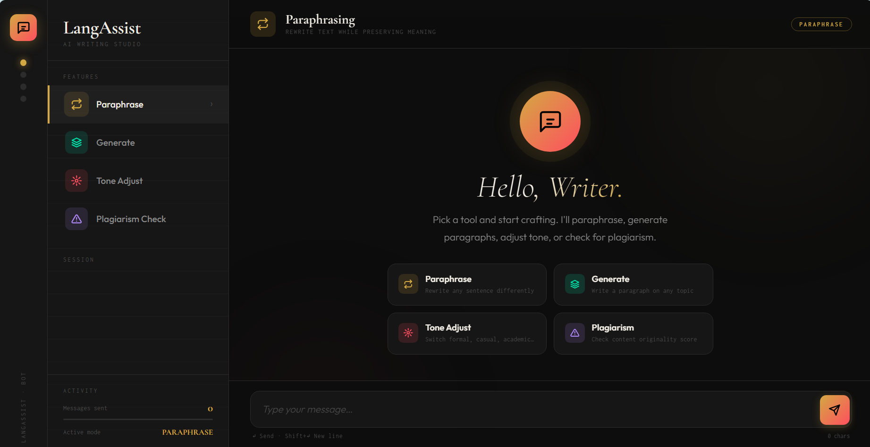
Paraphrase:
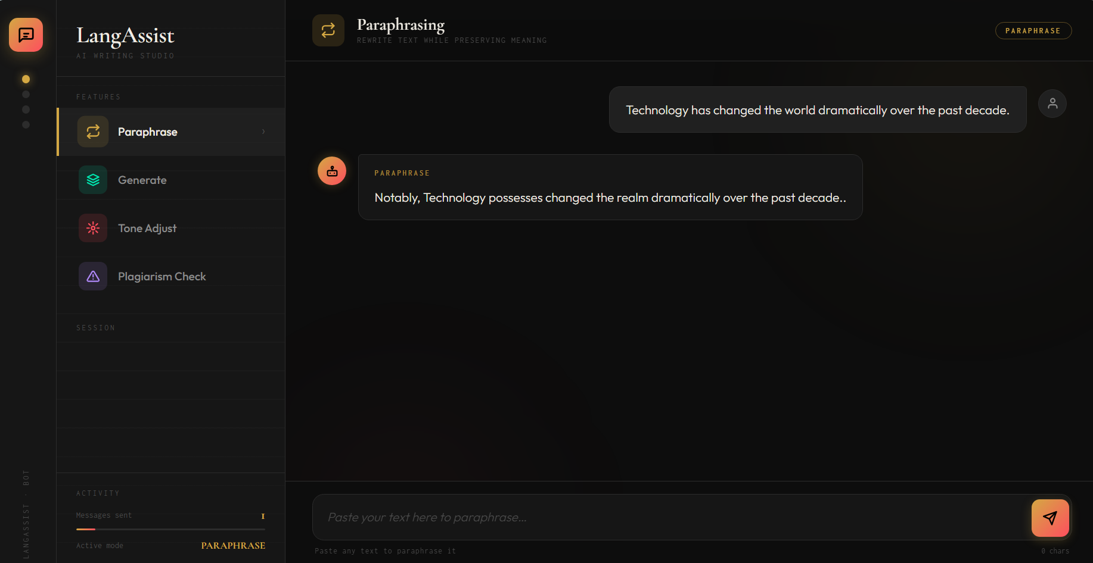

Generate:
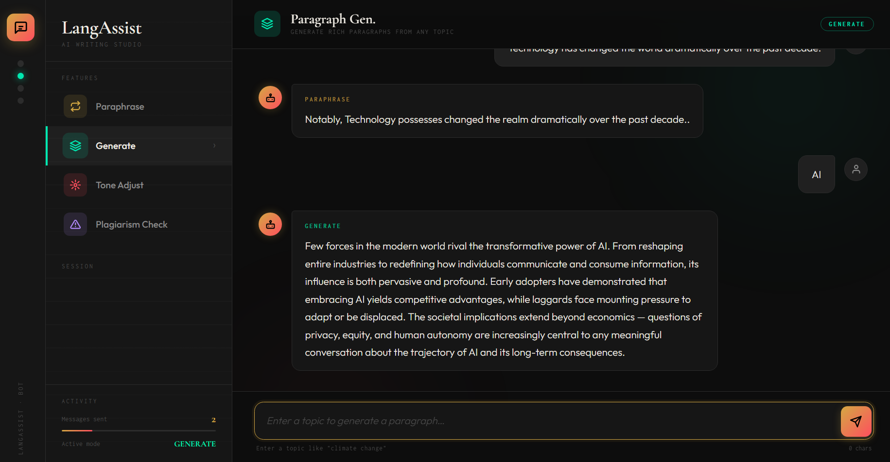
Tone Adjustment:
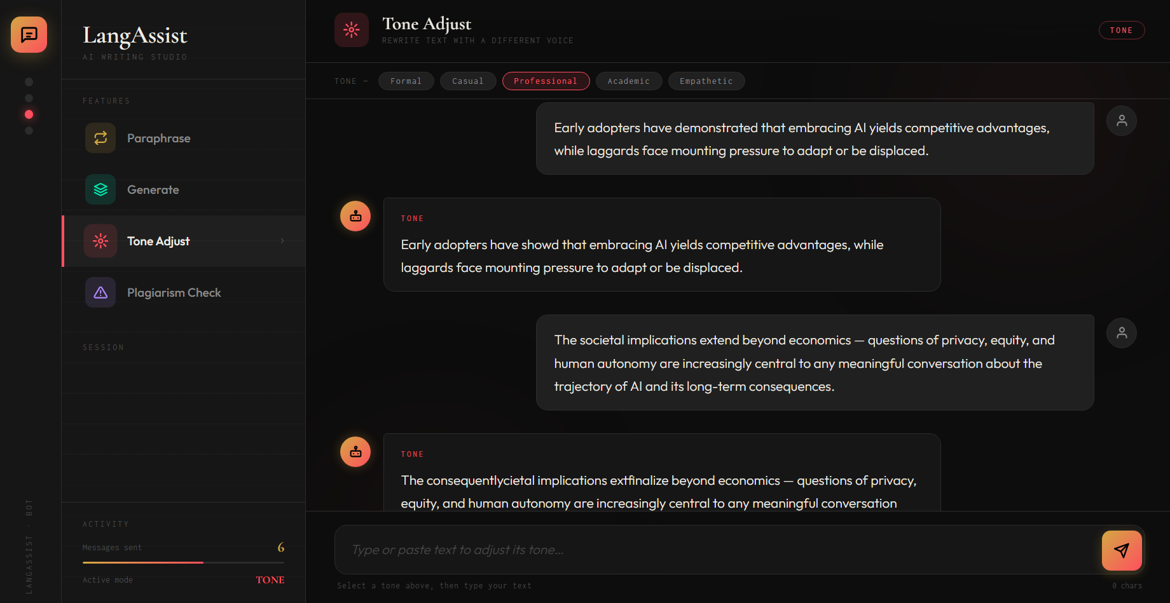

Plagiarism Check:
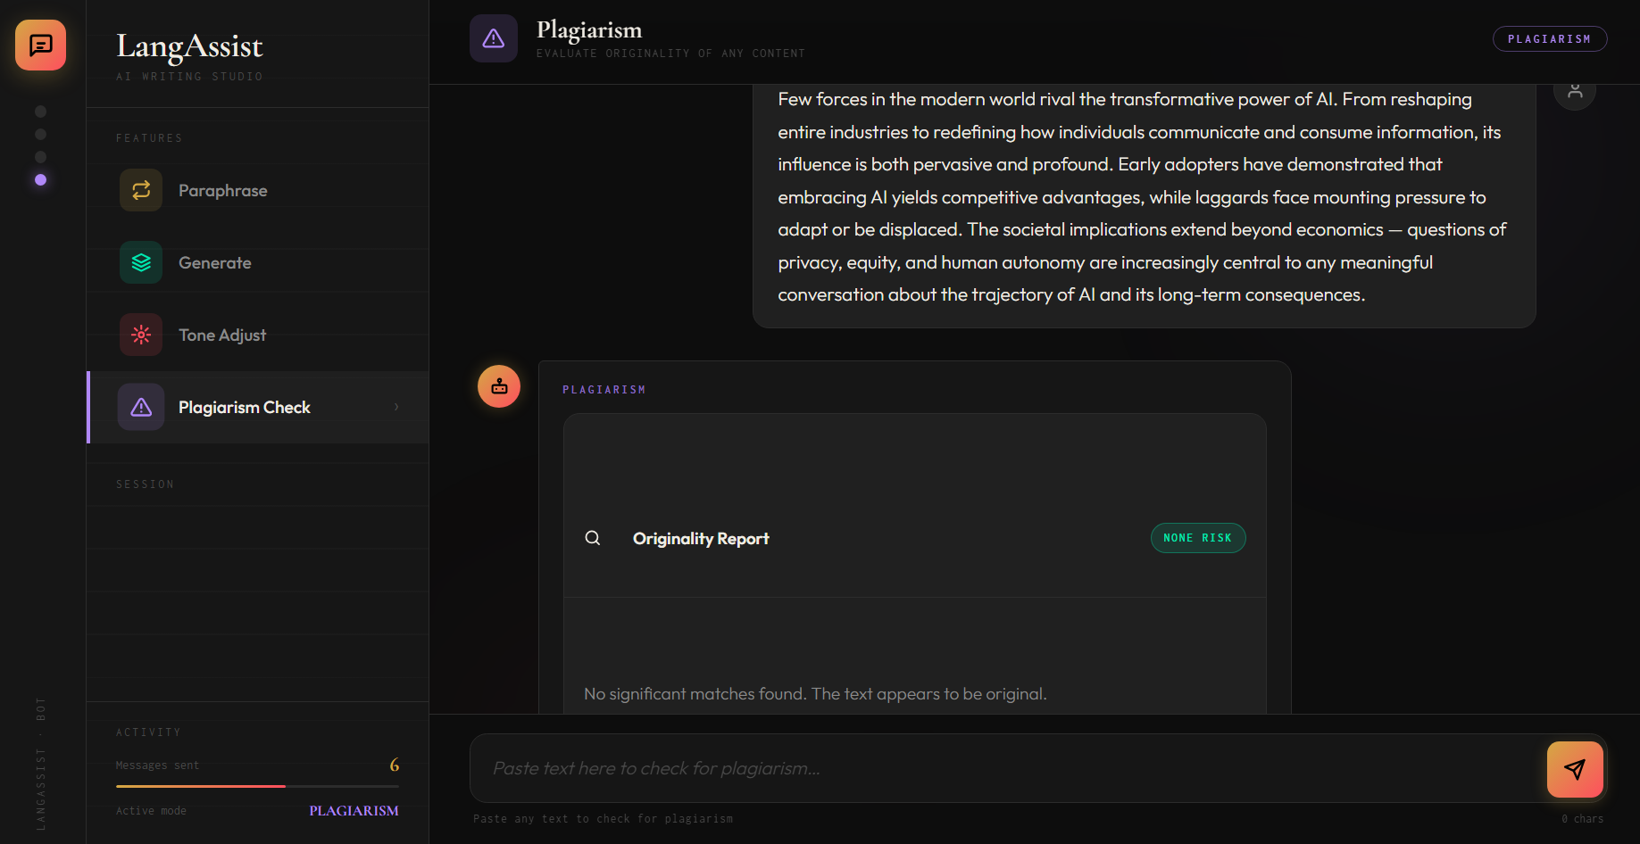
Output:
