**Bash Scripting –1**

1. To create a test file to know how to run the Bash script

#!/bin/bash -- First line tells us about the which shell we are using

#! - -shebang characters

/bin/bash--- shell name

Comments: # helps us to understand what we are doing in the script like purpose , date and time and last modified date, and created by ownership

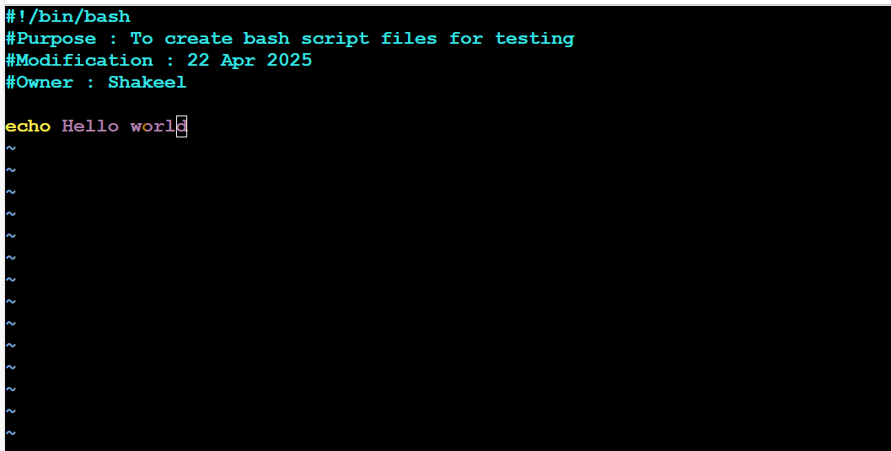

Commands

Pwd

mkdir –p scripts

cd /ec2-user/scripts

Ls

Pwd

Vi hello_world.bash

Enter the script and save the file :wq!

Now change the file permission to execute the bash file

Chmod 755 hello_world.bash

./hello_world.bash or (bash hello_world.bash)

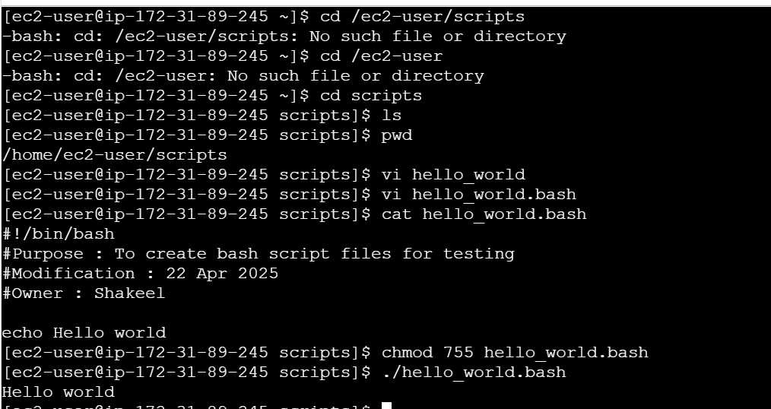 2. 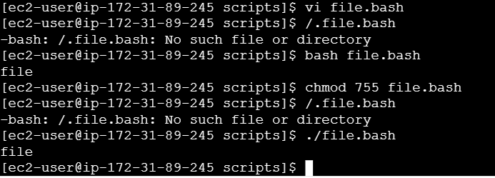

3.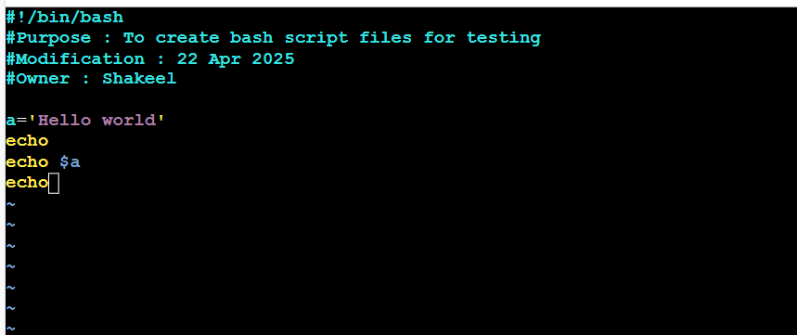

Here Defining the variable into a

Echo print the output

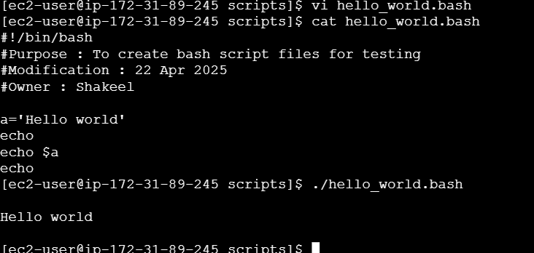

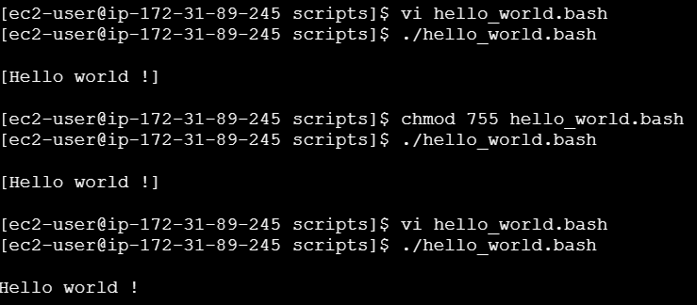

Here we are executing the linux commands using bash script

Pwd- present working directory

Ls- list of files

Date – shows the present date and current time

Cal- to show the calendar

Touch a b c- to create the 3 files with 0 bytes

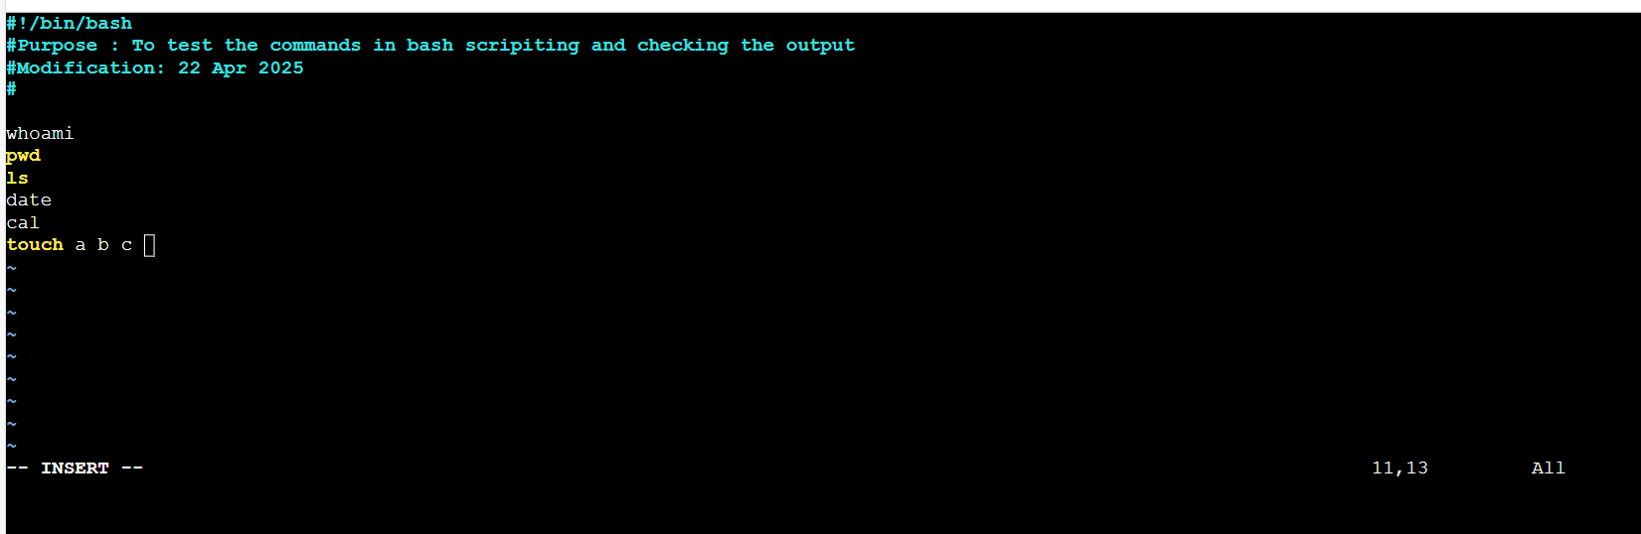

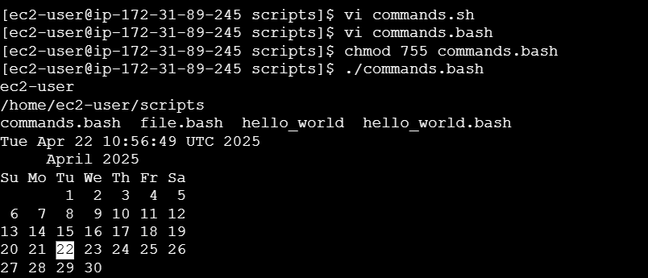

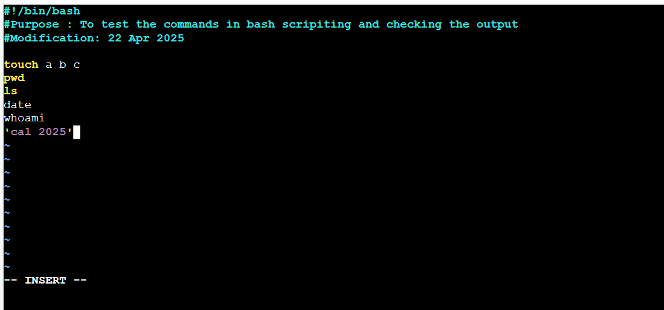

In bash script execution always from top to bottom

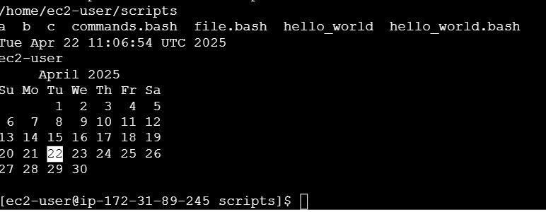

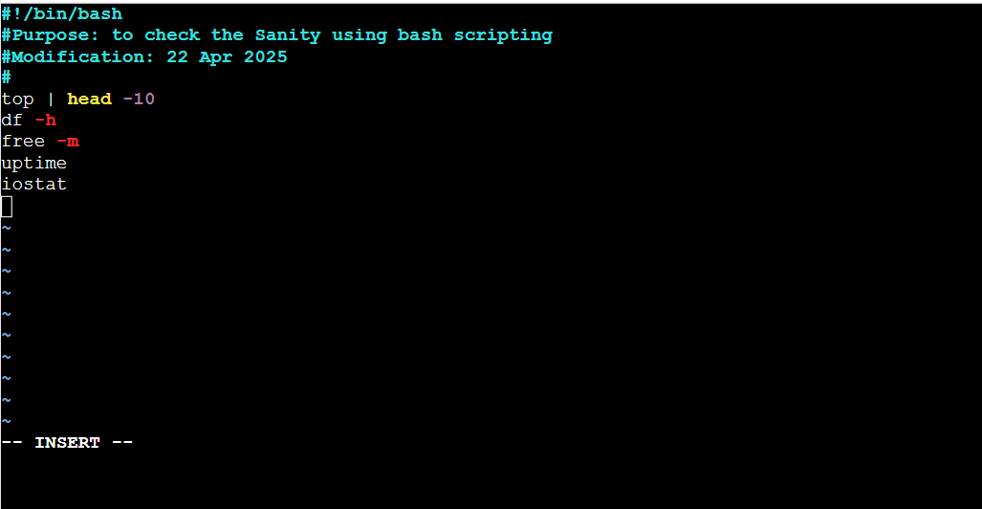

Top – complete CPU utilization

Df –h --- Available space in a file system

Free –m –Available memory in a file system to install new apps

Uptime – The system active time and number of users also

Iostat—CPU and device utilization

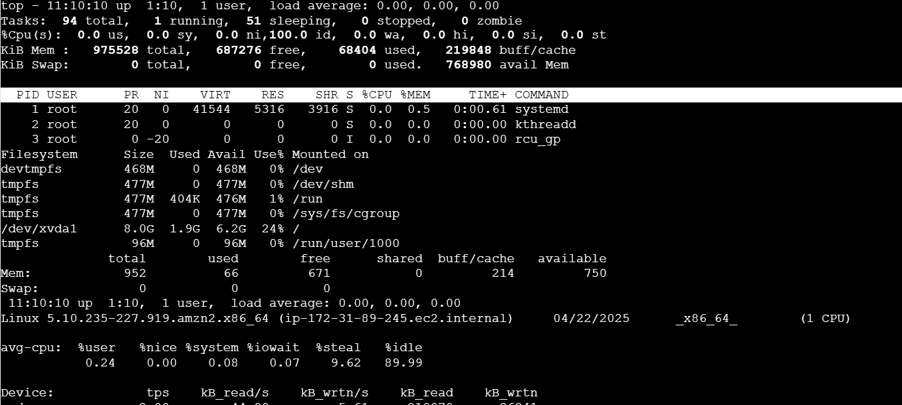

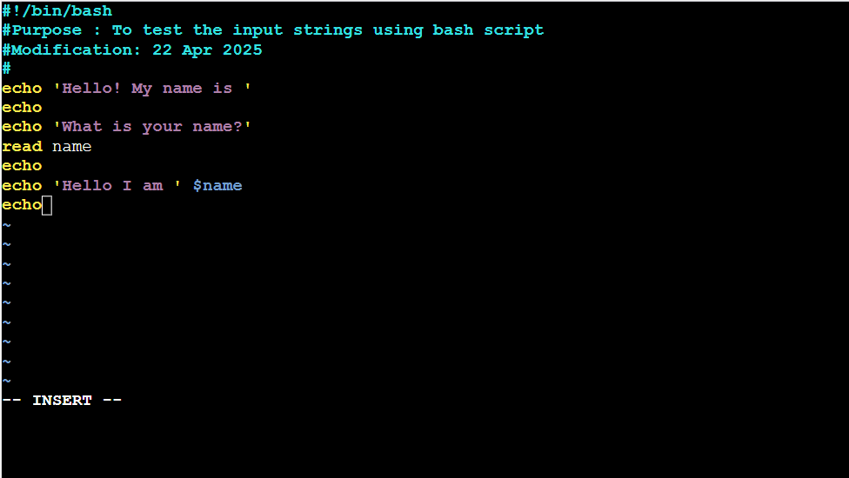

Read – to take the command from the user (input string command)

Echo – to print the output

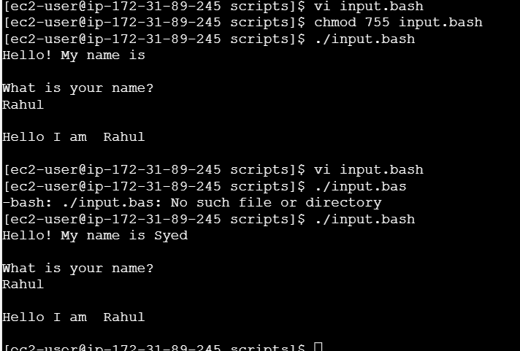

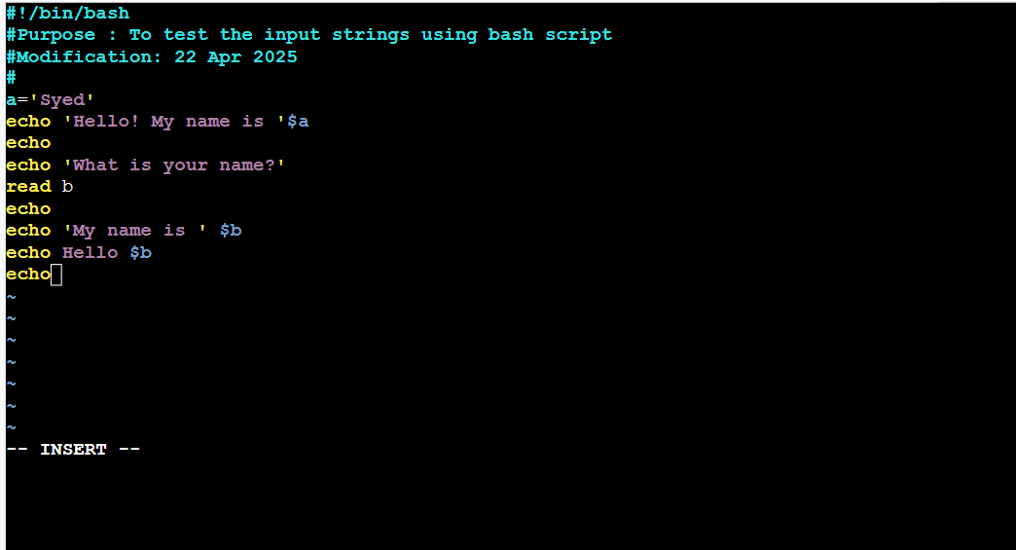

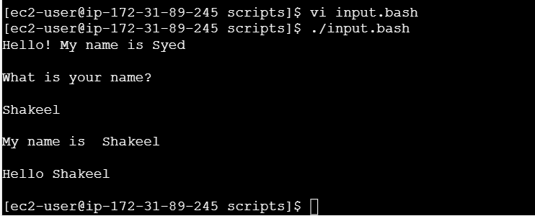

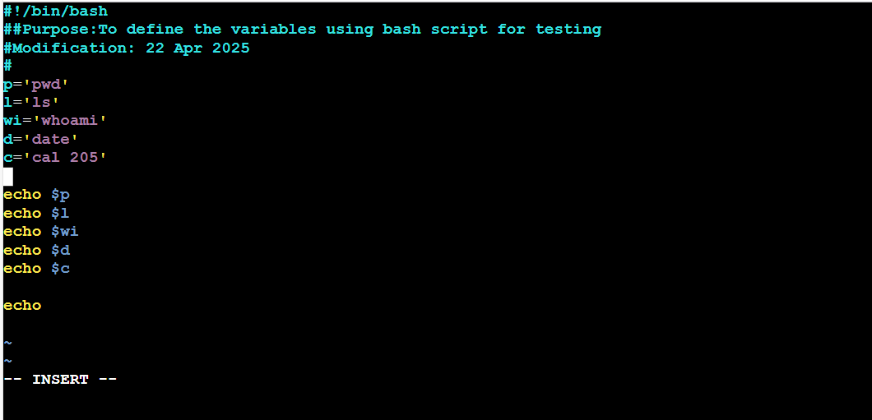

Here we are defining variables p ,l,wi,d,c and we are executing them using echo

