Game Title : Scrabble

1. Game Overview
Scrabble is a fun and educational word-making board game played by 2–4 players.
Players use letter tiles to create words on the board, connecting them like a crossword puzzle.
Each letter carries a specific point value, and the player with the highest total score at the end wins.
Scrabble helps improve vocabulary, spelling, strategic thinking, and language skills, making it a favorite family and classroom game.

2. Materials Required
• Scrabble game board (15×15 grid of squares).
• 100 letter tiles (each with a specific letter and point value).
• 4 tile racks (one for each player).
• Tile bag or box for drawing letter tiles.
• Score sheet and pen/pencil for keeping track of points.
• Dictionary (optional, for word verification).
• Timer (optional, for timed play).

3. Time Needed
• Setup Time: 5–10 minutes to arrange the board and draw tiles.
• Gameplay Duration: 45–60 minutes (depends on players).
• Wrap-up Time: 5 minutes for scoring and discussion.
➡️ Total Estimated Time: Around 55–75 minutes per match.

4. Rules / How to Play
- Place the Scrabble board in the center and give each player a tile rack.
- Mix all letter tiles face down and let each player draw seven tiles.
- The first player forms a word using the center square (marked with a star).
- Words must read left to right (across) or top to bottom (down).
- After forming a word, players count their points using the tile values and any bonus squares:
- Double Letter (DL) – letter score × 2
- Triple Letter (TL) – letter score × 3
- Double Word (DW) – total word score × 2
- Triple Word (TW) – total word score × 3
- Players then draw new tiles from the bag to replace the used ones, keeping seven at all times.
- Each new word must connect with at least one existing word on the board.
- Proper nouns, abbreviations, and foreign words (not in the dictionary) are not allowed.
- Players may challenge a word they believe is invalid — if proven wrong, the player loses their turn.
- A player may skip their turn to exchange tiles but cannot score that round.
- The game continues until all tiles are used or no moves remain.
- The player with the highest total score after all moves wins.
- Bonus: Using all 7 tiles in one turn earns a 50-point “Bingo” bonus.
- Scoring tip: Try to form words on bonus squares for higher scores.

5. Demo Videos or Downloadable Documents
Demo Videos:
You can watch a short demo video of how to play Scrabble here:
YouTube video Link
https://youtu.be/swlg3vQXboE?si=bzt4JxNBnRyIqKTM

Additional Tips:
- Focus on high-value letters like Q, Z, X, and J for big points.
- Use prefixes and suffixes (e.g., un, re, ed, ing) to extend existing words.
- Try to make two or more words in a single move by overlapping letters.
- Save vowels and common consonants for flexible plays.
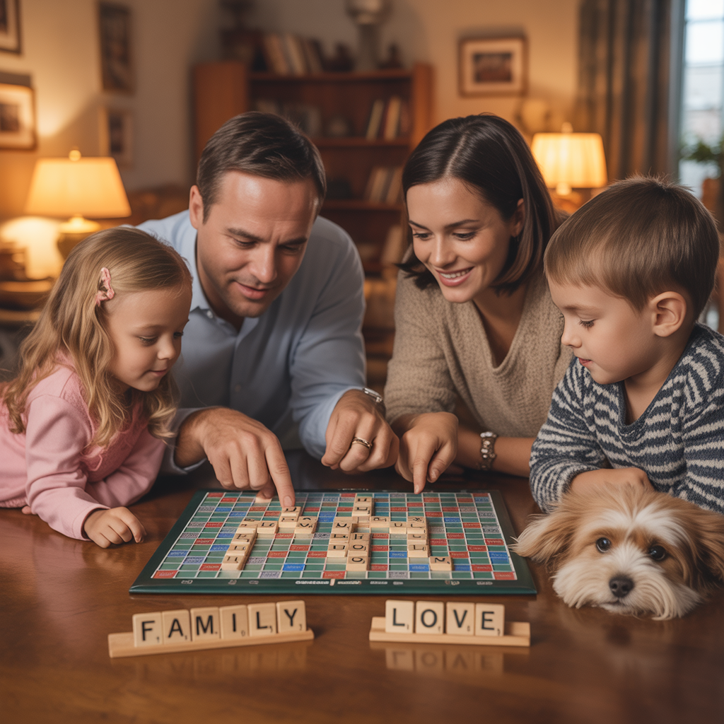
- Keep an eye on bonus squares and plan moves strategically.

