VISVESVARAYA TECHNOLOGICAL UNIVERSITY
JnanaSangama, Belagavi – 590018


Stock Market Analysis Using Deep Neural Networks

Submitted in partial fulfilment of the requirements as a part of the curriculum,

Bachelors of Engineering in Artificial Intelligence and Machine Learning

Submitted by

SYED ZAKARIA 1CR25AI412

SUMAN THAPA 1CR25AI131

MOHAMMAD YOUSUF 1CR25AI075

Under the Guidance of
Dr. Venkata Gopal
Associate Professor
Department of Artificial Intelligence and Machine Learning


Department of Artificial Intelligence and Machine Learning
CMR INSTITUTE OF TECHNOLOGY
132, AECS Layout, Kundalahalli, ITPL Main Rd, Bengaluru – 560037


CERTIFICATE

Certified that the Mini Project entitled “Stock Market Analysis Using Deep Neural Networks”is presented by
Syed Zakaria 1CR25AI412,
Suman Thapa 1CR25AI131,
Mohammad Yousuf 1CR25AI075,

bonafide student(s) of CMR Institute of Technology in partial fulfillment of the requirements as a part of the curriculum, Bachelors of Engineering in Artificial Intelligence and Machine Learning, of Visvesvaraya Technological University, Belagavi during the year 2025-26. It is certified that all correction/suggestion indicated for Internal Assessment have been incorporated in the report deposited in the departmental library. The Entrepreneurial Project report has been approved as it satisfies the academic requirements in respect of the Technical Seminar prescribed for the bachelor of engineering degree.

(Dr. Venkata Gopal) (Dr. Shyam P Joy)

Signature of the GuideSignature of the HOD

DECLARATION
We, the undersigned, students of CMR Institute of Technology, hereby declare that this mini project report titled
“Stock Market Analysis Using Deep Neural Networks”
is a record of our original work done under the supervision of Dr. Venkata Gopal, Associate Professor, Department of Artificial Intelligence and Machine Learning. And has not formed the basis of award of any other degree, in this or any other Institution or University. In keeping with the ethical practice in reporting scientific information, due acknowledgements have been made wherever the findings of others have been cited.

1. Syed Zakaria (USN: 1CR25AI412)
2. Suman Thapa (USN: 1CR25AI131)
3. Mohammad Yousuf (USN: ICR25AI075)

ABSTRACT
Stock Market Prediction using Deep Neural Networks is a machine learning-based system designed to predict future stock prices using historical market data. In this project, a Long Short-Term Memory (LSTM) network, which is a type of deep neural network suitable for time-series forecasting, is used for prediction. Historical stock price data is collected using the Yahoo Finance API and preprocessed through normalization techniques. The processed data is then used to train the LSTM model to learn market trends and patterns. After training, the model predicts future stock prices, and the predicted values are compared with actual stock prices using graphical visualization. The project demonstrates the application of deep learning techniques in financial forecasting and highlights the effectiveness of LSTM networks in analyzing sequential stock market data.

ACKNOWLEDGEMENTS
It is my proud privilege and duty to acknowledge the kind of help and guidance received from several people in preparation of this report. Apart from my own, the success of this report depends largely on the encouragement and guidelines of many others. It would have not been possible to prepare this report in this form without their valuable help, co-operation and guidance.
I would like to express my deep sense of gratitude to our Principal Dr. Sanjay Jain, CMR Institute of Technology, Bangalore for his motivation and for creating an inspiring atmosphere in college by providing state of the art facilities for preparation and delivery of this report.
My sincere thanks to Dr. Shyam P Joy , Head of Department of Artificial Intelligence and Machine Learning, for his whole-hearted support in completion of the Entrepreneurial Project.
I am highly indebted to my project guide Dr. Venkata Gopal, Associate Professor for guiding and giving timely advice and suggestions in the successful completion of this project.
My sincere thanks to Sandhya Prasad, Associate Professor, mini-project coordinator for having supported the work related to this project.
Last but not the least, I would like to put forward my heartfelt acknowledgement to all my classmates, friends and all those who have directly or indirectly provided their overwhelming support during my seminar work and the development of this report.

TABLE OF CONTENTS
[instruction: click and update the entire table before final submission]
CERTIFICATE 2
DECLARATION 3
ABSTRACT 4
ACKNOWLEDGEMENTS 5
1. INTRODUCTION 8
1.1 Overview 8
1.2 Problem Statement 8
1.3 Objectives 8
1.4 Scope of the Project 8
2. LITERATURE SURVEY 9
3. METHODOLOGY 10
3.1 SYSTEM DESIGN 10
3.1.1 System Requirements 10
3.1.2 System Architecture / High-Level Design (HLD) 10
3.1.3 Database Design (ER Diagram / Schema) 10
3.1.4 Module Description 11
3.1.5 Dataset Description 12
3.1.6 Model(s) Used 12
3.2 IMPLEMENTATION 13
3.2.1 Technology Stack 13
3.2.2 Implementation of Key Modules 13
3.2.3 Data Preprocessing 14
3.2.4 Feature Engineering 14
3.2.5 Model Training 14
3.2.6 Model Evaluation 14
3.2.7 Comparison of Models 14
3.2.8 Model Deployment 14
4. RESULTS & DISCUSSIONS 15
5.1 Testing Methodology 15
5.2 Screenshots of Results 15
5.3 Performance Evaluation 16
5.4 Discussion 16
5. CONCLUSION 17
5.1 Conclusion 17
5.2 Limitations 17
5.3 Future Scope 17
6. REFERENCES 18
APPENDIX A: SOURCE CODE 19
APPENDIX B: ADDITIONAL SCREENSHOTS 20

1. INTRODUCTION
The stock market plays a major role in the global economy by enabling companies to raise capital and investors to earn profits through trading shares. Predicting stock market prices has always been a challenging task because stock prices are influenced by various factors such as economic conditions, company performance, political events, and investor behavior. Accurate stock price prediction can help investors make better financial decisions and reduce investment risks.
Traditional stock prediction methods mainly rely on statistical techniques and mathematical models. However, these methods often fail to capture the complex and nonlinear patterns present in stock market data. With the advancement of Artificial Intelligence and Machine Learning, deep learning techniques have become more effective for analyzing financial time-series data.
In this project, a Deep Neural Network known as Long Short-Term Memory (LSTM) is used for stock market prediction. LSTM is a type of Recurrent Neural Network (RNN) specially designed to learn sequential and time-dependent data patterns. It can remember previous information for a long period, making it suitable for stock price forecasting.
The project uses historical stock market data collected from Yahoo Finance. The collected data is preprocessed, normalized, and used to train the LSTM model. After training, the model predicts future stock prices and compares them with actual stock values using graphical analysis.
This project demonstrates the application of deep learning in financial forecasting and highlights the capability of LSTM networks in predicting stock market trends using historical data patterns.

1.1 Overview
The “Stock Market Prediction Using Deep Neural Networks” project is designed to predict future stock prices using historical stock market data and deep learning techniques. The project mainly focuses on analyzing past stock trends and forecasting future prices with the help of an LSTM (Long Short-Term Memory) neural network.
The system collects historical stock data such as opening price, closing price, highest price, lowest price, and trading volume from the Yahoo Finance API. Among these values, the closing stock price is used for prediction because it represents the final trading value of the stock for a particular day.
Before training the model, the collected data is preprocessed and normalized to improve the efficiency and accuracy of the neural network. The normalized data is then converted into sequential datasets because LSTM models work effectively on time-series data.
The deep learning model is built using multiple LSTM layers and a Dense output layer. The model learns patterns and dependencies from previous stock prices during the training process. After training, the model predicts future stock prices based on historical trends.
Finally, the predicted stock prices are compared with actual stock prices using graphical visualization. The project demonstrates how deep learning algorithms can be applied in financial forecasting and stock market analysis.
The main objective of the project is to explore the use of artificial intelligence and deep learning techniques in predicting stock market behavior and improving forecasting accuracy.

1.2 Problem Statement
Predicting stock market prices is a difficult task due to the highly dynamic and volatile nature of financial markets. Stock prices are influenced by multiple factors such as market trends, economic conditions, political events, company performance, and investor sentiment. Traditional statistical and mathematical prediction methods are often unable to accurately capture complex and nonlinear patterns present in stock market data.
The main problem addressed in this project is to develop a system that can analyze historical stock market data and predict future stock prices with better efficiency using deep learning techniques. The project aims to use a Long Short-Term Memory (LSTM) based Deep Neural Network to learn sequential patterns from past stock prices and generate future price predictions.
The system focuses on improving stock forecasting by utilizing time-series analysis and deep learning methods to assist investors and analysts in understanding market trends and making informed financial decisions.

1.3 Objectives
• To collect historical stock market data from online financial sources.
• To preprocess and normalize stock price data for efficient model training.
• To develop a Deep Neural Network model using Long Short-Term Memory (LSTM).
• To train the neural network using historical stock market data.
• To analyze stock market trends and patterns using deep learning techniques.
• To predict future stock prices based on previous stock data.
• To compare actual and predicted stock prices using graphical visualization.
• To study the effectiveness of deep learning algorithms in financial forecasting.
• To improve understanding of time-series prediction using neural networks.

1.4 Scope of the Project
The scope of the “Stock Market Prediction Using Deep Neural Networks” project is focused on analyzing historical stock market data and predicting future stock prices using deep learning techniques. The project demonstrates the application of Artificial Intelligence and Deep Neural Networks in financial forecasting and time-series analysis.
The system can be used to study stock market trends, identify hidden patterns in stock price movements, and generate future price predictions based on historical data. By using LSTM networks, the project handles sequential and time-dependent stock data more effectively than traditional prediction methods.
This project can assist:
- Investors in analyzing market trends
- Financial analysts in forecasting stock behavior
- Researchers in studying deep learning applications in finance
- Students in understanding practical implementation of neural networks
The project currently focuses on prediction using historical closing prices of stocks. In the future, the scope can be extended by integrating:
- Real-time stock market data
- News sentiment analysis
- Hybrid AI models
- Multiple stock comparisons
- Web or mobile-based deployment
- Automated trading systems
Thus, the project provides a foundation for intelligent financial forecasting systems using deep learning technologies.

2. LITERATURE SURVEY
Stock market prediction has been an important research area in the fields of finance, machine learning, and artificial intelligence. Researchers have proposed various techniques and models to analyze stock market trends and forecast future stock prices. Traditional statistical methods such as Moving Average, Linear Regression, and ARIMA models were initially used for stock prediction. However, these methods were limited in handling complex and nonlinear market patterns.
With the advancement of Machine Learning and Deep Learning, more efficient prediction models have been developed. Machine learning algorithms such as Support Vector Machines (SVM), Decision Trees, and Random Forests improved prediction accuracy to some extent, but they still faced difficulties in handling sequential and time-dependent stock market data.
Recent studies show that Deep Neural Networks, especially Recurrent Neural Networks (RNN) and Long Short-Term Memory (LSTM) networks, provide better performance in time-series forecasting tasks. LSTM models are capable of remembering previous information using memory cells, making them highly suitable for stock market prediction.
Several researchers have successfully applied LSTM models to predict stock prices using historical financial datasets. These models analyze past stock trends, learn hidden market patterns, and generate future predictions with improved accuracy compared to traditional approaches.
The literature survey indicates that deep learning techniques, particularly LSTM networks, are effective tools for financial forecasting because they can manage nonlinear relationships, sequential dependencies, and large volumes of stock market data. Based on these studies, the proposed project uses an LSTM-based Deep Neural Network for stock market prediction.

3. METHODOLOGY

3.1 SYSTEM DESIGN
System Design defines the overall architecture and working structure of the “Stock Market Prediction Using Deep Neural Networks” project. It describes how different modules interact with each other to collect stock market data, preprocess it, train the deep learning model, and generate predictions.
The proposed system is designed using a modular approach to improve simplicity, efficiency, and maintainability. The system mainly consists of the following modules:
- Data Collection Module
- Data Preprocessing Module
- Feature Scaling Module
- LSTM Model Training Module
- Prediction Module
- Result Visualization Module
The system takes historical stock market data as input and processes it through multiple stages before generating stock price predictions.
+-------------------+
| Historical Stock |
| Dataset |
+-------------------+
|
v
+-------------------+
| Data Preprocessing|
| & Cleaning |
+-------------------+
|
v
+-------------------+
| Data Normalization|
+-------------------+
|
v
+-------------------+
| Sequence Creation |
+-------------------+
|
v
+-------------------+
| LSTM Neural Network|
+-------------------+
|
v
+-------------------+
| Model Training |
+-------------------+
|
v
+-------------------+
| Stock Prediction |
+-------------------+
|
v
+-------------------+
| Graphical Output |
+-------------------+

3.1.1 System Requirements
Functional Requirements
• The system shall collect historical stock market data from online financial sources such as Yahoo Finance.
• The system shall preprocess and clean the collected stock market data before training.
• The system shall normalize stock price values to improve neural network performance.
• The system shall create sequential datasets required for LSTM model training.
• The system shall train the Deep Neural Network using historical stock price data.
• The system shall use the LSTM algorithm for time-series stock market prediction.
• The system shall predict future stock prices based on previous stock market trends.
• The system shall compare actual stock prices with predicted stock prices.
• The system shall display graphical visualization of prediction results.
• The system shall allow analysis of stock market trends using historical data.
• The user should be able to run the prediction model using Python environment.
• The system shall store and process stock market data efficiently.
• The system shall generate output graphs for better understanding of prediction accuracy.
• The system shall support prediction for different company stocks by changing the stock symbol.
• The user should be able to observe model training performance during execution.]
Non-Functional Requirements
• The system should provide accurate and reliable stock price predictions based on historical data.
• The system should process stock market data efficiently with minimum execution time.
• The system should have a simple and user-friendly interface for easy operation.
• The system should be scalable to support larger stock datasets and additional company stocks.
• The system should maintain data consistency during preprocessing and prediction.
• The system should provide graphical visualization for better understanding of prediction results.
• The system should support easy maintenance and future enhancements.
• The system should be compatible with standard Python development environments such as VS Code and Jupyter Notebook.
• The system should efficiently utilize system memory and processing resources during model training.
• The system should allow flexibility for integrating real-time stock market data in future versions.
• The system should provide stable performance during repeated model training and prediction.
• The system should ensure availability of prediction results whenever the system is executed.
• The system should support portability across different operating systems such as Windows, Linux, and macOS.
• The system should be capable of handling continuous sequential data for time-series prediction.
• The system should support future integration of advanced deep learning and AI techniques.
Hardware and Software Requirements

Category | Development
OS | Windows 10 or Higher / Ubuntu 22.04
Processor | Intel Core i5 or above
GPU | NVIDIA A100 or write NA
RAM | 8 GB RAM
Software | Python 3.14, VS Code
Libraries | NumPy, Pandas, Matplotlib, Scikit-learn, TensorFlow, Keras, and yfinance.

3.1.2 System Architecture / High-Level Design (HLD)
The High-Level Design (HLD) of the “Stock Market Prediction Using Deep Neural Networks” project describes the overall structure of the system and interaction between major components. The system is designed to collect stock market data, preprocess it, train the deep learning model, and generate future stock price predictions.
The architecture follows a layered and modular approach to improve efficiency, scalability, and maintainability.

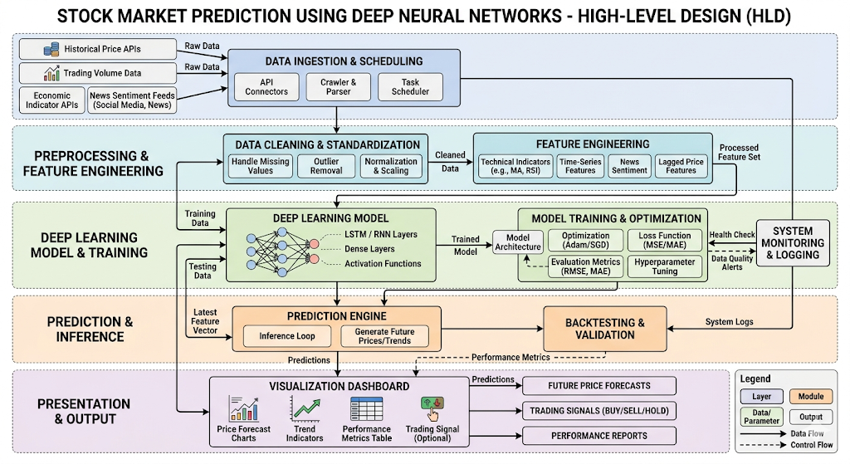
Figure 3.1: System Architecture Diagram

3.1.3 Database Design (ER Diagram / Schema)

Not Applicable
This project does not use a traditional database management system such as MySQL, PostgreSQL, or MongoDB. The system is designed as a standalone Deep Learning application where stock market data is directly collected from the Yahoo Finance API using the yfinance Python library.
The collected stock data is temporarily stored and processed in memory using Pandas DataFrames and NumPy arrays during execution.

3.1.4 Module Description
[Instruction: Break your system into 3–6 major modules. For each module, write 2–3 lines describing its purpose and what it does. This is like a brief design spec. Below is the example modules, so modify them as per the project requirements]example below]:
No. | Module Name | Description
1 | Data Collection | This module collects historical stock market data from Yahoo Finance using the yfinance library. It retrieves stock information such as opening price, closing price, highest price, lowest price, and trading volume for analysis and prediction.
2 | Data Input / Pre-processing Module | This module preprocesses the collected stock data by selecting relevant features, handling missing values, and normalizing the data using MinMaxScaler. The processed data is then converted into sequential datasets required for LSTM training.
3 | Core Processing / ML Model | This module contains the LSTM-based Deep Neural Network model. The model learns historical stock market patterns and trends from sequential data and performs stock price prediction using trained neural network layers.
4 | Output / Result Display | This module displays the predicted stock prices and compares them with actual stock prices using graphical visualization. It helps users analyze the prediction accuracy and overall model performance.
5 | Admin / Dashboard Module | This module is responsible for monitoring model training, execution, and prediction results. It allows observation of training progress, epochs, loss values, and system performance during model execution.

3.2IMPLEMENTATION
The implementation phase describes how the “Stock Market Prediction Using Deep Neural Networks” system was developed using Python and Deep Learning technologies. The system was implemented using an LSTM-based neural network model to analyze historical stock market data and predict future stock prices.
The implementation process includes:
- Data collection
- Data preprocessing
- Sequence generation
- LSTM model creation
- Model training
- Prediction
- Graphical visualization

3.2.1 Technology Stack

3.2.1 Technology Stack
Technology | Purpose | Reason for Selection
Python | Core programming language | Python is simple, easy to learn, and widely used for Machine Learning and Deep Learning applications. It provides extensive library support compared to languages like C++ and Java.
TensorFlow | Deep learning framework | TensorFlow provides efficient tools for building, training, and deploying Deep Neural Networks. It is highly optimized and widely used in AI research and industry.
Keras | Neural network API | Keras simplifies the implementation of LSTM models with easy-to-use functions and faster model development compared to low-level frameworks.
Pandas | Data preprocessing and handling | Pandas provides powerful DataFrame structures for efficient data manipulation and preprocessing of stock datasets.
NumPy | Numerical computations | NumPy supports fast mathematical operations and array processing required for neural network computations.
Matplotlib | Data visualization | Matplotlib is used to generate graphs for comparing actual and predicted stock prices in a simple and effective manner.
Scikit-learn | Data normalization | Scikit-learn provides preprocessing tools like MinMaxScaler, which improve model training performance through feature scaling.
yfinance | Stock market data collection | yfinance allows direct access to Yahoo Finance stock data, making data collection simple and efficient without manual dataset creation.
VS Code / Jupyter Notebook | Development environment | These tools provide easy coding, debugging, visualization, and execution support for Machine Learning projects.
LSTM (Deep Learning Model) | Stock price prediction | LSTM is suitable for time-series forecasting because it can learn long-term dependencies and sequential stock market patterns better than traditional models.

4. RESULTS& DISCUSSIONS
The Results and Discussion section describes the testing performed on the “Stock Market Prediction Using Deep Neural Networks” system and analyzes the output generated by the LSTM model. Testing was conducted to verify whether each module of the system performs correctly and whether the complete system generates accurate stock market predictions.
The system was tested using historical stock market data collected from Yahoo Finance. The obtained results show that the LSTM model successfully learned stock market trends and generated predictions that closely follow actual stock prices.

4.1 Unit Testing
Unit Testing verifies the correct functioning of individual modules in the system.

Unit Testing Table
Test Case ID | Module Tested | Test Input | Expected Result | Actual Result | Status
UT1 | Data Collection Module | Stock Symbol (AAPL) | Historical stock data should be downloaded | Stock data downloaded successfully | Pass
UT2 | Data Preprocessing Module | Raw stock dataset | Cleaned and normalized dataset should be generated | Dataset normalized successfully | Pass
UT3 | Sequence Creation Module | Normalized stock prices | Sequential training data should be created | Sequences generated correctly | Pass
UT4 | LSTM Model Module | Training dataset | Model should train successfully | Model trained successfully | Pass
UT5 | Prediction Module | Trained model | Predicted stock prices should be generated | Predictions generated correctly | Pass
UT6 | Visualization Module | Actual and predicted values | Graph should display comparison | Graph displayed successfully | Pass

4.2 System / Integration Testing
System Testing verifies whether all modules work together correctly as a complete system.

Integration Testing Table
Test Case ID | System Functionality | Expected Result | Actual Result | Status
ST1 | Complete stock prediction workflow | System should process data and predict stock prices | Prediction completed successfully | Pass
ST2 | Data preprocessing + model training | Model should train using processed data | Training executed correctly | Pass
ST3 | Prediction + visualization | Predicted prices should be displayed graphically | Graph generated successfully | Pass
ST4 | Multiple stock data execution | System should handle different stock symbols | System executed successfully | Pass

4.3 Output Results
The output graph generated by the system compares actual stock prices with predicted stock prices.
- Blue Line → Actual Stock Prices
- Red Line → Predicted Stock Prices
The graph shows that the predicted stock prices closely follow the actual stock price trends, indicating that the LSTM model successfully learned temporal patterns from historical stock data.

Result Analysis
The Deep Neural Network model achieved effective prediction performance for stock market forecasting. The LSTM model was able to capture sequential dependencies and historical stock patterns with reasonable accuracy.
The prediction graph demonstrates:
- Similarity between actual and predicted trends
- Successful learning of stock price movements
- Efficient handling of time-series financial data
Minor variations between actual and predicted values occurred due to:
- Market volatility
- External economic factors
- Random fluctuations in stock prices
However, the overall prediction trend confirms that the proposed system performs effectively for stock market forecasting applications.

Discussion
The project demonstrates the practical application of Deep Learning and LSTM networks in financial prediction systems. Compared to traditional prediction techniques, the LSTM model provides better capability for handling sequential stock market data.
The system successfully integrates:
- Data collection
- Data preprocessing
- Neural network training
- Prediction generation
- Graphical visualization
The experimental results validate the effectiveness of Deep Neural Networks for stock market trend prediction and financial data analysis.

5.2 Screenshots of Results

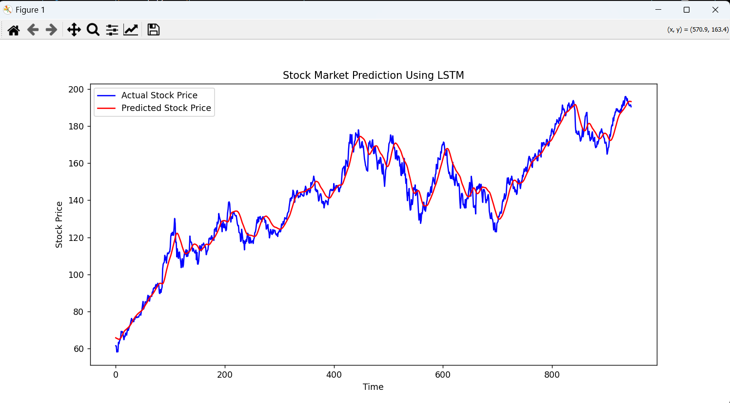
Figure 5.1: The graph compares actual and predicted stock prices, showing that the LSTM model successfully learns historical market trends and predicts future stock movements with reasonable accuracy.

5.3 Performance Evaluation
The performance of the “Stock Market Prediction Using Deep Neural Networks” system was evaluated using graphical analysis and error-based evaluation metrics. Since the project uses an LSTM-based Deep Neural Network for time-series forecasting, the prediction performance was measured by comparing actual stock prices with predicted stock prices.
The model was trained using historical stock market data collected from Yahoo Finance. After training, the predicted stock prices closely followed the actual stock price trends, indicating that the model successfully learned temporal market patterns.

Evaluation Metrics Used
The following performance metrics were considered for evaluating the prediction model:
Metric | Purpose
Mean Squared Error (MSE) | Measures prediction error
Loss Function | Evaluates model training performance
Prediction Graph | Compares actual and predicted prices
Training Curve | Shows reduction in loss during training

1. Mean Squared Error (MSE)
Mean Squared Error measures the average squared difference between actual and predicted stock prices.
MSE Formula:
MSE=\frac{1}{n}\sum_{i=1}^{n}(y_i-\hat{y}_i)^2
Where:
- ( y_i ) = Actual stock price
- ( \hat{y}_i ) = Predicted stock price
- ( n ) = Total number of observations
A lower MSE value indicates better prediction accuracy.

2. Training Performance
The LSTM model was trained using:
- Optimizer: Adam
- Epochs: 5
- Batch Size: 32
During training, the loss value gradually decreased, indicating successful learning of stock market patterns by the neural network.

3. Prediction Accuracy Analysis
The prediction graph compares:
- Actual Stock Prices (Blue Line)
- Predicted Stock Prices (Red Line)
Observation:
- The predicted curve closely follows the actual stock price trend.
- Minor deviations occur due to stock market volatility and external market factors.
- Overall trend similarity confirms effective model performance.

4. Graphical Performance Evaluation
The output graph demonstrates:
- Trend learning capability of LSTM
- Sequential data prediction efficiency
- Effective time-series forecasting
The graphical comparison validates that the proposed system can predict stock price movements with reasonable accuracy using historical data.

5. Discussion of Results
The performance evaluation shows that the LSTM-based Deep Neural Network performs effectively for stock market prediction tasks. The model successfully captures hidden temporal dependencies from historical stock prices and generates predictions close to actual market trends.
Advantages observed:
- Good trend prediction capability
- Effective handling of sequential data
- Reduced prediction error after training
Limitations observed:
- Sudden market fluctuations affect accuracy
- External economic factors are not considered
- Prediction accuracy depends on dataset quality

Conclusion
The performance evaluation confirms that the proposed Deep Neural Network model is suitable for stock market forecasting applications. The LSTM model successfully learns historical market behavior and predicts future stock trends with reasonable accuracy, demonstrating the effectiveness of deep learning techniques in financial time-series analysis.

5. CONCLUSION

5.1 Conclusion
The “Stock Market Prediction Using Deep Neural Networks” project was successfully developed and implemented using an LSTM-based Deep Neural Network model. The system collected historical stock market data, performed preprocessing and normalization, trained the LSTM model, and generated future stock price predictions.
The project demonstrated the practical application of Deep Learning techniques in financial forecasting and time-series analysis. The predicted stock prices closely followed the actual stock price trends, showing that the LSTM model effectively learned historical market patterns and sequential dependencies from stock market data.
Throughout the project, several challenges were encountered, including:
- Handling large volumes of stock market data
- Managing sequential time-series datasets
- Selecting appropriate training parameters
- Dealing with market volatility and prediction uncertainty
Despite these challenges, the system achieved reasonable prediction performance and successfully demonstrated the capability of Deep Neural Networks for stock market forecasting.
The project can be further improved by:
- Integrating real-time stock market data
- Increasing training dataset size
- Using advanced hybrid deep learning models
- Incorporating news sentiment analysis
- Developing a web or mobile-based prediction system
- Improving prediction accuracy using additional financial indicators
In conclusion, the project highlights the effectiveness of LSTM-based Deep Neural Networks in analyzing historical stock market trends and predicting future stock prices. The system provides a strong foundation for future research and development in AI-based financial forecasting systems.

5.2 Limitations
- The prediction accuracy depends heavily on the quality and quantity of historical stock market data.
- Stock markets are highly volatile and influenced by unpredictable external factors such as political events, economic conditions, and global news.
- The system uses only historical stock prices and does not consider market sentiment, social media trends, or financial news.
- The LSTM model requires significant training time and computational resources for larger datasets.
- Sudden market crashes or unexpected events cannot be accurately predicted by the model.
- The project focuses mainly on closing stock prices and ignores other financial indicators that may improve prediction accuracy.
- The model performance may vary for different company stocks and market conditions.
- Real-time stock market prediction is not implemented in the current system.
- Overfitting may occur if the model is trained excessively on limited datasets.
- The system does not provide guaranteed financial or investment advice.

5.3 Future Scope
The “Stock Market Prediction Using Deep Neural Networks” project can be further enhanced in several ways to improve prediction accuracy, functionality, and real-world usability.
- Real-time stock market prediction can be implemented by integrating live financial APIs for continuous data updates and forecasting.
- News sentiment analysis and social media analysis can be added to improve prediction accuracy by considering public opinion and market sentiment.
- Advanced hybrid deep learning models such as CNN-LSTM or GRU networks can be used to achieve better forecasting performance.
- Additional financial indicators like moving averages, RSI, MACD, and trading volume can be incorporated for more accurate market analysis.
- The system can be developed into a web or mobile application to provide user-friendly real-time stock prediction services for investors and analysts.
- Cloud deployment and automated trading features can be integrated for large-scale financial applications and smart investment systems.
- Prediction performance can be improved by training the model on larger datasets with more historical market records.
- Multi-stock comparison and portfolio analysis features can be added to support broader financial decision-making.

6. REFERENCES
[1] Ian Goodfellow, Yoshua Bengio and Aaron Courville, Deep Learning, MIT Press, 1st Edition, 2016.
[2] François Chollet, Deep Learning with Python, Manning Publications, 2nd Edition, 2021.
[3] Aurélien Géron, Hands-On Machine Learning with Scikit-Learn, Keras and TensorFlow, O’Reilly Media, 2nd Edition, 2019.
[4] Sepp Hochreiter and Jürgen Schmidhuber, “Long Short-Term Memory”, Neural Computation, Vol. 9, No. 8, Nov 1997, pp. 1735–1780.
[5] Fischer Thomas and Krauss Christopher, “Deep Learning with Long Short-Term Memory Networks for Financial Market Predictions”, European Journal of Operational Research, Vol. 270, No. 2, Oct 2018, pp. 654–669.
[6] Devis Tuia, “Machine Learning in Financial Market Prediction”, International Journal of Computer Applications, Vol. 180, No. 25, Mar 2018, pp. 15–21.
[7] TensorFlow Documentation, TensorFlow Deep Learning Framework, Available:
TensorFlow Official Website
[8] Yahoo Finance Historical Stock Data, Available:
Yahoo Finance Official Website
[9] Python Software Foundation, Python Programming Language Documentation, Available:
Python Official Website
[10] Pedregosa F., Varoquaux G., Gramfort A. et al., “Scikit-learn: Machine Learning in Python”, Journal of Machine Learning Research, Vol. 12, Oct 2011, pp. 2825–2830.

APPENDIX A: SOURCE CODE

APPENDIX A: SOURCE CODE
The complete source code for the project is available in the GitHub repository given below.

GitHub Repository
Stock Market Prediction Using Deep Neural Networks - GitHub Repository

A.1 Module / File Name: stock_prediction.py

Description
This is the main implementation file of the project. It performs:
- Data collection
- Data preprocessing
- Sequence generation
- LSTM model training
- Stock price prediction
- Graph visualization

Code Snippet
import yfinance as yf
from tensorflow.keras.models import Sequential
from tensorflow.keras.layers import Dense, LSTM

data = yf.download('AAPL',
start='2020-01-01',
end='2024-01-01')

model = Sequential()

model.add(LSTM(50,
return_sequences=True,
input_shape=(x_train.shape[1],1)))

model.add(LSTM(50))

model.add(Dense(1))

A.2 Module / File Name: data_preprocessing.py

Description
This module handles:
- Data cleaning
- Feature scaling
- Sequence creation
- Preparing input data for LSTM training

Code Snippet
from sklearn.preprocessing import MinMaxScaler

scaler = MinMaxScaler(feature_range=(0,1))

scaled_data = scaler.fit_transform(closing_prices)

A.3 Module / File Name: visualization.py

Description
This module is used for:
- Plotting graphs
- Comparing actual and predicted stock prices
- Displaying output visualization

Code Snippet
plt.plot(real_prices,
color='blue',
label='Actual Price')

plt.plot(predictions,
color='red',
label='Predicted Price')

A.4 Module / File Name: requirements.txt

Description
This file contains all required Python libraries and dependencies for running the project.

Code Snippet
tensorflow
numpy
pandas
matplotlib
scikit-learn
yfinance

