|  |  |  |  |  |  |  |  |  |  |  |  |  |  |  |  |  |  |  |  |  |  |  |  |  |  |  |  |  |  |  |  |  |  |  |  |  |  |  |  |  |  |  |  |  |  |  |  |  |  |  |  |  |  |  |  |  |  |  |  |  |  |  |  |  |  |  |  |  |  |  |  |  |  |  |  |  |
| --- | --- | --- | --- | --- | --- | --- | --- | --- | --- | --- | --- | --- | --- | --- | --- | --- | --- | --- | --- | --- | --- | --- | --- | --- | --- | --- | --- | --- | --- | --- | --- | --- | --- | --- | --- | --- | --- | --- | --- | --- | --- | --- | --- | --- | --- | --- | --- | --- | --- | --- | --- | --- | --- | --- | --- | --- | --- | --- | --- | --- | --- | --- | --- | --- | --- | --- | --- | --- | --- | --- | --- | --- | --- | --- | --- | --- |
| |  | | --- | | .data | | .float | | const_5f: 5.0 | | const_9f: 9.0 | | const_32f: 32.0 | | .word | | const_studentid: 150201133 #my student ID, in integer :) | | const_36: 36 | | const_24: 24 | | const_101: 101 | | const_59: 59 | |  | | .text | | # MAIN PROGRAM | | main: | |  | | ####################################################### | | ## - Compress student ID to [25, 35] | | ## - Convert new student ID from Celcius to Fahrenheit | | ## - RESULT stored in $f2 | | ####################################################### | | lw $t0, const_studentid # prepare input, load student_id to $t0 | | lw $t5, const_24 # prepare input, load 24 to t5 | | lw $t6, const_36 # prepare input, load 36 to t6 | | jal compress_student_id # compress student id to range (24, 36) i.e. [25, 35] | | mov.s $f12, $f0 # copy compress_student_id output to f12, input for c2f | | jal c2f # call c2f, once completes, result stored in $f0 | | mov.s $f2, $f0 # copy & store result of c2f into f2, for verification | |  | | ####################################################### | | ## - Compress student ID to [60, 100] | | ## - Convert new student ID from Fahrenheit to Celcius | | ## - RESULT stored in $f4 | | ####################################################### | | lw $t0, const_studentid # prepare input, load student_id to $t0 | | lw $t5, const_59 # prepare input, load 59 to t5 | | lw $t6, const_101 # prepare input, load 101 to t6 | | jal compress_student_id # compress student id to range (59, 101) i.e. [60, 100] | | mov.s $f12, $f0 # copy compress_student_id output to f12, input for f2c | | jal f2c # call c2f, once completes, result stored in $f0 | | mov.s $f4, $f0 # copy & store result of f2c into f4, for verification | |  | | li $v0, 10 # send exit signal | | syscall # handover call to OS | |  | | # T(°C) = 5.0/9.0 * (T(°F) - 32.0) | | f2c: #input: $f12, output: $f0 | | lwc1 $f16, const_5f # f16 = 5.0 | | lwc1 $f18, const_9f # f18 = 9.0 | | div.s $f16, $f16, $f18 # f16 = f16 / f18 = 5.0 / 9.0 | | lwc1 $f18, const_32f # f18 = 32.0 | | sub.s $f18, $f12, $f18 # f18 = f12 - f18 = T(°F) - 32 | | mul.s $f0, $f16, $f18 # f0 = f16 * f18 = 5.0/9.0 * (T(°F) - 32.0) | | jr $ra | |  | | # T(°F) = T(°C) × 9/5 + 32 | | c2f: #input: $f12, output: $f0 | | lwc1 $f16, const_5f # f16 = 5.0 | | lwc1 $f18, const_9f # f18 = 9.0 | | div.s $f16, $f18, $f16 # f16 = f18 / f16 = 9.0 / 5.0 | | mul.s $f16, $f12, $f16 # f16 = f12 * f16 = T(°C) * 9/5 | | lwc1 $f18, const_32f # f18 = 32.0 | | add.s $f0, $f16, $f18 # f0 = f16 + f18 = T(°C) * 9/5 + 32.0 | | jr $ra # exit subroutine | |  | | compress_student_id: #input: $t0, $t5, $t6, output: $f0 | | _LOOP: | | srl $t0, $t0, 1 # t0 = t0 / 2 | | slt $t1, $t0, $t6 # t1 = 1 if Student_ID < 36, else 0 | | slt $t2, $t5, $t0 # t2 = 1 if 24 < Student_ID, else 0 | | and $t1, $t1, $t2 # t1 = AND (t1, t2), i.e. t1 = 1 if 24 < Student_id < 36, else 0 | | bne $t1, 1, _LOOP # loop back to SRL until t1 = 1 (i.e. 24 < Student_id < 36) | | _END_LOOP: # optional label | | mtc1 $t0, $f0 # move t0 value to floating registers | | cvt.s.w $f0, $f0 # convert integer value in f0 to float | | jr $ra # exit subroutine | |
|  |
|  |
|  |
|  |
|  |

**ºF of Student ID = 95.0**

Screenshot:

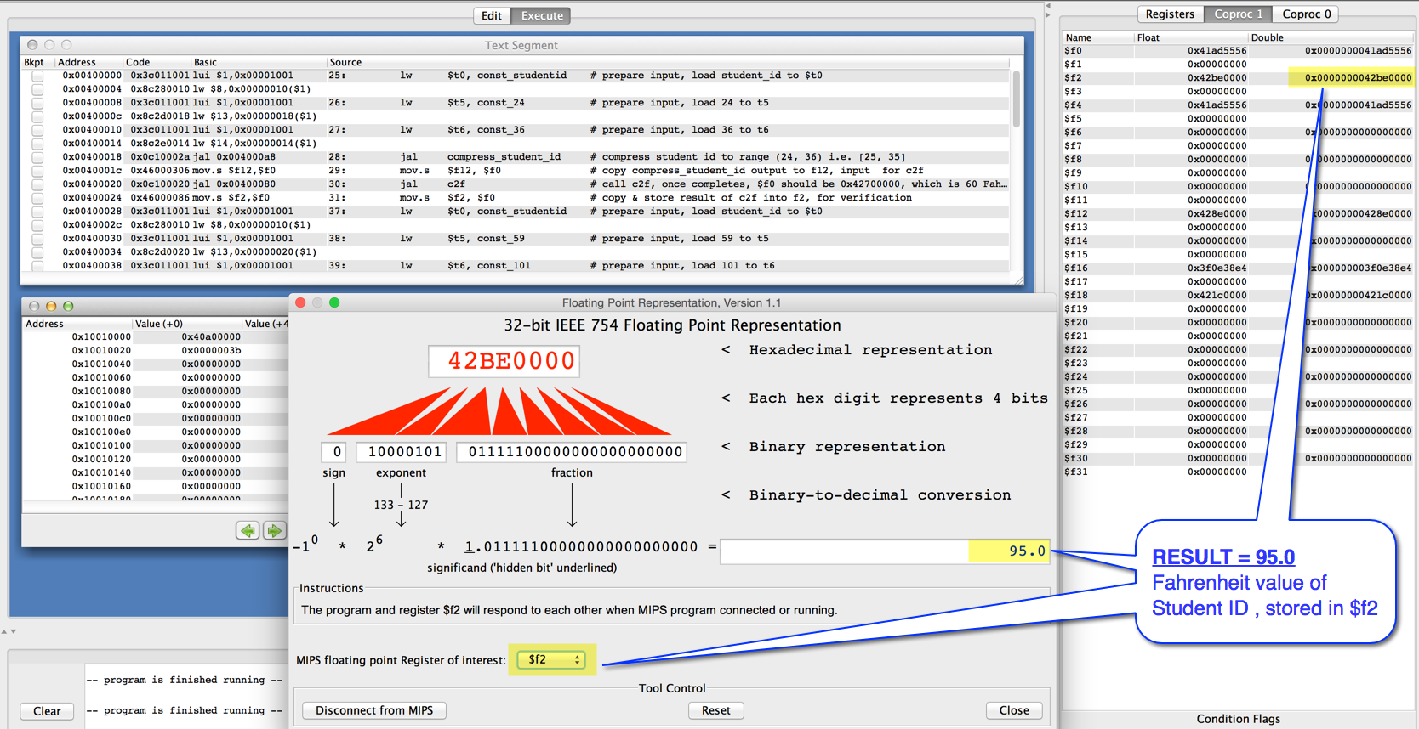

**ºC of Student ID = 21.666668**

Screenshot:

