# Theory

### Compare Bridge, Hub, layer-2 Switch

|  |  |  |  |
| --- | --- | --- | --- |
|  | **Hub** | **Bridge** | **Switch** |
| **Definitions** | * Central element of star layout physically (a bus logically), act as repeater * Each station connects to hub using 2 lines * Broadcast model (frame is forwarded to all stations) | * Connects similar LANs with identical physical & link layer protocols * Review destination address but do not modify MAC fields, thus do not contain LLC layer * Frame handling by SW * Fw 1 frame at a time * Only has store & fwd ops | * Frame is delivered to recipient node (no broadcast) * Frame forwarding using HW * Can handle multiple frames at a time * Can have cut-through ops (beside store & fwd) |
| **Pros & Cons** | * Good for building wiring practices * Limited length of line 100m * Collision occurs if 2 stations transmit at the same time | * Reliability * Performance * Security * Geography * Only 2 ports | * Dedicated capacity equal to original LAN * Total throughput of the network increases (because of no broadcast) * No change to SW or HW is required to replace current bus/hub to switch * Scale easily * More ports than bridge |

### Why certain devices are used for certain bandwidth?

### How does info flow in different cable types?

### Compare twisted pair, coaxial cable, optical fiber.

## [Signal Encoding]

### Compare AM & FM

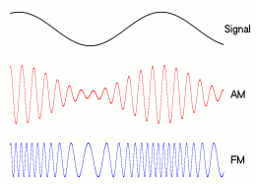

|  |  |  |
| --- | --- | --- |
|  | **AM** | **FM** |
| **Definitions** | * Amplitude Modulation * Freq: 535-1705Khz * Up to 1200 bps | * Frequency Modulation * Freq: 88-108 Mhz * 1200 to 2400 bps |
| **Pros and Cons** | * Poorer quality sound than FM * Cheaper * longer distance | * Less prone to interference than AM. * Better sound quality (higher bandwidth) * Shorter distance |
| **Bandwidth** | * Twice the modulating freq | * Twice the sum of modulating signal freq & deviation freq |
| **Noise** | * More susceptible to noise | * Less susceptible to noise |

### Compare ASK, FSK, PSK, & QAM

|  |  |  |  |
| --- | --- | --- | --- |
|  | ASK | FSK | PSK |
| Definitions | * Amplitude of carrier signal is varied to represent 1 or 0 | * Frequency of carrier signal is varied to represent 1 or 0 | * Phase of carrier signal is varied to represent 1 or 0 |
| Demodulation | * Determines the presence or absence of a sinusoid in a given time | * Determines 2 frequencies is present at a time | * Determines the phase of received sinusoid wrt some reference phase |
| Pros & Cons | * Simplicity * Susceptible to noise * Probability of error (Pe) is high, SNR low | * less susceptible to noise than ASK * Pe is low, SNR is high * Spectrum is 2x ASK spectrum | * less susceptible to errors than ASK while requiring same b/w as ASK * more efficient use of b/w (higher data rate) v/s FSK * Pe is low, SNR is high * More complex signal detection / recovery process than ASK, FSK |
| Application | * Transmit digital data over optical fiber | * Voice lines, high freq. radio transmission | * Widely used in wireless transmission |

### Terms in Digital Data

|  |  |
| --- | --- |
| Unipolar | * All signal elements have same sign |
| Polar | * Positive and negative voltages |
| Data Rate | * Rate of data transmission (bps) |
| Duration (length of bit) | * Time to emit 1 bit |
| Modulation Rate | * Rate of signal level changes (baud i.e. signal per sec) |
| Mark and Space | * Binary 1, 0 respectively |

### Compare Encoding Schemes:

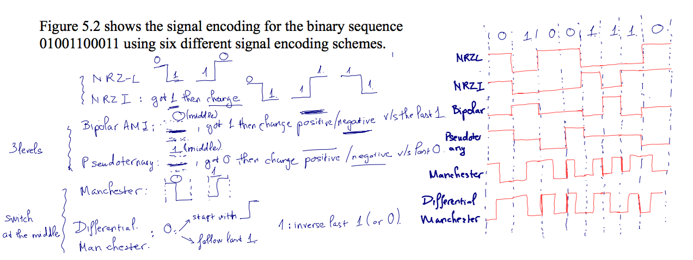

|  |  |  |  |  |  |  |
| --- | --- | --- | --- | --- | --- | --- |
|  | NRZ-L(Non return to zero) | NRZ-I | Binary Bipolar-AMI | Binary Pseudo ternary | Manchester | Differential Manchester |
| Definitions | * Voltage is constant during a bit interval * Positive and negative voltage levels for binary digits | * Constant voltage pulse during a bit interval * Differential encoding in which signal decoded by comparing the polarity of adjacent levels | * 0 is represented by a lack of pulse; 1 is by a positive or a negative pulse, alternatively. | * A multilevel binary encoding that complements the bipolar-AMI. * 1 is lack of pulse, 0 is positive or negative, alternatively. | * Biphase encoding, transition takes place in the middle of the bit period: 0 is high to low transition, 1 is low to high transition. | * Biphase encoding, transition takes place at the middle of the bit period, and transition at the start of the bit period represents 0, lack of transition at the start of the bit represents 1. |
| Pros & Cons | * Most of energy spent between dc and half the bit rate. * Easy to engineer * Efficient use of bandwidth * Suffer from the presence of dc component * Lack of synchronization capability due to potential of long runs of unchanged voltage levels. | | * Each 1 introduces a transition that can be used for synchronization * Error detection is possible * No dc component * Smaller b/w than NRZ * Long runs of 0s hurt synch * Overhead: three level use log2(3)=1.58 bits, Rx require 3dB more signal power for three-valued signals, smaller b/w than NRZ (based on spectral density graph). | | * Easy clocking mechanism (sync) for both kinds of bits. * Modulation rate 2x NRZ, greater b/w. * No dc component and relatively narrow b/w by spectral density graph * Manchester: Specified by IEEE802.3 for baseband coaxial cable and twisted pair CSMA/CD bus LAN. * Require high signaling rate relative to data rate –> costly for long-distance application * Differential Manchester: Specified by IEEE802.5 for token ring LAN, using shielded twisted pair. | |
| Application | * Digital magnetic recording (but not for signal transmissions) | |  |  |  |  |

Still no B8ZS and HDB3.

### How data scrambling works?

Using B8ZS or HDB3.

**B8ZS**

The bipolar-AMI encoding supplemented with a scrambling scheme, which uses two code violations to ensure synchronization in runs of 0's.

* Replace `00000000' with `000+-0-+', if the preceding voltage pulse was positive
* Replace `00000000' with `000-+0+-', if the preceding voltage pulse was not positive

 | | || | | | | | | | | | || | | | |
1 1 0 0|0|0|0|0|00 1 1 0 0 0|0|0|1|0|
|-| | || | | | | | |-| | | || | |-| |
| | |-||-|-

 | | || | | | | | | | | | || | | | |
1 1 0 0|0|0|0|0|00 1 1 0 0 0|0|0|1|0|
|-| | || | |-| |-| |-| | | || | |-| |
| | |-||-| 

* The amount of data remains unchanged.
* The spectrum graph shows that there is no dc component, with most of the energy concentrating in a relative sharp spectrum. Making the encoding suitable for high-rate transmissions.
* Used mainly in North America.

**HDB3**

The bipolar-AMI encoding supplemented with the following substitution scheme for `0000' runs.

|  |  |  |
| --- | --- | --- |
| **Number of bipolar pulses (ones) since last substitution** | | |
| **Polarity of preceding pulse** | **Odd** | **even** |
| **-** | 000- | +00+ |
| **+** | 000+ | -00- |

 | | || | | | | | | | | | || | | | |
1 1 0 0|0|0|0|0|00 1 1 0 0 0|0|0|1|0|
|-| | || | | | | | |-| | | || | |-| |
| | |-||-|-

 | | || | | | | | | | | | || | | | |
1 1 0 0|0|0|0|0|00 1 1 0 0 0|0|0|1|0|
|-| | || | |-| | |-| |-| | || | |-| |
| | |-||-| 

* Used in Europe and Japan
* Successive violations are of alternate polarity to avoid dc component.

### Relationship & formula of data rate (bps), bit length, signal rate, bandwidth, frequency, lamda, etc.

Bit Per Baud: usually 12 bits (1 bit for start, 8 bits for data, 1 bit for parity, 2 bit for stops)

***Prob 1: A digital has 8 levels, how many bits are needed per level?***

Number of bits per level: . Each signal level is represented by 3 bits. (it should be integer, rounded up)

***Prob 2: Download a document at rate 100 pages per sec. What is the required bit rate of the channel?***

Page has 24 lines, 80 chars each line, each char requires 8 bit (ascii), bit rate is

***Prob 3: A digitized voice channel is made by digitizing a 4-kHz bandwidth analog voice signal. We need to sample the signal at twice the highest frequency (two samples per hertz). We assume that each sample requires 8 bits. What is the required bit rate?***

Bit rate can be calculated:

***Prob 4: What is the bit rate for high-definition TV (HDTV)?***

HDTV uses digital signals to broadcast high quality video signals. The HDTV screen is normally a ratio of 16 : 9. There are 1920 by 1080 pixels per screen, and the screen is renewed 30 times per second. Twenty-four bits represents one color pixel.

TV Stations reduce this rate to 20-40 Mbps through compression.

### What affect the receiver to interpret incoming signal?

Digital signal: timing of bits – start/end, and signal levels

Signal interpretation: SNR increase, bit error rate (BER) decreases;

Data Rate increases, BER increases; Bandwidth increases, data rate increases.

## Transmission Media

### Factors that affect Data Rate & Distance in media transmission

Bandwidth (proportional with data rate), Transmission impairments (attenuation, noise), Interference (overlapping of BW), Number of receivers (attenuation)

### What are the most common guided and non-guided media in used?

Guided media: twisted pair, coaxial cable, optical fiber; Non-guided media: wireless, microwave

### Most common guided media for analog signal?

Twisted Pair.

### What is NEXT (near end crosstalk)?

Near-end crosstalk (NEXT) is an error condition that can occur when connectors are attached

to twisted pair cabling. NEXT is usually caused by crossed or crushed wire pairs. The error condition

does not require that the wires be crushed so much that the conductors inside become exposed.

### Compare Twisted Pair, Coaxial Cable, Optical Fiber.

|  |  |  |  |
| --- | --- | --- | --- |
|  | Twisted Pair | Coaxial Cable | Optical Fibre |
| Definitions | * Pair of twisted conductors | * Pair of conductors separated by insulation | * Three components: light source, transmission system, and a detector      * Detector generates an electric pulse when hit by light (1-light, 0-no light) * Optical rays travel in glass or plastic core * The light bending depends on the properties of the media * Lights at shallow angles propagates, those at less than critical angle are absorbed in the jacket. * Cladding is glass or plastic with properties differs from core. |
| Pros & Cons | * Twisting reduces interference * Cheap medium * Unshielded (UTP) and shielded (STP) forms, different performance * Cable hold hundreds of pairs. Neighbor pairs have different twist lengths to reduce cross talk | * Offers longer distances and better speeds v/s twisted pair, due to better shielding. * Used for | * Good in long distance communication * Not affected by electromagnetic fields, no energy radiation -> high degree of security from eavesdropping. * Greater capacity, smaller size and lighter weight, lower attenuation, electromagnetic isolation, greater repeater spacing * **Multimode**: rays propagation at different angles of reflections, thus spread signal elements in time, and limits the rate in which data can be accurately received. * **Single mode**: achieved by sufficient reduction of radius of the core, which reduces the reflected angles. * **Multimode graded index** transmission is obtained by varying the index of reflection of the core to improve multimode without paying the cost of single mode. (index of reflection = speed in vacuum / speed in medium) |
| Data Rate | * 4 Mbps | * 500 Mbps | * 2 Gbps |
| Bandwidth | * 3 Mhz | * 350 Mhz | * 2 Ghz |
| Frequency | * 0-1 Mhz | * 0-500 Mhz | * 186-370 Thz |
| Attenuation | * 0.2-0.7 dB/km @ 1 kHz | * 7 dB/km @ 10 Mhz | * 0.2 – 0.5 dB / km |
| Repeater Distance | * 2 km | * 1-9 km | * 40 km |
| Application | * Commonly used for comms within buildings and telephone networks | * Used for cable TV and LAN. Had been used widely for telephone, but replaced by optical fibre. |  |

### Transmission modes of optical fibre?

Refer previous Ans.

### What types of wireless transmission, its frequencies and application?

|  |  |
| --- | --- |
| 1-40 Ghz | * Referred to as microwave frequencies * Highly directional beams are possible * Suitable for point to point transmissions * Also used for satellite communications |
| 30 Mhz – 1 Ghz | * Suitable for omnidirectional applications * Referred to as the radio range |
|  | * Infrared portion of the spectrum * Useful to local point-to-point and multipoint applications within confined areas |

### Antenna Gain (Gdb) & formula

Antenna Gain is a measure of directionality of an antenna, defined as the power output, in a particular direction.

Measure in dB, effective area is related to the physical size and shape.

## LAN

### What is Star Topology?

Each station connects to common central node, usually via p-2-p links.

Central node operates in broadcast fashion; resubmit to all stations each frame it gets.

Central node acts as a frame switching device, buffer incoming, and resubmit to their destination.

One station can transmit at a time (hub). Physical star, logical bus.

### What is IEEE802? Describe Physical, DLC layer (MAC, LLC).

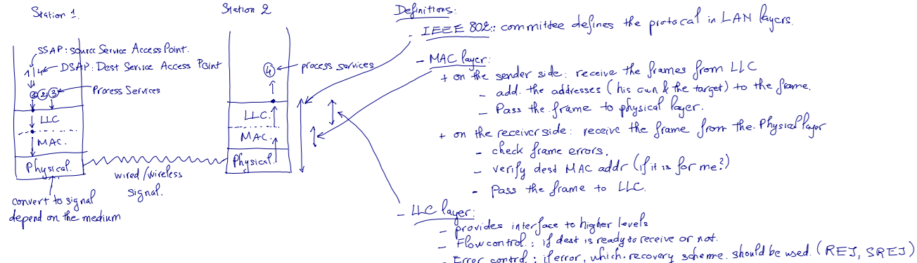

PHY: encoding/decoding of signals, preamble generation/removal, bit transmission/reception.

### LLC PDU in MAC Frame Structure

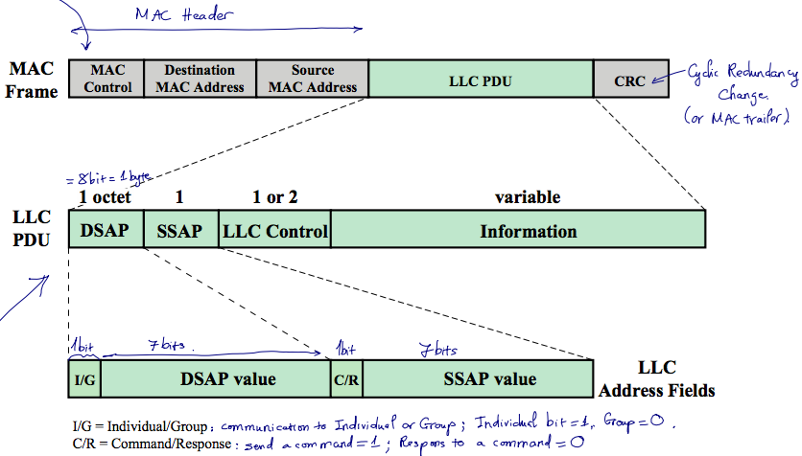

### What are three LLC Services?

|  |  |
| --- | --- |
| **Unacknowledged connectionless service** | * Requires minimum logic * Avoids duplication of mechanisms * Preferred option in most cases |
| **Connection-mode service** | * Used in simple devices * Provides flow control and reliability mechanisms |
| **Acknowledged connectionless service** | * Large communication channel needed * Time critical or emergency control signals |

### In MAC protocol, what are 2 techniques used?

Synchronous: allocates a specific capacity to each connection

Asynchronous: dynamically allocate capacity to meet changing demands: Round Robin, Reservation, Contention.

### What are three approaches used in Asynchronous Mac Allocation?

|  |  |  |  |
| --- | --- | --- | --- |
|  | Round Robin | Reservation | Contention |
| Definitions | * The needy stations alternatively get their turn in some order and for some duration of time * Control of sequence: centralized or distributed. | * Time in the medium is divided into slots. * Stations may reserve future slots for arbitrary duration of time. * Station without reservation must wait for timeslots to be released. * Control of sequence: centralized or distributed. | * Different stations compete among themselves for a share. * Control of sequence: no control. |
| Pros & Cons | * If only a few stations have data to transmit, there will be a considerable overhead of passing the turn. * No waste bandwidth * Need a master to divide the time * Commonly used technique. | * good for stream traffic. * No master, you reserve your slot * Waste of time if a user has nothing to share –> under utilization of BW | * Good for burst traffic * No control of whose turn –> no master, no SPOF. * Simple to implement * Performance tends to collapse under heavy load * Commonly used technique. * No waste of BW |

### Which layer takes care of flow control and error detection in IEEE802?

Flow control: LLC

Error Detection: Mac, LLC

### Describe three mechanisms a bridge uses to update its routing table base on spanning algorithm.

|  |  |  |  |
| --- | --- | --- | --- |
|  | Frame Forwarding | Address Learning | Loop Resolution |
| Definitions | * Maintain fwding db for each port attached to LAN | * Update fwd db to include source address of arriving frame from port X. * Set timer on each entry, if expired, remove. * Timer refresh for existing record | * The algo works if there is no alternate routes (closed loop) in the network. |
| Spanning Tree Algorithm   * Each bridge assigned unique identifier * Cost assigned to each bridge port * Exchange info between bridges to find spanning tree * Automatically update whenever topology changes. | | | | |

### What are two types of layer 2 switch? Compare.

Store-and-forward: delays, check CRC, boost integrity

Cut-through: no delay, no error check

### Why we need VLAN? And 3 types of VLAN.

A VLAN is a logical subgroup within a LAN that is created by software rather than by physically moving and separating devices. It combines user stations and network devices into a single broadcast domain regardless of the physical LAN segment they are attached to and allows traffic to flow more efficiently within populations of mutual interest. The VLAN logic is implemented in LAN switches and functions at the MAC layer. Because the objective is to isolate traffic within the VLAN, in order to link from one VLAN to another, a router is required.

Membership by:

* Port group: easy to configure, network admin must reconfigure membership from time to time
* Mac Address: physically movable, must be assigned initially, and if user change dock (with different MAC), need to reconfigure.
* Protocol: based on IP address, flexible.

### 

## Error Detection & Correction

### What are 2 types of Error Detection?

|  |  |  |
| --- | --- | --- |
|  | Parity Check | Cyclic Redundacy Check (CRC) |
| Definitions | * One error-detection bit whose value depends on the count of 1’s in the input * Even parity: even number of 1’s. Used for synchronous transmission. * Odd parity: odds number of 1s, used for asynchronous transmission. | * Most common and powerful error-detection codes * Add n bits to each block of k bits (data) so that the n+k will be divisible by a predetermined number. |

### What is Internet Checksum

Ones-complement operation: invert all bits 0 <–> 1. If there is a carry out of left most bit, add 1 to the sum.

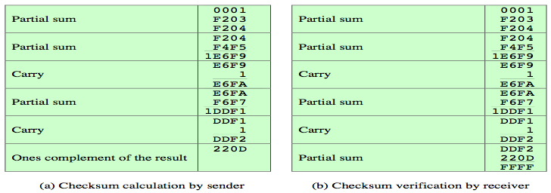

## Data Link Control Layer (DLC)

### HDLC Frame Structure

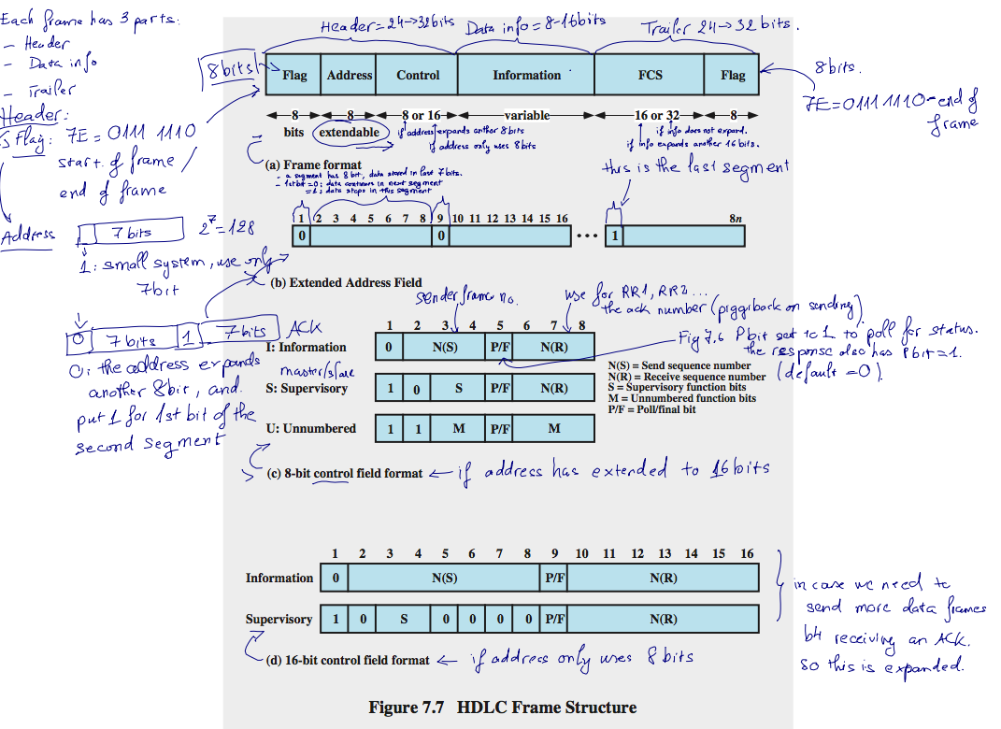

### What is Bit Stuffing

**Bit stuffing**: Add stuff bits at transmission to delimiter-like bit runs, and remove these bits at destination

Example: For delimiters of the form `01111110', add a '0' after each sequence '11111' that is not in a delimiter.

**Character stuffing**: Duplicate each appearance of the distinguished character outside the delimiter.

Example: For delimiters of the form `X', add a 'X' after each 'X' that is not a delimiter.

### What services being offered in DLC?

* Framing
* Error Detection (Parity, CRC)
* Flow Control (Stop-and-Wait, Sliding-Window)
* Error Control (Stop-and-Wait ARQ, Go-Back-N ARQ, Selective-reject ARQ)

### Two Flow Control in DLC

|  |  |  |
| --- | --- | --- |
|  | Stop-and-Wait | Sliding Window |
| Definitions | * The sender waits for an ack to old submissions before initiating a new one. | * The sender maintains a window of frames it is allowed to send without ack. * The receiver maintains a windows of frames that it prepares to receive. * The receiver ack the seq no. of frame it expect next. |
| Pros and Cons | * Minimal overhead if sending large frames (large frame has high probability of transmission error) * Inefficient with large number of small frames |  |

### Four Error Control Techniques in DLC

Error detection

Positive acknowledgment

Retransmission after time out

Negative acknowledgment and retransmission

### Three Error Control Protocol in DLC

|  |  |  |  |
| --- | --- | --- | --- |
|  | Stop and Wait Protocol | Go Back N ARQ Protocol | Selective Reject ARQ Protocol |
| Definitions | * Alternate messages are labeled by 0 or 1, to handle duplications. * Sender resubmits messages if acknowledgments do not arrive in predetermined time * Receiver discards duplications time | Variant of sliding-windows with negative acknowledgment for damaged frames.   * Receiver ignores damaged frames and their successors * Sender asks an acknowledgment from the receiver, if none is received within some predetermined time. | * Frames resubmitted only on time-out or negative acknowledgments. Useful for transmission with poor error rates. |

# Exercise

### Given a binary string, draw how each method encodes the data to digital signal.

### How modulator work (sender/receiver), explain the mechanism (formula), give an example.

### Practice QPSK & OQPSK modulator at home (5.11)

# Midterm Qns

### What is digital signal? Draw a digital signal encoding wave forms for the given bit.

Digital Signal: is a electrical signal that contains a sequence of discrete voltage pulses,

representing of a sequence of discrete values, for an example of an arbitrary bit stream.



Calculation

### What is unipolar and polar signal? Prove that for a given voltage difference between

### the two logic states, polar signal requires less energy for transmission.

Polar signals are signals in which one logical state is represented by a positive voltage level and the other

by a negative voltage level. Unipolar signals: all signals have the same sign, either positive or negative.

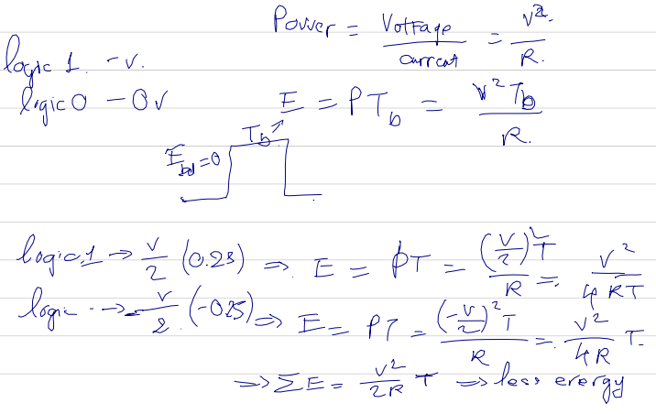

### An MFSK of 4 elements has carrier frequency fc = 1Mhz and the difference frequency, fd = 50 Khz.

### How many bits each signal element represents? What are the frequencies of all signal elements?

Calculation

### What is the purpose of LLC layer? What are the services it provides to users of higher layer, explain them.

Purpose of LLC layer:

* Control framing, frame synchronization
* Flow Control
* Error Control, Error Checking
* MAC Sub-layer addressing

### What is SAP? How many bits are used for SAP field?

SAP is service access point, defined in 8-bit address fields.

The 802.2 header includes 2 SAP fields, SSAP (Source SAP) and DSAP (Destination SAP)

### Mention three different schemes by which you can govern an asynchronous network.

### Explain their relative strengths and weaknesses.

|  |  |  |  |
| --- | --- | --- | --- |
|  | Round Robin | Reservation | Contention |
| Definitions | * The needy stations alternatively get their turn in some order and for some duration of time * Control of sequence: centralized or distributed. | * Time in the medium is divided into slots. * Stations may reserve future slots for arbitrary duration of time. * Station without reservation must wait for timeslots to be released. * Control of sequence: centralized or distributed. | * Different stations compete among themselves for a share. * Control of sequence: no control. |
| Pros & Cons | * If only a few stations have data to transmit, there will be a considerable overhead of passing the turn. * No waste bandwidth * Need a master to divide the time * Commonly used technique. | * good for stream traffic. * No master, you reserve your slot * Waste of time if a user has nothing to share –> under utilization of BW | * Good for burst traffic * No control of whose turn –> no master, no SPOF. * Simple to implement * Performance tends to collapse under heavy load * Commonly used technique. * No waste of BW |

### Mention and explain four important benefits achieved by incorporating bridges into a physical network. What are the key design aspects of a bridge?

Four benefits:

* **Reliability**: To create partitions on the network into self-contained units so that a fault occur on the network   
  will not disable communication for all devices.
* **Performance**: In general, performance on a LAN declines with an increase in the number of devices or the   
  length of the wire. A number of smaller LANs will often give improved performance if devices can be clustered   
  so that intra-network traffic significantly exceeds internetwork traffic.
* **Security**: to keep different types of traffic on physically separate media, and different types of users   
  (with different levels of security needs) under control and monitoring.
* **Geography**: to support devices clustered into two geographically distant locations.

Key design aspects

* Makes no modification to the content or format of the frames it receives
* Should contain enough buffer space to meet peak demands
* Must contain routing and addressing intelligence
* May connect more than two LANs
* Bridging is transparent to stations

### What is a hub? Explain with a diagram how better data rate is achieved by using a switch in place of a hub.

A hub is

* Active central element of star layout
* Each station connected to hub by two lines
* Hub acts as a repeater
* Length of a line is limited to about 100m
* Optical fiber may be used to about 500m
* Physically a star, logically a bus
* Transmission from any one station is received by all other stations
* If two stations transmit at the same time, there will be a collision

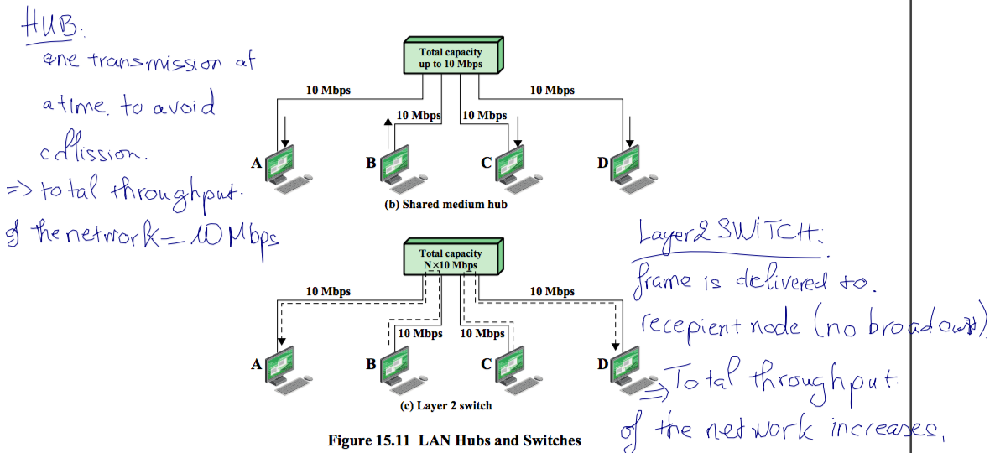

### What do you mean by a bit error in a digital system? By means of a diagram show the types of bit errors and their cause in digital system.

**A bit error** in a digital system is a bit of data stream over a communication channel that   
have been altered due to noise, interference, distortion or bit synchronization errors.

There are 2 types of bit errors: - Single bit errors - Burst errors

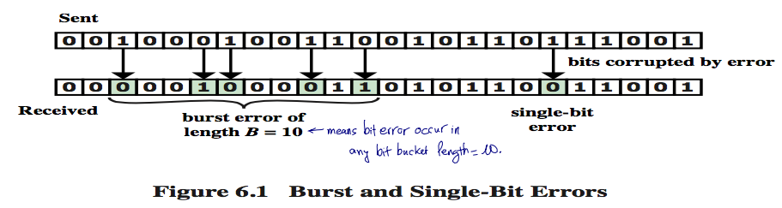

### What are the factors that determine the data rate in a data transmission system, explain qualitatively.

SNR increase, bit error rate (BER) decreases; Data Rate increases, BER increases;   
Bandwidth increases, data rate increases. Bandwidth (proportional with data rate),   
Transmission impairments (attenuation, noise), Interference (overlapping of BW),   
Number of receivers (attenuation).

### Explain the necessity of designing twisted pair cables and coaxial cable in lieu of just a copper wire for signal transmission through guided media. Compare and contrast the usage of twisted pair cable and coaxial cable. Why they are unsuitable in very high frequencies.

|  |  |  |
| --- | --- | --- |
|  | Twisted Pair | Coaxial Cable |
| Definitions | * Pair of twisted conductors | * Pair of conductors separated by insulation |
| Pros & Cons | * Twisting reduces interference * Cheap medium * Unshielded (UTP) and shielded (STP) forms, different performance * Cable hold hundreds of pairs. Neighbor pairs have different twist lengths to reduce cross talk | * Offers longer distances and better speeds v/s twisted pair, due to better shielding. * Used for |
| Data Rate | * 4 Mbps | * 500 Mbps |
| Bandwidth | * 3 Mhz | * 350 Mhz |
| Frequency | * 0-1 Mhz | * 0-500 Mhz |
| Attenuation | * 0.2-0.7 dB/km @ 1 kHz | * 7 dB/km @ 10 Mhz |
| Repeater Distance | * 2 km | * 1-9 km |
| Application | * Commonly used for comms within buildings and telephone networks | * Used for cable TV and LAN. Had been used widely for telephone, but replaced by optical fibre. |

### Explain the principle of Optical Fiber transmission

Optical fibers work on the principle of total internal reflection.

* Light rays are reflected and guided down the length of an optical fiber.
* The acceptance angle of the fiber determines which light rays will be   
  guided down the fiber.
* Fiber optical cables are highly transparent, cylindrical conduits for light.   
  These cables are formed of two materials with different refractive indices.   
  This creates a optimal waveguide for transmitting light. When light enters   
  the fiber made of material with higher refractive index than the cladding   
  surrounding it, it stays inside the material due to total internal reflection   
  and is thus transmitted forward.

### In HDLC frame format, how length of address field is decided?

Usually 8 bits long, may be extended to multiples of 7 bits (left most indicates if it is the last octet (1) or not (0)

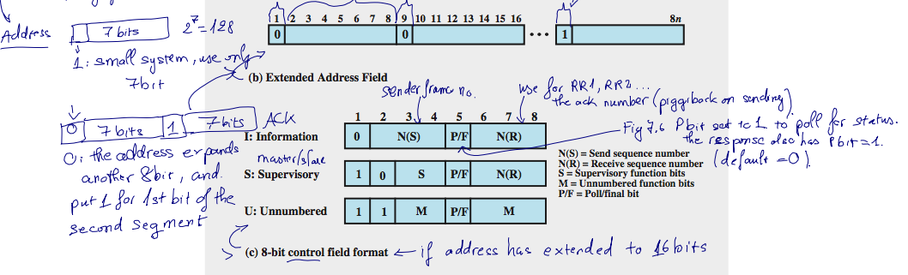

### What is bit stuffing and why it is required to be used in HDLC?

**Bit stuffing**: Add stuff bits at transmission to delimiter-like bit runs, and remove these bits at destination

Example: For delimiters of the form `01111110', add a '0' after each sequence '11111' that is not in a delimiter.

**Why**: With the use of bit stuffing, arbitrary bit patterns can be inserted into the data field of the frame.   
This property is known as data transparency.

### What is delay distortion? What are the different transmission system it can occur?

Delay Distortion is signal impairment caused because the velocity of propagation of a signal in a guided media varies, i.e. different frequency signals, emitted at same time, will reach the receiver at different times. Delay distortion in digital signaling may cause one bit to overlap over (inter symbol interference) other causing error. Delay distortion can be reduced by equalization process.

### What is an optical fiber? What are the different types of optical fiber? Explain with a diagram how data is generally tranxsmitted and received by means of an optical fiber channel. Why optical fiber is increasing replacing coaxial cables in data network.

|  |
| --- |
| Optical Fibre |
| * Three components: light source, transmission system, and a detector      * Ultrapure fiber is difficult to manufacture; higher- loss multicomponent glass fibers are more economical and still provide good performance. Plastic fiber is even less costly and can be used for short-haul links, for which moderately high losses are acceptable. * Detector generates an electric pulse when hit by light (1-light, 0-no light) * Optical rays travel in glass or plastic core * The light bending depends on the properties of the media * Lights at shallow angles propagates, those at less than critical angle are absorbed in the jacket (buffer cloating). * Cladding is glass or plastic with properties differs from core. |
| * Good in long distance communication * Greater capacity, smaller size and lighter weight, lower attenuation, greater repeater spacing * Not affected by electromagnetic fields, no energy radiation -> high degree of security from eavesdropping. * **Step-index Multimode**: rays propagation at different angles of reflections, thus spread signal elements in time, and limits the rate in which data can be accurately received. * **Single mode**: achieved by sufficient reduction of radius of the core, which reduces the reflected angles. * **Graded-index Multimode** transmission is obtained by varying the index of reflection of the core to improve multimode without paying the cost of single mode. (index of reflection = speed in vacuum / speed in medium) |
| * 2 Gbps |
| * 2 Ghz |
| * 186-370 Thz |
| * 0.2 – 0.5 dB / km |
| * 40 km |
| * fiber optic links were used to replace copper or digital radio links between telephone switches, beginning with long-distance links, called long lines or long haul, where fiber’s distance and bandwidth capabilities made fiber significantly more cost-effective. Optical fiber is used to connect all central offices and long-distance switches because it has thousands of times the bandwidth of copper wire and can carry signals hundreds of times further before needing a repeater, making the cost of a phone connection over fiber only a few percent of the cost of the same connection on copper. |