# Theory

## LAN

### What is Star Topology?

Each station connects to common central node, usually via p-2-p links.

Central node operates in broadcast fashion; resubmit to all stations each frame it gets.

Central node acts as a frame switching device, buffer incoming, and resubmit to their destination.

One station can transmit at a time (hub). Physical star, logical bus.

### What is IEEE802? Describe Physical, DLC layer (MAC, LLC).

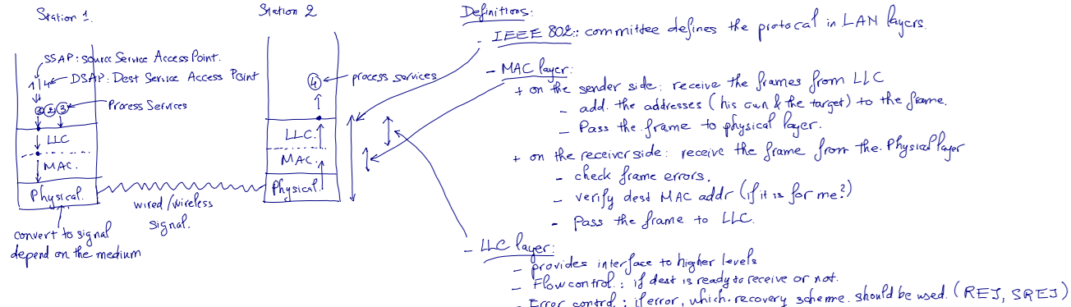

PHY: encoding/decoding of signals, preamble generation/removal, bit transmission/reception.

### LLC PDU in MAC Frame Structure

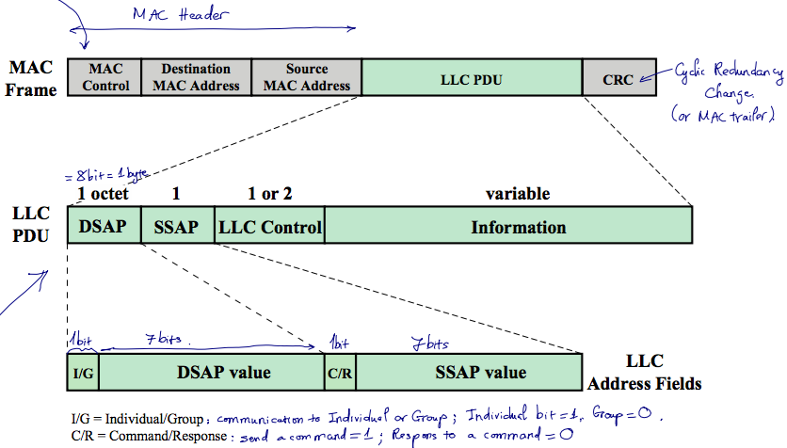

### What are three LLC Services?

|  |  |
| --- | --- |
| **Unacknowledged connectionless service** | * Requires minimum logic * Avoids duplication of mechanisms * Preferred option in most cases |
| **Connection-mode service** | * Used in simple devices * Provides flow control and reliability mechanisms |
| **Acknowledged connectionless service** | * Large communication channel needed * Time critical or emergency control signals |

### In MAC protocol, what are 2 techniques used?

Synchronous: allocates a specific capacity to each connection

Asynchronous: dynamically allocate capacity to meet changing demands: Round Robin, Reservation, Contention.

### What are three approaches used in Asynchronous Mac Allocation?

|  |  |  |  |
| --- | --- | --- | --- |
|  | Round Robin | Reservation | Contention |
| Definitions | * The needy stations alternatively get their turn in some order and for some duration of time * Control of sequence: centralized or distributed. | * Time in the medium is divided into slots. * Stations may reserve future slots for arbitrary duration of time. * Station without reservation must wait for timeslots to be released. * Control of sequence: centralized or distributed. | * Different stations compete among themselves for a share. * Control of sequence: no control. |
| Pros & Cons | * If only a few stations have data to transmit, there will be a considerable overhead of passing the turn. * No waste bandwidth * Need a master to divide the time * Commonly used technique. | * good for stream traffic. * No master, you reserve your slot * Waste of time if a user has nothing to share –> under utilization of BW | * Good for burst traffic * No control of whose turn –> no master, no SPOF. * Simple to implement * Performance tends to collapse under heavy load * Commonly used technique. * No waste of BW |

### Compare Bridge, Hub, layer-2 Switch

|  |  |  |  |
| --- | --- | --- | --- |
|  | **Hub** | **Bridge** | **Switch** |
| **Definitions** | * Central element of star layout physically (a bus logically), act as repeater * Each station connects to hub using 2 lines * Broadcast model (frame is forwarded to all stations) | * Connects similar LANs with identical physical & link layer protocols * Review destination address but do not modify MAC fields, thus do not contain LLC layer * Frame handling by SW * Fw 1 frame at a time * Only has store & fwd ops | * Frame is delivered to recipient node (no broadcast) * Frame forwarding using HW * Can handle multiple frames at a time * Can have cut-through ops (beside store & fwd) |
| **Pros & Cons** | * Good for building wiring practices * Limited length of line 100m * Collision occurs if 2 stations transmit at the same time | * Reliability * Performance * Security * Geography * Only 2 ports | * Dedicated capacity equal to original LAN * Total throughput of the network increases (because of no broadcast) * No change to SW or HW is required to replace current bus/hub to switch * Scale easily * More ports than bridge |

### Which layer takes care of flow control and error detection in IEEE802?

Flow control: LLC

Error Detection: Mac, LLC

### Describe three mechanisms a bridge uses to update its routing table base on spanning algorithm.

|  |  |  |  |
| --- | --- | --- | --- |
|  | Frame Forwarding | Address Learning | Loop Resolution |
| Definitions | * Maintain fwding db for each port attached to LAN | * Update fwd db to include source address of arriving frame from port X. * Set timer on each entry, if expired, remove. * Timer refresh for existing record | * The algo works if there is no alternate routes (closed loop) in the network. |
| Spanning Tree Algorithm   * Each bridge assigned unique identifier * Cost assigned to each bridge port * Exchange info between bridges to find spanning tree * Automatically update whenever topology changes. | | | | |

### What are two types of layer 2 switch? Compare.

Store-and-forward: delays, check CRC, boost integrity

Cut-through: no delay, no error check

### Why we need VLAN? And 3 types of VLAN.

A VLAN is a logical subgroup within a LAN that is created by software rather than by physically moving and separating devices. It combines user stations and network devices into a single broadcast domain regardless of the physical LAN segment they are attached to and allows traffic to flow more efficiently within populations of mutual interest. The VLAN logic is implemented in LAN switches and functions at the MAC layer. Because the objective is to isolate traffic within the VLAN, in order to link from one VLAN to another, a router is required.

Membership by:

* Port group: easy to configure, network admin must reconfigure membership from time to time
* Mac Address: physically movable, must be assigned initially, and if user change dock (with different MAC), need to reconfigure.
* Protocol: based on IP address, flexible.

### 

## MULTIPLEXING

### How many types of MUX?

**Time Division Multiplexing** and **Frequency Division Multiplexing**.

### What are the 2 processes of FDM?

Use modulation to move each signal to the required frequency band.

Use multiplexing equipment to combine the modulated signals, each called subcarrier.

### What are problems that FDM must cope with?

- Crosstalk, this may happen since the component signals are close to each other.

- Intermodulation noise.

### What high capacity, long distance transmission use?

FDM, example AT&T.

### What is the derivative of FDM, and what is it used for?

Derivative of FDM is WDM (Wavelength Division Multiplexing), used in optical fiber where multiple beams of light are transmitted with different frequencies on the same fiber cable.

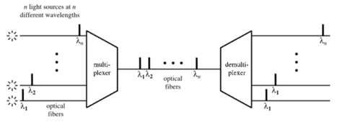

### What is TDM?

Method of transmitting and receiving independent signals on common path by letting each signal appears on the line inly a fraction of time.

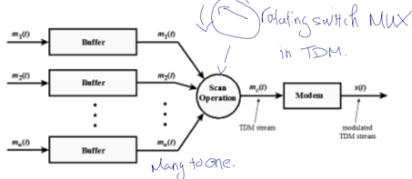

### What does Syncrhonous TDM means?

NOT because synchronous transmission, but because time slots are already pre-assigned and fixed.

### Does TDM have header and trailer? (Data Link Control)

No, it does not need data link control protocol thus NO header nor trailer. The main reason is because TDM share transmission B/W with among all channels so if one channel miss the bus it should not stop others from transmitting. Error control should be applied to per channel using HDLC.

### How to maintain synchronization between source and destination in TDM?

One control bit is added into each TDM frame.

### How TDM maintains steady data rate of incoming signal?

It inserts extra dummy bits into each incoming signal (Pulse Stuffing) until it matches the local clock (equalization of data rate).

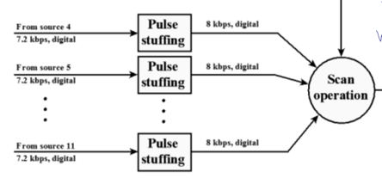

### The SONET data rate

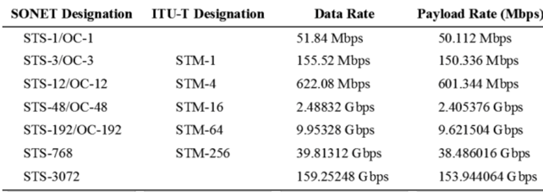

**How to deduce the bandwidth of STS-1**

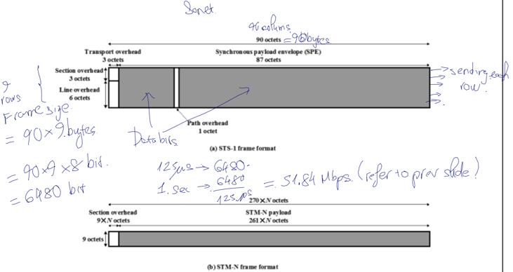

### What is the freq of voice signal or telephone signal

4Khz

### Prove why DS-1 = 1.544Mbps (1-bit stuffing)

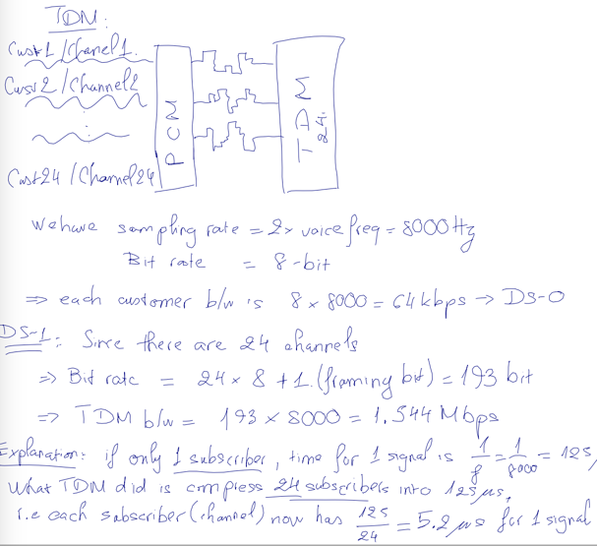

### Find out how many bits are stuffed for DS-2?

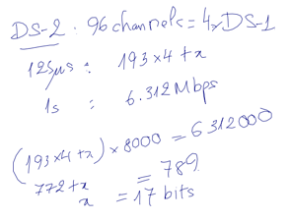

### What is North American TDM Carrier Standards?

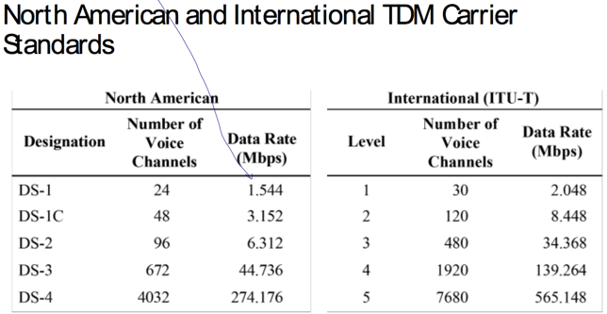

### FDM Multiplexing

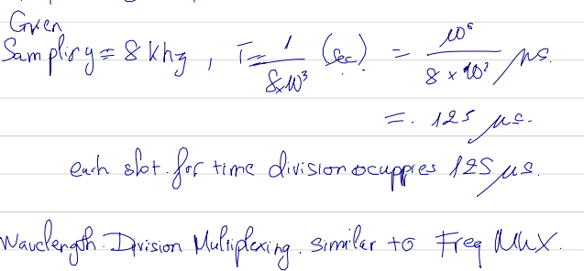

## WAN

### In Switch comm, what is the link type of Node-State, and Node-Node?

Node-Station: point-to-point

Node-Node: Multiplexed, FDM or TDM

### What are the technologies used in WAN?

Circuit Switching, and Packet Switching.

### Which Switching technology derived from public Telephone?

Circuit Switching.

### Compare Circuit Switching, Datagram Packet Switching, and Virtual Circuit Packet Switching

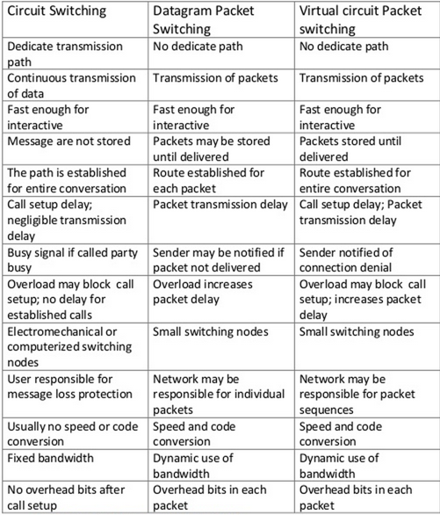

**Packet Switching**: Connectionless

**Virtual Circuit**: preferable for **long** message.

### Compare 2 types of space division switching.

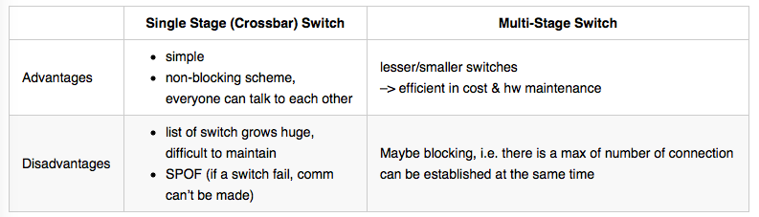

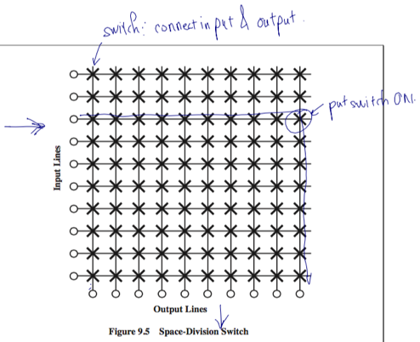

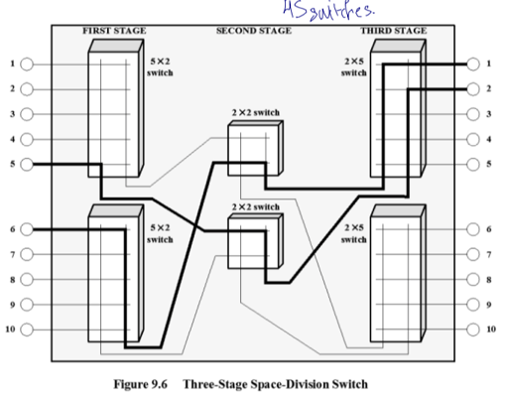

### What is soft switch?

A general-purpose computer running specialized software is used as a smart phone switch.

Cost less and has more functions than traditional circuit switches.

### Which packet switching is more preferreabled for long message?

Virtual Circuit.

## IP Protocol

### What is the advantage of connectionless (in IP protocol)?

Flexible, can be made robust, no unnecessary overhead.

### Which layers are implemented all end stations and routers in order to communicate through IP protocol?

Physical, MAC, LLC, IP.

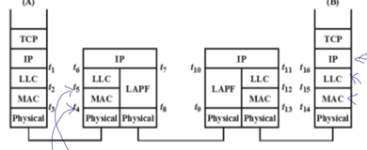

### What does IP layer provide?

Routing service, datagram lifetime, fragmentation and reassembly, error control, and flow control.

### What are the routing techniques used by Internet Protocol?

Routing table (indicate next hop, can be dynamic or static), source routing, route recording, sequence number for each packet.

### What is the structure of the IP fragmentation?

The original datagram is split into multiple fragments, in multiple of 8 bytes.

Each fragment has IP Header, and Payload (data).

Each **IP header** has:

* Data Unit Identifier (ID), source address & destination address, the protocol layer that generate the data.
* Data Length: length of user data field (1 unit = 8 bits)
* Offset: position of fragment in org datagram (1 unit = 64 bits, for example 208 in octets identical to 26 in 64-bit)
* IP Flag: M: 0 (false) no more packet, 1 (true) has more packets

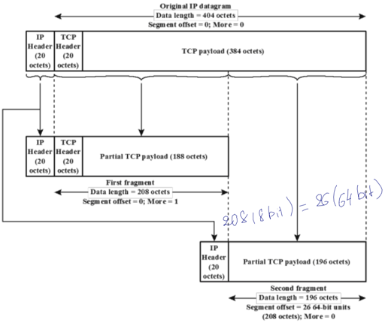

### How Error Control works in IP?

Error Control is used to discard certain diagrams: expired lifetime, congestion, FCS error.

### How Flow Control works in IP?

Target node sends flow control packet (ICMP) to indicate its busy status and availability in secs to the source. The source will reset waiting time when receiving new availability.

### What is the biggest advantage of IP?

Flexible, is not tied to any path.

### Why we need IP address if we already have Mac Address?

(a) Carry info from one network to another, (b) distribute information based upon mac address, (c) IP addr is dynamic, MAC addr is fixed.

### Which ensemble way does IP datagram use?

At the destination (not intermediate node).

### How does IHL measure the size of the IPv4 Header?

1 unit in IHL field = 4 bytes of header size.

### How does Total Length measure the size of the IPv4 data?

1 unit in Total Length field = 1 byte in IP datagram.

### What are the IP service parameters?

Source & dest address, protocol, type of service, identification, fragment indicator, TTL, data length, option data, user data.

### IP v4 Header?

20 bytes minimum (5x4)

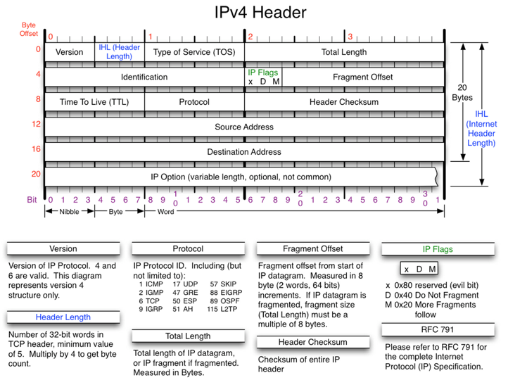

### IPv4 Classes

Network identifier comes with prefix:

Binary 0: for class A IP address

Binary 10: for class B IP address

Binary 110: for class C IP address

Binary 1110: for class D IP address, for future use

Binary 11110: for class E IP address, for future use

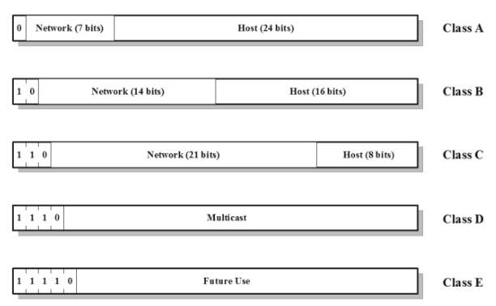

### Calculate Network ID, Host ID base on IP address and Netmask.

**Network ID:**: Operate AND on the IP address and the Subnet Mask will produce the Network ID. For example: 192.228.17.57 AND 255.255.255.224 = 192.228.17.32

**Host ID**: Operate AND on the IP address and the bit inversion of Subnet Mask will produce the Host ID. For example: 192.228.17.57 AND bit-inverse(255.255.255.224) = 192.228.17.57 AND 0.0.0.31 = 25

### 

### How congestion is controlled in IP?

Via ECN bit, congestion indication.

### What WLAN consist of?

* a **backbone wired LAN**, for connecting to Internet, or let other stations connecting to.
* a **Control Module (CM)** as interface of the WLAN (broadcast/receive), includes either a bridge or router linking the WLAN to the backbone.
* several **stations** or routers connecting to the Control Module.
* several **User Modules** (bridge & control a number of stations on another wired LAN)

### What are 10 requirements of WLAN?

throughput: maximize capacity by efficient use of medium

number of nodes: can support several client nodes

connection to backbone LAN: has connection to backbone LAN for other stationary nodes or internet connectivity.

service area: wireless signal should cover certain area space

battery consumption: low power usage for Wireless LAN connectivity

transmission robustness and security: reliable signals, and secured connection (not easy to hack)

collocated network operation: can co-exist with other Wireless LANs

license-free operation: does not need to pay license fee when operating under certain bandwidth

handoff/roaming: user can move from one cell to the other in the same network freely, without disrupting service.

dynamic configuration: add, remove user/nodes, or reconfigure does not cause disruption to other users.

### IEEE 802.11 WLAN std

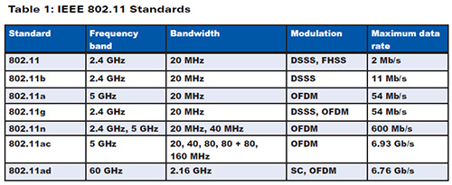

### WLAN Architecture

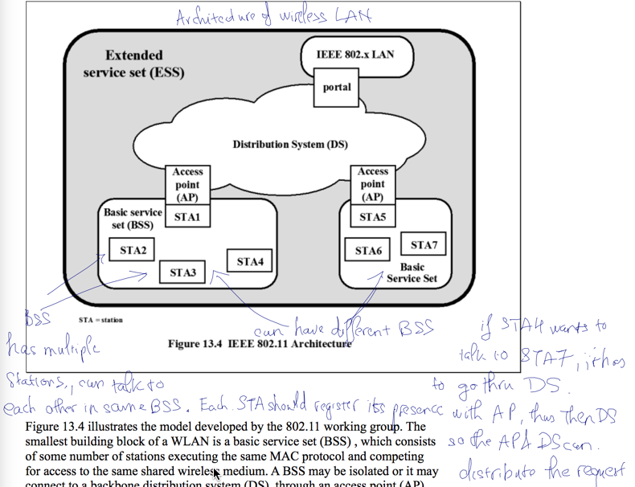

### IEEE 802.11 Services

* **Station Service (SS)**: SS is about connecting the STA and is similar to plugging in an ethernet cable.
  + Authentication
  + Deauthentication
  + Encryption
  + MSDU delivery 1
  + Dynamic Frequency Selection (DFS)
  + Transmit Power Control (TPC)
  + Higher-layer timer synchronization (QoS only)
  + QoS traffic scheduling (QoS only)
  + Radio Measurement
  + DSE
* **Distribution System Service (DSS)**: DSS is all about how to get the data message from one point to another. It does that by exchanging the MAC frames from one station in one BSS to another station in another BSS, via the DS. Distribution service can also work in the same BSS, the frame will go through the AP between 2 stations.
  + Association: A station must be associated before the Distribution Service can deliver data to / from a station.
  + Reassociation: transfer an already established association to another AP, from one BSS to another.
  + Disassociation: station or AP sends this signal to terminate the association, for leaving an ESS or shutting down.
  + Distribution
  + Integration
  + QoS traffic scheduling (QoS only)
  + DSE
  + Internetworking with the DS
* **Integration Service (IS)**: enable the delivery of the MAC frames betwee the DS and a non-802.11 network via a portal, aka a frame format transfer method, basically translates a 802.11 frame into a 802.3 frame.

### What are mobility transition types in WLAN?

No transition, BSS transition, ESS transition.

### 3 functional areas of Medium Access Control?

Reliable data delivery (using Four Frame Exchange), access control, and security.

### What is Four Frame Exchange?

Mechanism used in IEEE 802.11 to transfer data in reliable way:

* Source send Request to Send (RTS)
* Dest responds Clear to Send (CTS)
* Source transmit data after receiving CTS
* Dest responds immediately with an ACK each time it receives new frame.

This technique replaces Colission Detection in CSMA/CD.

# Test Qns

### What is SAP? How many bits are used for SAP field?

SAP is service access point, defined in 8-bit address fields.

The 802.2 header includes 2 SAP fields, SSAP (Source SAP) and DSAP (Destination SAP)

### Mention three different schemes by which you can govern an asynchronous network.

### Explain their relative strengths and weaknesses.

|  |  |  |  |
| --- | --- | --- | --- |
|  | Round Robin | Reservation | Contention |
| Definitions | * The needy stations alternatively get their turn in some order and for some duration of time * Control of sequence: centralized or distributed. | * Time in the medium is divided into slots. * Stations may reserve future slots for arbitrary duration of time. * Station without reservation must wait for timeslots to be released. * Control of sequence: centralized or distributed. | * Different stations compete among themselves for a share. * Control of sequence: no control. |
| Pros & Cons | * If only a few stations have data to transmit, there will be a considerable overhead of passing the turn. * No waste bandwidth * Need a master to divide the time * Commonly used technique. | * good for stream traffic. * No master, you reserve your slot * Waste of time if a user has nothing to share –> under utilization of BW | * Good for burst traffic * No control of whose turn –> no master, no SPOF. * Simple to implement * Performance tends to collapse under heavy load * Commonly used technique. * No waste of BW |

### Mention and explain four important benefits achieved by incorporating bridges into a physical network. What are the key design aspects of a bridge?

Four benefits:

* **Reliability**: To create partitions on the network into self-contained units so that a fault occur on the network   
  will not disable communication for all devices.
* **Performance**: In general, performance on a LAN declines with an increase in the number of devices or the   
  length of the wire. A number of smaller LANs will often give improved performance if devices can be clustered   
  so that intra-network traffic significantly exceeds internetwork traffic.
* **Security**: to keep different types of traffic on physically separate media, and different types of users   
  (with different levels of security needs) under control and monitoring.
* **Geography**: to support devices clustered into two geographically distant locations.

Key design aspects

* Makes no modification to the content or format of the frames it receives
* Should contain enough buffer space to meet peak demands
* Must contain routing and addressing intelligence
* May connect more than two LANs
* Bridging is transparent to stations

### What is a hub? Explain with a diagram how better data rate is achieved by using a switch in place of a hub.

A hub is

* Active central element of star layout
* Each station connected to hub by two lines
* Hub acts as a repeater
* Length of a line is limited to about 100m
* Optical fiber may be used to about 500m
* Physically a star, logically a bus
* Transmission from any one station is received by all other stations
* If two stations transmit at the same time, there will be a collision

