**CS500 – Vo Doan Quoc Sy – 150201133**

# Case Study 2

pi@rpi2 ~/case-study-2 $ vi app.c

pi@rpi2 ~/case-study-2 $ vi Makefile

pi@rpi2 ~/case-study-2 $ make

/usr/bin/gcc -Wall -Wshadow -Os -fomit-frame-pointer  -D_GNU_SOURCE -I/include -I.   -c -o app.o app.c

/usr/bin/gcc -s -Wl,-warn-common --static -o app  app.o

/usr/bin/strip -s --remove-section=.note --remove-section=.comment app

pi@rpi2 ~/case-study-2 $ vi app_script

pi@rpi2 ~/case-study-2 $ chmod u+x app_script

pi@rpi2 ~/case-study-2 $ ./app_script  20

Question 7)

**Screen Output:**

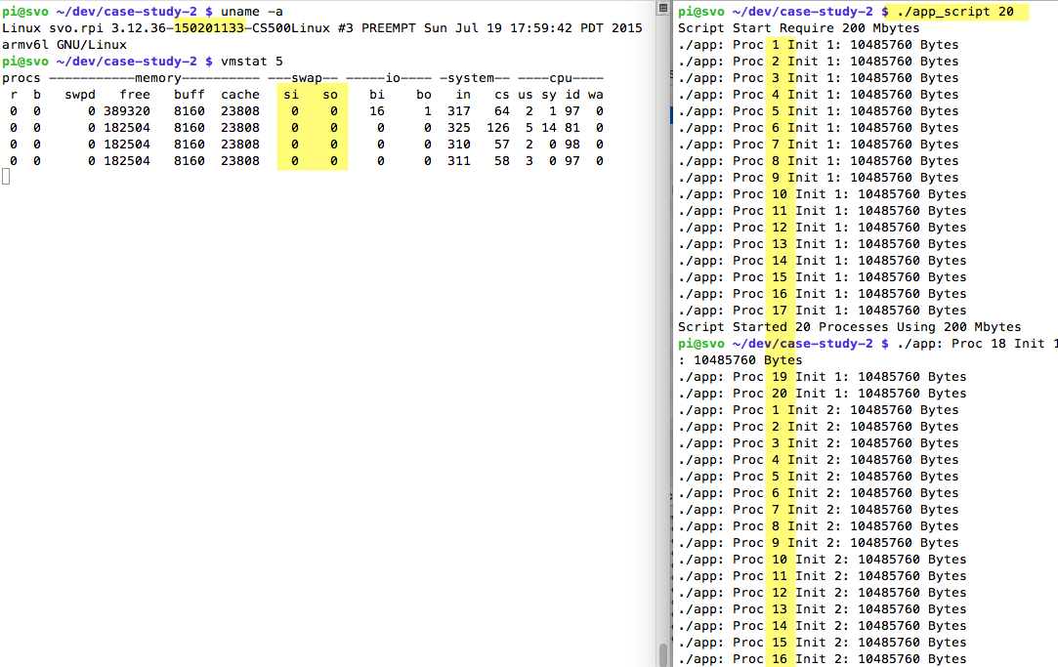

QN: What is the value of "si" and "so" column

ANS: Both show 0.

EXPLAIN: As si/so = 0, no memory is swapped in from disk or out to disk, i.e. the RAM has sufficient memory for app_script with 20 processes.

pi@rpi2 ~/case-study-2 $ ./app_script  50

Question 8)

**Screen Output:**

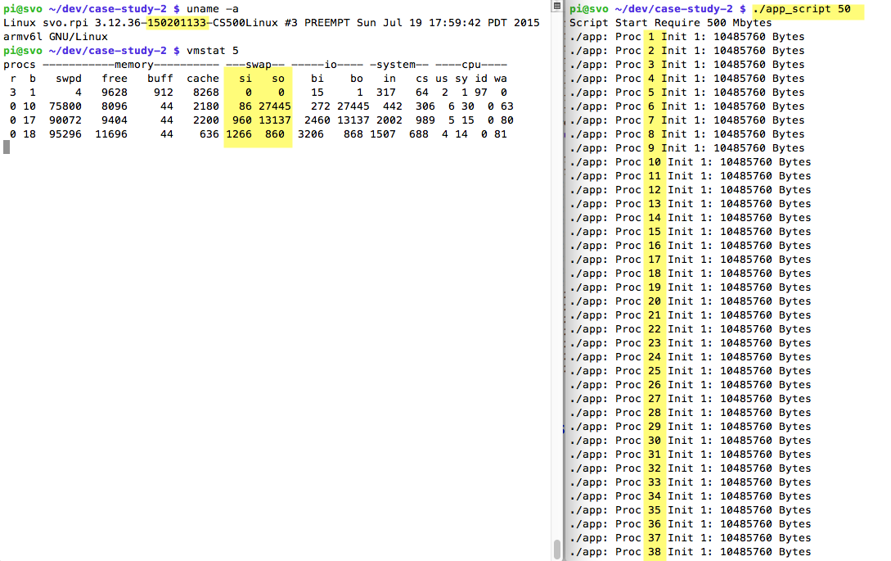

QN: What is the value of "si" and "so" column

ANS: both are **not** 0 after app_script execute with parameter 50.

EXPLAIN:

