# CS500 – Case Study 3

## Student ID: 150201133

## Student Name: VO, DOAN QUOC SY

### Q1) Create **smallFile** and print out `**uname –a**` on RPi

**uname screen**

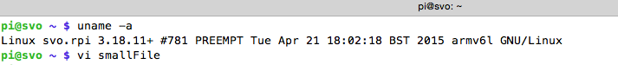

**cat screen:**

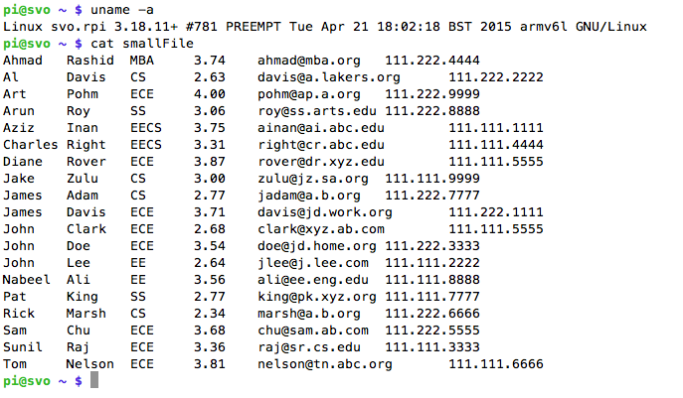

### Q2) Distribute `sort` command to remote host using `ssh` command, input from local host, output to local host.

**SSH command screen**

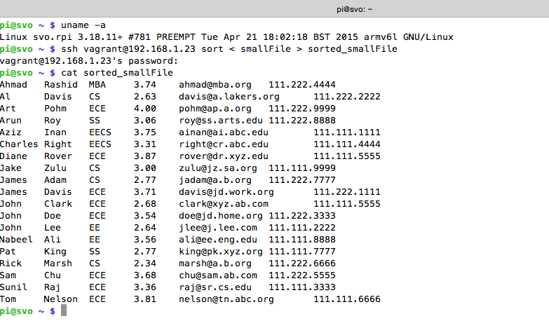

***Note: 192.168.1.23 is the IP address of the remote host.***

### Q3) Distribute `sort` command to remote host using `ssh` command, input from local host, output to remote host.

**Screenshot – RPI left – Remote Host (Ubuntu) right:**

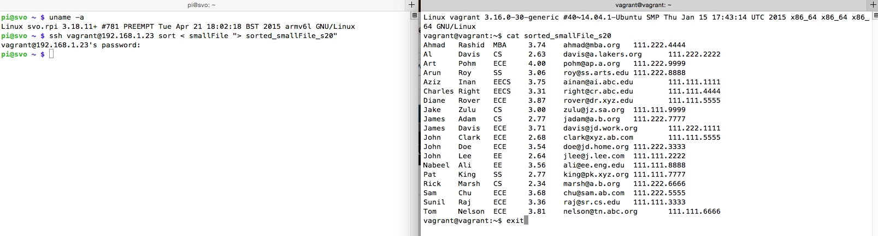

### Q4) Transfer smallFile to remote host using command `scp`. Distribute the `sort` command on remote host, input from remote host, output to local host.

