**Dokumentasi web Perpustakaan**

1. Screenshot Struktur Table dan Data dalam table

1. Table Buku  
   Struktur Table

Data dalam table

1. Table Kategori

Struktur Table

Data dalam table

1. Hasil Uji Coba Postman

**Kategori**

1. Insert Kategori  
   A screenshot of a computer

   Description automatically generated
2. Select All kategori

1. Update Kategori

1. Select Kategori by Kode Kategori

1. Delete Kategori

**Buku**

1. Insert Buku

1. Update Buku

1. Delete Buku

1. Select All Buku

1. Select Buku by Kode Buku

1. Screenshot Frontend

**Kategori**

1. Kategori Index

1. Kategori Create

1. Kategori Update

1. Kategori Delete

1. Kategori Filter by Kode Kategori

**Buku**

1. Buku Index

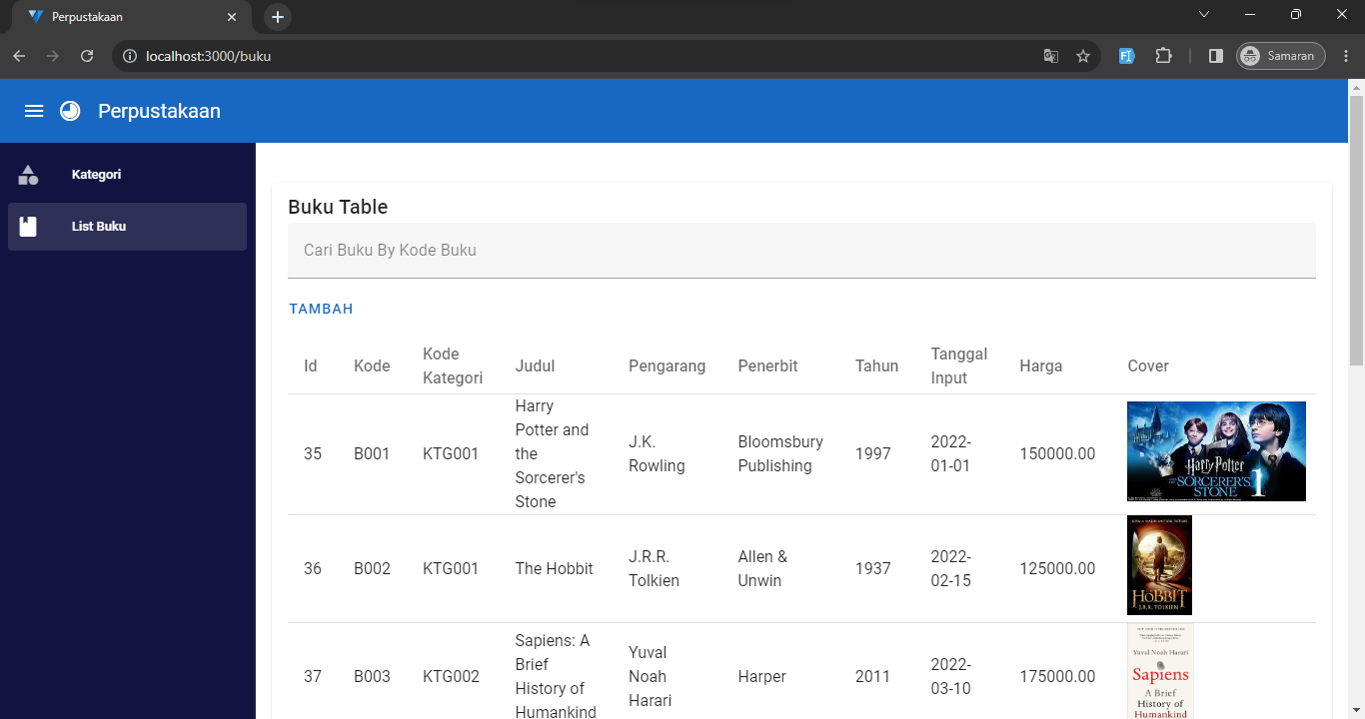

1. Buku Create  
   A screenshot of a computer

   Description automatically generated
2. Buku Edit

1. Buku Delete

1. Buku Filter by Kode Buku

1. Link Source Code
2. Backend <https://github.com/SyifaSalsabilla/Perpustakaan/tree/master/Backend>
3. Frontend <https://github.com/SyifaSalsabilla/Perpustakaan/tree/master/Frontend>