
VIT BHOPAL UNIVERSITY
Bhopal-Indore Highway, Kothri Kalan, Sehore, MP - 466114
Library Management System
A CLI Based Application
Subject Code: CSE2006
Subject Name: Programming in Java

Submitted By | Details
Name | Mayank Kushwaha
Registration No. | 24BCY10147
Program | B.Tech CSE
School | School of Computer Science
Date | 18 September 2026

Submitted to: Department of Computer Science & Engineering
VIT Bhopal University

PROJECT REPORT

Abstract
This project is a simple CLI app for college library. It helps librarian manage books and students issue and return books. Data is saved in CSV files. The app has login, book management, issue and return, and simple reports. It is made for easy understanding and runs with Java and Maven.

Table of Contents
1. Introduction ...................................................................................... 2
2. Problem Statement ......................................................................... 2
3. Objectives ........................................................................................ 2
4. Scope ............................................................................................... 2
5. Target Users .................................................................................... 3
6. Functional Requirements ............................................................... 3
7. Non-Functional Requirements ...................................................... 4
8. System Architecture .................................................................... 4
9. Process Flow ................................................................................... 5
10. UML Diagrams .......................................................................... 5
11. Database Design ...................................................................... 6
12. Implementation ........................................................................ 6
13. Testing .......................................................................................... 7
14. Screenshots .............................................................................. 7
15. Conclusion .................................................................................. 9
16. References ................................................................................. 9

1. Introduction
College library was using manual register. It was slow and had errors. This project makes it digital with a simple menu system. It is made for college level, easy to run and understand. The project uses Java and Maven and stores data in CSV files.

2. Problem Statement
Manual tracking makes it hard to know which books are available, who has taken books, and when to return. Records get lost. Students wait and librarian does extra work. We need simple software to keep all this.

3. Objectives
- Make easy login and register
- Let admin add and manage books
- Let students search, issue and return books
- Show simple reports

4. Scope

In Scope
- Register and login
- Add, view, edit and delete books
- Search books
- Issue and return with limit check
- My books list
- Reports for admin
- CSV file storage

Out of Scope
- Payment
- Email or SMS
- Barcode
- Web or mobile app

5. Target Users

Admin (Librarian)
- Goal: Needs to add books, see stock, see who has books
- Pain: Lot of manual entries, no quick search

Member (Student)
- Goal: Find books, take and return easily
- Pain: Not knowing if book is there and forgetting due date

6. Functional Requirements
- FR1: Register new member
- FR2: Login and check role
- FR3: Admin can add member and librarian
- FR4: Admin can add book with id, title, author, copies
- FR5: Admin can edit and delete book
- FR6: Search books by title or author
- FR7: Issue book if copy is there and limit not crossed
- FR8: Return book and show fine if late
- FR9: Show my active books
- FR10: Show reports like total books, overdue, most borrowed
Input/Output Structure:
Input | Check | Output
username, password | check csv | login ok or error
book id, title, author, copies | save to books.csv | book added
username and book id for issue | check copy and limit | issued or error
username and book id for return | check active issue | returned or fine

7. Non-Functional Requirements
- Performance: works fast for 100 books, file read each time
- Security: role check, admin pages only for admin
- Usability: simple menu, clear messages
- Reliability: if csv missing it is created, bad line skipped
- Maintainability: separate packages for model, repo, service
- Logging: simple console output

8. System Architecture
Modules: model, repo, service, util, Main. Each does one work. CSV files are used for storage, no database needed.
Folder structure:
src/main/java/com/cse2006/library/
model/User, Book, Issue, Role
repo/UserStore, BookStore, IssueStore
service/AuthService, BookService, IssueService, ReportService
util/Validator, Ansi
Main
Architecture: Main CLI -> Services -> Repo -> CSV files in data/
Mermaid diagram (for docs/DESIGN.md):
graph TD
A[Main CLI] --> B[AuthService]
A --> C[BookService]
A --> D[IssueService]
A --> E[ReportService]
B --> F[UserStore]
C --> G[BookStore]
D --> G
D --> H[IssueStore]
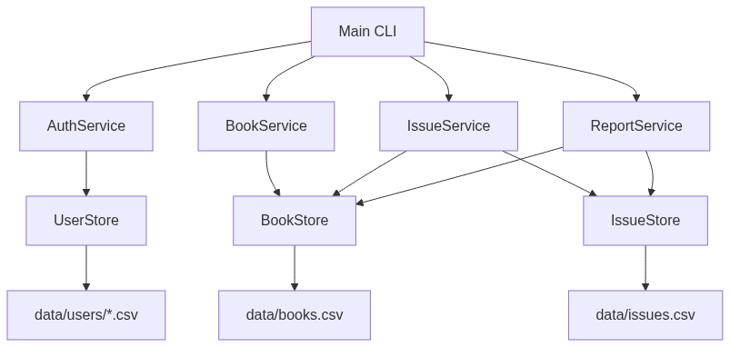
Screenshot of graph TD diagram

9. Process Flow
Steps: start -> login/register -> go to dashboard based on role -> do work -> logout.
flowchart TD
Start --> Login
Login --> Check{Login ok?}
Check -- Yes --> Role{Role?}
Role -- Admin --> Manage Books/Members/Reports
Role -- Member --> Browse/Issue/Return
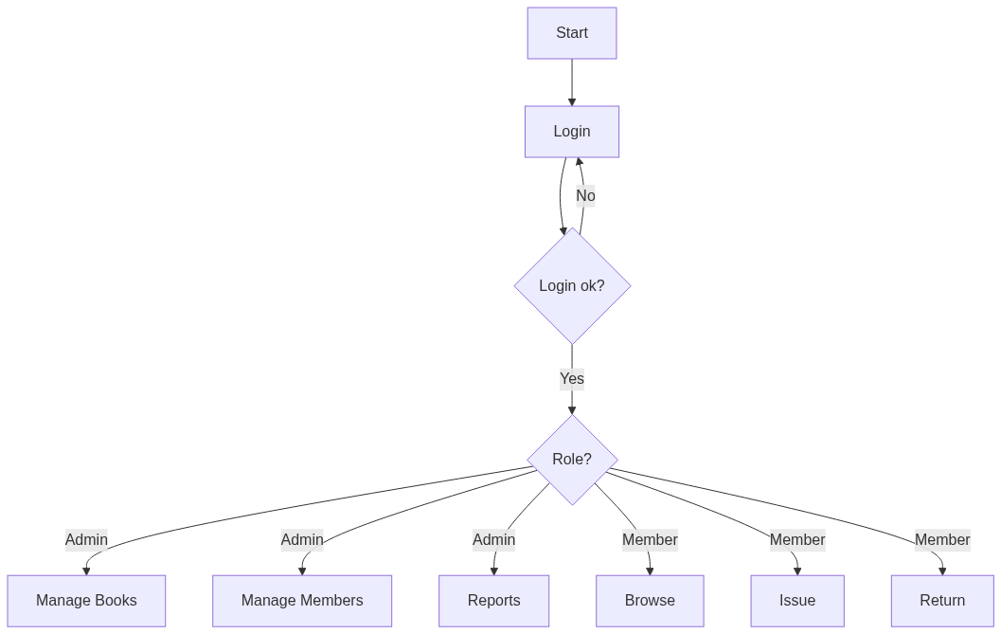
Screenshot of flowchart TD diagram

10. UML Diagrams

Use Case
Admin: Login, Manage Books, Manage Members, View Reports
Member: Login, Search Books, Issue Book, Return Book
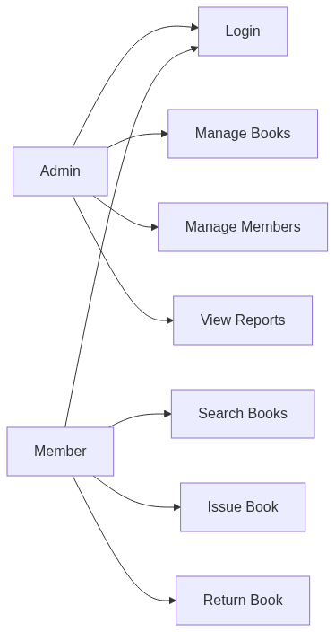
Screenshot of use case diagram

Class Diagram
classDiagram
class User { String id; String username; String password; Role role; }
class Book { String id; String title; int total; int available; }
class Issue { String id; String bookId; String username; LocalDate due; }
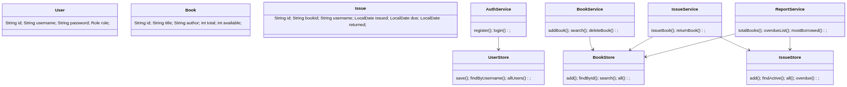
Screenshot of classDiagram diagram

Sequence
sequenceDiagram
Main->>AuthService: login(username, password)
AuthService->>UserStore: findByUsername()
Main->>IssueService: issueBook(user, bookId)
IssueService->>BookStore: findById()
IssueService->>IssueStore: add()
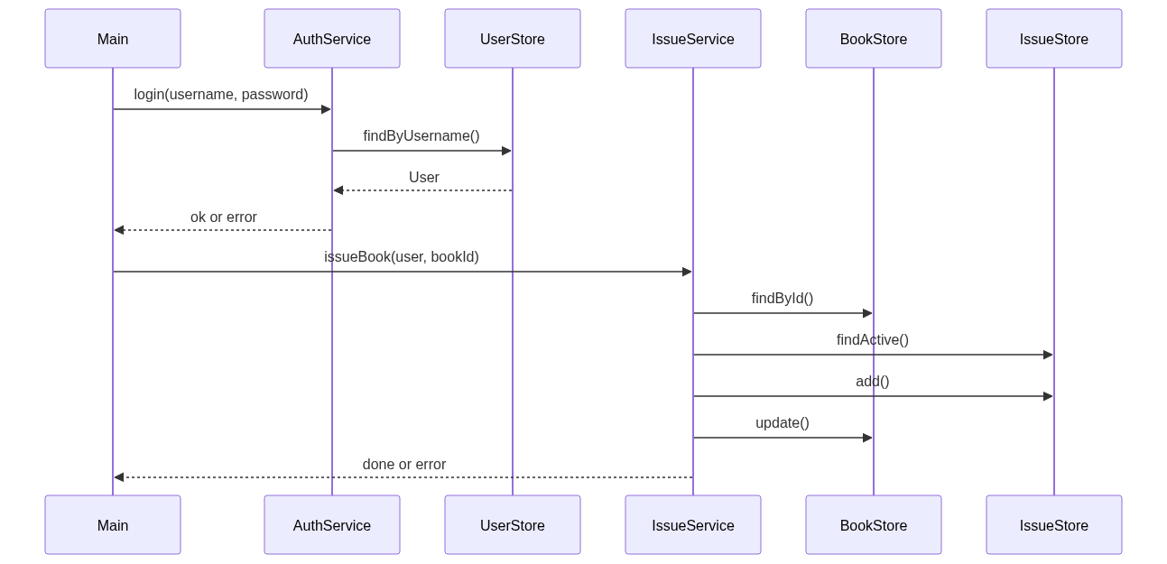
Screenshot of sequenceDiagram diagram

11. Database Design
Files in data folder, not pushed to github. Each user has own csv, books and issues are single files.

ER Diagram
erDiagram
USER ||--o{ ISSUE : has
BOOK ||--o{ ISSUE : issued_as
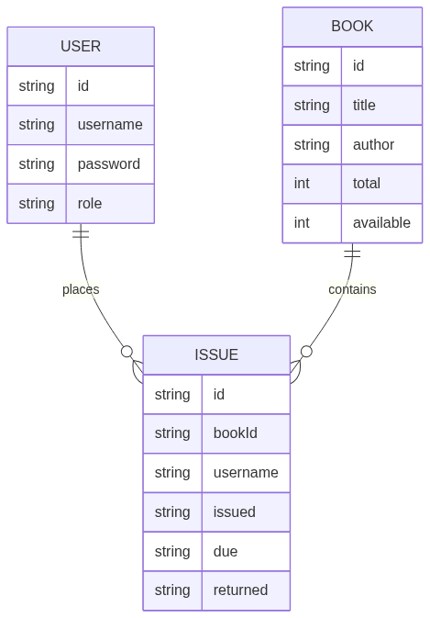
Screenshot of erDiagram diagram

Schema
users: data/users/<username>.csv -> username,password,role,id,createdAt e.g. admin,admin123,ADMIN,a1,2026-09-18
books: data/books.csv -> id,title,author,total,available e.g. B001,Intro to Java,Herbert Schildt,5,5
issues: data/issues.csv -> id,bookId,username,issued,due,returned e.g. abc123,B001,alice,2026-09-18,2026-10-02,
Rules: username is file name, book id is unique, issue is active if returned is empty

12. Implementation
Language: Java 17, Build: Maven, Storage: CSV files, CLI: Scanner and simple menu
Key code is simple if-else and file read/write, no framework. All logic is in service classes with plain checks.
To run:
git clone https://github.com/SykikXO/CSE2006.git
cd CSE2006
mvn compile
mvn exec:java -Dexec.mainClass="com.cse2006.library.Main"
# demo logins: admin/admin123 , alice/pass123
To test:
mvn test

13. Testing
Tests in src/test/java/com/cse2006/library/BasicTest.java:
- username and password check
- book add and find
- user register and login
- book service add/search/delete
- issue service issue and return
- report counts
Result: 7 tests, all pass. Run mvn test to verify.

14. Screenshots
All screenshots are taken from actual program run. They show the CLI menus and flows.
Login and Auth Menu - shows demo logins and member registration note
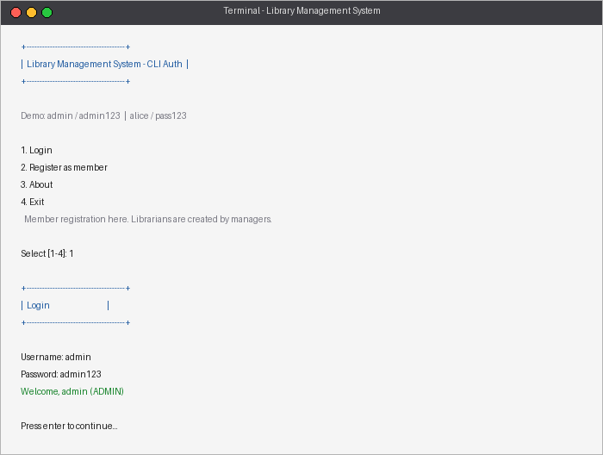
Admin Dashboard - manage books, members, reports
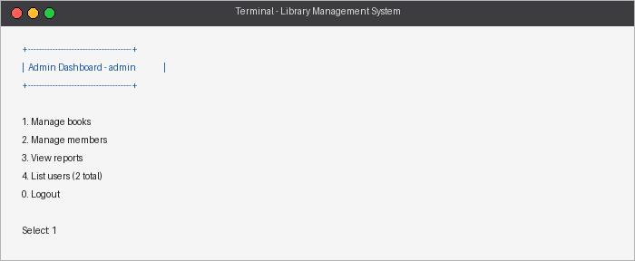
Manage Books - list with Avail/Total, add/search/edit/delete
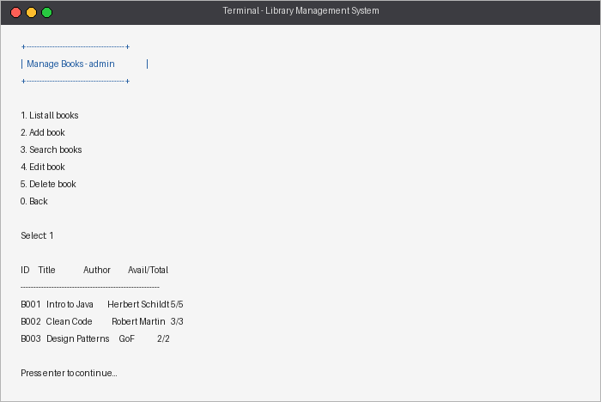
Member Dashboard - browse, search, issue, return, my books
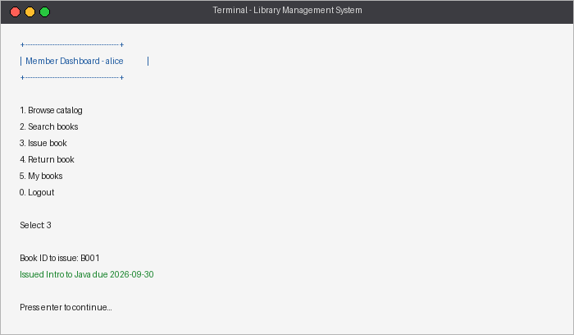
Reports - totals, copies, issues, overdue and most borrowed
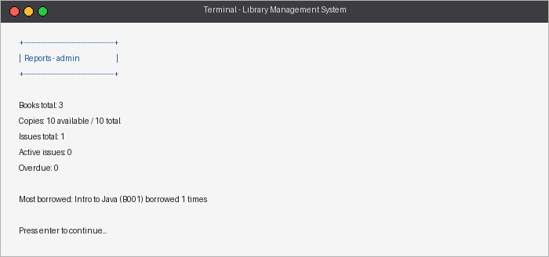
Issue and Return flow - issuing a book and viewing my books
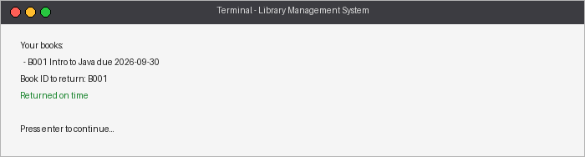

15. Conclusion
The app covers all asked parts: user management, catalog and circulation, reporting, with simple CSV storage and clear menu flow. It is easy to run and check. Future work can add PDF export or fine payment. The code is kept simple for college level, easy to understand and explain.

16. References
- Java docs - docs.oracle.com/javase/17
- Maven docs - maven.apache.org
- College lab notes for library system - CSE2006

