**Home**

**Our firm**

**Our Services**

**Portfolio**

**Contact**

**Our firm**

Welcome to our new firm, where innovation meets imagination!

At SHK Associates, we are fueled by a burning desire to redefine the art of architecture and design. With fresh perspectives and boundless creativity, we embark on a journey to shape spaces that inspire and elevate human experiences.

Our passion for excellence drives us to push the boundaries of what's possible, constantly seeking new horizons in design and construction. As a young and dynamic team, we bring a unique blend of expertise, enthusiasm, and dedication to every project we take on.

From residential wonders that reflect the essence of individuality to groundbreaking commercial ventures that leave a lasting impression, we aim to create spaces that stand the test of time.

Welcome to a world of limitless possibilities with SHK Associates. Together, let's create architectural marvels that will shape a brighter, more inspiring future for generations to come.

***Our mission: Redefining possibilities through visionary design.***

**Our Services**

**Virtual Consultations**

We recognize the challenges of conducting in-person meetings, especially in today's world. To address this, we proudly offer virtual one-on-one consultations with our experienced team members, including architects and engineers. Our online collaboration platform allows you to conveniently connect with a qualified professional who is enthusiastic about helping you bring your dream project to life.



**Architectural Planning**

Whether you're embarking on the journey of building a new custom home or revitalizing your existing space, selecting the right architect is essential to materialize your vision. At Design Everest, our team of skilled and innovative architects excels at translating your wish list into awe-inspiring designs that harmoniously blend aesthetics with practicality.

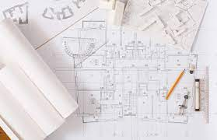 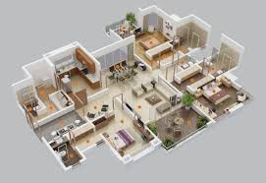

**Civil Engineering**

Thorough site preparation before construction is paramount to the success and longevity of your project. Even a minor oversight can result in significant issues such as cracked foundations, uneven floors, or water damage. At our company, we understand the importance of meticulous planning, which is why our team of licensed civil engineers is dedicated to developing robust solutions that address all potential concerns.

 

**Construction Administration**

Undoubtedly, construction can be a complex process, and even the most dedicated contractors may encounter challenges in interpreting architectural or engineering plans during the build phase. That's where construction administration plays a pivotal role in ensuring the success of your project. At our company, we recognize the significance of construction administration, and we are committed to providing ongoing support and guidance throughout the construction process.

 

**Structural Engineering**

A strong foundation in structural engineering is crucial to mitigate risks in any home improvement project. At -------------, we prioritize the safety and success of your project by meticulously organizing a comprehensive structural plan. Our team is dedicated to identifying potential challenges and troubleshooting solutions to ensure a seamless construction process.

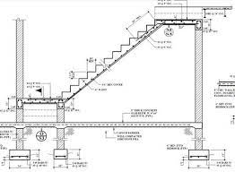 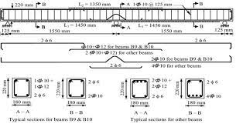

**On-site structural Evaluation**

Whether you're in the process of purchasing a new home and need a thorough evaluation before making a significant investment or you have concerns about structural issues in your current home, our team of experienced engineers is here to assist you with a professional on-site structural evaluation.

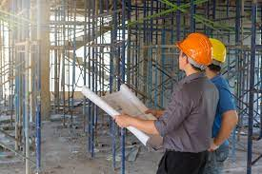 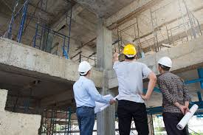

**Interior Design**

We are passionate about interior design that breathes life into spaces. Our team of talented and experienced designers are dedicated to crafting environments that reflect your unique style and aspirations. From residential projects that feel like home the moment you step inside, to commercial spaces that make a striking statement, our interior design expertise knows no bounds.

Discover the art of creating extraordinary spaces with SHK Associates. Let us infuse your surroundings with a touch of magic and bring your dreams to life in every detail.

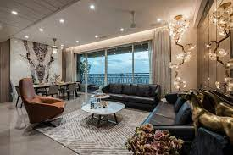 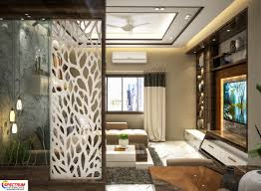

**Portfolio**

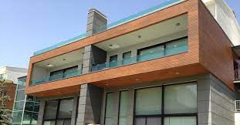 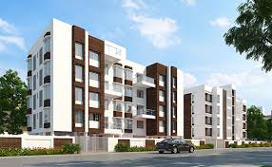

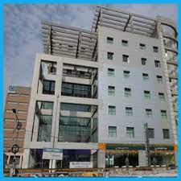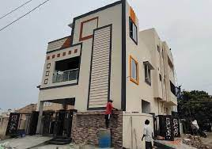 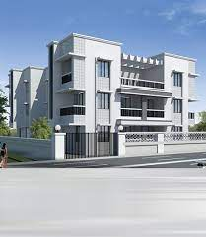

**Contact**

Feel free to contact us regarding your project, we would love to hear from you.

SHK Associates

North Guwahati, Guwahati 781039, Assam

Phone: 9000000029

Email: shkassociates@gmail.com