Homework: Defend One Architectural Decision
The decision
Data is automatically saved after every transaction. If power or the internet fails, the system continues operating locally and prevents duplicate records using unique transaction IDs when syncing.

What forced it
The system must not lose transaction data during power outages, network failures, or unexpected system interruptions. This requirement means that staff must be able to continue processing transactions even when technical failures occur. Every transaction must be preserved immediately to ensure business operations are not disrupted, and no sales or purchase records are lost.

What I rejected
Alternative: Saving transactions only on a central server and requiring a constant internet connection. This approach was rejected because transactions would be lost or delayed whenever the internet connection failed. For this client, staff must continue working during outages, so relying entirely on a remote server would not meet the reliability requirement.

What it costs me
The main downside is additional synchronization complexity. The system must manage local copies of data, track which transactions have already been synchronized, and resolve any conflicts that occur. It also requires extra storage on client devices and more development effort to ensure duplicate records are not created during synchronization.

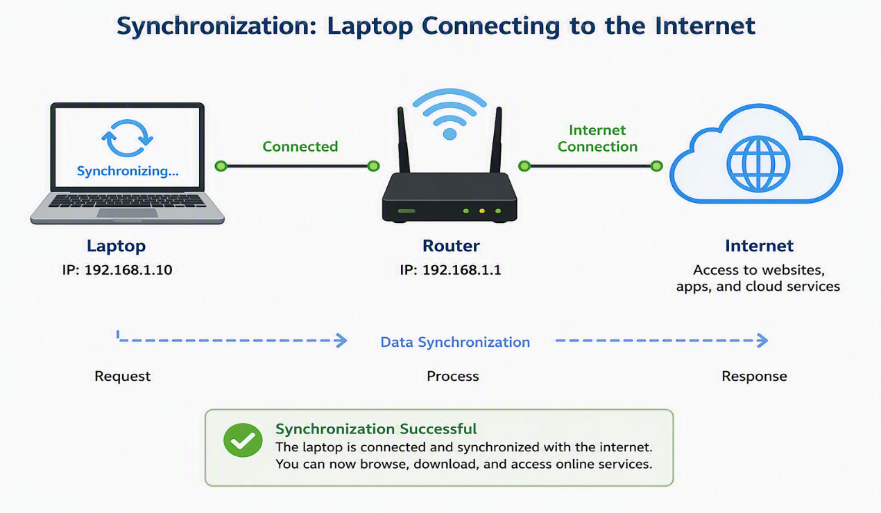
Justification: This design ensures that no transaction data is lost during power or network failures while allowing staff to continue working. The trade-off is the added complexity of synchronization and duplicate-prevention mechanisms

AI Declaration: help in drawing the synchronization image or the diagram.

