# Slide 1

Thyroid Profile

Module 8 – Unit 1  
Dr Poonam Vichare

# Slide 2

Chapter outline

Thyroid hormones  
Complete thyroid profile  
Interpretation of thyroid function tests  
Primary thyroid disorders  
Secondary thyroid disorders  
Subclinical Hypothyroidism  
Sample reports

# Slide 3

Thyroid gland & its importance

The thyroid is a small, butterfly-shaped gland located in the front of the neck.   
Despite its size, it plays a crucial role in regulating the body’s metabolism through the release of thyroid hormones — primarily T3 (triiodothyronine) and T4 (thyroxine).   
These hormones influence nearly every organ system, controlling heart rate, energy production, body temperature, and weight.   
A healthy thyroid is essential for growth, brain development, and maintaining overall hormonal balance.   
Dysfunction of the thyroid can lead to wide-ranging health issues, including fatigue, weight changes, and mood disturbances.

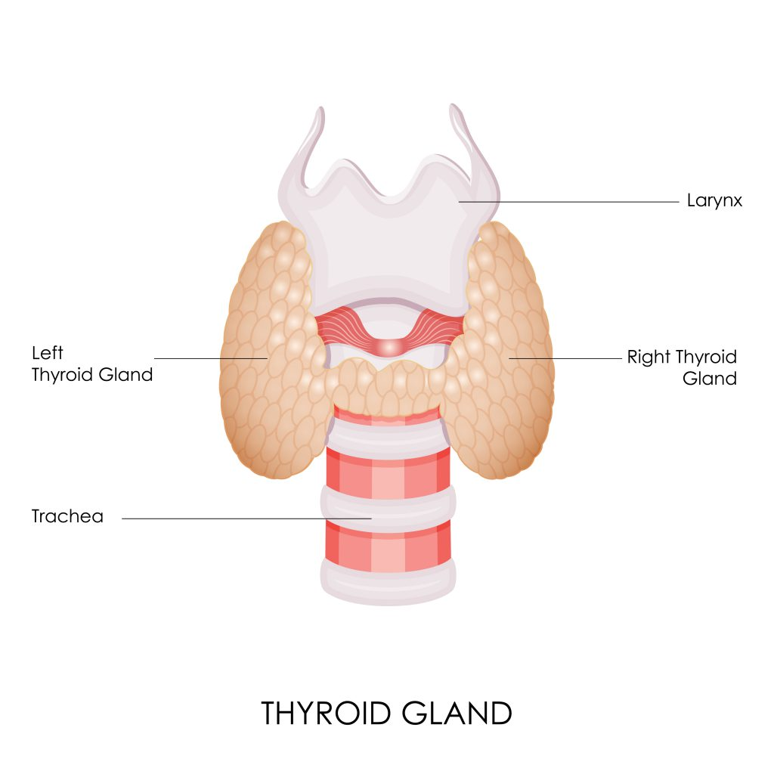

# Slide 4

Hypothalamo – Pituitary Axis

The HPT axis is a vital hormonal feedback system that regulates thyroid function.  
Disruptions in any part of this axis can lead to thyroid disorders such as hypothyroidism or hyperthyroidism.

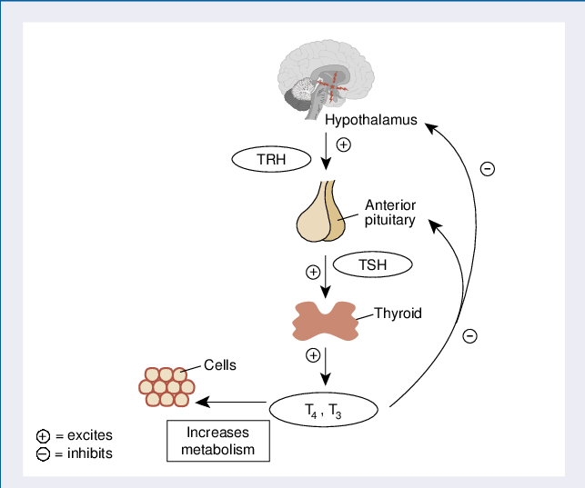

# Slide 5

Understanding the Thyroid Trio

The "Thyroid Trio" refers to the three key hormones commonly measured to assess thyroid function:   
  
TSH (Thyroid-Stimulating Hormone),   
Free T3 (Triiodothyronine), and   
Free T4 (Thyroxine).  
Evaluating all three together provides a comprehensive picture of thyroid health and helps in diagnosing conditions like hypothyroidism, hyperthyroidism, or central (secondary) thyroid disorders.

# Slide 6

TSH – The pituitary messenger

Produced by the anterior pituitary gland.  
The primary "signal" to the thyroid gland to produce T3 and T4.  
Clinical Significance:  
Often the first and most sensitive indicator of thyroid dysfunction.  
Reflects the pituitary's attempt to regulate thyroid hormone levels.  
Normal Reference Range (Typical, ranges may vary slightly by lab):  
0.4 – 4.0 mIU/L (or 0.4 – 2.5 mIU/L for optimal health/pregnancy planning)

# Slide 7

Ultrasensitive TSH (uTSH or usTSH

Ultrasensitive TSH refers to a third-generation TSH assay that can detect very low levels of TSH (as low as 0.01 mIU/L).  
It's not a different hormone—just a more sensitive testing method.  
Often labeled simply as “TSH” in modern lab reports because ultrasensitive assays are now standard practice in most labs.

# Slide 8

Why is Ultrasensitive TSH is better than TSH?

It can accurately detect subclinical hyperthyroidism (when TSH is low but T3/T4 are normal).  
Useful in monitoring thyroid cancer patients, where even tiny TSH changes are important.  
Helps in fine-tuning thyroid medication dosing in hypothyroid patients.

# Slide 9

T4 (Thyroxine) – The main prohormone

Produced by the thyroid gland (approx. 80% of thyroid hormone output).  
Role:  
Less biologically active than T3.  
Acts as a prohormone, converting to T3 in peripheral tissues (liver, kidney, muscle, brain).  
Total T4 vs. Free T4:  
Total T4: Measures both bound (to proteins like TBG) and unbound T4. Influenced by protein levels (e.g., pregnancy, certain medications).  
Free T4 (FT4): Measures only the metabolically active, unbound form of T4. More accurate reflection of thyroid function.  
Normal Reference Range (Free T4 - Typical):  
0.8 – 1.8 ng/dL (or 10.3 – 23.2 pmol/L)

# Slide 10

T3 (Tri-iodothyronine) – The active hormone

Source: Mostly produced by the conversion of T4 to T3 in peripheral tissues; small amount directly from the thyroid.  
Role: The most biologically active thyroid hormone, responsible for metabolic effects.  
Total T3 vs. Free T3:  
Total T3: Measures bound and unbound T3. Also affected by protein levels.  
Free T3 (FT3): Measures only the unbound, active form. Provides direct insight into cellular metabolic activity.  
Normal Reference Range (Free T3 - Typical):  
2.3 – 4.2 pg/mL (or 3.5 – 6.5 pmol/L)  
Note: Free T3 is often tested when TSH and Free T4 are normal but symptoms persist, or in specific cases of hyperthyroidism.

# Slide 11

Reverse T3

Reverse T3 (rT3):  
Reverse T3 is an inactive metabolite of T4 (thyroxine). It's structurally similar to the active hormone T3 (triiodothyronine) but biologically inactive.  
How is it made? When T4 is converted in the body, it can be converted to rev T3It tends to rise during:- Chronic stress- Starvation or severe caloric restriction- Illness (e.g., critical illness, trauma, liver/kidney dysfunction)- Hypothyroidism or euthyroid sick syndrome

# Slide 12

Significance of Reverse T3

Why does it matter?Elevated rT3 can compete with T3 at receptor sites, blocking T3's action, leading to symptoms of hypothyroidism despite normal T3/T4 levels.  
This is often called "thyroid resistance" or "low T3 syndrome".

# Slide 13

Reverse T4

Reverse T4 (rT4):  
Reverse T4 is not a commonly recognized or clinically measured hormone. It is sometimes confused with rT3. There's no standard test or functional role attributed to "reverse T4" in human physiology.  
Likely confusion: People often mistakenly refer to rT3 as "reverse T4" because it's derived from T4, but rT4 is not an established or meaningful term in clinical endocrinology.

# Slide 14

Anti-TPO (Thyroid Peroxidase Antibodies)

Targets the thyroid peroxidase enzyme, which helps produce thyroid hormones.  
Most common antibody found in autoimmune thyroid disorders.  
Seen in:  
>90% of patients with Hashimoto’s thyroiditis  
70–80% of those with Graves’ disease  
Indicates autoimmune destruction of the thyroid, even before hormone levels change.  
Helps predict progression from subclinical to overt hypothyroidism.

# Slide 15

Anti-Tg (Thyroglobulin Antibodies)

Targets thyroglobulin, a protein used in making thyroid hormones.  
Commonly seen in Hashimoto’s thyroiditis and sometimes in Graves’ disease.  
Used to monitor thyroid cancer recurrence, especially after thyroid removal.  
Often ordered together with Anti-TPO for complete autoimmune assessment.

# Slide 16

Free hormones Vs Total hormones

# Slide 17

Why Free T4 is more reliable than total T4

Medicines to treat asthma, arthritis, skin conditions, and other health problems—can lower T4 levels. These conditions and medicines change the amount of proteins in your blood that “bind,” or attach, to T4. Bound T4 is kept in reserve in the blood until it’s needed. “Free” T4 is not bound to these proteins and is available to enter body tissues. Because changes in binding protein levels don’t affect free T4 levels, many healthcare professionals prefer to measure free T4.

# Slide 18

Thyroid disorders – General classification

Depending on the etiology or the level at which problem occurs in the HPT axis, the thyroid disorders can be classified as following :

# Slide 19

Primary Thyroid disorders

# Slide 20

Primary Hypothyroidism

Pathophysiology: The thyroid gland is underactive and cannot produce enough T3 and T4.  
Causes: Hashimoto's thyroiditis (autoimmune), iodine deficiency, thyroidectomy, radioactive iodine therapy.  
Lab Values:  
TSH: HIGH (Pituitary senses low T3/T4 and works harder to stimulate the thyroid).  
Free T4: LOW (Thyroid isn't producing enough).  
Free T3: Often Normal or Low (Depends on severity, but Free T4 drops first).  
Clinical Presentation: Fatigue, weight gain, cold intolerance, constipation, dry skin, depression.

# Slide 21

Primary Hyperthyroidism

Pathophysiology: The thyroid gland is overactive and produces too much T3 and T4.  
Causes: Grave's disease (autoimmune), toxic nodule, thyroiditis.  
Lab Values:  
TSH: LOW / UNDETECTABLE (Pituitary senses high T3/T4 and shuts down TSH production to try to stop the thyroid).  
Free T4: HIGH (Thyroid is overproducing).  
Free T3: HIGH (Often elevated disproportionately in Grave's disease).  
Clinical Presentation: Weight loss, heat intolerance, palpitations, anxiety, tremor, increased appetite.

# Slide 22

Secondary thyroid disorders

# Slide 23

Secondary Hypothyroidism

Pathophysiology: The pituitary gland (or hypothalamus) isn't producing enough TSH (or TRH), leading to under stimulation of a healthy thyroid gland.  
Causes: Pituitary adenoma, Sheehan's syndrome, cranial radiation, severe head trauma.  
Lab Values:  
TSH: LOW / NORMAL (inappropriately) (Pituitary isn't signaling enough TSH, even though T3/T4 are low).  
Free T4: LOW (Thyroid is not being stimulated).  
Free T3: LOW  
Clinical Presentation: Similar to primary hypothyroidism, but may also have symptoms related to pituitary dysfunction (e.g., visual field defects, other hormone deficiencies).

# Slide 24

Secondary Hyperthyroidism

Pathophysiology: The pituitary gland is overproducing TSH (e.g., a TSH-secreting pituitary adenoma), leading to overstimulation of a healthy thyroid gland.  
Causes: TSH-secreting pituitary adenoma (very rare).  
Lab Values:  
TSH: NORMAL / HIGH (inappropriately) (Pituitary is overproducing TSH despite high T3/T4).  
Free T4: HIGH  
Free T3: HIGH  
Clinical Presentation: Similar to primary hyperthyroidism, but may have symptoms related to pituitary mass (e.g., headaches, visual disturbances).

# Slide 25

Subclinical Hypothyroidism

The term ‘subclinical’ is used when the serum concentration of TSH is persistently abnormal (however defined), while the concentrations of T4 and T3 remain within their reference intervals. Because results can fluctuate spontaneously, a new diagnosis of subclinical thyroid dysfunction is not warranted on basis of a single laboratory sample. The following five criteria define endogenous subclinical thyroid dysfunction:  
  
TSH increased above or decreased below designated limits (see below)  
Normal free T4 concentration (and free T3 for hyperthyroidism)  
Abnormality is not due to medication (see below)  
There is no concurrent critical illness or pituitary dysfunction.  
A sustained abnormality is demonstrated over 3-6 months.

# Slide 26

Sample report

# Slide 27

When to treat Subclinical hypothyroidism

According to the American Thyroid Association (ATA) and American Association of Clinical Endocrinologists (AACE) guidelines, levothyroxine therapy would be considered for 92% of women with subclinical hypothyroidism and TSH ≤10 mU/L   
Subclinical hypothyroidism or mild thyroid failure (increased TSH, normal free T4 estimate)Non-specific symptoms may improve with treatment Progression to overt hypothyroidism Independent risk factor for atherosclerosis Increased risk of coronary artery disease Increased frequency of congestive heart failure Adverse effects on vascular compliance Abnormal cardiac function may improve with treatment Beneficial effect of treatment on lipids Increased prevalence of depressive illness Impaired fibrinolysis

# Slide 28

Elevated TSH - To treat or not to treat

With an elevated TSH, it is reasonable to assume that the T4 concentration is at or below the lowest acceptable limit for that patient. If the patient is symptomatic, and especially when there are signs of hypothyroidism, treatment is indicated even if the value of T4 is within the "normal" range. Patients who have normal values of T4 and no symptoms or signs of hypothyroidism, but in whom the TSH is clearly elevated, pose a special problem that may best be resolved by a period of observation.

# Slide 29

Subclinical hyperthyroidism

Subclinical hyperthyroidism (suppressed TSH, normal free T4, and free T3 estimates)  
Exposure to iodine may precipitate severe thyrotoxicosis   
Threefold increased risk of atrial fibrillation after 10 years   
Abnormalities of cardiac function   
Osteoporosis risk increased   
Progression to overt hyperthyroidism

# Slide 30

Other considerations

Non-Thyroidal Illness (Sick Euthyroid Syndrome): Acute illness can affect thyroid hormone levels (often low T3, sometimes low T4, TSH variable).  
Medications: Many drugs can affect thyroid tests (e.g., biotin, amiodarone, corticosteroids, estrogen).  
Pregnancy: TSH reference ranges change during pregnancy.  
Thyroid Antibodies  
TPO Ab (Thyroid Peroxidase Antibodies): Common in Hashimoto’s.  
Tg Ab (Thyroglobulin Antibodies): Also in Hashimoto's, some thyroid cancers.  
TSI (Thyroid-Stimulating Immunoglobulin): Specific for Grave's disease

# Slide 31

Summary – Key values

# Slide 32

Takeaway

TSH is the cornerstone for screening thyroid function.  
Free T4 and Free T3 provide crucial confirmation and detail.  
The HPT axis feedback loop explains the reciprocal relationship between TSH and thyroid hormones in primary disorders.  
Secondary disorders present a different pattern, indicating a central problem.  
Always integrate lab results with clinical symptoms for accurate diagnosis and management.

# Slide 33

Thankyou

# Slide 34

References

Feldt-Rasmussen U, Klose M. Clinical Strategies in the Testing of Thyroid Function. [Updated 2020 Nov 20]. In: Feingold KR, Ahmed SF, Anawalt B, et al., editors. Endotext [Internet]. South Dartmouth (MA): MDText.com, Inc.; 2000-. Available from: https://www.ncbi.nlm.nih.gov/books/NBK285558/  
Dunlap DB. Thyroid Function Tests. In: Walker HK, Hall WD, Hurst JW, editors. Clinical Methods: The History, Physical, and Laboratory Examinations. 3rd edition. Boston: Butterworths; 1990. Chapter 142. Available from: https://www.ncbi.nlm.nih.gov/books/NBK249/  
https://www.niddk.nih.gov/health-information/diagnostic-tests/thyroid  
National Guideline Centre (UK). Thyroid function tests: Thyroid disease: assessment and management: Evidence review C. London: National Institute for Health and Care Excellence (NICE); 2019 Nov. (NICE Guideline, No. 145.) Available from: https://www.ncbi.nlm.nih.gov/books/NBK577224/