Player’s goal

Opponents’ goal

Player (AI)

Ball

Opponent

Player’s goal

Opponents’ goal

Player (AI)

Opponent

Ball

Player’s goal

Opponents’ goal

Ball

Opponent

Player (AI)

Player (AI)

Ball

Opponent

Player’s goal

Opponents’ goal

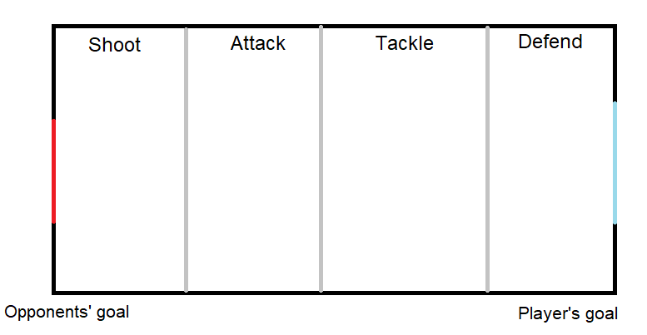

Opponent

Ball

Player (AI)



Opponent

Player (AI)

Ball

Score

Timer

Weapon

Ammo

Health Bar

Stamina Bar

Shield bar

Ball

Player 2

Player 1

Weapons

Main player controller

User Interface

Global settings

Sword

**Player Game Object**

Configuration component

Colliders

Shield

Audio component

Team component

Controls component

Collider

Collider

Fire Point

Player

Audio component

Bullet

Current weapon

Main Controller

Gun List

**Weapon Game Object**

Player

Audio component

Ball

User

AI Player

**Sword Game Object**

Main Controller

Look At Object

**AI Basic Behaviour**

Use weapons – shield, gun, or sword

Move Forward

Move Towards Object

**AI Movement**

**Choose what to do next**

The actual behaviour – can be a number of behaviours

Other variables like amount of health, opponents health, available weapon etc.

Distance from the ball

Position of the players and the ball

Position of the ball

**Choose what to do next**

***Actual Behaviour***

**Ball Position**

**Other**

**Distance from ball**

**Ball, player and opponent position**

Default

Ball In The Range

Close To Opponent

*Use Gun*

*Look At The Ball*

Far

Close

Position Three

Position Two

Position Zero

Position One

Shoot

Tackle

Shoot

Attack

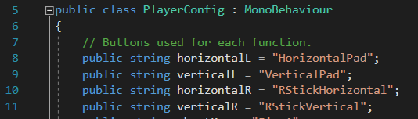 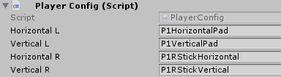 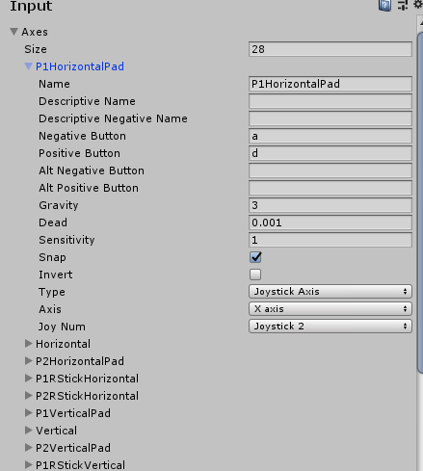

Game Setup

Start Screen

End Screen

Game Scene

Shooter – Fire()

Weapons

AbstractGun – Shoot()

***CurrentGun****, Pistol or MachineGun*

WeaponController – Shoot()

Weapons

Controls -Shoot()

Player