305475915

Dan Davydov

I choose my heuristic function to be Manhattan distance between 2 boards,

Well denote A= {Ro1 , Ro2} as the original location of the 1st and 2nd red marbles in the original board, respectively.

Next we mark B = {Rd1, Rd2} as the destination location of the red Marbles.

Next, for each Marble m in our board, we calculate the Manhattan Distance s.t.

All possible permutations between A and B are combined into pairs.

One possible outcome would be MannhatanDistance(Ro1->Rd1 + Ro2->Rd2).

We then choose the minimum of those permutations.

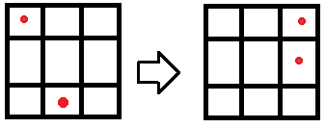

We get 4:

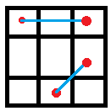

Since in a real board this also reflects the actual cost(in this setting) ,

I chose those heuristics.

Admissible

Since h(n) is calculated per color , it ignores the locations of the other marbles.

So for each color.

1. Assume h(n) > h\*(n)
2. H is consistent.
3. According to (2) h(n) <= cost(n,goal) + h(goal)
4. We know that h(goal) is 0, and cost(n, goal) =h\*(n)
5. So we get h(n) <= h\*(n) which is a contradiction to (1).

Consistent

For each marble in each color there are at most 4 available moves each turn:

Up, down, left and right. Each move cost the same.

Let h(n) denote the manhattan distance between n and goal state.

h(n,m) denotes the manhattan distance between n and m.

Lets take h(n) to be the distance from the goal and lets take m to be one of n’s children.

Clearly h(n) = h(n,m) + h(m) by the definition of our function, and the case presented above.

On the other hand h(n,m) < = cost(n,m) since our function takes all possible children of n.

Therefore h(n) <= cost(n,m) + h(m) , which shows that our heuristic is locally consistent, which also proves its globally consistent.