ADBMS
UNIT 2

Q1: What is an Entity in the E-R model? An entity in the E-R model represents a real-world object or concept that can be distinctly identified, such as a person, place, or event. For example, a 'Student' in a university database.
Q2: Define an Attribute in the E-R model. An attribute is a property or characteristic of an entity. It provides more details about the entity, like 'Name,' 'Age,' and 'Address' for a 'Student' entity.
Q3: What are the different types of Attributes in an E-R model? Attributes in an E-R model include:
- Simple Attribute (e.g., Name)
- Composite Attribute (e.g., Address)
- Derived Attribute (e.g., Age from Date of Birth)
- Multi-valued Attribute (e.g., Phone Numbers)
Q4: What is a Relationship in an E-R model? A relationship in the E-R model is an association among two or more entities. For instance, a 'Student' entity might have a relationship 'Enrolls' with a 'Course' entity.
Q5: Define the term "Primary Key" with an example. A primary key is a unique identifier for each entity instance. For example, 'Student ID' in the 'Student' entity uniquely identifies each student.
Q6: What is a Composite Key? A composite key is a primary key that consists of two or more attributes. For example, 'Course ID' and 'Student ID' together uniquely identify an 'Enrollment' entity.
Q7: What are Mapping Constraints in an E-R model? Mapping constraints define the number of entity instances that can participate in a relationship. They specify cardinality, such as one-to-one, one-to-many, or many-to-many.
Q8: What is a Weak Entity Set? A weak entity set is an entity that cannot be uniquely identified by its attributes alone and relies on a 'strong entity' and a relationship to be uniquely identified. For example, 'Dependents' of an 'Employee.'
Q9: Define Cardinality in the context of the E-R model. Cardinality specifies the number of instances of one entity that can be associated with instances of another entity in a relationship, defining one-to-one, one-to-many, or many-to-many relationships.
Q10: What is an Alternate Key? An alternate key is any candidate key that is not chosen as the primary key. For instance, if both 'Student ID' and 'Email' are unique in the 'Student' entity, one can be the primary key, and the other an alternate key.
Q11: What is Generalization in E-R modeling? Generalization is the process of combining multiple entities into a single, generalized entity based on shared characteristics. For example, 'Employee' and 'Customer' entities might be generalized into a 'Person' entity.
Q12: What is Specialization in an E-R model? Specialization is defining a subset of an entity that has distinct attributes or relationships. For instance, the 'Person' entity might be specialized into 'Employee' and 'Customer' entities.
Q13: Define Aggregation in the E-R model. Aggregation is a concept where a relationship set is treated as a higher-level entity set. For example, a 'Project' entity might aggregate a 'Works_On' relationship between 'Employee' and 'Task' entities.
Q14: How do we convert an E-R model to tables? Give two examples.
- Example 1: An 'Employee' entity with attributes 'Employee ID,' 'Name,' and 'Department' converts to a table with columns for each attribute.
- Example 2: A 'Works_On' relationship between 'Employee' and 'Project' converts to a table with 'Employee ID,' 'Project ID,' and 'Hours Worked' columns.
Q15: What is a Super Key in a database? A super key is any set of attributes that uniquely identifies an entity instance. It includes the primary key as well as other sets of attributes that can uniquely identify instances.
Q16: What is a Foreign Key? Give an example. A foreign key is an attribute that creates a link between two tables. For example, 'Student ID' in the 'Enrollment' table can be a foreign key referencing the 'Student' table.
Q17: What is the difference between a Primary Key and a Candidate Key?
- Primary Key: Uniquely identifies an entity instance; only one primary key per table.
- Candidate Key: Any attribute(s) that can uniquely identify an entity instance; multiple candidate keys possible, one chosen as the primary key.
Q18: What is Participation Constraint in an E-R model? A participation constraint specifies whether all or only some entity instances participate in a relationship. It can be 'total' (all entities participate) or 'partial' (only some entities participate).
Q19: Define Weak Entity Set. A weak entity set is an entity that cannot be uniquely identified by its attributes alone and relies on a 'strong entity' and a relationship to be uniquely identified. For example, 'Dependents' of an 'Employee.'
Q20: What is the purpose of the E-R model in database design? The E-R model visually represents the structure of data, helping understand relationships among entities, organizing data logically, and designing a database schema that accurately reflects the real-world domain.

Q21. Explain different types of Attributes with examples.
Here are the different types of attributes in the E-R model, explained in points:
- Simple Attribute:
  - Definition: Cannot be divided into smaller parts.
  - Example: 'Age' attribute of a 'Person' entity.
- Composite Attribute:
  - Definition: Can be divided into smaller, meaningful parts.
  - Example: 'Address' can be split into 'Street,' 'City,' 'State,' and 'Zip Code.'
- Single-Valued Attribute:
  - Definition: Holds a single value for each entity instance.
  - Example: 'Social Security Number' for an 'Employee.'
- Multi-Valued Attribute:
  - Definition: Can hold multiple values for each entity instance.
  - Example: 'Phone Numbers' for a 'Contact' entity.
- Derived Attribute:
  - Definition: Can be derived from other attributes.
  - Example: 'Age' can be derived from 'Date of Birth.'
- Key Attribute:
  - Definition: An attribute that uniquely identifies an entity within an entity set.
  - Example: 'Student ID' for a 'Student' entity.

Q22. Differentiate between Weak and Strong Entities with examples.
Here are the key differences between Weak and Strong Entities in the E-R model:
- Identification:
  - Strong Entity: Can be uniquely identified by its attributes alone.
  - Weak Entity: Cannot be uniquely identified by its attributes alone and relies on a strong entity for identification.
- Key Attribute:
  - Strong Entity: Has a primary key that uniquely identifies each instance.
  - Weak Entity: Does not have a primary key and uses a partial key in conjunction with the strong entity's key.
- Symbol in E-R Diagram:
  - Strong Entity: Represented by a rectangle.
  - Weak Entity: Represented by a double rectangle.
- Examples:
  - Strong Entity: 'Employee' entity with attributes like 'Employee ID' and 'Name.'
  - Weak Entity: 'Dependent' entity with attributes like 'Dependent Name,' relying on 'Employee' entity for unique identification.
- Relationship:
  - Strong Entity: Can exist independently in the database.
  - Weak Entity: Exists only in relation to a strong entity, often through a identifying relationship.

Q23. Explain the different types of Relationships in an E-R model.
Types of Relationships in ER diagrams
There are three main types of relationships in a database model: one-to-one, one-to-many, and many-to-many.
- In a one-to-one relationship, each record in one table is associated with one and only one record in another table.
- In a one-to-many relationship, each record in one table can be associated with one or many records in another table.
- In a many-to-many relationship, each record in one table can be associated with many records in another table, and vice versa.
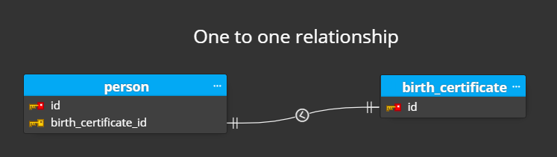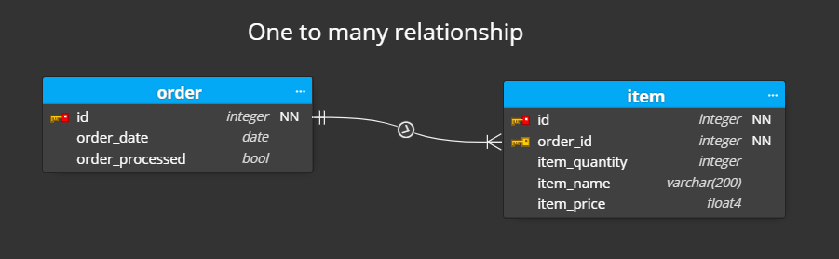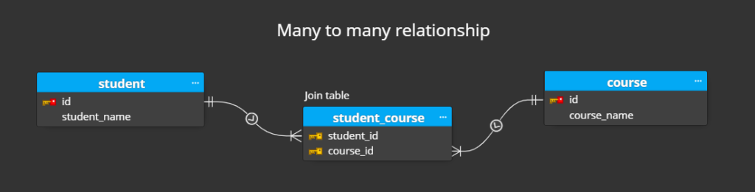
Q24. Discuss various types of Mapping Constraints in the E-R model.
Mapping constraints define the number of entity instances that can participate in a relationship in the E-R model. Here are the different types:
- One-to-One (1:1) Constraint:
  - Definition: A single instance of one entity is associated with a single instance of another entity.
  - Example: Each 'Person' is assigned one 'Passport.'
- One-to-Many (1:M) Constraint:
  - Definition: A single instance of one entity is associated with multiple instances of another entity.
  - Example: One 'Department' has multiple 'Employees.'
- Many-to-One (M:1) Constraint:
  - Definition: Multiple instances of one entity are associated with a single instance of another entity.
  - Example: Multiple 'Students' enrolled in one 'Class.'
- Many-to-Many (M:N) Constraint:
  - Definition: Multiple instances of one entity are associated with multiple instances of another entity.
  - Example: 'Students' enrolling in multiple 'Courses' and each 'Course' having multiple 'Students.'

Q25: Describe Generalization and Specialization in the Extended E-R model with examples.
Generalization:
- Definition: Generalization is the process of combining multiple entities into a single, generalized entity based on shared characteristics.
- Example: 'Employee' and 'Customer' entities can be generalized into a 'Person' entity, as both share attributes like 'Name' and 'Address.'
- Purpose: Simplifies the E-R model by reducing redundancy and highlighting common features.
- Generalization is also called as ‘ Bottom-up approach”.
Specialization:
- Definition: Specialization is the process of defining a subset of an entity that has distinct attributes or relationships.
- Example: The 'Person' entity can be specialized into 'Employee' (with attributes like 'Employee ID' and 'Salary') and 'Customer' (with attributes like 'Customer ID' and 'Purchase History').
- Purpose: Increases specificity by capturing unique characteristics of each subset, enhancing the model's detail.
- Specialization is also called as ” Top-Down approch”.

Q26: What is Aggregation in an E-R model? How is it different from a Relationship?
In an Entity-Relationship (E-R) model, Aggregation is a concept used to express a relationship between a relationship and an entity. Aggregation is a concept where a relationship set is treated as a higher-level entity set. Think of it as a higher-level abstraction that combines multiple entities and relationships into a single unit.
Here's how Aggregation works and how it differs from a standard Relationship:
Aggregation:
- Purpose: To simplify complex E-R diagrams by grouping related entities and relationships into a single higher-level entity.
- Representation: Typically shown as a diamond (representing the relationship) enclosed within a rectangle (representing the aggregate entity).
- Usage: Used when you want to treat a relationship itself as an entity and establish a relationship with other entities.
Relationship:
- Purpose: To show how two or more entities are related to each other.
- Representation: Represented by a diamond shape connecting the entities involved.
- Usage: Used to directly connect entities, defining how they interact with each other.
Example to Illustrate the Difference:
- Relationship: Suppose we have entities Teacher and Course. There is a relationship Teaches connecting them. This simply shows which teacher teaches which course.
- Aggregation: Now, let's say we have another entity Department. Instead of creating multiple relationships between Department and each combination of Teacher and Course, we can use Aggregation. We aggregate the Teaches relationship into a higher-level entity and then connect this aggregate entity to Department.

Q27: Explain the process of converting an E-R diagram into relational tables.
Here are the steps to convert an E-R diagram into relational tables:
- Entity to Table Conversion:
  - Create a table for each entity in the E-R diagram.
  - Each attribute of the entity becomes a column in the table.
  - The primary key of the entity becomes the primary key of the table.
Example: 'Student' entity with attributes 'Student ID,' 'Name,' and 'Age' becomes the 'Student' table with corresponding columns.
- Relationship to Table Conversion:
  - For one-to-one (1:1) relationships, merge tables or create a foreign key in one table referencing the other.
  - For one-to-many (1:M) relationships, add a foreign key in the table representing the 'many' side, pointing to the 'one' side.
  - For many-to-many (M:N) relationships, create a new table to capture the relationship, including foreign keys referencing the related entities.
Example: 'Enrolls' relationship between 'Student' and 'Course' entities becomes an 'Enrolls' table with 'Student ID' and 'Course ID' as foreign keys.
- Weak Entity Set Conversion:
  - Create a table for each weak entity set.
  - Include attributes of the weak entity and a foreign key referencing the strong entity.
  - The primary key of the weak entity table is a combination of its own key attributes and the foreign key.
Example: 'Dependent' entity with 'Dependent Name' and 'Employee ID' attributes becomes a table with both attributes and 'Employee ID' as a foreign key.
- Composite Attribute Conversion:
  - Break down composite attributes into their component attributes and represent them as columns in the table.
Example: 'Address' attribute split into 'Street,' 'City,' 'State,' and 'Zip Code.'
- Multi-Valued Attribute Conversion:
  - Create a new table for each multi-valued attribute.
  - Include a foreign key referencing the original entity and a column for the attribute values.
Example: 'Phone Numbers' attribute for 'Employee' becomes a separate table with 'Employee ID' and 'Phone Number' columns.

Q28: Discuss the role of Cardinality in E-R modeling and explain its types.
Role of Cardinality:
- Cardinality specifies the number of instances of one entity that can be associated with instances of another entity in a relationship.
- It defines the quantitative nature of relationships, ensuring accurate data modeling and integrity.
- Cardinality helps in understanding constraints and designing efficient database structures.
Types of Cardinality:
- One-to-One (1:1):
  - Definition: One instance of an entity is associated with one instance of another entity.
  - Example: Each 'Person' has one 'Passport.'
- One-to-Many (1:M):
  - Definition: One instance of an entity is associated with multiple instances of another entity.
  - Example: One 'Teacher' teaches multiple 'Students.'
- Many-to-One (M:1):
  - Definition: Multiple instances of an entity are associated with one instance of another entity.
  - Example: Multiple 'Employees' work in one 'Department.'
- Many-to-Many (M:N):
  - Definition: Multiple instances of one entity are associated with multiple instances of another entity.
  - Example: 'Students' enrolling in multiple 'Courses,' and each 'Course' having multiple 'Students.'

Q29. Describe the concept of Relationship in an E-R model.
A Relationship Type represents the association between entity types. For example, ‘Enrolled in’ is a relationship type that exists between entity type Student and Course. In ER diagram, the relationship type is represented by a diamond and connecting the entities with lines.
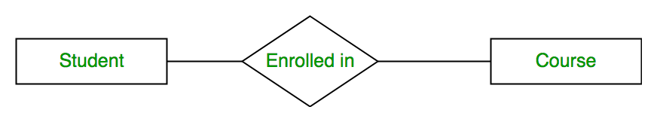
See 23

Q30. Explain the difference between Primary Key, Super Key, Candidate Key, and Foreign Key with examples.
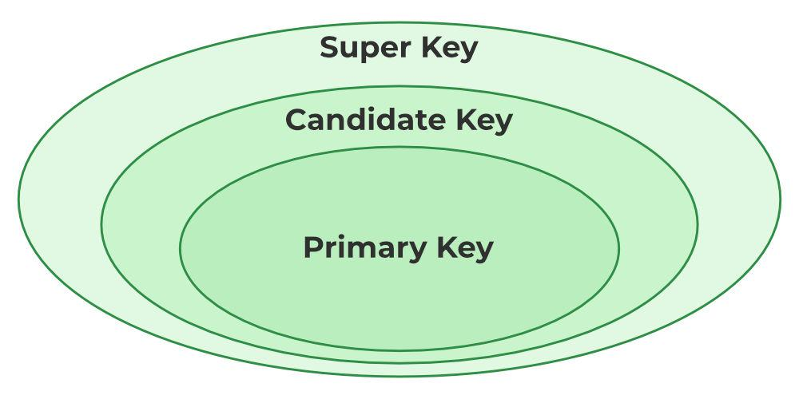

Primary Key:
- Definition: A unique identifier for each entity instance in a table.
- Example: In the 'Student' table, 'Student ID' is the primary key, uniquely identifying each student.
Super Key:
- Definition: Any set of attributes that uniquely identifies an entity instance.
- Example: In the 'Employee' table, the combination of 'Employee ID' and 'Email' forms a super key, as both together uniquely identify an employee.
Candidate Key:
- Definition: A minimal set of attributes that can uniquely identify an entity instance, from which the primary key is chosen.
- Example: In the 'Student' table, both 'Student ID' and 'Email' are candidate keys, as each can uniquely identify a student. One of these is chosen as the primary key.
Foreign Key:
- Definition: An attribute that creates a link between two tables, referencing the primary key of another table.
- Example: In the 'Enrollment' table, 'Student ID' is a foreign key referencing the 'Student' table's 'Student ID' primary key, linking enrollments to students.

Q31. A university maintains data about students, professors, courses, and departments. Each student is assigned a unique student ID, enrolls in multiple courses, and is advised by one professor. Each professor belongs to a department, and each department offers multiple courses. Design an E-R diagram for this scenario, showing entities, attributes, relationships, cardinality constraints, and keys. Convert the E-R model into relational tables.

Q34. Discuss the impact of Generalization and Specialization and aggregation on the database design. Provide real-life examples.
Impact of Generalization, Specialization, and Aggregation on Database Design
Generalization:
- Impact: Reduces redundancy by combining similar entities into a single generalized entity.
- Example: In a university database, generalizing 'Undergraduate Student' and 'Graduate Student' into 'Student' reduces repeated attributes.
- Real-Life Scenario: Generalizing 'Savings Account' and 'Checking Account' into 'Bank Account' for a banking system, simplifying common account-related operations.
Specialization:
- Impact: Increases specificity by defining subsets of entities with unique attributes or relationships.
- Example: In an HR database, specializing 'Employee' into 'Manager' and 'Staff' to capture distinct attributes like 'Department Managed' for managers.
- Real-Life Scenario: Specializing 'Vehicle' into 'Car' and 'Truck' in an automotive database to manage different characteristics and functionalities.
Aggregation:
- Impact: Simplifies complex relationships by treating them as higher-level entities.
- Example: In a project management database, aggregating 'Works_On' relationship between 'Employee' and 'Task' into a 'Project' entity.
- Real-Life Scenario: Aggregating 'Sales' relationship between 'Customer' and 'Product' into a 'Transaction' entity in a retail database, improving sales data analysis.

Q37. Explain the difference between Primary Key, Super Key, Candidate Key, and Foreign Key with examples.
- Primary Key:
  - Uniquely identifies each record in a table.
  - Cannot be NULL.
  - Example: RollNo in Student table.
- Super Key:
  - Any combination of attributes that uniquely identifies a record.
  - Can have extra fields.
  - Example: (RollNo, Name) is a super key if RollNo is unique.
- Candidate Key:
  - Minimal super key (no extra attributes).
  - Can have multiple candidate keys.
  - Example: If both RollNo and Email are unique, both are candidate keys.
- Foreign Key:
  - A key in one table that refers to the primary key in another table.
  - Maintains referential integrity.
  - Example: CourseID in Enrollment table refers to CourseID in Course table.
✅ Conclusion: All keys ensure data uniqueness and consistency but serve different roles in table relationships.

Q38. Explain the following with respect to Entity-Relation (ER) Model:
a) Entity:
- A real-world object or thing.
- Example: Student, Book, Employee.
b) Attributes:
- Properties that describe entities.
- Example: For Student – Name, RollNo, Age.
c) Relationship:
- Association between two or more entities.
- Example: A Student borrows a Book.
d) Weak Entity:
- Cannot be identified without a related strong entity.
- Example: Dependent entity depends on Employee.
e) Generalization:
- Process of combining similar entities into a single high-level entity.
- Example: Car and Bike generalized into Vehicle.
✅ Conclusion: ER model helps in designing a clear structure of the database with entities, attributes, and relationships.

Q39. Draw an ER diagram for a Library Management System. Identify the entities, attributes, relationships, and key constraints. Explain the assumptions made while designing the ER diagram.
Entities and Attributes:
- Book (BookID*, Title, Author, Publisher)
- Student (StudentID*, Name, Department)
- Librarian (LibrarianID*, Name)
- Issue (IssueID*, IssueDate, ReturnDate)
Relationships:
- Student issues Book → Many-to-Many (with Issue as a relationship)
- Librarian manages Book → One-to-Many
Key Constraints:
- BookID, StudentID, and IssueID are Primary Keys.
- StudentID in Issue table is a Foreign Key referencing Student.
Assumptions:
- A book can be issued to multiple students at different times.
- A librarian can manage multiple books.
- ReturnDate can be NULL if the book is not yet returned.
✅ Conclusion: This ER diagram models real-world library operations efficiently with clear relationships and data structure.

