AnQA Software

Help File

Author: Sylvain RAMA
20/02/2020

Table of Contents

I. Introduction 3
II. Main Interface 4
1. Menu Bar 5
2. List of Objects 6
3. Main Display 7
Graphs Panel 7
Picture Panel 8
4. Task List and Operations Buttons 10
5. Results Window 11
6. Attributes Manager 12
7. Scripts Manager 15
8. ROIs Manager 17
9. Text Importer 18
10. User Settings 19
11. User Shortcuts 21
III. Using Modules 22
1. General Comments 22
2. Scriptable Modules 22
3. List of available Modules 23
IV. Examples of Analysis 26
1. Detection of APs when recording an Input-Output Curve. Measure of APs parameters. 26
2. Detection and comparison of miniature events. 31

Introduction
AnQA (Analyze Quite Anything) is a software developed in Labview in order to analyse electrophysiology and imaging data.
The main framework was developed in 2017-2020 by Sylvain RAMA; Laboratory of Synaptic Imaging, Department of Clinical and Experimental Epilepsy, University College London. Some of the modules are way older.
It was written with some goals in mind:
- Any Data loaded or created in the software is saved as an Object in a TDMS exchange file on the hard drive. There is a constant streaming of data between the hard drive and the software. This means that if the software or the computer crashes, the User can simply reload the TDMS file and recover all the previous objects and results.
- It is modular. Anyone can write a module, place it in the \Modules\ folder and it will be available in the software to use on selected objects.
- It can modify multiple objects at the same time, and scripts can be created to do batch modifications of Objects. Scripts can be saved as XML files and distributed between users, so every user can reproduce the same analyse.
- No operation is destructive. When using a module, a new object is created each time. It is possible to compare multiple analysis at the same time.
- It is able to open .abf files, .WCP files, .tif files, .tdms files, .dat files and text files. It also uses the Windows clipboard to import and export data. Every result is sent to the clipboard, to be pasted in another software. Objects can be exported as text, ATF, pdf, PNG and GIF files.
- Data has to be displayed easily: moving through files, zooming in & out in a displayed object is performed by using the keyboard and mouse wheel. Keyboard shortcuts can be set by the User. This limits the number of actions needed to process the data.

This software is distributed “As is”, but the Author will be happy to correct small bugs or blatant errors.

Requirements:
The full version will need Labview 2017 and Vision 2017 or later, with OpenG. For the executable version, you will need the Labview Runtime Engine and Vision Runtime Engine.

Main Interface
The main window of the software has five different groups of elements.
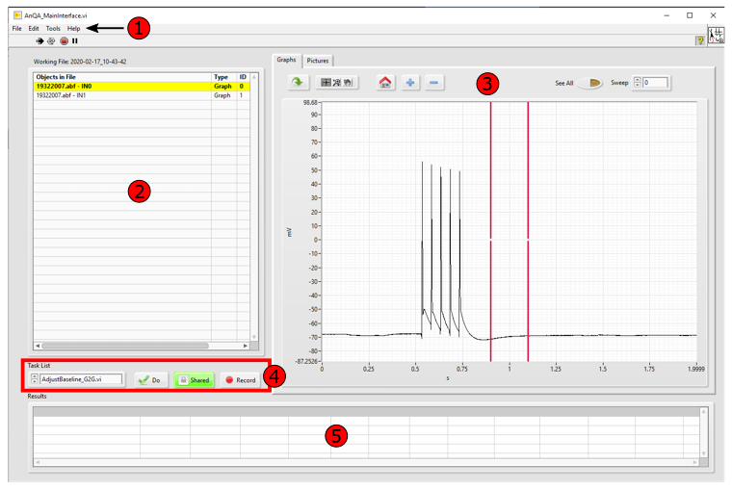
Those elements are:
- The Menu Bar, used for loading objects, changing their attributes and representations, showing different tools, etc…
- The List of Objects presently in the working file, with the name of this working file at the top of it.
- The Main Display, showing either Graph Objects or Picture Object, with different settings to display these objects.
- The Task List and Operation buttons, which you can use to select a module and modify the selected objects.
- The Results window, displaying any calculated result after applying a module.
And to these main elements, we can add:
- The Attributes Manager, to modify how Objects are named and displayed.
- The Script Manager, which shows recorded actions and parameters. It is used for batch processing of objects and files.
- The ROI Manager, to create, display and save complex ROIs on Picture objects.
- The Text Importer, used to open text files or to create new Objects from the computer clipboard.
- The User Settings, to modify some general parameters of the software.
- The User Shortcuts, to set shortcuts to different modules.

Menu Bar
The main Menu Bar has four menus:
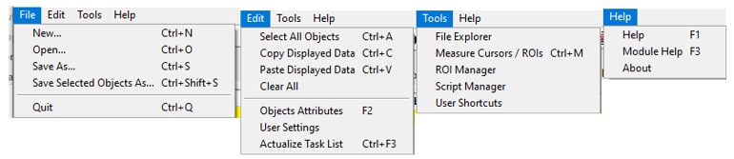
File Menu:
- New… (Ctrl+N) Creates a new TDMS file to store the objects to work on.
- Open… (Ctrl+O) Open files to be analysed. Supported formats are .abf from Clampex software (Molecular Devices), .wcp from WINWCP software (John Dempster, Strathclyde), .DAT data files from D. Kullmann lab, tiff files and text files.
- Save As… (Ctrl+S) Save the current TDMS file, with all the objects inside.
- Save Selected Objects As… (Ctrl+Shift+S) Save the selected objects in a new TDMS file. Currently not developed and not working.
- Quit (Ctrl+Q) Quit the AnQA software. If there are objects in the TDMS file, the software will ask to save them before quitting.

Edit Menu:
- Select All Objects (Ctrl+A) Select every objects currently in the TDMS file.
- Copy Displayed Data (Ctrl+C) Copy the object displayed in the display panel and put it in the computer clipboard.
- Paste Displayed Data (Ctrl+V) Paste any data from the clipboard to the software. This opens the text importer to create a new object.
- Clear All Delete every object in the file. This operation cannot be cancelled, make sure to save your objects first.
- Objects Attributes (F2) Opens the Attribute manager, to modify how the object is displayed.
- User Settings Open the general settings of the AnQA software.
- Actualize Task List (Ctrl+F3) Detect all the modules placed in the \Modules\ folder of the software. Use this when creating new modules for the software, so you do not have to re-start it.

Tools Menu:
- File Explorer Show the Labview TDMS File Explorer. Use this to check if anything is wrong with the TDMS file.
- Measure Cursors / ROIs (Ctrl+M) Measure the value of the selected graphs or picture object(s) in the cursors or the ROIs.
- ROI Manager Show the ROI Manager, used to set ROIs on pictures, save them, etc…
- Script Manager Show the script manager, used to make batch operations used on the software and replay them.
- User Shortcuts Display the User Shortcuts, and the interface to set your own keyboard shortcuts.

Help Menu:
- Help (F1) Display this Help file.
- Module Help (Ctrl+F1) Display the help file of the selected module.
- About Show information about the current version of the software.

List of Objects
This is the list displaying every object in the TDMS exchange file.
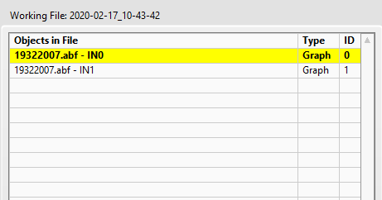

The title of the working file is generated at the startup of the software, with the date of the day and its time of creation. By default, the file is created in the software root folder but this can be changed in the User Settings. By choosing File > Save As… (Ctrl+S) in the menu bar, you can move and rename this TDMS file.
From left to right, this list shows the name of the object, its type (Graph or Picture) and its ID, which is the “real” name of the object for the software. By using the horizontal scrollbar (at the bottom of the list), you can see the time of creation of the object as well.
Graph Objects are multiple arrays of number with the same X values array. Picture Objects are 3D arrays of numbers.
Comments:
- Double-click on an object will display it in the Main Display (3). Ctrl + Double-click will display multiple Graph objects on the same window.
- Left-click will select an object. Shift+Click or Ctrl+Click will select multiple objects to be modified by the same module. Selected objects will appear in bold, with yellow background.
- Objects order can be modified by selecting and moving objects up or down.
- By pressing “Suppr”, an object can be deleted from the TDMS file. This operation cannot be cancelled.

Main Display
This main display has two panels, showing either Graphs objects or Picture objects.

Graphs Panel
The Graphs Panel has four groups of elements:
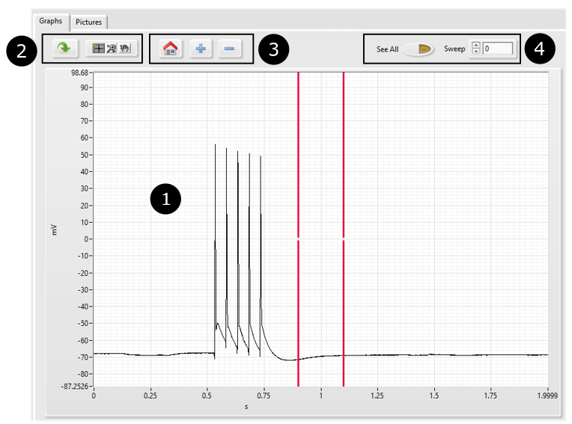
Those elements are:
- The graph display showing the selected objects (here a train of 5 Action Potentials), with axis values and axis labels (here, mV and s) and a pair of cursors (red vertical lines).
- From Left to Right: Button to centre the display on the selected object; Button to select and move cursors; Button to modify the view (Zoom In, Zoom Out, etc…) and Button to pan the view.
- From Left to Right: “Home” Button to centre the cursors in the display, Buttons “+” and “-“ to add or remove a pair of cursors.
- From Left to Right: “See All” Button to display every Sweep of the object at the same time on the display; “Sweep” Button to display only the desired sweep. If “See All” is pushed, the “Sweep” Button is useless and replaced by a “Rainbow” Button, changing the color of every displayed sweep to better show if there was a gradual change in the recorded sweeps.
Comments:
For smoother operation, the Graphs display should be used with keyboard and mouse:
- MouseWheel will scale the X axis. Shift+MouseWheel will scale the Y axis. Ctrl+MouseWheel will pan the view on the X axis.
- On the keyboard, “W”, “A”, “S” and “D” keys will pan the object down, right, up and left, respectively. “E” will center and zoom the display on the selected object (same operation than clicking on the left Button of (2)).
- “Space” will display the next sweep; “BackSpace” will display the previous sweep. This will work only if the “See All” Button in (4) is not selected.
- Ctrl+C will copy the displayed data and put it in the computer clipboard. This is the same as choosing Edit > Copy Displayed Data.
- Right-Click button on the graph display is used to export the displayed data to the computer clipboard (as a text file) or as a PNG or pdf picture.

Picture Panel
The Picture Panel has five groups of elements:
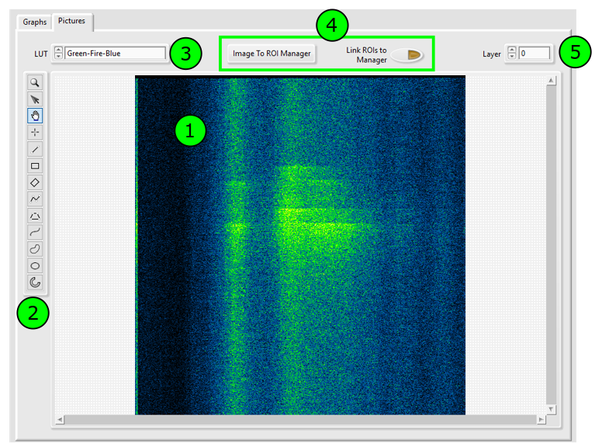
Those elements are:
- The Picture Display Window.
- The Region Of Interests tools, to select any ROIs on the picture.
- The Look-Up Table selector, to choose the colours to display the selected picture. There are currently 17 different LUTs, mainly inspired from ImageJ.
- Two buttons to link the Picture object and ROIs to the ROI Manager. Left: to send the current Picture object to the ROI manager. Right: to link the ROIs drawn on this window to the ROI manager. By putting this “ON”, any ROI selected on this picture will be sent to the ROI manager, where it can be modified or saved.
- The selector of the layer of the Picture, for 3D Pictures objects.
Comments
For smoother operation, the Picture display should be used with keyboard and mouse:
- MouseWheel will zoom IN & Out of the picture.
- Shift+MouseWheel will change the layer displayed. This will work only if the Picture is a multi-layered one.
- On the keyboard, “E” will adjust the Display to show the full Picture
- Ctrl+C will copy the displayed data and put it in the computer clipboard. This is the same as choosing Edit > Copy Displayed Data.
- “Space” will display the next layer; “BackSpace” will display the previous layer.
- Right-Click button on the Picture display is used to export the displayed data to the computer clipboard (as a text file), as a PNG picture or as a GIF picture sequence.

Task List and Operations Buttons
These elements are used to apply modules to object, in order to modify them, create a new object or calculate a result.
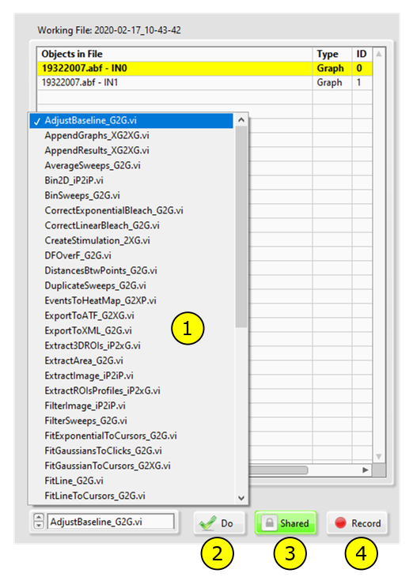
There are four elements:
- The Task List will show every module available in the \Modules\ folder of the main software.
- The “Do” button will apply this module to the selected Object(s). This will create new Object(s) to the file and update the List of Objects (2).
- The “Shared” button, when “ON”, will apply the same module settings to every selected objects. If a module ask for an input from the User (for example, the number of points needed to perform a moving average), the user will enter this parameter only once and it will be applied to every selected object(s). If this button is “OFF”, the software will ask to re-enter these parameters for every selected Object(s). This button is “ON” by default.
- The “Record” Button, when “ON”, will record every module and store every parameters used on the Objects in the Script Manager (7). This can be used to record a sequence of action on different Objects, to do batch processing on objects or to export the sequence of actions as an XML file to be shared between users.
Comments:
- Created Objects will have an automatic name made by default as [Original Name]/[Name of the Last Applied Module]. In the User Settings (10), it is possible to choose between this “Short Name” configuration and a “Long Name” configuration, which will keep the list of every module applied on the object.
- Modules have a name describing their action, followed by an identifier (“_G2G” for example). This identifier is essential to understand the behaviour of the module. “G2G” means it will take a Graph object and produces another Graph (“Graph to Graph”). “P” or “iP” indicates the module will take or produce a Picture object (“P2P”: “Picture to Picture”). “X” means it will take or produce multiple object. So, for example, a module with the identifier “_iP2XG” will accept a Picture object and will produce multiple Graph objects.
- Therefore, not every module can be applied to every object. If the module is not adapted to the object (for example, a module designed for Picture is applied to a Graph object), the software will not perform the selected module and will display this kind of error message:
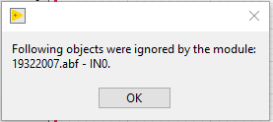

Results Window
The Results Window will display any result calculated by a Module. In parallel, the Results will be loaded in the computer clipboard, to be pasted in any other analysis software.
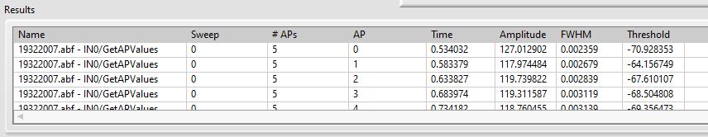
Example of the Results Window after using the module “GetAPValues”, which detect Action Potentials and calculates multiple parameters on these APs. You can see from left to right the name of the object in the format [Old Name]/[Module Name], the sweep analysed, the number of APs per sweep and then the timing, amplitude, width and threshold of each individual AP.

Attributes Manager
The Attributes Manager is opened automatically when loading new objects from file. It is possible to call it by choosing the Menu Edit > Objects Attributes or pressing “F2”. This will allow modifying the attributes of every selected object(s). It is composed of three groups of elements:
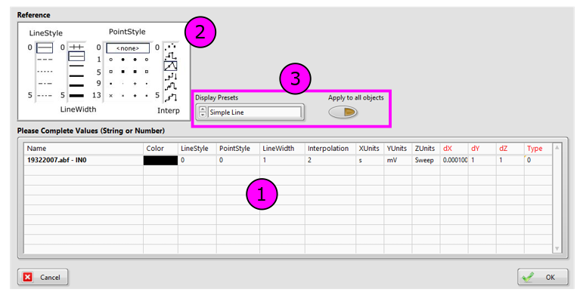
Those elements are:
- The main window showing the Name of the selected Object(s), how they are represented (Colour, Line Style, Point Style, Line Width and Interpolation), the names of every axis (XUnits, YUnits, ZUnits) and their dimensions (dX, dY, dZ). Finally, their Type: “0” means the Object is a Graph, “1” it is a Picture, “2” means the Object should not be displayed.
- The Reference window is a reminder of the different values possible for Line Style, Point Style, Line Width and Interpolation.
- The Display Presets button allows choosing between already set configurations such as Simple Lines, Scatter Plots, Histograms representation, etc… The “Apply to All Objects” button will apply any modification of one object to all the other objects.
Comments
- As an example, we can see that the object in (1) is a Graph, named “19922007.abf – IN0”, and this object will be displayed as a thin black line. Units were automatically loaded from an .abf file. The sampling (dX) is 0.0001 per s, or 10 kHz.
If the User double-click on it on the Object List, it will be displayed like this:
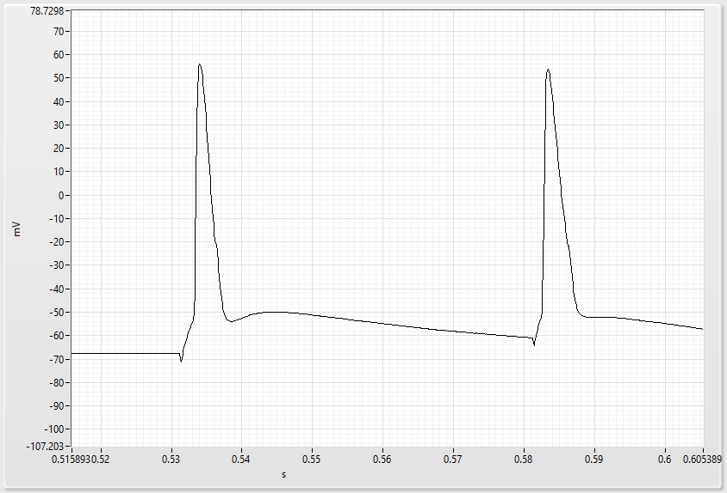
If the User modifies its attributes to the following, it selects plain red dots, not connected by any lines:
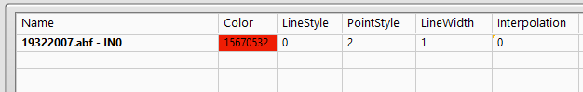
And the Object will be now displayed this way:
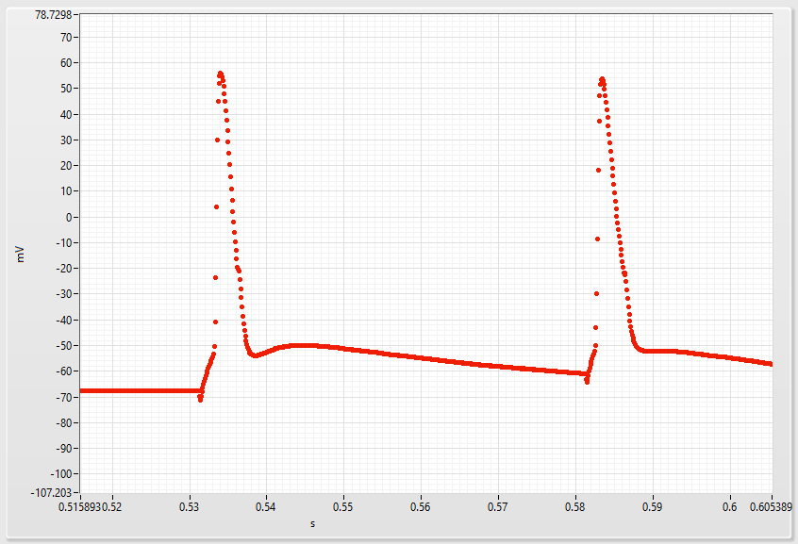

- The User can make an extensive use of the display, changing attributes of Objects in order to compare them. For example, the original black signal was filtered by a Moving Average of 5 points, and the Object display was changed to a thick green line. With Ctrl+Double-Click on the List of Objects, the User can display multiple objects at the same time and thus super-impose them.
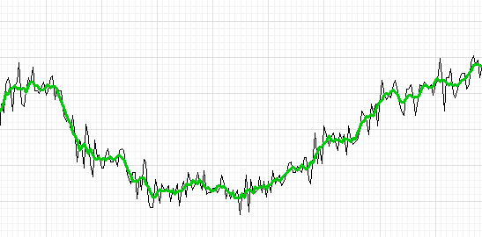
- Attributes with black names (Colour, Line Style, Point Style, Line Width, Interpolation, XUnits, YUnits and ZUnits) are important for displaying the Object, but do not change it in any way.
- Attributes with red names (dX, dY, dZ and Type) will change the object itself. This is useful to change the sampling of a signal or the resolution of a Picture object, but it has to be modified with caution.
- The software makes no assumption on the units or resolution of any axis. The User has to check herself or himself if the units, sampling and other parameters are accurate. These parameters can be extracted automatically in some cases but not always. This is why the Attribute Manager is opened automatically when importing new Objects from files.
- Unless the Module specifies it, Attributes will be inherited from the previous Object.

Scripts Manager
The Script Manager can be accessed by choosing the menu Tools > Script Manager. It is composed of four groups of objects:
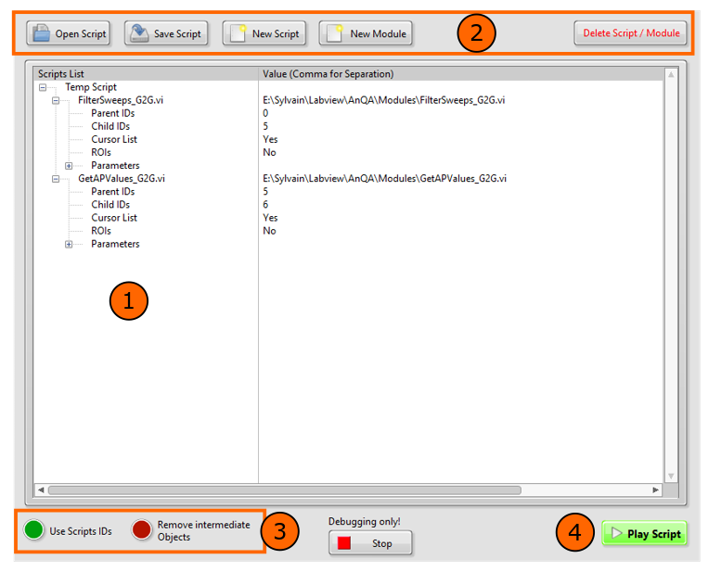
Those elements are:
- The main Scripts window, showing all the recorded modules. Scripts are simple list of modules, with all their parameters. Each time a module is recorded, the software records: the ID of the original Object (Parent IDs), the ID of the produced Object (Child IDs), the Cursors of the Graph display and the ROIs of the Picture display if they are used. In the “Parameters” field, it saves all the parameters needed by the Module itself to work automatically.
- Buttons to save scripts to disk, open scripts already recorded or delete previously recorded modules and scripts.
- Two buttons will modify the behaviour of the script system. The button “Use Script IDs”: If “Off”, the script will be applied to the Objects selected in the List of Objects (2) and will produce new Objects. If “On”, the script will be applied to the Object IDs recorded in the script (Parents IDs) and will produce Objects with IDs recorded in the script (Child IDs). “Remove Intermediate Objects”: if “On”, the software will keep only the last Objects produced and remove all the others. By default, those two buttons are “Off”.
- The “Play Script” button will apply the script (and thus, the list of modules recorded in the script) either to the selected Objects (if the button “Use Scripts IDs” is “Off”) or to the Objects with IDs recorded in the script (if the button “Use Scripts IDs” is “On”).
Comments
- The User can select either a full script to be played, or only a few modules of it. Modules will be played in a top-down order.
- Modules can be moved up and down and transferred from different scripts.
- The “Parameters” Fields of the script can be opened to check the values of all the parameters:
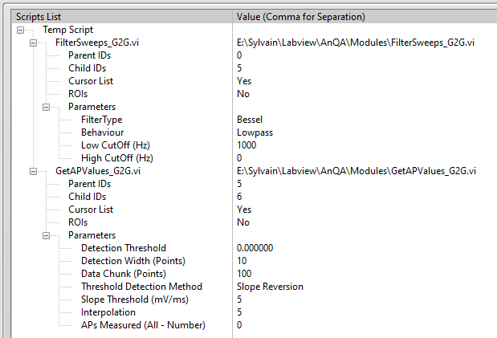
- These parameters can be modified directly in the script system (with a triple-click) and if played, the script will now apply the new parameters. The script system can replace entirely the Task List and the “Do” button of the main interface (4).
- When using the “Use Script IDs” button, the User has to pay attention to the IDs used. The script system may create an Object with the same ID than an existing one, which will concatenate the Objects.
- The “Debugging Only” Stop button is present only for development purpose and should not be used by unexperienced Users. By pressing it, it will stop the Script Manager independently from the main AnQA software and break the link between both programs. The Script Manager has to be restarted itself after that (White “Run” Arrow). This allows to work independently on the Script Manager and quickly check the result, without restarting the main AnQA framework.
- The User can close the Script Manager window at any moment by pressing the “Close Window” button top-right. This simply hides the window without stopping the Manager.

ROIs Manager
The ROIs Manager can be accessed by choosing the menu Tools > ROIs Manager. To display an image on the main display, the User has to press “Image to ROI Manager” in the Main Picture Display (4). It is composed of five groups of elements:
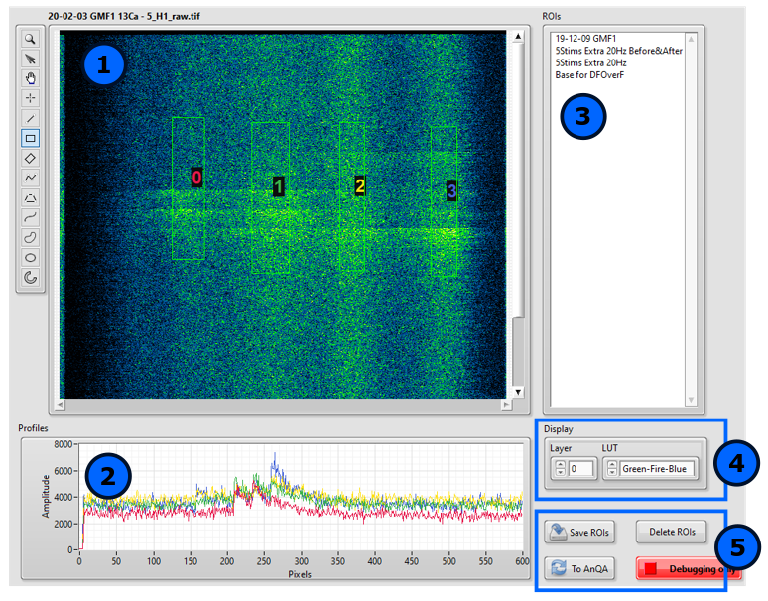
These elements are:
- The main window displaying the Picture Object sent from the main AnQA software, with image navigation and ROI tools on the left. The User set 4 ROIs on this one, named from 0 to 3 and with different colors.
- A graph window showing the profiles of each ROI set on the image. The longest dimension of the ROI is used as main axis for the profile. Profiles colors are the same than ROIs names in the display window (1).
- A list of every ROIs or group of ROIs recorded in the \ROIs\ folder of the software. The User can select one or many ROIs, they will be shown on the main window (1) and their profiles will be displayed in (2).
- Two buttons to choose the layer to display (in case of multi-layered Picture Objects) and the LUT applied to this object.
- Buttons to save created ROIs (if the User saves the ROI in the \ROIs\ folder of the software, it will be listed automatically in (3)) and delete unwanted ROIs. The button “To AnQA” will send the selected ROIs to the main AnQA software, for example to be used by modules.
Comments
- The “Debugging Only” Stop button is present only for development purpose and should not be used by unexperienced Users. By pressing it, it will stop the ROI Manager independently from the main AnQA software and break the link between both programs. The ROI Manager has to be restarted itself after that (White “Run” Arrow). This allows to work independently on the Manager and quickly check the result, without restarting the main AnQA framework.
- The User can close the ROI Manager window at any moment by pressing the “Close Window” button top-right. This simply hides the window without stopping the Manager.
- ROIs colors (and corresponding graphs colors) can be modified in the User Settings (10).

Text Importer
The Text Importer is used in two occasions: when the User wants to open a text file to import new Objects or when pasting data in the software (Edit > Paste data (Ctrl+V)). It has three group of elements:
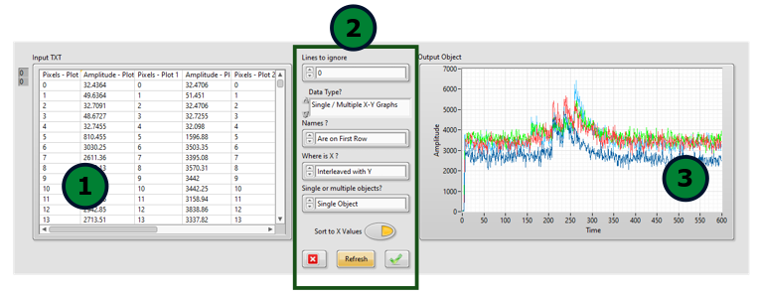
These elements are:
- The text window showing what is in the file or in the computer clipboard.
- Different settings to choose, for the software to know how to interpret the data. From top to bottom:
- If there are lines to ignore before the start of data.
- If the data will be a Graph or a Picture Object.
- Where are the names of the different data columns
- Where is the “X” column. If there are none, the software can create one.
- If the Importer should create multiple Objects or a single one with multiple recordings.
- If the Importer should re-order all data points according to the values on X axis.
- When everything is set, the User has to press “Refresh” for the next graph to appear.
- The graph window showing the elements extracted from the text file or the computer clipboard.
Comments:
- The software will call the Attribute Manager after importing text files or the clipboard. The User has to check if units, resolution values, etc… are accurate.
- This Text Importer only considers Column-wise data in Tab-delimited text files.

User Settings
General User Settings can be accessed by choosing Edit > User Settings of the Menu Bar.
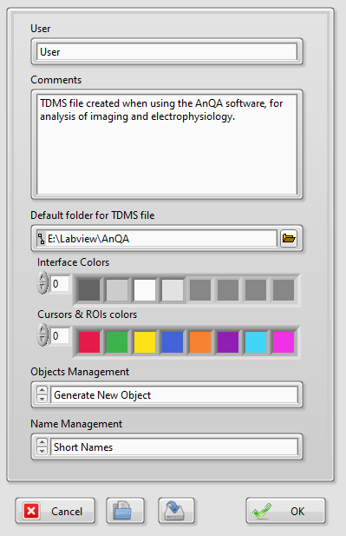

From top to bottom:
- The “User” and “Comments” fields are saved in the TDMS file and can be used to identify the person who worked on the data and store some comments about the general analyse.
- The Folder path to the TDMS exchange file. By default, it is at the root of the AnQA software.
- Main colours of the interface. The User can change this to modify the colours of the interface, for example to get a dark theme (better suited for dark rooms). Currently not developed and not working.
- Cursors and ROIs colours, used to set the colours of the ROIs of the Picture Display, the cursors of the Graph Display, and the automatic colours of Graph objects. These colours are originally selected by Sasha Trubetskoy, https://sashat.me/2017/01/11/list-of-20-simple-distinct-colors/
- Objects Management settings allow to choose between two behaviour of the software: “Generate New Object” will create a new object when using a module. This is non-destructive but needs more space on the hard-drive. “Work On Current Object” will replace the current object with the new one. This saves space on the hard drive but removes the raw data and every step of the analyse. Currently not developed and not working. The software always generates a new object when using a module.
- Name Management settings allow to choose between creating objects with short names keeping only the name of the last module (format “[Name]/[Last Module]”) and long names keeping the sequence of every module used on the object (format “[Name]/[Module1]/[Module2]/…”). By default, the software uses the “Short Names” system.
Settings can be saved as an XML text file and loaded or exchanged by different users. To be set as Default settings for the next time, it has to be saved as “AnQA Default Settings.txt”.

User Shortcuts
User Shortcuts can be accessed by choosing Tools > User Shortcuts of the Menu Bar.
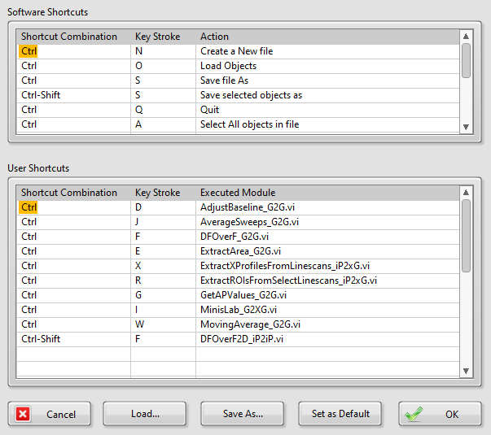
From Top to Bottom:
- Software Shortcuts are Menu Items shortcuts, hard-coded in the software. The User cannot change them.
- User Shortcuts can be changed by clicking on a cell “Shortcut Combination” and “Key Stroke” to set the shortcut and “Executed Module” to choose which module this new shortcut will call.
- Those shortcuts can be saved as an XML text file and loaded or exchanged by different users. To set Default Shortcuts for the next time, save the file as “AnQA_UserShortcuts.txt”.
Comments:
- If a User creates a shortcut identical to a Software Shortcut, the software will ignore it.

Using Modules

General Comments
Help files of individual Modules can be accessed directly in the software by selecting the desired module and choosing the Help > Module Help (Ctrl+F1) in the Menu Bar.
As described in the Comments of section II.4) about the Task List:
- Modules have a name describing their action, followed by an identifier (“_G2G” for example). This identifier is essential to understand the behaviour of the module. “G2G” means it will take a Graph object and produces another Graph (“Graph to Graph”). “P” or “iP” indicates the module will take or produce a Picture object (“P2P”: “Picture to Picture”). “X” means it will take or produce multiple object. So, for example, a module with the identifier “_iP2XG” will accept a Picture object and will produce multiple Graph objects.
- Therefore, not every module can be applied to every object. If the module is not adapted to the object (for example, a module designed for Picture is applied to a Graph object), the software will not perform the selected module and will display this kind of error message:

Scriptable Modules
When using the script system, the main AnQA framework will call the different modules defined in the script. However, depending of the programming of the Modules, 3 behaviours will appear:
- The Module is fully automatic and do not need any input from the User. This is the case for example for the modules AdjustBaseline, AppendGraphs, etc…
- The Module needs some input from the User. If the “Shared” Button is “On” (See II.4)), the User will be asked once and then the parameters will be set for every remaining Object. If the “Shared” button is “Off”, the software will ask about parameters for every selected Objects. This is the case for example for the modules GetAPValues, FilterSweeps, etc…
- The Module cannot be automatic because the Author decided it should not be so. This is the case of most high-complexity modules such as MinisLab, ExtractGaussianROIs, etc… All parameters will be asked for every selected Object. This is a voluntary behaviour, as wrong results are too likely to appear if the Module is fully automatic.
[Have to finish about writing Modules…]

List of available Modules
This list shows the Modules already created by the Author of the Software. Please check the Help of each Module separately for more information (Help > Module Help (Ctrl+F1)) in the software or browse help files.

AdjustBaseline_G2G
For each sweep of the Graph Object, measures the mean value between the first pair of cursors (baseline) and subtract this value to the sweep.

AppendGraphs_XG2G
Concatenate multiple graphs to create a multi-sweep Graph Object.

AppendResults_XG2G
Concatenate the Results of multiple Graph Objects to a single empty Object containing all the results.

AverageSweeps_G2G
Average every sweep of the Graph Object. Produces an Object with a single sweep.

Bin2D_P2P
Bin a Picture Object in X and Y, with desired number of pixels.

BinSweeps_G2G
Bin the points of every sweep of a Graph Object in the X axis.

CorrectExponentialBleach_G2G
Fit an Exponential between the first pair of Cursors and subtract the result to the Graph Object. If there is a second pair of Cursors, this will be used to ignore a part of the Object.

CorrectLinearBleach_G2G
Same than the Exponential version, but with a linear fit.

CreateStimulation_2XG
Module to create complex waveforms, to be used as stimulation files in ClampX for example.

DFOverF_G2G
Calculates DF/F of a Graph Object. The first pair of cursors set the F0 area.

DistancesBtwPoints_G2G
Calculates distances between every pairs of X, Y coordinates.

DuplicateSweeps_G2G
Duplicate the sweeps of a Graph Object.

EventToHeatMap_G2P
Creates a Picture Object from a Graph Object contaning Events coordinates. This creates a Heatmap with the time course of all events. Working but not Finished.

ExportToATF_G2G
Export the Graph Object to ATF, to be opened by ClampX or ClampFit.

ExportToXML_G2G
Export the Graph Object to XML format, for saving coordinates or Events.

Extract3DROIs_P2XG
Extract ROIs of multi-layered pictures, with Magic Wand tool or 2D Gaussian fitting. Not Finished.

ExtractArea_G2G
Extract the area of the first pair of cursors from a Graph Object.

ExtractImage_P2P
Extract the ROIs from a Picture Object.

ExtractROIsProfiles_P2XG
Extract the profile of the ROI on an image. The largest dimension of the ROI is used as axis.

FilterImage_P2P
Polynome-filtering of an image. On X & Y axis only.

FilterSweeps_G2G
Classic filters for Graph Objects.

FitExponentialToCursors_G2G
Fit an exponential curve between every pair of cursors.

Fit GaussiansToClicks_G2G
Fit a Gaussian curve where the User will click.

FitGaussianToCursors_G2G
Fit a gaussian curve between every pair of cursors.

FitLine_G2G
Fit a line between every pair of cursors.

GetAPValues_G2G
Measure multiple parameters from Action Potentials.

HeatmapsToSynchrony_P2P
Take the Heatmaps produced by EventsToHeatMap and calculates all the combinations to establish synchrony maps.

Histograms&Averages_G2G
Make histograms or cumulative curves with the Y values of a Graph Object.

HistogramsAlign&Bin_G2G
Align multiple histograms by their first peak.

LS-BinByTheta_P2P
For Linescan images acquired with Spiral Mode. Will bin all pixels in an angle of Theta value.

LS-CircularShift_P2P
Does a circular shift on the X axis.

LS-DFOverF_P2P
Performs DF/F on the Y axis of an image, using the first ROI as F0 area.

LS-ExtractGaussianROIs_P2G
Extract ROIs by taking X profiles of the Linescan and fitting gaussians on peaks of this profile.

LS-ExtractROIs_P2G
Extract ROIs by using the ROI tools from the software.

LS-SubtractBckgrd_P2P
Removes the background on the Y axis of an image, using the first ROI as background area.

LS-WrapToCoords_P2P
Map a Linescan acquisition to its X, Y coordinates, to make a 3D image.

LS-WrapToSpiral_P2P
Map a Linescan acquisition to an Archimedean spiral, to make a 3D image. Actually quite useless as linescans rarely follow a perfect spiral.

MinisLab_G2G
Versatile tool to detect peaks in any kind of Graph Object. Can be automatic, semi-automatic or manual.

MovingAverage_G2G
Makes a moving average on the X axis of a Graph Object.

MovingAverage2D_P2P
Makes a moving average on both X and Y axis of a Picture Object.

MultiGaussianFit_P2G
Automatic Gaussian fits to detect ROIs. Works only if profiles are perfect.

NormalizeSignal_G2G
Normalizes the signal between the first pair of Cursors (Baseline) and the second one (Peak)

ProfilesOddROIsMinusEvenROIs_P2G
Takes the profiles of every ROIs, and subtract the Even ones to the Odd Ones.

Savitzky-Golay_G2G
Savitzky-Golay filter of a Graph Object

SelectSweeps
To select any subset of sweeps from a Graph Object.

SeparateEven&OddSweeps
Separate Even from Odd sweeps.

Examples of Analysis

Detection of APs when recording an Input-Output Curve. Measure of APs parameters.
When measuring the excitability of a neuron, a common parameter is the number of Action Potentials induced by a depolarizing current injected in the cell. Moreover, the different characteristics of an AP (Threshold, Height, Width) can be used as clues to know the state of inactivation of Na+ and K+ ion channels. This example will use extensively the “GetAPValues” module to measure an Input-Output curve and the different characteristics of triggered APs.
After starting the software, choose File > Open… (Ctrl+O) and select the file “I-O Curve.abf” located in Help\Example Files\. As it is an abf file, the software will create two new objects corresponding to the recorded potential (IN 0) and injected current (IN 1) in the cell. Do not change anything in the Attributes Manager, detected settings should be fine. You can then double-click on the first Object created (I-O Curve.abf - IN 0) to display it. By selecting “See All” to display every sweep and pressing “E” to fit the display to the object, the result should be similar to this:
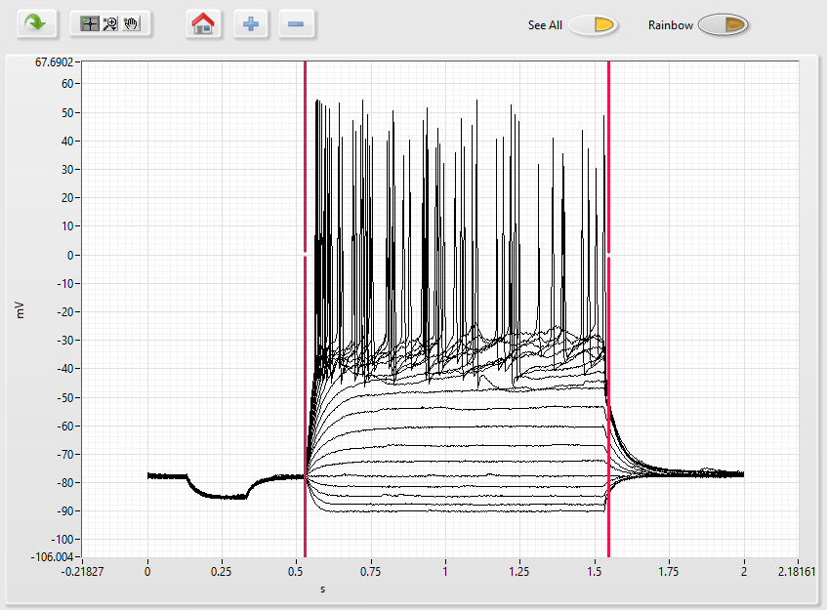
Move the cursors to each side of injected current area. You can press the “Rainbow” Button to set a different color to each sweep, from red to purple. This is useful to see if there was a regular change through time. In that case, the resulting display should be similar to this:
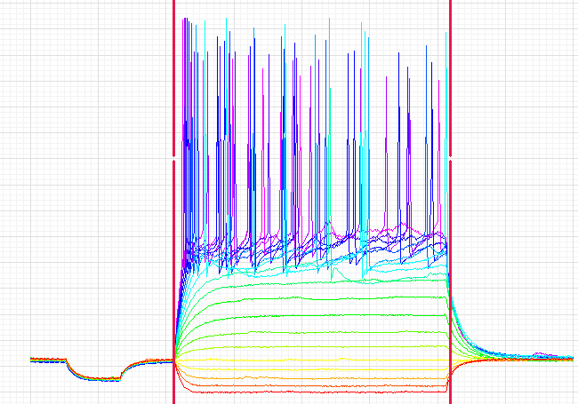
Make sure the proper Object is selected (it should be in Bold with yellow background in the List of Objects). With the cursors set to each side of the current injection area, choose the Module “GetAPValues_G2G” and press “Do”. The interface of this module should open; change the different fields for these ones:
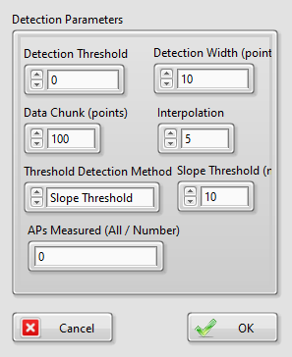
Press “OK”, a new Graph Object should have appeared in the list, named I-O “Curve.abf - IN 0/GetAPValues”. Double-Click on “I-O Curve.abf - IN 0” and then Ctrl+Double-Click on “Curve.abf - IN 0/GetAPValues” to display both Object at the same time, you should get this result, with “See All” on “On” and “Rainbow on “Off”:
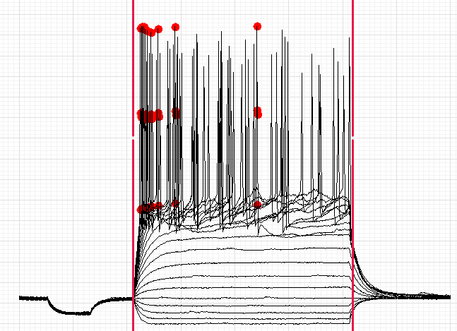
You can zoom In & Out with the Mouse wheel, the black trace is the original Object, “I-O Curve.abf - IN 0” and the red points are the new object “Curve.abf - IN 0/GetAPValues” showing the threshold, peak and Full Width at Half Maximum (FWHM) of every first AP of the sweep, if there was any.
The Results Window should display something similar to this (if not, double-click again on the created Object, “Curve.abf - IN 0/GetAPValues”:
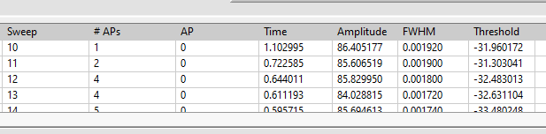
This is the number of APs per sweep (sweeps without APs are ignored), and the different parameters measured for each first AP. As those values are already in the computer clipboard, you can paste them in Excel or any other program.

Now we have to measure the current injected in the cell. However, we cannot simply measure it, as we injected some base current to maintain the cell at -80 mV. We thus have first to subtract this current by adjusting the baseline. Display the second Object “I-O Curve.abf - IN 1” by double-clicking on it, “E” to center the display on it. Set the cursors on the baseline, choose the module “AdjustBaseline_G2G” and press “Do”. A new Object is created as we corrected the baseline. Display it and place the cursors on the current injection area. With “See All” selected, it should be similar to this:
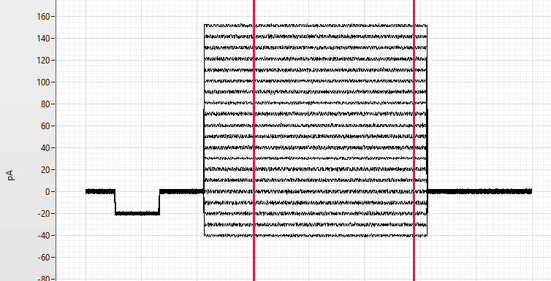
If you choose Tools > Measure Cursors/ROIs (Ctrl+M), th software will measure the values of the signal between each pair of cursors for each sweep and display it the Results window. Here is the result:
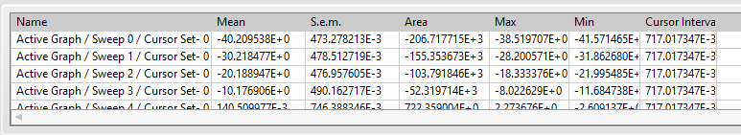
The “Mean” Column is the average current injected in the cell. These results can be pasted in Excel for example, and with the previous ones about number of APs here is the I-O curve of this cell:
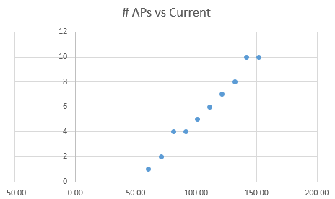

If you want the parameters of every APs recorded, simply select the first Object “I-O Curve.abf - IN 0”, apply the module “GetAPValues_G2G” and indicates you want the parameters of every APs:
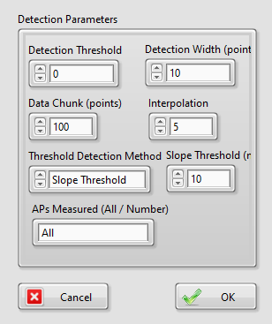
Here is the result when displaying the new Object with the first one:
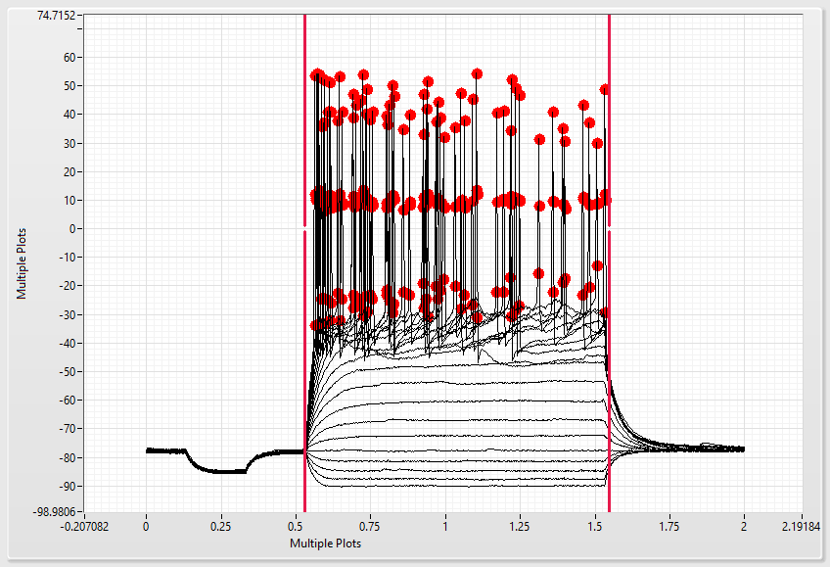

Zoomed in to show the detection of the threshold, amplitude & FWHM:
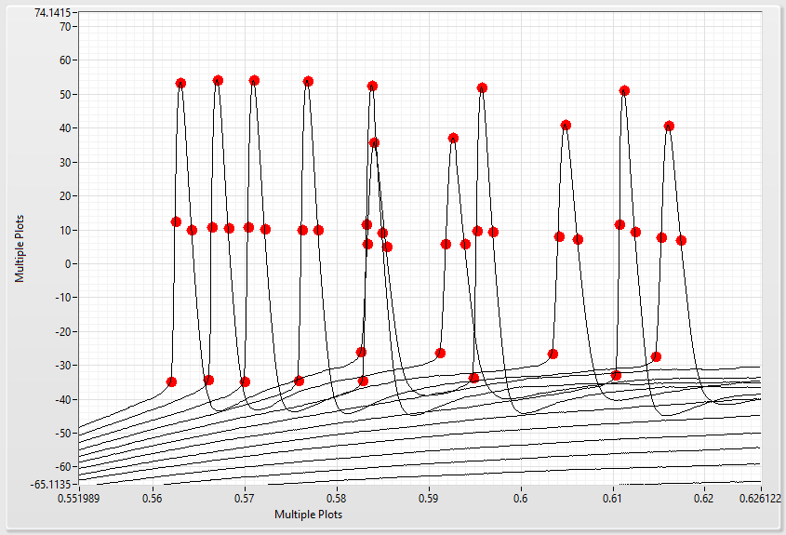
And the corresponding results:
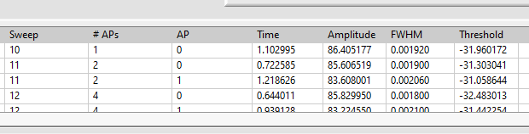

Detection and comparison of miniature events.
After starting the software, choose File > Open… (Ctrl+O) and select the file “Miniatures.abf” located in Help\Example Files\. As it is an abf file, the software will create two new objects corresponding to the recorded current (Im_Prime) and holding voltage (Vm_Sec) in the cell. Do not change anything in the Attributes Manager, detected settings should be fine.
Select the Object and choose “MinisLab_G2XG”. To see the Module Help, choose Help > Module Help (Ctrl+F1). Press “Do” to start the MinisLab module.
After adjusting the display with the keyboard (Shift+”E”), the Module should look similar to this:
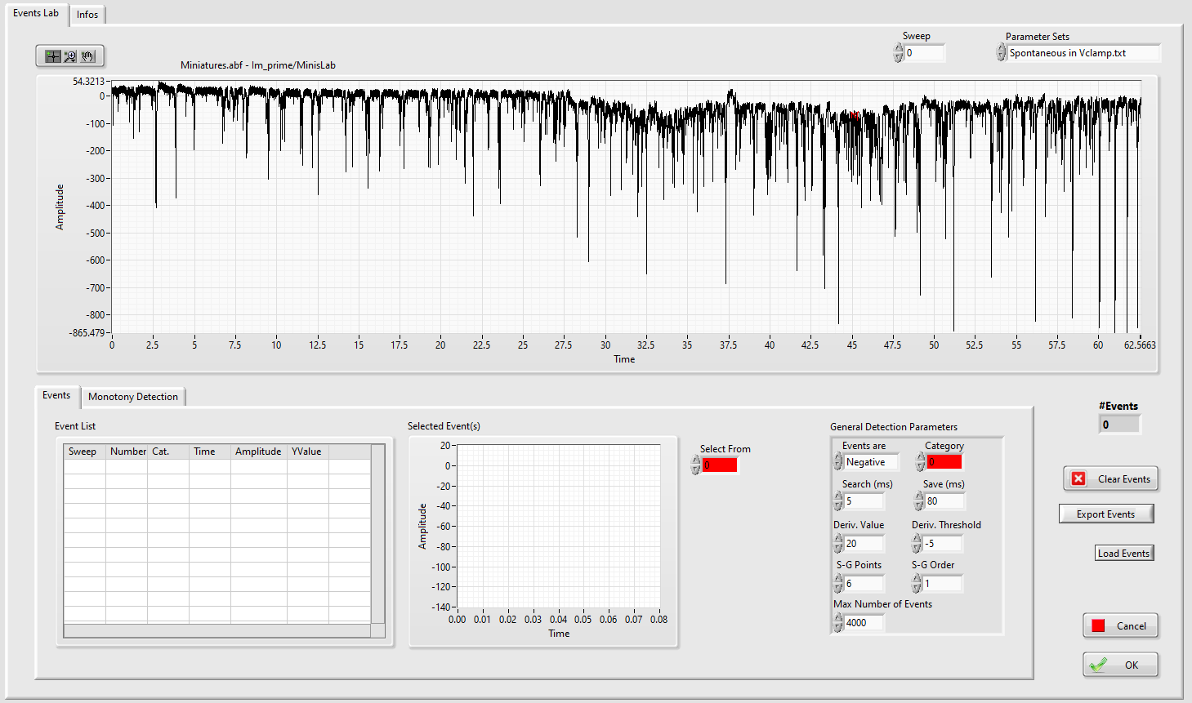
In the Parameter Sets (Top right), choose “Spontaneous in Voltage Clamp”.
Zoom in the first half of the trace (from 0 to 23s). In the Monotony detection panel, choose “Current View” for “Autodetect On” and press “Autodetect”.
Then move on the second half of the trace (from 40 to 63s), change the category for the number 3 (Green) and press again “Autodetect” with “Current View” selected. When zooming out (Shift+”E”), it should look like this:
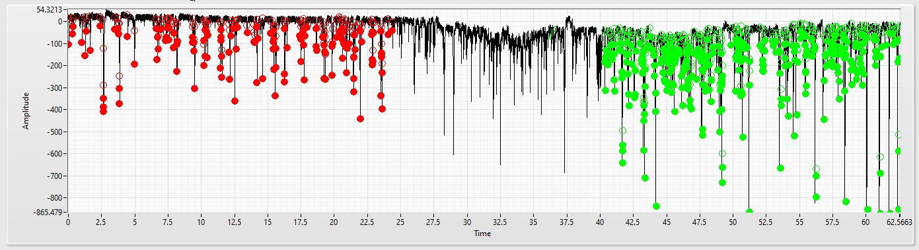
Simply press “OK”, the Module will close and 8 new Objects (4 per Event category) will appear in the List of Objects.
By using Ctrl+Double-Click, the User can super-impose multiple Objects. Here is the result when showing the original Object (Miniatures.abf – Im_Prime) with the time courses of the different categories (Miniatures.abf – Im_Prime/MinisLab-TimeCourse-Cat0 & Miniatures.abf – Im_Prime/MinisLab-TimeCourse-Cat3):
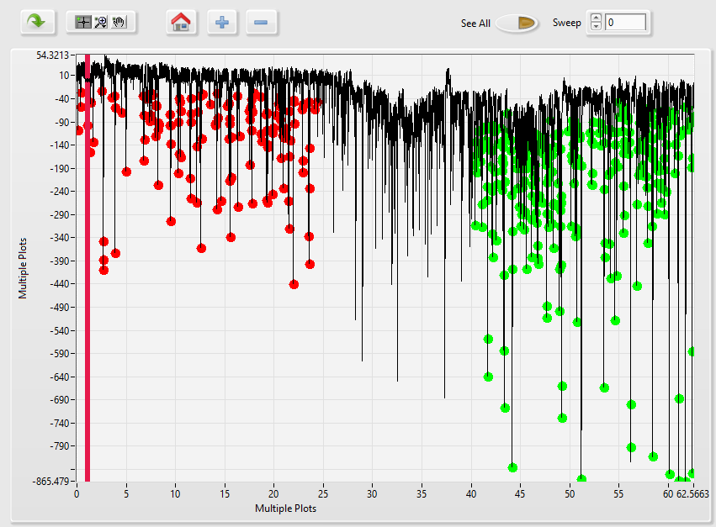
Each new Object can be used for further analysis by other modules. For example, to analyse the amplitude of detected Events the User can now use the “Histograms&Averages” Module on the “Amplitudes” Objects of both categories.
By applying these settings (See the Module Help for further details on this module):
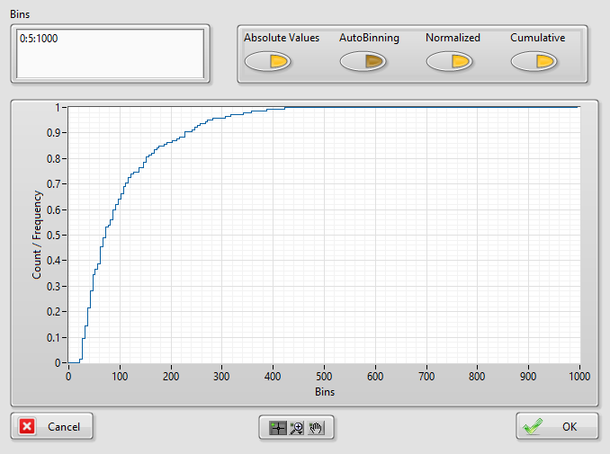
Cumulative histograms shows that for the category 3 (green), there are more Events with a big amplitude:
