* Introduction

The main purpose of this project is to design a low size surveillance system which can be installed everywhere, without using an existing infrastructure.

The surveillance system is made up of an autonomous video acquisition battery powered system, and a high-level processing system.

Both systems are linked via a wireless connection.Our project focuses on motion detection with tracking.

We are three team members and we distributed the tasks in the following way:

Natacha will work on embedded system because she feels more comfortable in this field

Sylvain Ard will work on Human silhouette detection and tracking because he have some experience in development and he is is interested in shape recognition.

Arthum will also work on embedded system because it’s his expertise field.

* work completed

We have completed the user requirements.

We want a system with a minimal consumption. Natacha has completed the motion detection. The principle is that our system in on standby mode when there is no movement. We detect movement with the HC-SR501 sensor which is piloted by the ESP8266 microcontroller. If one person enters the field of the sensor, then the sensor will send an impulsion to the microcontroller. Then, the microcontroller will send a message to wake up the other component.

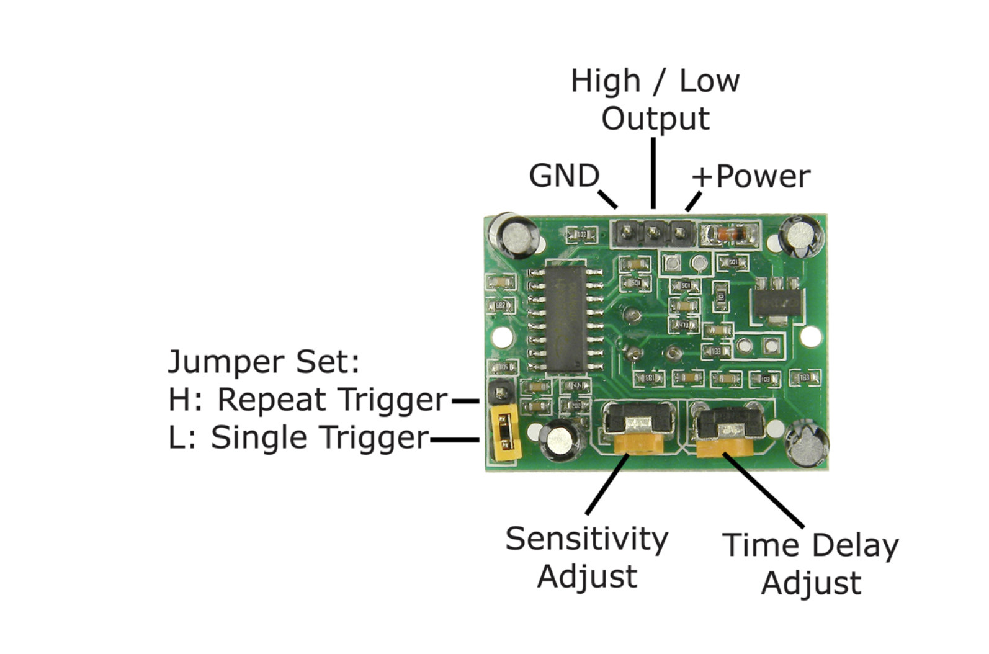

First Sylvain has done some research on silhouette detection algorithms. Next he took 10 images and tested the detection of silhouette with each algorithm. He chose the algorithm that provides the best detection.

Then he installed the script on Rapsberry. The camera captures images and then the script detects the silhouette on the image capture.

He test the silhouette at different frame rate and resolution.

With Artheum he tried to install GitLab but it crashes the Rapsberry because there was not enough memory on the Rapsberry.

The next day he reinstalled the script. Finally he wrote a script which detects a silhouette

and then determines the key points inside it.

The key points are special points as corners that are easily followed.

After that the script follows the key points on the next video frame and so on.

If the key points have disappeared, the script redetects the silhouette and so on.

* work in progress

The Arducam camera has crashed. We are trying to solve this problem.

* work remaining

We have to connect the script and the different hardware to the robot, doing some research on communication WIFI with ESP8266 and sending the data from ESP8266 to Rasberrypi.