Architecture
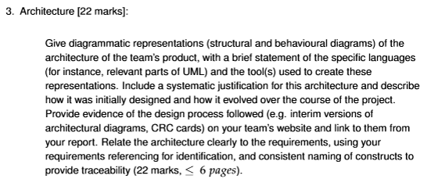

A diagram of the software architecture. Give info about languages used. Why languages were used and why / how they changed. Provide evidence of design process for objects. Write what we did in context of what we said we would do in requirements document.

Decisions and ideas from meeting 22/10/26

Classes:
- Sprite (implementable _
  - Game Object
    - Tile
      - Wall
      - Non-wall
    - Map item. Relates to an inventory item.
    - Player
      - Inventory (composition)
    - Goose
  - Inventory item
- Pannel
  - Text box
  - Menu
    - Start
    - Pause
  - Button
- Score tracker (has a text box)

