Risk assessment and mitigation
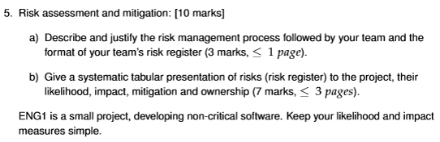

Risk Monitoring
- Owners of risks need to reassess their likelihood and severity regularly.
- A process must be put in place for reporting on the status of risks
  - Easy to neglect and assume that no news is good news

Risk ID | Risk description | Likelihood (1-5) | Impact (1-5) | Mitigation | Ownership
1 | Eye strain | 1 | 1 | Ensure all members take regular breaks and observe the “20-20-20” rule. | Individual
2 | Repetitive strain injury (RSI) | 1 | 2 | Ensure members take regular breaks and recommend using ergonomic mouse/keyboard
3 | Burnout | 3 | 4 | Ensure equal distribution of work and regularly check in as to whether members are feeling overwhelmed. | Individual
4 | Software interactions (making versions match) | 2 | 3 | Ensure all team members a present when implementing software so all can check if there is difficulting with interfacing. | Sky Burrows
5 | Loss or destruction of hardware | 1 | 5 | Ensure all hardware is handled carefully and securely and that all documents are stored on the cloud | Individual
6 | Schedule delays | 3 | 3 | Keep a thorough timetable and factor in a reasonable amount of slack time to account for potential delays | Oliver Quantrill-Scott
7 | Integration issues | 4 | 3 | Ensure that members review the structure of relevant pushes so that the project elements can interface with one another more easily. | Erikas
8 | Unavailable team member(s) | 5 | 3 | Ensure there is no task that is only given to a single individual so it can be worked on if that member is unavailable | Sky Burrows
9 | Loss of software | 1 | 5 | Ensure all software is backed up to the cloud and that all previous file versions are kept as to return to them if neccesary | Team
10
11
12
13
14
15
16

