Architecture
Group 9 - Inside No.9:
- Sky Burrows
- Oli Quantrill-Scott
- Daniel Basset
- Erikas Jovaisa
- James Garfield
- Oliver Lockett
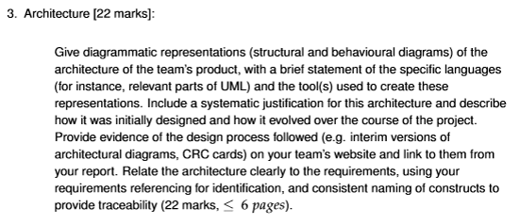

4.4 Architecture documentation
• Marked on how well your architecture describes the essential structure and behaviour of your system: you will lose marks for making the architecture too detailed.
• Marked on how clearly you describe your team’s design process and the evolution of your architecture over time.
• Assessed on the clarity and appropriateness with which you state the language(s) and tools that you use.
• Marked on how clearly your architecture justification follows the structure of your architecture, and accounts for unusual features or notations.
• Marked on how clearly and comprehensively you trace the architecture back to the requirements.

A diagram of the software architecture. Give info about languages used. Why languages were used and why / how they changed. Provide evidence of design process for objects. Write what we did in context of what we said we would do in requirements document.

Classes:
- Sprite (implementable _
  - Game Object
    - Tile
      - Wall
      - Non-wall
    - Map item. Relates to an inventory item.
    - Player
      - Inventory (composition)
    - Goose
  - Inventory item
- Pannel
  - Text box
  - Menu
    - Start
    - Pause
  - Button
- Score tracker (has a text box)
^^^^^Decisions and ideas from meeting 22/10/26^^^^^^^
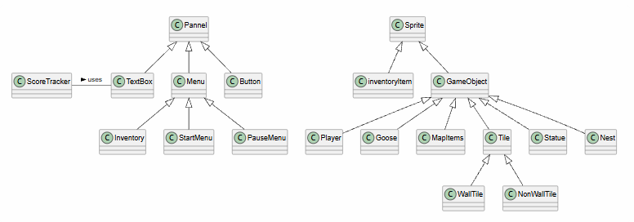
Fig 1… UML class diagram…
Intended to show basic relationships and hierarchies that we can improve as we flesh out the classes.

-Will menus have buttons and textboxes as attributes?
-How to show on a class diagram what is implementable or abstract?
-Tiles will have (through composition) an item? Or a statue/nest?
-Inventory on the same level as Start and Pause menus?: I imagined start and pause “menus” as screens. I.e GameScreen, MenuScreen, PauseScreen all inherit from Screen.

Pixel art format: Blow up vs Prefab
Decided on Blow up, implemented using a function of Screen. Because …

Long boi inherits from Goose:
Despite not having the “Distractible”/”Shoo” attribute(s)/method(s), we think it would be confusing to have the main goose class inherit from a unique variant.

Decided to change selecting an item from the inventory from controlled by mouse scroll to controlled by number keys, for ease of implementation. We don't think this would negatively affect player experience.

Game loads in its initial state, immediately freezes. Then activate the start menu.

Inventory implemented as a stack with a fixed size.

TMX collision map vs separate painted tiles:
TMX provides more flexibility in changing the look of the world and adding decorations without accidentally breaking our collision layout.
However it requires drawing / managing two parallel layers (the visual map and the collision map).
29/10 Meeting^^^^

Key Considerations:
(guided by Sommerville’s ‘Software Engineering’ [1])
- Choose the most appropriate structure (e.g client-server, or layered).
- Decide on strategy for decomposing components into subcomponents.
- Develop a model of the control relationships between parts of the system. Also, make decisions about how the execution of components is controlled.
These should depend on the non-functional requirements.

Smaller number of larger components means less communication between components: Beneficial for performance.
Security and safety are less relevant requirements: Meaning layered structure is less necessary.
Availability: …importance?
Maintainability: …importance?

Collision handled by Player and Goose. Not using listeners. Advantages of not using / using fewer listeners: Fewer classes, limit scope. Remove ‘middle men’ classes to reduce instructions executed by the system; improves performance.

Change Duck Statue to extend NonWallTile.
05/11 Meeting^^^^^

New public abstract InteractibleObject class, extends GameObject. Statute and Nest extend this, instead of GameObject.

From branch made 09/11/26^^^^

References
[1] I. Somerville. “Requirements Engineering” In Software Engineering, 10th Global ed. London, England: Pearson, 2015, pp. 102-1xx. [Online]. Available: https://eu.alma.exlibrisgroup.com/leganto/public/44YORK_INST/citation/67444944630001381?auth=SAML

