Method selection and planning
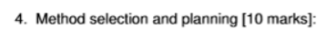
Sky:
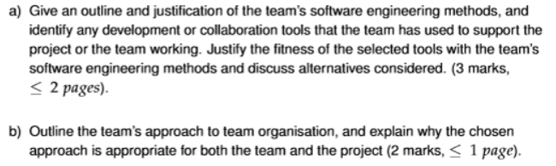
James:
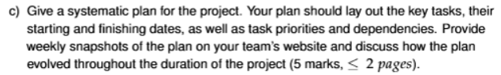
(5 marks each)

C) I Think the vast majority of this question is answered through having our plan on the website and then i think we just need to type out some start and end dates and we’re 90% of the way there.
Outline and justification of the team’s software engineering methods.

This team chose to follow a “waterfall” model for our software engineering model. This was considered over an “agile” model due to the limited time we found ourselves with after receiving our client brief, having the ability to outline a task, define it’s approximate length and set a deadline for its completion has given us distinct milestones within the project so we can quantify our progress in a way that is meaningful to the organisation for those leading the project. We perhaps would have used an “agile” model if this project had the benefit of a looser time schedule, but faced with the hard deadline of fewer than 7 weeks to fully plan, implement and complete a project of this magnitude with our skill set and knowledge, we ultimately have set in motion a project model that will allow us to complete our objectives sequentially and definitely, with more time allocated to tasks individually but ultimately resulting in requiring less time to revise these implementations.

To implement this, we have implemented a system where we have a GANTT chart which is revised each week after its creation to adequately reflect on our progress and milestones, and use that data to project how long we imagine the tasks within the project will take. The GANTT chart also allows us to visualise the distinction between the phases of the project (requirements, design, implementation, etc..), something key to the “waterfall” model’s project lifecycle.

Within the project, a number of tools were considered for the various aspects of the project’s development, but we ultimately decided to use GitHub for storing the project files, LibGDX for use as a game engine, Discord for team communication, and PlantUML for design of GANTT charts.

GitHub was chosen above alternatives, like GitLab and Azure, for its simplicity and wide use. There is plenty of documentation for use of GitHub, and we feel that most people who may pick up our project in the second course work will at worst be tentatively familiar with the software, and at best have used it themselves for their own project. GitLab and Azure provided almost as many benefits as GitHub, but GitLab was discounted over GitHub as it is less well-known and Azure was discounted as it requires a paywall to use, after a 30-day free trial, which the team was not comfortable expending. This fit our “waterfall” model well as it could be used to track milestones and updates for a more definite projection of how the project would work temporally.

LibGDX was chosen for a similar reason to GitHub, in that of the examples of game engines we were given, it seemed to be the most reputable and documented, and we determined that other teams may have also come to this conclusion, thus it would likely be more easy to understand for the masses than other alternatives, such as jMonkeyEngine, the other software we discussed using. The idea of using no game engine and just implementing the project using the base java software and packages was discussed, but ultimately we determined that people taking over the project were more likely to recognise some game engine than no game engine. This fit our software engineering method as well as most game engines could as it allows for easier error catching and fixing of bugs, over the alternative of no game engine, which perhaps would have allowed for a lower level implementation of the game and given more control but ultimately this was deemed less important than the benefits LibGDX provided; with this less revisions would need to be made, fitting the “waterfall” model better.

Discord was chosen as our communications channel over alternatives such as Slack and Whatsapp due to all team members already having the software, and it’s ability to have multiple communication channels for different purposes. Whatsapp does have a Communities feature, but we determined it would just be easier for people to join a Discord server than have to exchange phone numbers, as in the first weeks of the project we did not have any meeting in which all team members attended the meetings. This system of communication allowed for us to have dedicated sections for scheduling so we could ensure milestones were met within the right time frames, further benefiting our “waterfall” method.

PlantUML was chosen as the tool for GANTT charts over the discussed alternative Lucidchart due to how precisely we could manipulate data and it’s ease of allowing us to do so. Lucidchart was a tempting alternative, but it was determined the software interface allowed for too many things, too “noisy” in choices, that using a more dedicated software would be more convenient. This was the most beneficial to our “waterfall” method of all tools we used, as it allowed for the distinct visualisation of milestones, tasks and how they would fit into our schedule.

Team’s approach to team organisation

The team had a loose approach to team organisation with little distinction between the role types, as we all determined towards the start of the project we mostly fill the same role types as each other. That being said, one member of the team, alongside of the work assigned to the group at large, acted slightly more in a directorial or administrative role, creating and maintaining the website, assigning people to the different tasks that needed to be done, booking the meeting rooms and leading the meetings. The system for assigning work was covering it all in the meeting, seeing who was available for what work and when, distinguishing the sub-tasks that needed to happen by the next milestone and assigning (typically 2) people to head that task and see it completed.

This approach is appropriate for the team as each of the members operate in a similar role type and skill set, therefore tasks are assigned primarily by who is available to work. The team started at very similar points, with nobody having any experience in LibGDX but most of us having some experience in Java and game design and creation. This approach is appropriate for the project as we have a directing force outlining the tasks that need to be done within the project, but we have a force of 7 equally abled individuals who are capable of performing the determined sub-tasks. The software engineering method the project is following, the “waterfall” method, defines a structure which uses a predetermined projection of tasks and how long they will take to complete; given this, having a administrative presence who can direct the team members to do a certain item of work and when to finish by fits very well within that structure.

Systematic plan for the project
.
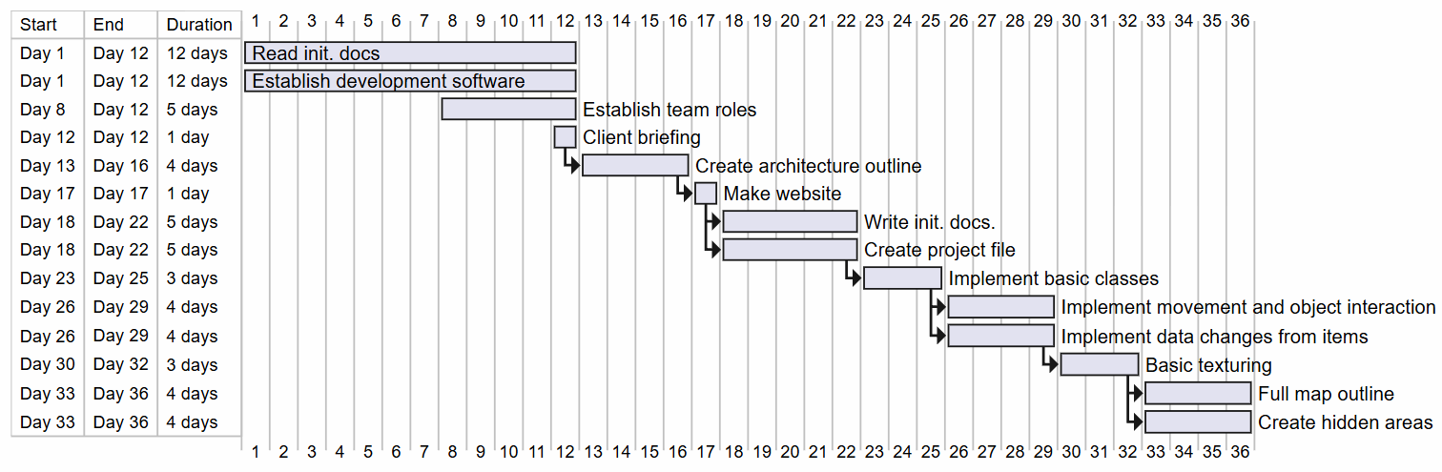
/\
This is the first GANTT chart I have developed for the project, this should help with your end of this document.
- Sky :)

