Risk assessment and mitigation
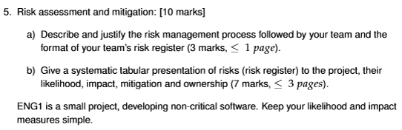

Risk Monitoring
- Owners of risks need to reassess their likelihood and severity regularly.
- A process must be put in place for reporting on the status of risks
  - Easy to neglect and assume that no news is good news

Risk ID | Risk description | Likelihood (1-5) | Impact (1-5) | Mitigation | Ownership
1 | Eye strain | 1 | 1 | Ensure all members take regular breaks and observe the “20-20-20” rule.
2 | Repetitive strain injury (RSI) | 1 | 2 | Ensure members take regular breaks and recommend using ergonomic mouse/keyboard
3 | Burnout | 3 | 4 | Ensure equal distribution of work and regularly check in as to whether members are feeling overwhelmed.
4 | Software interactions (making versions match) | 2 | 3 | Ensure all team members a present when implementing software so all can check if there is difficulting with interfacing.
5 | Loss or destruction of hardware | 1 | 5 | Ensure all hardware is handled carefully and securely and that all documents are stored on the cloud
6 | Schedule delays | 3 | 3 | Keep a thorough timetable and factor in a reasonable amount of slack time to account for potential delays
7 | Integration issues | 4 | 3 | Ensure that members review the structure of relevant pushes so that the project elements can interface with one another more easily.
8 | Unavailable team member(s) | 5 | 3 | Ensure there is no task that is only given to a single individual so it can be worked on if that member is unavailable
9 | Loss of software | 1 | 5 | Ensure all software is backed up to the cloud and that all previous file versions are kept as to return to them if neccesary
10
11
12
13
14
15
16

